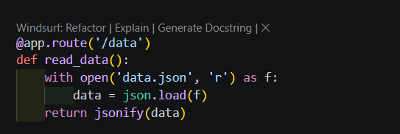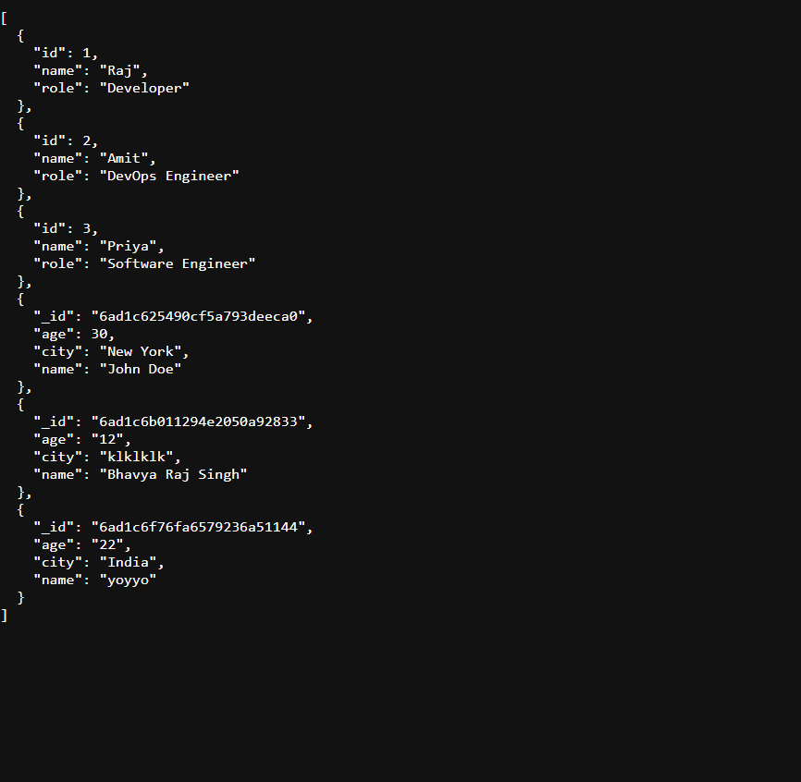
The data being read from the data.json file.


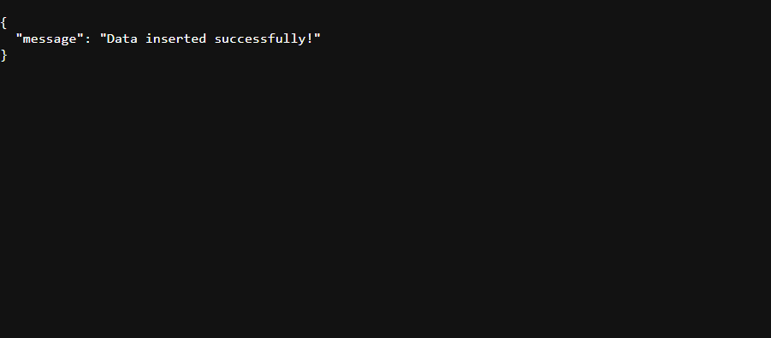
Added a basic index.html and it is stored in database and written in data.json as well.

Project Setup, Testing Commands, and Evidence
This section documents the commands used to install, run, test, and publish the Flask and MongoDB application. Screenshots should be placed below the related command or explanation.

1. Open the project and activate the virtual environment
cd "C:\Users\bhavy\OneDrive\Desktop\Flask_and_MongoDB_Bhavya_Raj_Singh"
.\.venv\Scripts\Activate.ps1

2. Install dependencies
pip install -r requirements.txt

3. Check Python syntax
python -m py_compile app.py

4. Start the Flask server
python app.py

5. Test the frontend
Open http://127.0.0.1:5000/ in a browser.

6. Test the JSON API
Invoke-RestMethod http://127.0.0.1:5000/data
Note: the current application returns the JSON list at /data. The assignment requirement expects the JSON-list route to be /api.

7. Test a successful form submission
Invoke-WebRequest -Uri http://127.0.0.1:5000/submit -Method POST -Body @{name="Bhavya Raj Singh"; age="25"; city="Delhi"}

8. Test error handling
Invoke-WebRequest -Uri http://127.0.0.1:5000/submit -Method POST -Body @{name=""; age=""; city=""}
Invoke-WebRequest -Uri http://127.0.0.1:5000/submit -Method POST -Body @{name="Test User"; age="abc"; city="Delhi"}

9. Verify MongoDB Atlas
Open MongoDB Atlas Data Explorer and select test > test_collection. The submitted document should appear with name, age, and city fields.
Insert the provided MongoDB Atlas screenshot here.

10. GitHub commands
git init
git add .
git commit -m "Complete Flask MongoDB assignment"
git branch -M main
git remote add origin YOUR_GITHUB_REPOSITORY_URL
git push -u origin main

11. GitHub repository link
Repository URL: Add the final GitHub repository URL here.

Evidence Checklist
- Flask server running at http://127.0.0.1:5000
- Frontend form displayed
- JSON API response displayed
- Successful MongoDB insertion shown in Atlas
- Error message displayed on the same form page
- GitHub repository link included

