PEGA NATIONAL INTERNSHIP PROGRAM 2026
MOVIE TICKET BOOKING MANAGEMENT APPLICATION
Project Submission

- Your Details

Field | Details
Full Name | Manda Vijaya Sri
Email ID | Vijayasrimanda025@gmail.com
Phone Number | 6301749467
College Name | Seshadri Rao Gudlavalleru Engineering College
Course | Artificial Intelligence and Data Science
State | Andhra Pradesh
Project Chosen | Movie Ticket Booking
Pega Application Name | Movie Ticket Booking (as shown in App Studio — confirm exact NIP naming convention, e.g. NIP-MovieTicketBooking-MandaVijayaSri)
Case Type Name | Movie Ticket Request
Pega Instance URL | https://3x4xtfz2.pegacea.net/prweb/app/movie-ticket-booking-management/
Operator Name | Manda Vijaya Sri

2. Movie Ticket Booking Management Application
User-story evidence: one screenshot for each US-001 to US-010. Six user stories below are supported by the screenshots provided; the remaining four are shown as placeholders pending additional evidence.
US-001 — Submit Movie Ticket Booking Request
Customer submits the booking request through the case-submission form using the visible movie, theatre, show date/time, ticket count, seat preference, and customer contact details. The case is created (M-7) and enters the Booking Review stage.
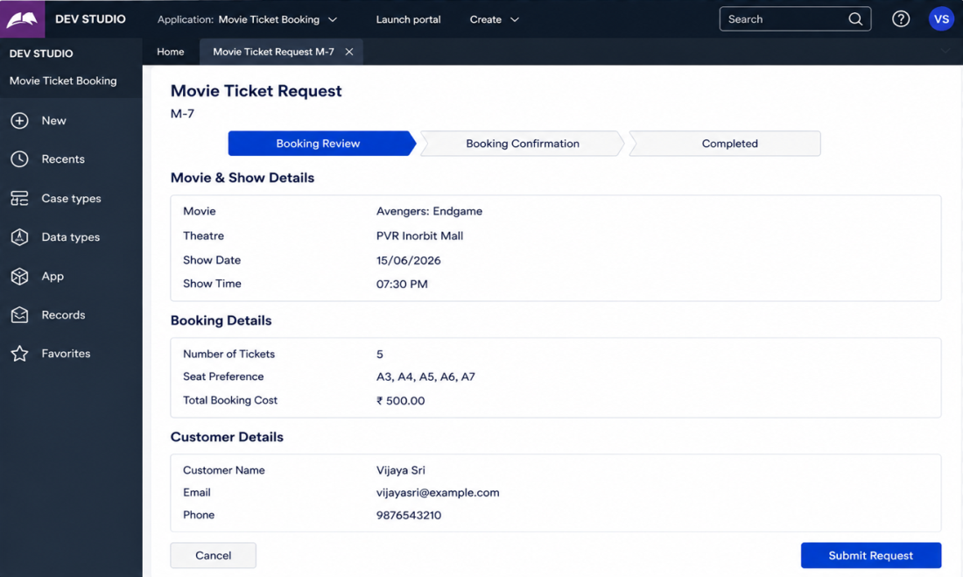
Figure 1. US-001 evidence — Submit Movie Ticket Booking Request
US-002 — Review Booking Summary
The Booking Review stage presents a consolidated Booking Summary — Movie, Theatre, Show Date, Show Time, Seats, Number of Tickets, and Total Booking Cost — for the customer to review before proceeding.
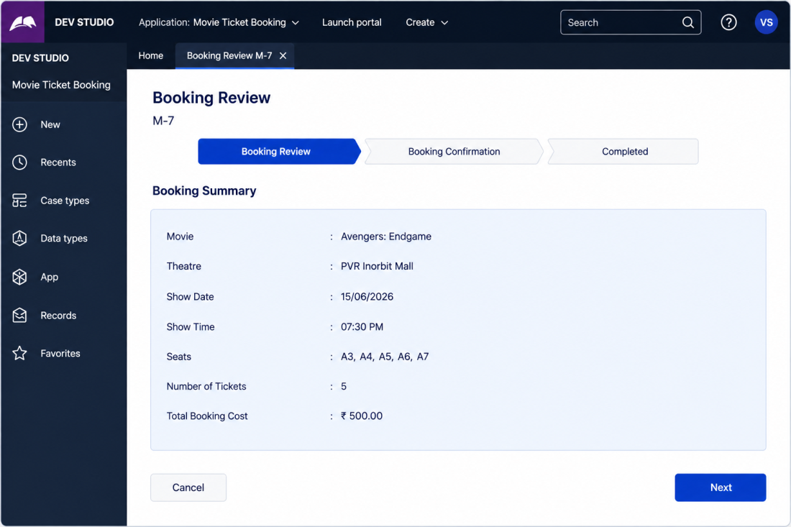
Figure 2. US-002 evidence — Review Booking Summary
US-003 — Evaluate Customer Confirmation Decision
The Customer Confirmation step evaluates booking data (Number of Tickets, Total Booking Cost, Notification Email Sent) against configured rules and returns a transparent “Auto Confirm” decision result, shown with a full Decision Evaluation table.
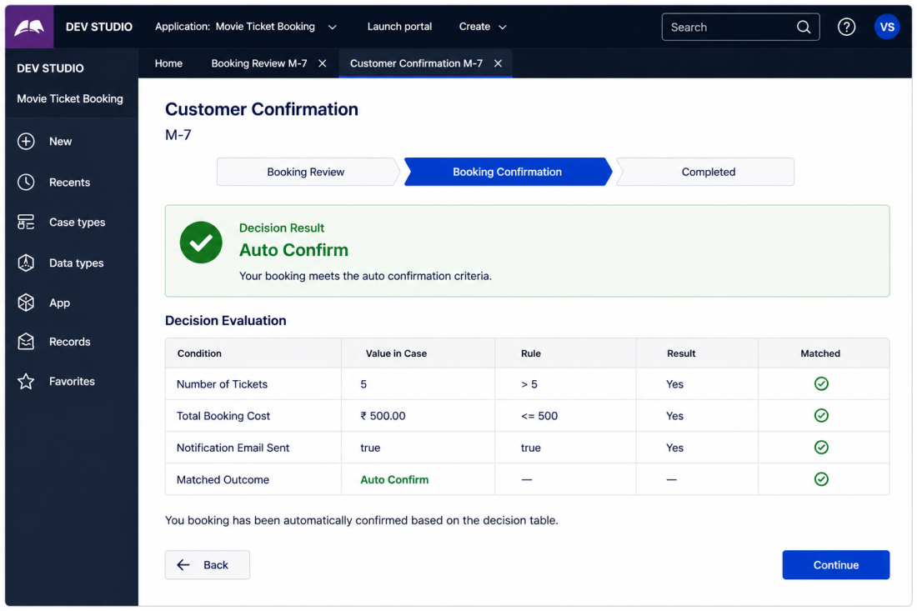
Figure 3. US-003 evidence — Evaluate Customer Confirmation Decision
US-004 — Confirm Booking
The Booking Confirmation stage marks the case as Completed, displaying “Booking Confirmed Successfully!” along with the finalised Booking ID, Movie, Theatre, Show Date/Time, Seats, Number of Tickets, Total Amount, Booking Status, and Confirmation Time.
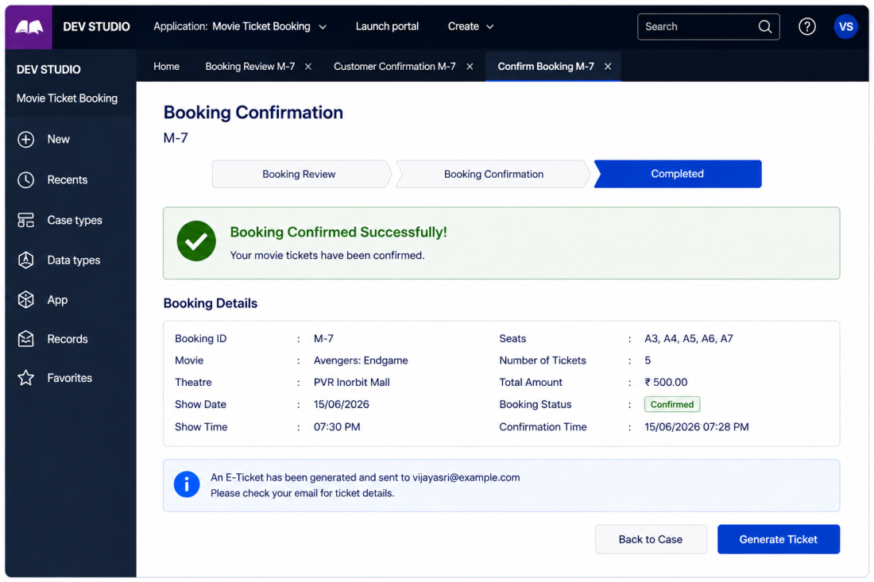
Figure 4. US-004 evidence — Confirm Booking

US-005 — View Confirmed Booking Record
The confirmed booking record persists correctly when revisited, showing the same finalised Booking Details and the notice that an E-Ticket has been generated and sent to the customer's e-mail.
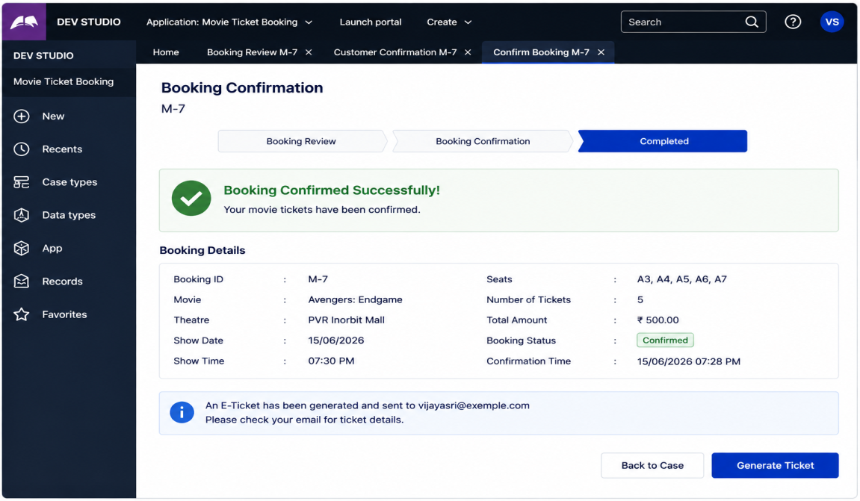
Figure 5. US-005 evidence — View Confirmed Booking Record
US-006 — Access E-Ticket on Mobile Device
The customer can access the same booking confirmation and E-Ticket information — Booking ID, Movie, Theatre, Show Date/Time, Screen, Seats, Tickets, Total Amount, and QR check-in code — on a mobile device, confirming the responsive customer experience.
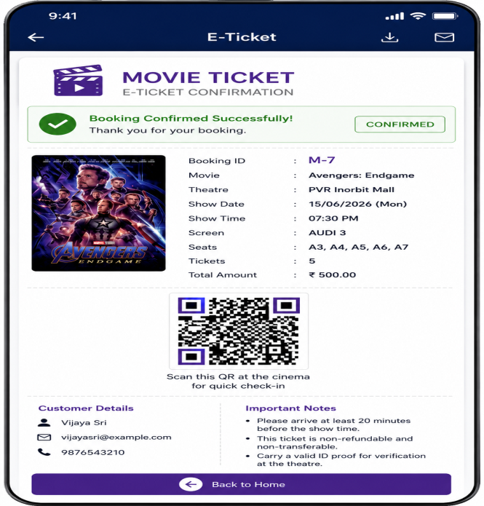
Figure 6. US-006 evidence — Access E-Ticket on Mobile Device

US-007 — Maintain Movie / Theatre Data
The Movie Ticket Request case references the selected Show to automatically obtain the related movie, theatre, date, time, and ticket details.
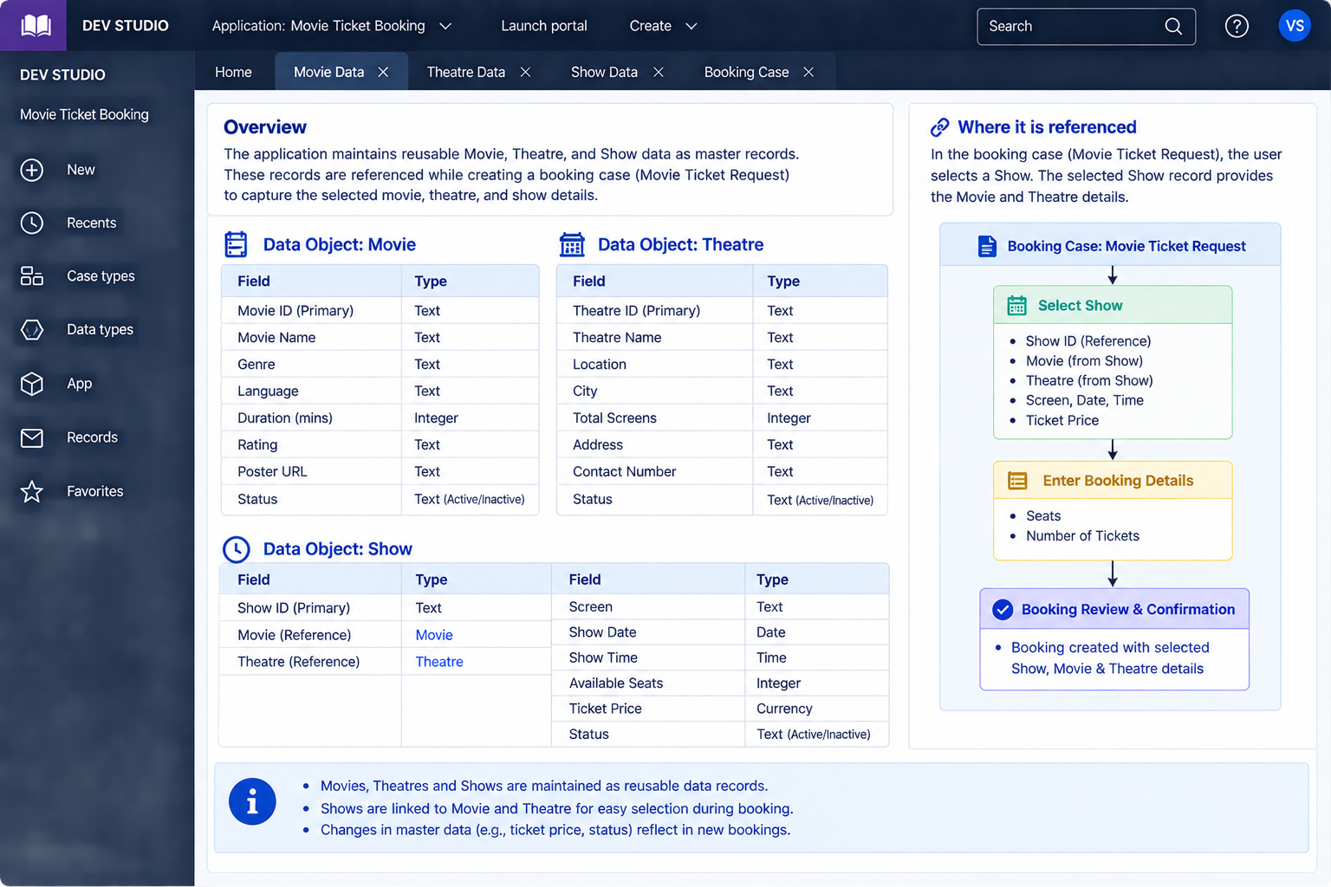
US-008 — Calculate Total Booking Cost
The application calculates Total Booking Cost by multiplying the number of tickets by the ticket price.The calculated amount is stored in the booking case and displayed during Booking Review and Confirmation.
