**Name- Rajkeshav Kumar Jha**

**TAS129**

Scala Assignment

**Q1)**

| object Main{   private def changeNum(d: Double):Double={   val temp=d*1000  // println(s"temp value ="+temp)   val remByHun=temp%100  // println(remByHun)   var desiredOutput=0.000   if(remByHun < 50)   desiredOutput=(temp-remByHun)/1000.000   else   desiredOutput=(temp-remByHun)/1000.00 +0.050   desiredOutput   }   def main(args:Array[String])={   val numbers = List(12.05, 12.03, 10.45, 11.299, 13.350,12.677,12.55)   val ranges = numbers.map { numb =>  // println(numb)   val num=((numb%1).abs)+0.0001  //println(s"the number is $num")  val lowerBound = math.floor(numb) + changeNum(num)   val upperBound = lowerBound + 0.049   f"$lowerBound%.3f-$upperBound%.3f"   }   println(ranges)   }  } |
| --- |

**Output:**

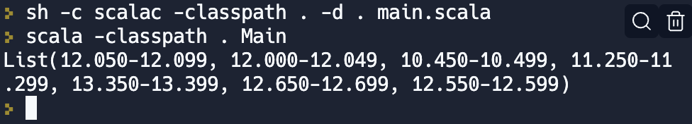

**Q2)**

| object PlayerStats {  case class Player(year: Int, name: String, country: String, matches: Int, runs: Int, wickets: Int)    def main(args: Array[String]): Unit = {  // Sample data  val players = Seq(  Player(2021, "Sam", "India", 23, 2300, 3),  Player(2021, "Ram", "India", 23, 300, 30),  Player(2021, "Mano", "India", 23, 300, 13)  )    // 1. Player with the highest run scored  val playerWithHighestRun = players.maxBy(_.runs)  println(s"Player with the highest run scored: ${playerWithHighestRun.name} (${playerWithHighestRun.runs} runs)")  // 2. Top 5 players by run scored  val top5PlayersByRun = players.sortBy(_.runs)(Ordering[Int].reverse).take(5)  println("Top 5 players by run scored:")  top5PlayersByRun.foreach(player => println(s"${player.name} (${player.runs} runs)"))    // 3. Top 5 players by wicket taken  val top5PlayersByWickets = players.sortBy(_.wickets)(Ordering[Int].reverse).take(5)  println("Top 5 players by wickets taken:")  top5PlayersByWickets.foreach(player => println(s"${player.name} (${player.wickets} wickets)"))    // 4. Rank players with overall performance  val rankedPlayers = players.map { player =>  val overallPerformance = player.runs + (player.wickets * 5)  (player, overallPerformance)  }.sortBy(_._2)(Ordering[Int].reverse)    println("Ranking players with overall performance (runs + 5*wickets):")  rankedPlayers.zipWithIndex.foreach { case ((player, score), index) =>  println(s"${index + 1}. ${player.name} (${player.runs} runs, ${player.wickets} wickets) - $score")  }  } } |
| --- |

**Output:**

