Assignment 3 Report - Profile Card Screen in Flutter
1. What the assignment was
Build a Flutter profile card screen using Column, Row, Container, CircleAvatar, Text, and Icon widgets, with custom theme colors instead of the default Material palette.
2. Files
• app_colors.dart - one class, AppColors, holding the custom palette as static constants.
• profile_stat.dart - ProfileStat (a simple label/value model) and ProfileStatColumn, the widget that displays one.
• profile_card.dart - ProfileCard, the card itself: avatar, name, role, location row, stats row, follow button.
• main.dart - ProfileApp sets up MaterialApp with the custom background color, ProfileScreen centers a ProfileCard on screen.
3. Concepts used
Container - the card is a Container with fixed width, padding, rounded corners, a background color from AppColors, and a drop shadow.
Column / Row - Column stacks the avatar, name, role, location, stats, and button vertically. Row is used twice: once for the location line (icon + text side by side), once for the three stats spread across the card.
CircleAvatar - two nested CircleAvatars make the ring around the icon: an outer one for the accent-colored ring, an inner one for the dark circle with the person icon on top.
Text / Icon - every label on the card is Text with a style pulled from AppColors. Icon is used for the location pin, the person icon in the avatar, and the icon on the follow button.
Custom theme colors - AppColors defines background, card background, accent, and two text colors. Nothing on the card uses a default Material color.
4. Output
Screenshot of the actual widget, rendered from the real ProfileScreen:
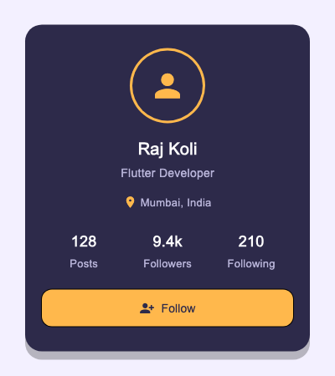
5. What I understood
• A Container's decoration (color, radius, shadow) can't be set together with a plain color property - once you need rounded corners or a shadow, the color has to move inside BoxDecoration.
• Nesting two CircleAvatars is a simple way to fake a ring/border around an avatar without drawing a custom shape.
• Centralizing colors in one AppColors class made it easy to keep the palette consistent - I only had to change a value in one place while tuning it.
• Row doesn't shrink its children by default - if the content is wider than the space available, it overflows instead of wrapping.
6. Challenges
Row overflow. The stats row (Posts / Followers / Following) overflowed the card width with a yellow-and-black striped warning in the console. Fixed by wrapping each stat in Expanded so the three columns share the row width instead of taking their natural size.
Getting a real screenshot without a running emulator. I didn't want to depend on a simulator being open, so I rendered the actual widget tree in a Flutter test and saved it as a PNG instead of a mockup.
Picking colors that actually look custom. First pass reused Material blue and just changed the background, which barely looked different from the default theme. Settled on a dark navy card with a warm accent color instead, which made the "custom theme" part of the assignment obvious at a glance.
7. Conclusion
This covers all five required widgets - Column, Row, Container, CircleAvatar, Text, and Icon - plus a custom color palette applied throughout instead of Material defaults. Tested by running the widget and checking the layout held together at the target size, with no overflow warnings.

