Assignment 6 Report - Dynamic Product Listing and Search in Flutter
1. What the assignment was
Create a dynamic product listing using ListView.builder with a data model class, and implement search/filter functionality using setState.
2. Files
• product_item.dart - Product data model class and ProductTile widget, rendering individual product cards.
• product_list_screen.dart - ProductListScreen, manages the search query input, dynamic filtering via setState, and ListView.builder.
• main.dart - entry point setting up MaterialApp with Material 3 theming.
3. Concepts used
Data Model Class - Product defines the data structure (name, category, price). Using a model class ensures type safety and makes it easy to pass and format structured data throughout the app.
ListView.builder - Renders the product list on demand as the user scrolls, creating only the visible items. It efficiently binds to the dynamic _filteredProducts list length.
setState for Reactive Filtering - As the user types into the TextField, the onChanged callback calls _filterProducts(query). setState triggers a UI rebuild with the newly filtered subset of products matching either the product name or category (case-insensitive).
Card & ListTile UI - Each item is displayed inside a styled Card with a ListTile containing a leading CircleAvatar displaying the product initial, title, category subtitle, and price badge.
Empty State Handling - When a search returns no matching items, a clean fallback message ("No products found") is rendered instead of an empty list.
4. Output
All products view (phone):
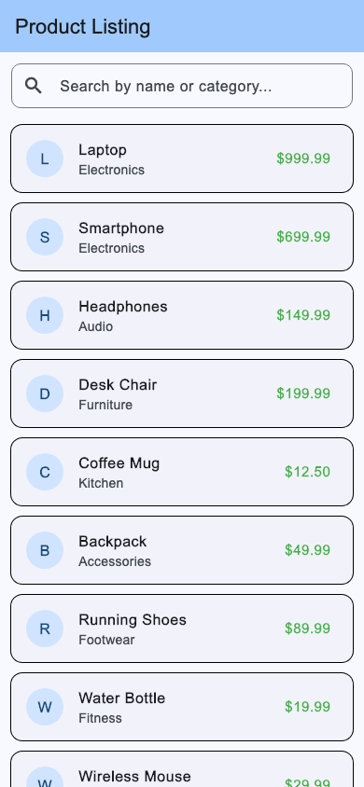
Search and filtered view (phone):
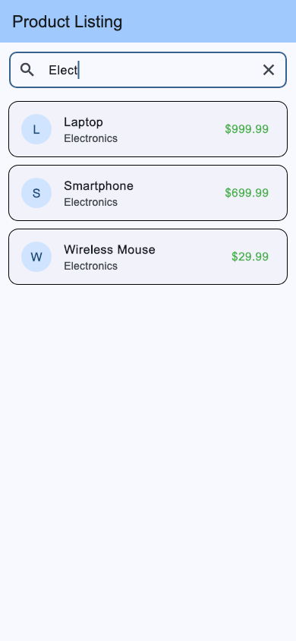
5. What I understood
• ListView.builder is much more memory efficient than default ListView when working with dynamic or large datasets, because items are created lazily only when they come into view.
• setState informs Flutter that internal state has changed, prompting a call to the build method to reconcile the UI against the updated data.
• Keeping the master list (_allProducts) separate from the visible list (_filteredProducts) is essential; modifying the original list directly would permanently erase data during filtering.
• Reusable component separation (e.g., separating ProductTile into its own file) keeps screens uncluttered and promotes clean code architecture.
6. Challenges
Avoiding mutating the original list. If filtering mutated _allProducts directly, clearing the search query or backspacing would not restore previously filtered-out items. Resolved by keeping _allProducts constant and maintaining a separate _filteredProducts list in state that updates dynamically.
Case sensitivity in search. A strict string comparison causes search terms like "laptop" to miss "Laptop". Solved by converting both the search term and product fields to lowercase (toLowerCase()) during comparison.
Searching across multiple fields. Users might search by category (e.g., "Electronics") or by name (e.g., "Headphones"). Solved by checking both product.name and product.category within the filter condition.
7. Conclusion
This project satisfies all required criteria: a structured Product data model, efficient dynamic list rendering with ListView.builder, and real-time search/filter capabilities driven by setState. The code is cleanly structured into separate files for readability and maintainability.

