Assignment 4 Report - Responsive Dashboard in Flutter
1. What the assignment was
Create a responsive multi-section dashboard using ListView, GridView, MediaQuery, and Flexible/Expanded that adapts to screen size.
2. Files
• stat_item.dart - StatItem model and StatCard, one tile in the stats grid.
• stats_grid.dart - StatsGrid, wraps GridView.builder and picks its own column count from the space it's given.
• activity_item.dart - ActivityItem model and ActivityTile, one row in the activity list.
• activity_list.dart - ActivityList, wraps ListView.separated.
• quick_actions.dart - QuickActionsBar, a Row of Flexible-wrapped buttons.
• dashboard_screen.dart - assembles all sections and switches the overall layout based on MediaQuery.
• main.dart - entry point.
3. Concepts used
GridView - StatsGrid uses GridView.builder with SliverGridDelegateWithFixedCrossAxisCount to lay out the stat cards.
ListView - ActivityList uses ListView.separated for the recent activity feed, with a divider between rows.
MediaQuery - DashboardScreen reads MediaQuery.of(context).size.width to decide whether the stats grid and activity list sit side by side (wide screen) or stacked (narrow screen).
Flexible / Expanded - the quick actions row wraps each button in Flexible so they shrink instead of overflowing on a narrow screen. The two-section layout uses Expanded (with different flex values) to split the width on wide screens, and Expanded again to let the activity list fill the remaining height on narrow screens.
Responsive layout - two different structures for wide vs narrow, not just resized widgets: Row with Expanded panels side by side on wide screens, Column with a fixed-height grid and an Expanded list underneath on narrow screens.
4. Output
Phone width (390px):
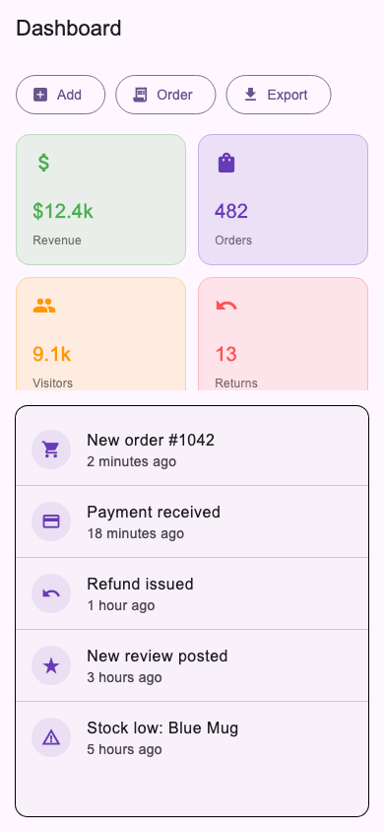
Desktop width (1100px):
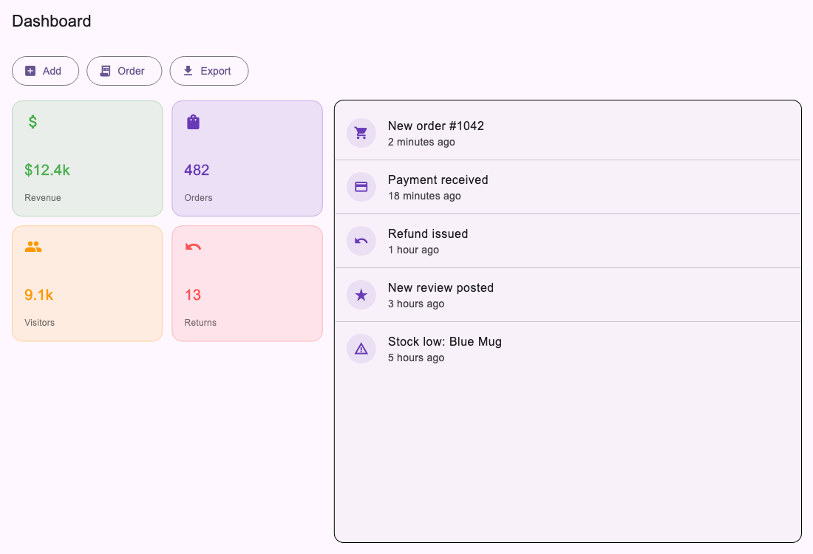
5. What I understood
• MediaQuery.of(context).size gives the full screen size, but a widget nested inside a Row/Expanded doesn't get that much space - it only gets its share. Column counts and sizing decisions are safer based on the widget's own constraints, not the screen's.
• Flexible lets a child shrink below its natural size when there isn't room; without it, a Row of buttons just overflows instead of adjusting.
• Expanded is Flexible with FlexFit.tight - it forces the child to fill the space instead of just allowing it to.
• GridView and ListView both need a bounded height unless they're the direct child of something like Expanded that gives them one.
6. Challenges
Grid columns based on the wrong width. First version picked the GridView column count from MediaQuery's full screen width. On a wide screen the grid only got a fraction of that width (it was sharing the row with the activity list via Expanded(flex: 2)), so the cards were forced too narrow and overflowed. Fixed by wrapping StatsGrid in a LayoutBuilder and picking the column count from its own constraints.maxWidth instead of the screen width.
Quick action labels getting clipped. On the narrow layout, Flexible buttons with longer labels like "Add product" got squeezed down to "Add ..." with an ellipsis. Shortened the labels instead of fighting the layout for more space.
Bounded height for ListView inside Column. On the narrow layout, ListView can't just be dropped into a Column - it needs a bounded height. Solved it by wrapping the grid in a fixed-height SizedBox and wrapping the list in Expanded, so the list gets whatever height is left.
7. Conclusion
This covers all four required pieces - ListView, GridView, MediaQuery, and Flexible/Expanded - with the layout genuinely restructuring itself (not just resizing) between phone and desktop widths. Tested by rendering the dashboard at both a phone size and a desktop size and confirming no overflow warnings and no leftover empty space at either size.

