Assignment 2 Report
Mock API Fetcher in Dart
Console program built with null safety, Future, and async/await
1. What the assignment was
Build a Dart program using null safety, Future, and async/await to fetch and display mock API data, and handle null and error cases. Instead of calling a real API, I built a MockApiService that simulates a network call with a delay, and used it to fetch user records by id.
2. How the program is structured
The project has one file per feature inside lib:
• user.dart holds the User model. Its email field is String? since not every user has one.
• api_exception.dart holds a small custom ApiException class, thrown when the mock API "fails."
• mock_api_service.dart holds MockApiService, which has one method, fetchUser(id), returning Future<User?>.
• main.dart is the entry point. It loops through a list of ids and calls fetchUser for each one, printing the result.
mock_api_service.dart imports both user.dart and api_exception.dart since it returns one and can throw the other. main.dart only needs to import mock_api_service.dart.
3. Concepts I used
Null safety - User.email is typed String? because a user might not have one. In User.toString() I used email ?? "not provided" so a missing email prints something readable instead of null. fetchUser itself returns Future<User?>, so the caller has to handle the case where the user doesn't exist at all, not just a missing field.
Future - fetchUser returns a Future<User?> instead of a plain User?, because the whole point is that it doesn't resolve immediately - it's meant to represent a network call. Inside it, Future.delayed(Duration(seconds: 1)) fakes that network delay.
async/await - fetchUser is declared async so I can await the delay inside it. printUser in main.dart is also async so it can await service.fetchUser(id) and get the actual User? back instead of a Future wrapper. main() itself is async too, and awaits printUser in a loop so the fetches happen one at a time in order instead of all firing at once.
Handling null and error cases - Two separate failure paths get handled differently, on purpose. If the id just doesn't exist in the mock database, fetchUser returns null - that's a normal, expected outcome, not an error. main.dart checks if (user == null) and prints a plain "not found" message. If the id is 99, fetchUser throws an ApiException - that represents an actual failure (like a dead server), and it's caught with try/catch in printUser, printing the error instead of letting the program crash.
4. Program output
This is the actual output from running dart run lib/main.dart:
Fetching user 1...
User(id: 1, name: Alice, email: alice@example.com)

Fetching user 2...
User(id: 2, name: Bob, email: not provided)

Fetching user 3...
User(id: 3, name: Charlie, email: charlie@example.com)

Fetching user 4...
No user found with id 4

Fetching user 99...
Failed to fetch user 99: ApiException: Server did not respond

Done fetching all users.
Screenshot of this same run:
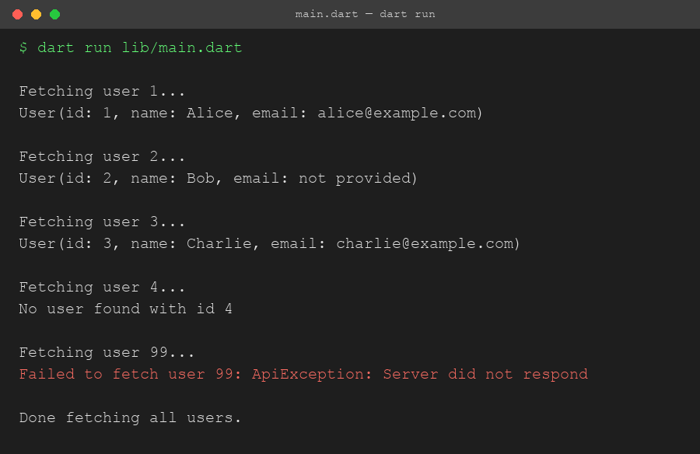
5. What I understood
Before this assignment I'd used async/await a little, but mostly copy-pasted without really thinking about what a Future was doing underneath. Doing this made a few things click:
• A Future<User?> is not the same as a User? - you can't just check it for null directly, you have to await it first to get the actual value out. I made this mistake once while testing and got a weird "not equal" comparison against a Future object instead of a real user.
• Returning null and throwing an exception are two different ways of saying "this didn't work," and they mean different things. null here means "the API worked fine, there's just nothing at that id." An exception means "the API itself failed." Mixing those up would make the caller's code confusing, since you'd have to guess whether a failure is normal or not.
• ?? is a clean way to give a default when something might be null, instead of writing an if check every time you want to print or use the value.
• Marking main() itself as async is what lets you await things directly inside it, which I hadn't done before - I'd always awaited inside some other function and called that from a non-async main.
6. Challenges I faced and how I solved them
Problem 1: Forgetting to await the Future.
On my first pass I wrote final user = service.fetchUser(id); without await, then tried to check user == null right away. Since a Future object itself is never null, that check always passed, and printing user just showed something like Instance of 'Future<User?>' instead of the actual data. Adding await in front of the call fixed it, since that's what actually waits for the value and unwraps it.
Problem 2: Deciding between returning null and throwing.
At first I was tempted to just throw an exception for every failure case, including "user not found." But that didn't feel right, since "not found" is a completely normal outcome for a lookup, not a system failure. I split it: missing id returns null and gets handled with a plain if check, while an actual simulated server failure (id 99) throws ApiException and gets handled with try/catch. This made the calling code in main.dart read more clearly, since the two cases are visibly different in how they're handled.
Problem 3: Making the delay actually visible.
Since everything runs so fast normally, without Future.delayed the "async" part wouldn't really be demonstrating anything - it would look the same as if I'd just written synchronous code. Adding a one second delay inside fetchUser made it obvious in the output that each fetch actually takes time, and running them with await inside a loop (instead of firing them all at once) meant they visibly happen one after another.
Problem 4: Custom exception class.
I wasn't sure at first if I needed a whole class for this or could just throw 'some string'. I went with a small class implementing Exception (ApiException) instead, since it's the more correct pattern in Dart and let me override toString() to control exactly how the error prints, plus it's more specific than a raw string if I ever wanted to catch just ApiException and not other error types.
7. Conclusion
This assignment made the difference between a Future and its resolved value, and the difference between "null" and "error," a lot more concrete than just reading about them. The program covers all the required pieces - null safety with a nullable field and the ?? operator, a Future-returning method, async/await used at multiple levels, and both a null case and a thrown-exception case handled separately - and I tested it by running it and checking every id in the list produced the output I expected.

