Assignment 7 Report - 3-Screen App with Named Routes & Form Validation
1. What the assignment was
Build a 3-screen Flutter app (Home, Form, Detail) using named routes, and implement a registration form with comprehensive validation (email, password, required fields).
2. Files
• user_data.dart - UserRegistration data model class encapsulating registered user fields (fullName, email, phone, password).
• home_screen.dart - HomeScreen (route /), welcoming users and providing entry to the registration flow.
• form_screen.dart - FormScreen (route /form), manages the registration form, input controllers, field validators, and submission handling.
• detail_screen.dart - DetailScreen (route /detail), retrieves arguments passed via named route and renders a verified user profile summary.
• main.dart - entry point defining MaterialApp with Material 3 theming and the central named route registry (routes table).
3. Concepts used
Named Routes Navigation - Instead of inline MaterialPageRoute calls, routes are declared centrally in main.dart via initialRoute and routes: { '/': ..., '/form': ..., '/detail': ... }. Navigation is triggered using Navigator.pushNamed() and Navigator.pushNamedAndRemoveUntil().
Route Arguments Passing - When the registration form is successfully validated, a UserRegistration object is passed directly through Navigator.pushNamed(context, '/detail', arguments: user). The destination screen retrieves it cleanly using ModalRoute.of(context)!.settings.arguments as UserRegistration.
Form & FormState Management - The form is bound to a GlobalKey<FormState>(). Calling _formKey.currentState!.validate() runs all field validators simultaneously and toggles validation error displays across invalid inputs.
Input Validation & Regular Expressions - Built custom validator logic for required fields, regex email verification, 10-digit phone checking, and password length/matching constraints.
User Experience & Feedback - Includes password visibility toggles, clear helper/hint texts, TextInputAction progression, and a Form Reset action.
4. Output
Home Screen (phone):
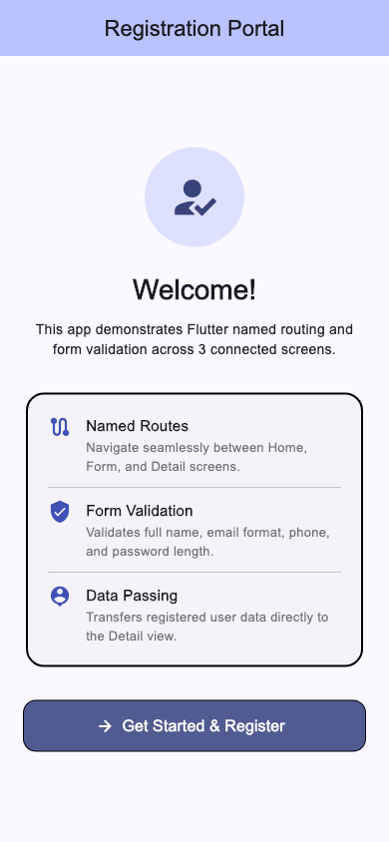
Registration Form Screen:
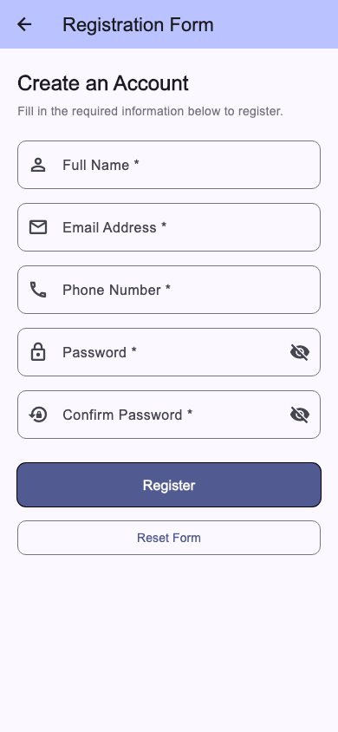
Active Validation Errors:
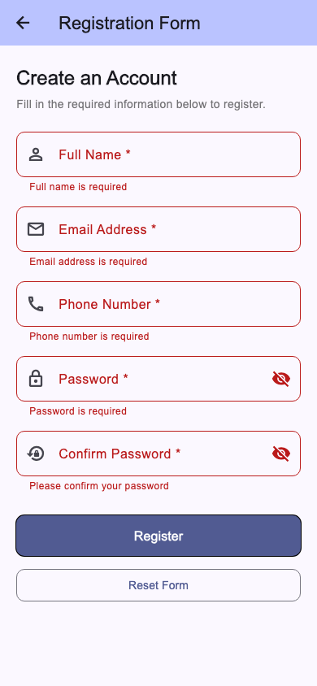
Detail Screen (Registered Profile):
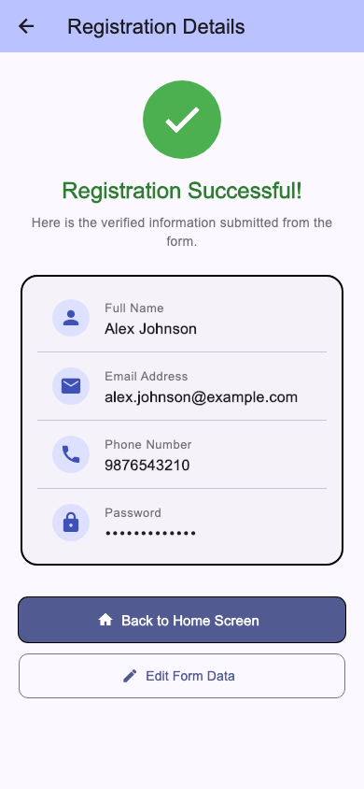
5. What I understood
• Named routes provide a single source of truth for application page hierarchy, decoupling screens from one another and simplifying navigation logic.
• GlobalKey<FormState> enables global form validation and resetting without managing manual error boolean flags for each field.
• Using a typed data model for route arguments keeps screen contracts type-safe and prevents parameter mismatches.
• SingleChildScrollView combined with SafeArea ensures forms remain accessible without keyboard overflow or notch clipping issues on various device sizes.
6. Challenges
Keyboard overflow and scrolling. Registration forms with multiple fields frequently exceed screen heights when mobile virtual keyboards pop up. Fixed by wrapping the form in a SingleChildScrollView with appropriate padding.
Retaining and resetting field values. Managing individual text controllers alongside FormState requires properly clearing both the text controllers and calling _formKey.currentState?.reset(). Disposing all controllers in the dispose() lifecycle prevents memory leaks.
Safe retrieval of route arguments. If the detail route is pushed directly without arguments, unwrapping settings.arguments could throw null cast exceptions. Solved by safely casting to UserRegistration? and providing a graceful error/redirect view if arguments are missing.
7. Conclusion
This project satisfies all required specifications: a structured 3-screen app utilizing named routes (/ , /form, /detail), complete registration form validation across email, password, and required inputs, and seamless argument transmission displaying the registered user details.

