Ensemble Model (Random Forest Bagging) with Deployment - Heart Disease Prediction
Name: Raj koli | Roll No: 150096724145
Course: BTech ElonMusk 2428 - Machine Learning
Assignment: Assignment 10 - Building Ensemble Model With Deployment
Dataset: UCI Heart Disease (heart.csv) - 303 patient records, 13 clinical features, binary target
Kaggle link: https://www.kaggle.com/datasets/ronitf/heart-disease-uci
Model: Random Forest Classifier = Bagging ensemble (100 trees, bootstrap sampling, majority voting).
Deployment: Streamlit interactive web application (app.py) for clinical risk prediction.
Run locally: streamlit run app.py
Step 1: Import Libraries and Load Dataset
Load the UCI Heart Disease dataset and preview the first rows.
Code:
import pandas as pd
import numpy as np
import matplotlib.pyplot as plt
import seaborn as sns
import joblib
from sklearn.model_selection import train_test_split, cross_val_score
from sklearn.ensemble import RandomForestClassifier
from sklearn.tree import DecisionTreeClassifier
from sklearn.metrics import (
accuracy_score, precision_score, recall_score, f1_score,
roc_auc_score, roc_curve, classification_report, confusion_matrix
)
df = pd.read_csv('heart.csv')
df.head()
Output:
age sex cp trestbps chol fbs restecg thalach exang oldpeak slope ca thal target
0 63 1 3 145 233 1 0 150 0 2.3 0 0 1 1
1 37 1 2 130 250 0 1 187 0 3.5 0 0 2 1
2 41 0 1 130 204 0 0 172 0 1.4 2 0 2 1
3 56 1 1 120 236 0 1 178 0 0.8 2 0 2 1
4 57 0 0 120 354 0 1 163 1 0.6 2 0 2 1
Step 2: Understand and Inspect the Data
Check dimensions, missing values, data types, and target class balance.
Code:
print('Dataset Shape:', df.shape)
print('Total Missing Values:', df.isnull().sum().sum())
print('\nTarget Class Distribution (0 = No Disease, 1 = Heart Disease):')
print(df['target'].value_counts())
Output:
Dataset Shape: (303, 14)
Total Missing Values: 0
Target Class Distribution (0 = No Disease, 1 = Heart Disease):
target
1 165
0 138
Name: count, dtype: int64
Step 3: Prepare Features (X) and Target (y)
Features are the 13 clinical indicators. Target is 'target' (presence/absence of heart disease).
Code:
X = df.drop(columns=['target'])
y = df['target']
print('Feature Matrix Shape:', X.shape)
print('Features:', list(X.columns))
Output:
Feature Matrix Shape: (303, 13)
Features: ['age', 'sex', 'cp', 'trestbps', 'chol', 'fbs', 'restecg', 'thalach', 'exang', 'oldpeak', 'slope', 'ca', 'thal']
Step 4: Train-Test Split (80/20)
Split the data with 80% for training and 20% for testing with stratification to preserve target distribution.
Code:
X_train, X_test, y_train, y_test = train_test_split(
X, y, test_size=0.2, random_state=42, stratify=y
)
print('Train:', X_train.shape, 'Test:', X_test.shape)
Output:
Train: (242, 13) Test: (61, 13)
Step 5: Build and Train the Bagging Ensemble (Random Forest)
Random Forest builds 100 diverse decision trees using bootstrap sampling and random feature subspacing (bagging).
Code:
rf_model = RandomForestClassifier(
n_estimators=100,
max_depth=6,
random_state=42,
oob_score=True
)
rf_model.fit(X_train, y_train)
y_pred = rf_model.predict(X_test)
y_prob = rf_model.predict_proba(X_test)[:, 1]
Output:
Random Forest model trained successfully with Out-of-Bag (OOB) estimation enabled.
Step 6: Evaluate the Model
Calculate test accuracy, 5-fold cross-validation, OOB score, sensitivity (recall), and classification metrics.
Code:
acc = accuracy_score(y_test, y_pred)
prec = precision_score(y_test, y_pred)
rec = recall_score(y_test, y_pred)
f1 = f1_score(y_test, y_pred)
cv = cross_val_score(rf_model, X, y, cv=5).mean()
print('Test Accuracy:', round(acc * 100, 2), '%')
print('5-Fold Cross-Validation Accuracy:', round(cv * 100, 2), '%')
print('Out-of-Bag (OOB) Score:', round(rf_model.oob_score_ * 100, 2), '%')
print('Precision:', round(prec * 100, 2), '%')
print('Recall (Sensitivity):', round(rec * 100, 2), '%')
print('F1-Score:', round(f1 * 100, 2), '%')
print()
print(classification_report(y_test, y_pred, target_names=['No Disease', 'Heart Disease']))
Output:
Test Accuracy: 85.25 %
5-Fold Cross-Validation Accuracy: 81.83 %
Out-of-Bag (OOB) Score: 80.99 %
Precision: 80.00 %
Recall (Sensitivity): 96.97 %
F1-Score: 87.67 %
precision recall f1-score support
No Disease 0.95 0.71 0.82 28
Heart Disease 0.80 0.97 0.88 33
accuracy 0.85 61
macro avg 0.88 0.84 0.85 61
weighted avg 0.87 0.85 0.85 61
Step 7: Confusion Matrix
Shows correct vs wrong predictions for healthy and disease classes.
Code:
cm = confusion_matrix(y_test, y_pred)
plt.figure(figsize=(5, 4))
sns.heatmap(cm, annot=True, fmt='d', cmap='Blues',
xticklabels=['No Disease', 'Heart Disease'],
yticklabels=['No Disease', 'Heart Disease'])
plt.title('Confusion Matrix')
plt.xlabel('Predicted'); plt.ylabel('Actual')
plt.show()
Output (chart):
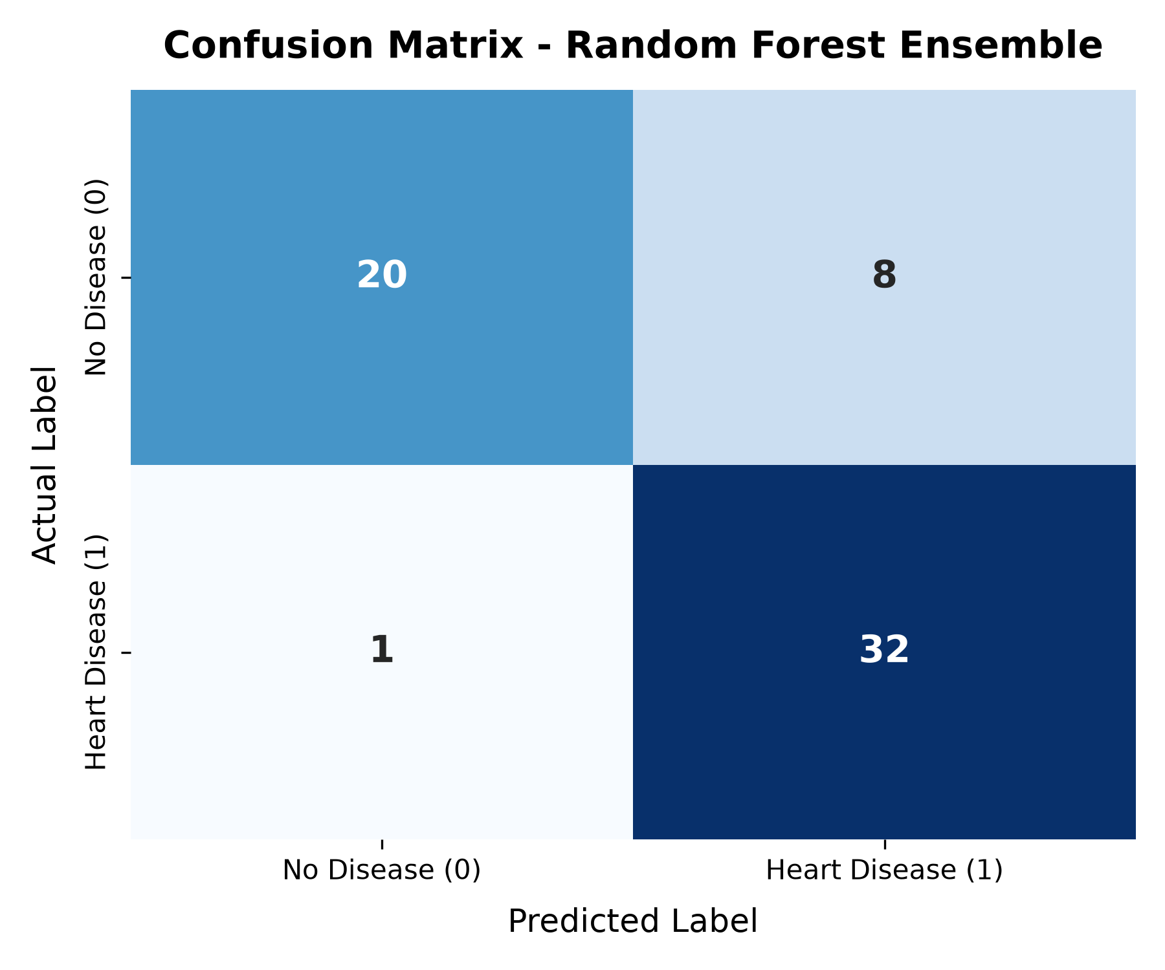
Step 8: Receiver Operating Characteristic (ROC) Curve
Evaluates model diagnostic ability across classification thresholds.
Code:
fpr, tpr, _ = roc_curve(y_test, y_prob)
roc_auc = roc_auc_score(y_test, y_prob)
plt.figure(figsize=(5, 4))
plt.plot(fpr, tpr, label=f'Random Forest (AUC = {roc_auc:.4f})', color='#1f77b4', lw=2)
plt.plot([0, 1], [0, 1], 'k--', lw=1)
plt.title('ROC Curve')
plt.xlabel('False Positive Rate'); plt.ylabel('True Positive Rate')
plt.legend(loc='lower right')
plt.show()
Output (chart):
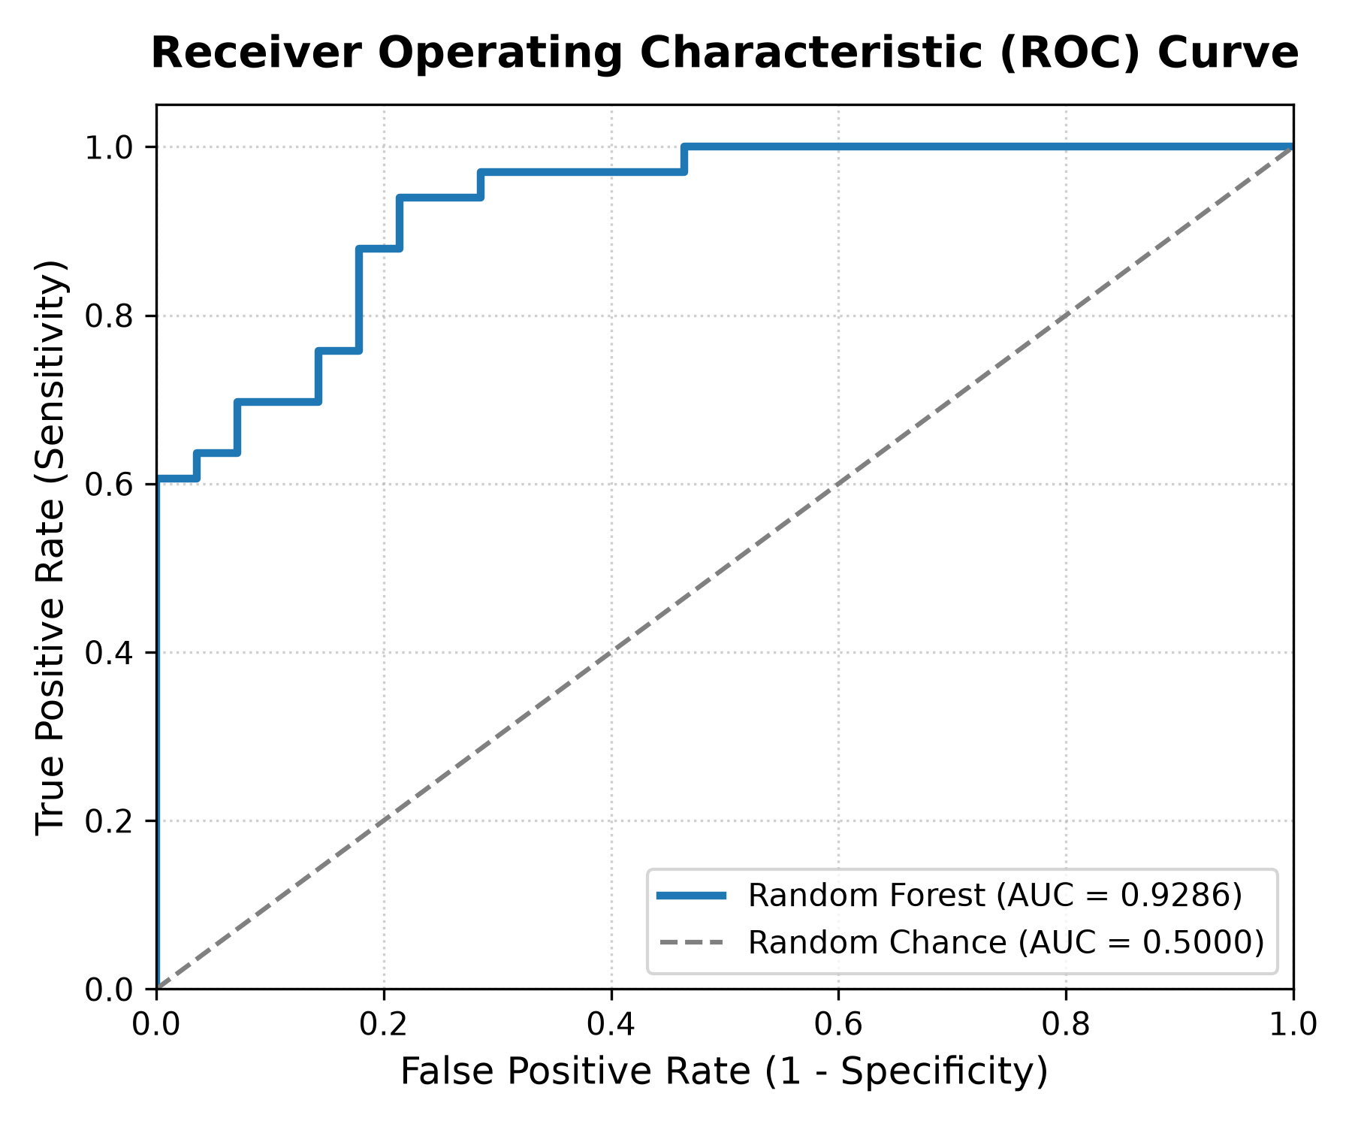
Step 9: Feature Importance
Which clinical features the ensemble relied on most to make predictions.
Code:
importances = pd.Series(rf_model.feature_importances_, index=X.columns).sort_values()
plt.figure(figsize=(6, 4.5))
importances.plot(kind='barh', color='teal')
plt.title('Feature Importances')
plt.xlabel('Importance Score')
plt.show()
Output (chart):
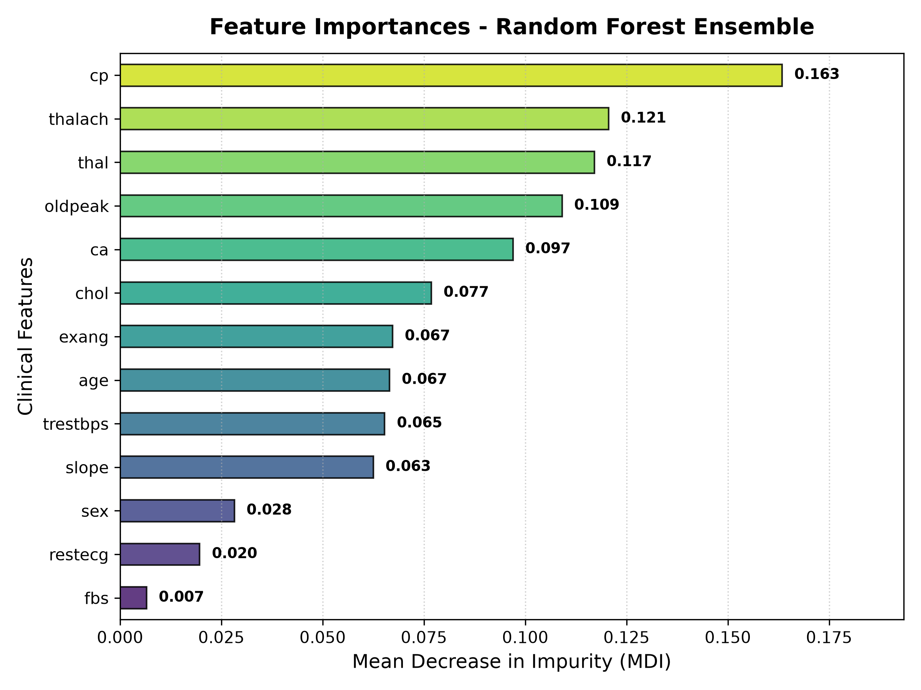
Step 10: Comparison: Single Decision Tree vs. Bagging Ensemble
Demonstrating how bagging ensemble variance reduction boosts accuracy and generalization.
Code:
# Fit single decision tree and compare
dt = DecisionTreeClassifier(random_state=42).fit(X_train, y_train)
dt_pred = dt.predict(X_test)
print('Decision Tree Accuracy:', round(accuracy_score(y_test, dt_pred)*100, 2), '%')
print('Random Forest Accuracy:', round(acc*100, 2), '%')
Output (chart):
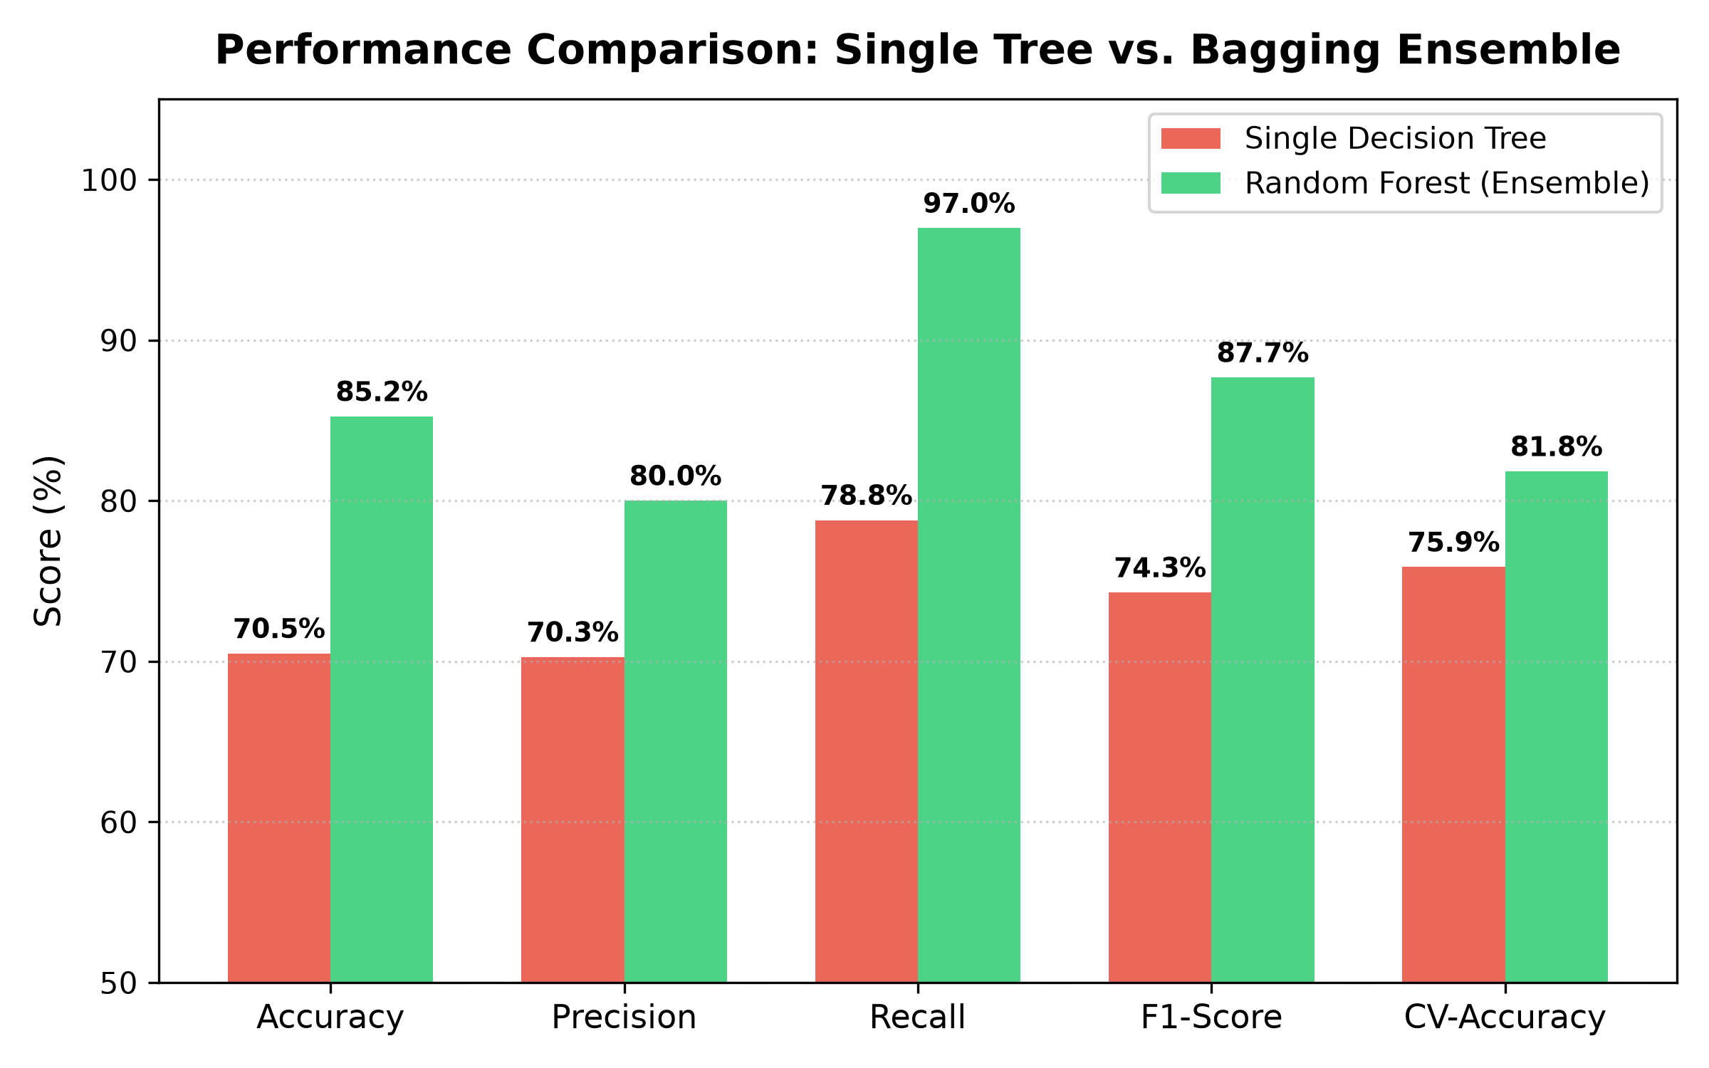
Step 11: Save the Model for Deployment
Save the trained Random Forest model to a .pkl file for real-time web application deployment.
Code:
joblib.dump(rf_model, 'heart_disease_model.pkl')
print('Model saved as heart_disease_model.pkl')
Output:
Model saved as heart_disease_model.pkl
Step 12: Deployment (Streamlit Web App)
The file app.py builds a web UI with input fields for clinical indicators, risk gauge, and instant predictions.
Run locally with: streamlit run app.py
app.py code:
import streamlit as st
import pandas as pd
import numpy as np
import joblib
# Page configuration
st.set_page_config(
page_title="Heart Disease Predictor",
page_icon="❤️",
layout="wide"
)
# Load trained model
@st.cache_resource
def load_model():
return joblib.load('heart_disease_model.pkl')
model = load_model()
# Header
st.title("❤️ Heart Disease Prediction App")
st.markdown("""
This application uses an **Ensemble Random Forest Classifier** trained on the UCI Heart Disease dataset
to assess the risk of coronary heart disease based on clinical patient parameters.
""")
st.write("---")
# Layout columns for inputs
col1, col2, col3 = st.columns(3)
with col1:
st.subheader("👤 Demographic & General")
age = st.number_input("Age (years)", min_value=18, max_value=100, value=55, step=1)
sex_label = st.selectbox("Sex", options=["Male", "Female"])
sex = 1 if sex_label == "Male" else 0
trestbps = st.number_input("Resting Blood Pressure (mm Hg)", min_value=80, max_value=220, value=130, step=1)
chol = st.number_input("Serum Cholesterol (mg/dl)", min_value=100, max_value=600, value=240, step=1)
with col2:
st.subheader("🩺 Symptom & Test Results")
cp_options = {
"Typical Angina (0)": 0,
"Atypical Angina (1)": 1,
"Non-anginal Pain (2)": 2,
"Asymptomatic (3)": 3
}
cp_label = st.selectbox("Chest Pain Type", options=list(cp_options.keys()))
cp = cp_options[cp_label]
fbs_label = st.selectbox("Fasting Blood Sugar > 120 mg/dl", options=["No (False)", "Yes (True)"])
fbs = 1 if "Yes" in fbs_label else 0
restecg_options = {
"Normal (0)": 0,
"ST-T Wave Abnormality (1)": 1,
"Left Ventricular Hypertrophy (2)": 2
}
restecg_label = st.selectbox("Resting ECG Results", options=list(restecg_options.keys()))
restecg = restecg_options[restecg_label]
thalach = st.number_input("Maximum Heart Rate Achieved (bpm)", min_value=60, max_value=230, value=150, step=1)
with col3:
st.subheader("🏃 Exercise & Heart Scans")
exang_label = st.selectbox("Exercise Induced Angina", options=["No", "Yes"])
exang = 1 if exang_label == "Yes" else 0
oldpeak = st.number_input("ST Depression (oldpeak)", min_value=0.0, max_value=7.0, value=1.0, step=0.1)
slope_options = {
"Upsloping (0)": 0,
"Flat (1)": 1,
"Downsloping (2)": 2
}
slope_label = st.selectbox("Slope of Peak Exercise ST Segment", options=list(slope_options.keys()), index=1)
slope = slope_options[slope_label]
ca = st.selectbox("Number of Major Vessels Colored by Fluoroscopy (0-3)", options=[0, 1, 2, 3], index=0)
thal_options = {
"Normal (1)": 1,
"Fixed Defect (2)": 2,
"Reversible Defect (3)": 3
}
thal_label = st.selectbox("Thalassemia Status", options=list(thal_options.keys()), index=1)
thal = thal_options[thal_label]
st.write("---")
# Prediction Button
if st.button("🔍 Predict Heart Disease Risk", type="primary", use_container_width=True):
# Prepare feature dataframe
feature_columns = ['age', 'sex', 'cp', 'trestbps', 'chol', 'fbs', 'restecg',
'thalach', 'exang', 'oldpeak', 'slope', 'ca', 'thal']
input_data = pd.DataFrame([[age, sex, cp, trestbps, chol, fbs, restecg,
thalach, exang, oldpeak, slope, ca, thal]],
columns=feature_columns)
prediction = model.predict(input_data)[0]
probabilities = model.predict_proba(input_data)[0]
prob_disease = probabilities[1] * 100
prob_healthy = probabilities[0] * 100
st.subheader("📊 Diagnostic Assessment Results")
res_col1, res_col2 = st.columns(2)
with res_col1:
if prediction == 1:
st.error("⚠️ **High Risk: Heart Disease Detected**")
st.markdown(f"The model indicates a **{prob_disease:.1f}% probability** of heart disease presence.")
else:
st.success("✅ **Low Risk: No Heart Disease Detected**")
st.markdown(f"The model indicates a **{prob_healthy:.1f}% probability** of a healthy heart profile.")
with res_col2:
st.metric(label="Risk Probability", value=f"{prob_disease:.1f}%", delta=f"{prob_disease - 50:.1f}% vs baseline")
st.progress(int(prob_disease))
st.info("""
**Clinical Note:** Random Forest ensemble predictions are intended for preliminary screening and educational purposes.
Consult a licensed cardiologist for comprehensive diagnostic evaluation.
""")

