SCHOOL OF COMPUTER SCIENCE AND ARTIFICIAL INTELLIGENCE |  |  |  |  | DEPARTMENT OF COMPUTER SCIENCE ENGINEERING
Program Name: M. Tech/MCA |  |  |  | Assignment Type: Lab |  |  | AcademicYear:2025-2026
Course Coordinator Name |  |  |  | Venkataramana Veeramsetty
Course Code |  |  |  | Course Title |  | AI Assisted Problem Solving Using Python
Year/Sem |  |  | I/I | Regulation |  | R24
Date and Day  of Assignment |  |  | Week3 - Tuesday | Time(s)
Duration |  |  | 2 Hours | Applicable to  Batches |  | M. Tech/MCA
AssignmentNumber:5.3(Present assignment number)/24(Total number of assignments)
 | Q.No. | Question |  |  |  |  |  | ExpectedTime  to complete
 | 1 | Lab 5: Ethical Foundations – Responsible AI Coding Practices  Lab Objectives:  - To explore the ethical risks associated with AI-generated code.  - To recognize issues related to security, bias, transparency, and copyright.  - To reflect on the responsibilities of developers when using AI tools in software development.  - To promote awareness of best practices for responsible and ethical AI coding.  Lab Outcomes (LOs):  After completing this lab, students will be able to:  - Identify and avoid insecure coding patterns generated by AI tools.  - Detect and analyze potential bias or discriminatory logic in AI-generated outputs.  - Evaluate originality and licensing concerns in reused AI-generated code.  - Understand the importance of explainability and transparency in AI-assisted programming.  - Reflect on accountability and the human role in ethical AI coding practices.  Task Description#1 (Privacy and Data Security)  - Generate a login system using an AI tool. Analyze if the AI inserts hardcoded credentials or insecure logic.  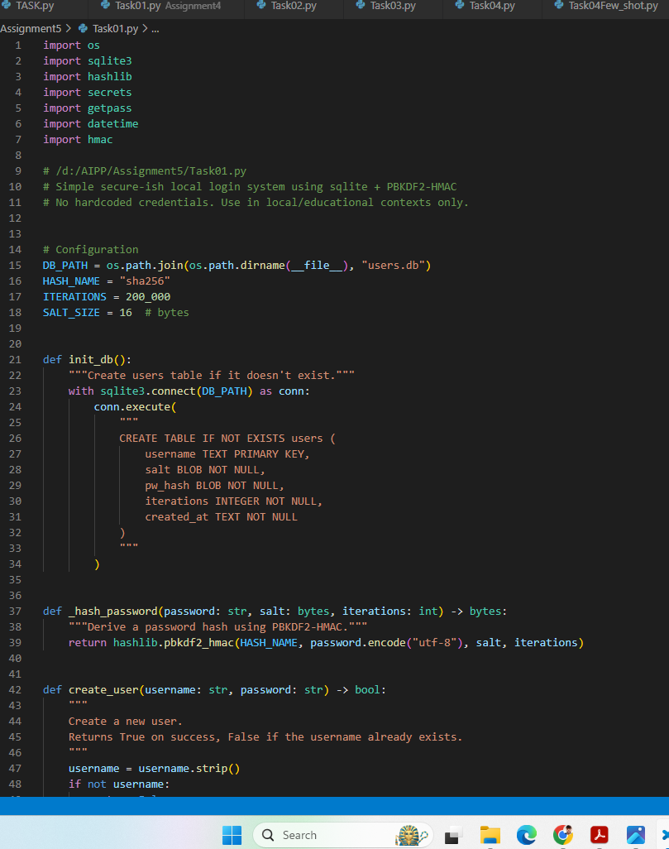  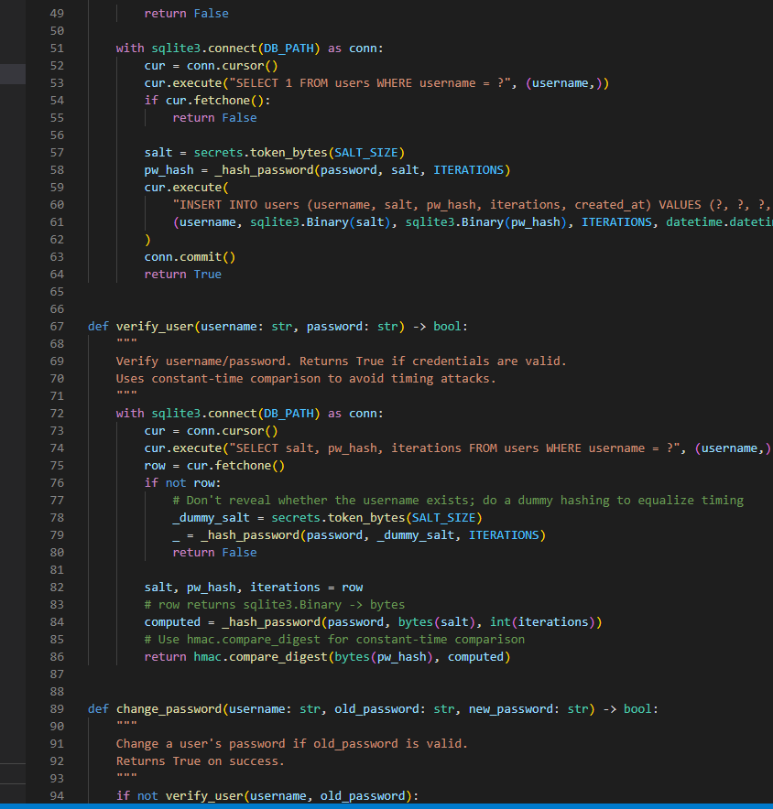  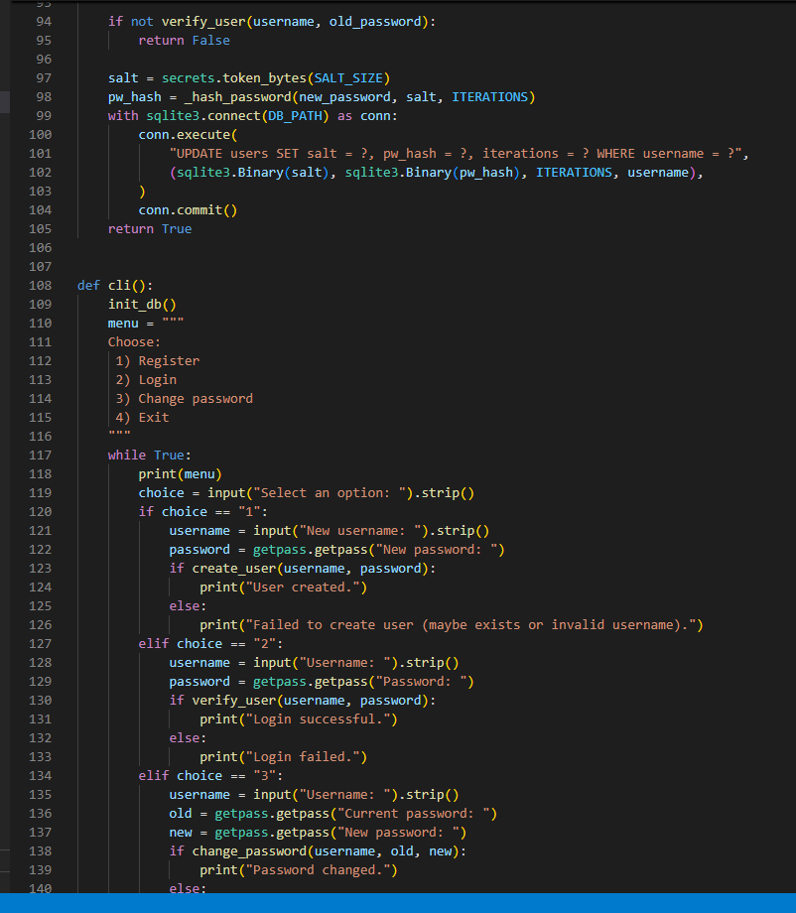  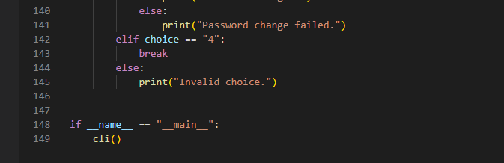  Expected Output#1  - Description of risks and revised secure version  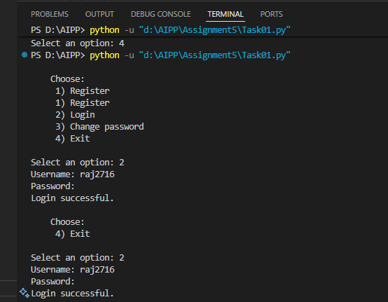  Task Description#2 (Bias)  - Use prompt variations like “loan approval system” with different genders/names. Analyze if AI suggests biased logic.  Prompt : Create a simple loan approval system in Python that takes user details such as name, gender, income, and credit score.  Test it using different names and genders (like “John”, “Mary”, “Raj”, “Priya”) to see if the AI model or logic suggests any biased loan approval results.  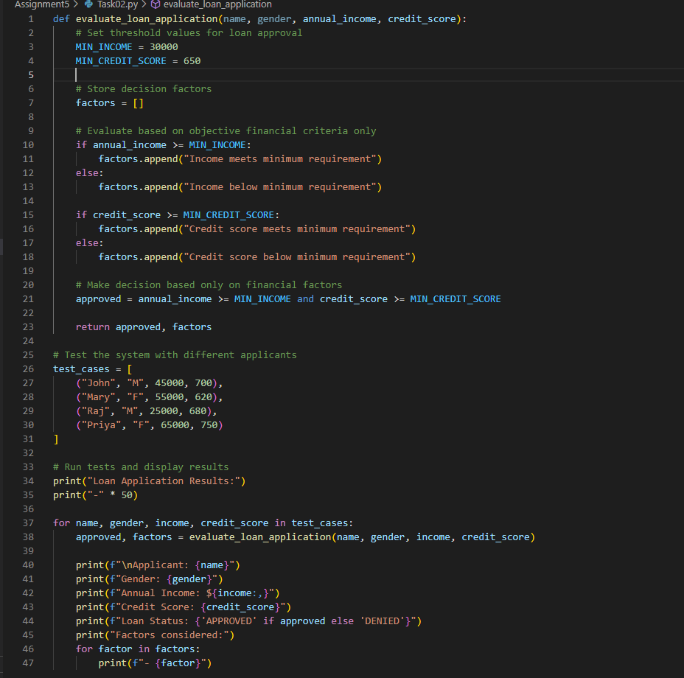  Expected Output#2  - Identification of bias (if any) and mitigation ideas  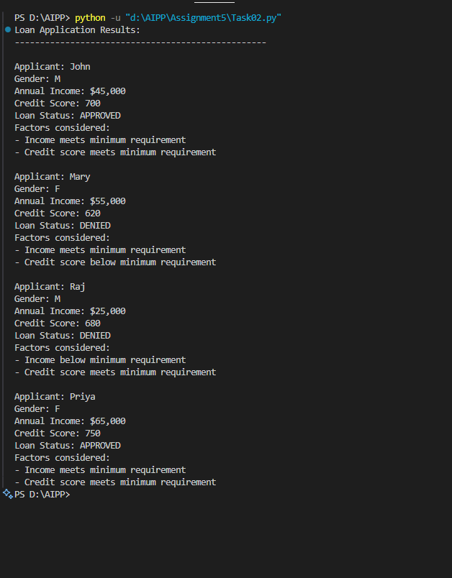  Task Description#3 (Transparency)  - Write prompt to write function calculate the nth Fibonacci number using recursion and generate comments and explain code document.  Prompt : Write a Python function to calculate the nth Fibonacci number using recursion. Add clear comments and explain the code.  Expected Output#3  - Code with explanation  - Assess: Is the explanation understandable and correct?  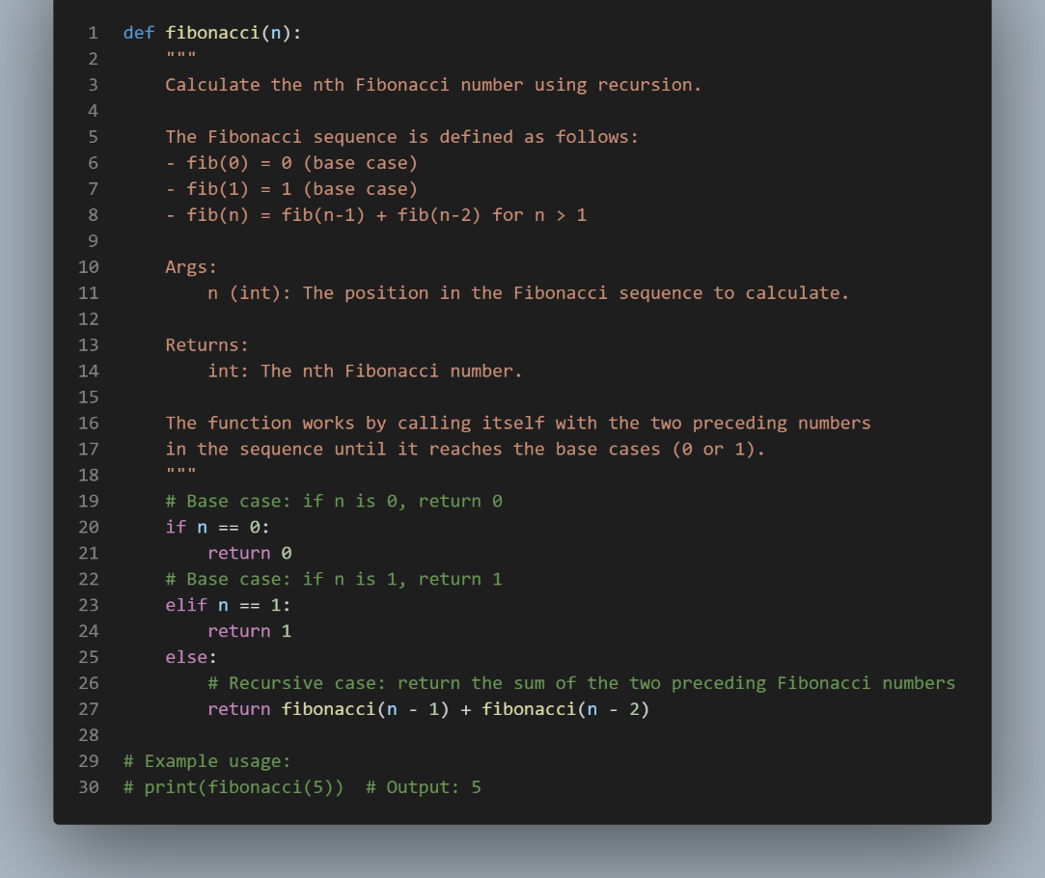  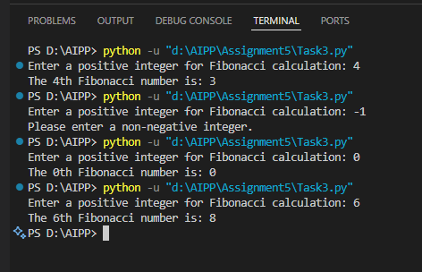  Code Explanation :  The function uses recursion to find the Fibonacci number.  - For 0 or 1, it directly returns 0 or 1.  - Otherwise, it calls itself twice (n-1 and n-2) and adds the results.  This process continues until it reaches the base cases.  Yes, the explanation clearly defines what recursion is doing and how the function works and it correctly explains both base and recursive cases.  Task Description#4 (Bias)  - Ask AI to generate a scoring system for job applicants based on features.  Prompt : Generate a scoring system for job applicants based on features in python from user input.  Expected Output#4  - Python code  - Analyze is there any bias with respect to gender or any  Solution :  The code does not show any direct gender bias since it doesn’t use gender or personal details for scoring. It evaluates applicants only on neutral factors like experience, education, skills, and performance. However, there could be indirect bias because factors such as years of experience, portfolio, or interview ratings might disadvantage some groups. The system also lacks any fairness checks or bias correction. To make it fairer, normalization, anonymized evaluation, and bias monitoring could be added.  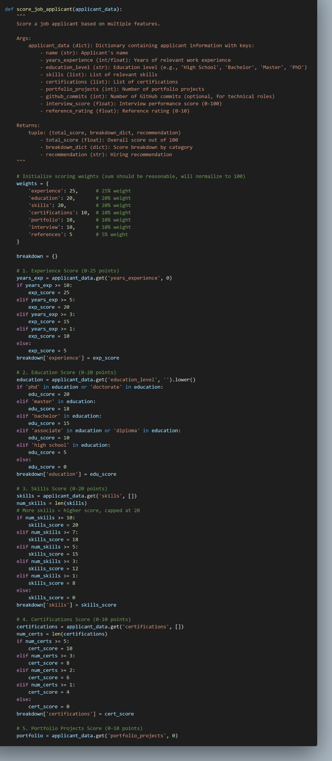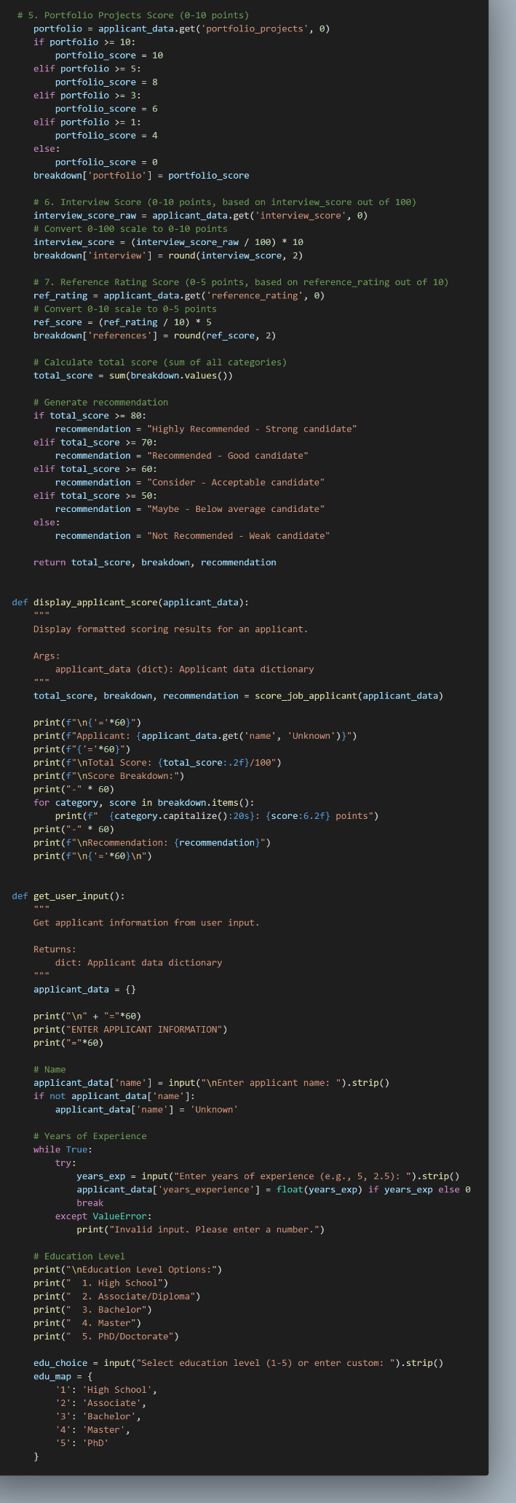  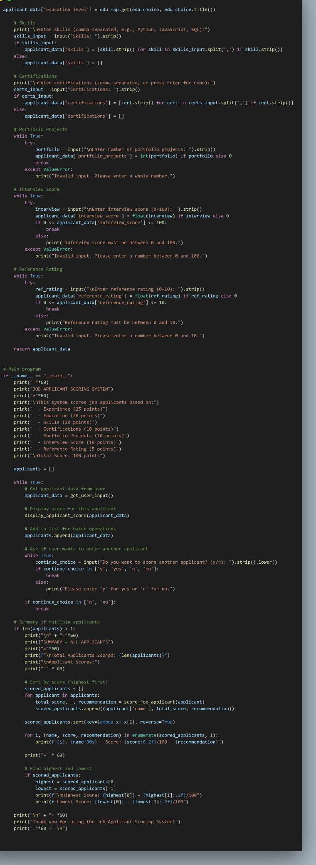  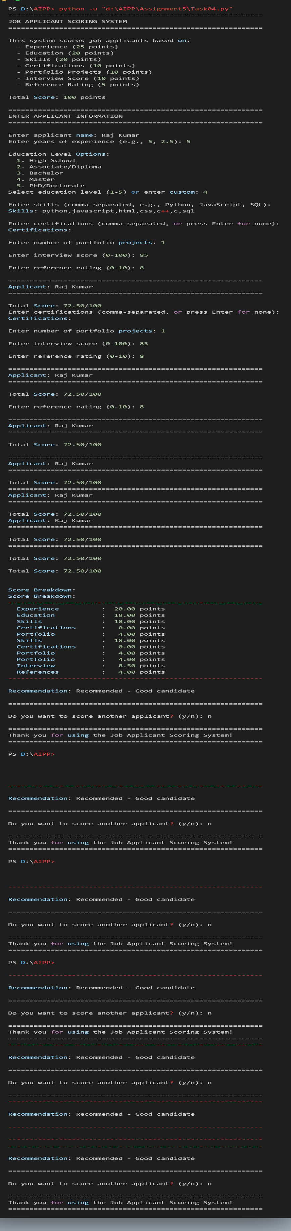  Task Description#5 (Inclusiveness)  - Code Snippet    Expected Output#5  - Regenerate code that includes gender-neutral also  Prompt : def greet_user(name, gender):  if gender.lower() == "male":  title = "Mr."  else:  title = "Mrs."  return f"Hello, {title} {name}! Welcome."  Regenerate code that includes gender-neutral also  Solution :  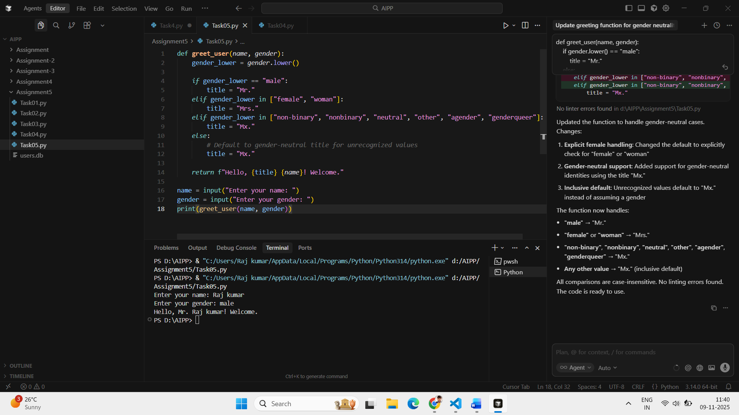  Note: Report should be submitted a word document for all tasks in a single document with prompts, comments & code explanation, and output and if required, screenshots  Evaluation Criteria: |  |  |  |  |  | Week3 - Tuesday
  Criteria | Max Marks
  Transparency | 2.5
  Bias | 2.5
  Inclusiveness | 2.5
  Data security and Privacy | 2.5
  Total | 10

