SCHOOL OF COMPUTER SCIENCE AND ARTIFICIAL INTELLIGENCE |  |  |  |  | DEPARTMENT OF COMPUTER SCIENCE ENGINEERING
Program Name: M. Tech/MCA |  |  |  | Assignment Type: Lab |  |  | AcademicYear:2025-2026
Course Coordinator Name |  |  |  | Venkataramana Veeramsetty
Course Code |  |  | 24CS002PC215 | Course Title |  | AI Assisted Problem Solving Using Python
Year/Sem |  |  | I/I | Regulation |  | R24
Date and Day  of Assignment |  |  | Week1 - Tuesday | Time(s)
Duration |  |  | 2 Hours | Applicable to  Batches |  | M. Tech/MCA
AssignmentNumber:03.3(Present assignment number)/24(Total number of assignments)
Name- Raj Kumar, Class- MCA, Enrollment No- 2503B09910
 | Q.No. | Question |  |  |  |  |  | Expected Time  to complete
 | 1 | Application for TGNPDCL  Objective: Build an application using Python program for TGNPDCL, to generate the bill based on energy consumption and type of customer with the help of AI tools.  Build a python application as per below instructions  - Read all the required data like PU,CU and Type of customer  - Calculate bill amount based on number of units consumed, type of customer and other charges  - Finally print the values of EC(Energy Charges),FC(Fixed Charges),CC(Customer Charges),ED(Electricity Duty Charges),bill as per expected output.  Requirements:  - VS Code with GitHub Copilot and/or Google Collab with Gemini  - Students should bring power bill from their home.  PROMPT : Create a python application that read all the required data like PU, CU and Type of customer. Calculate bill amount based on number of units consumed, type of customer and other charges. Finally print the values of EC(Energy Charges),FC(Fixed Charges),CC(Customer Charges),ED(Electricity Duty Charges),bill as per expected output.  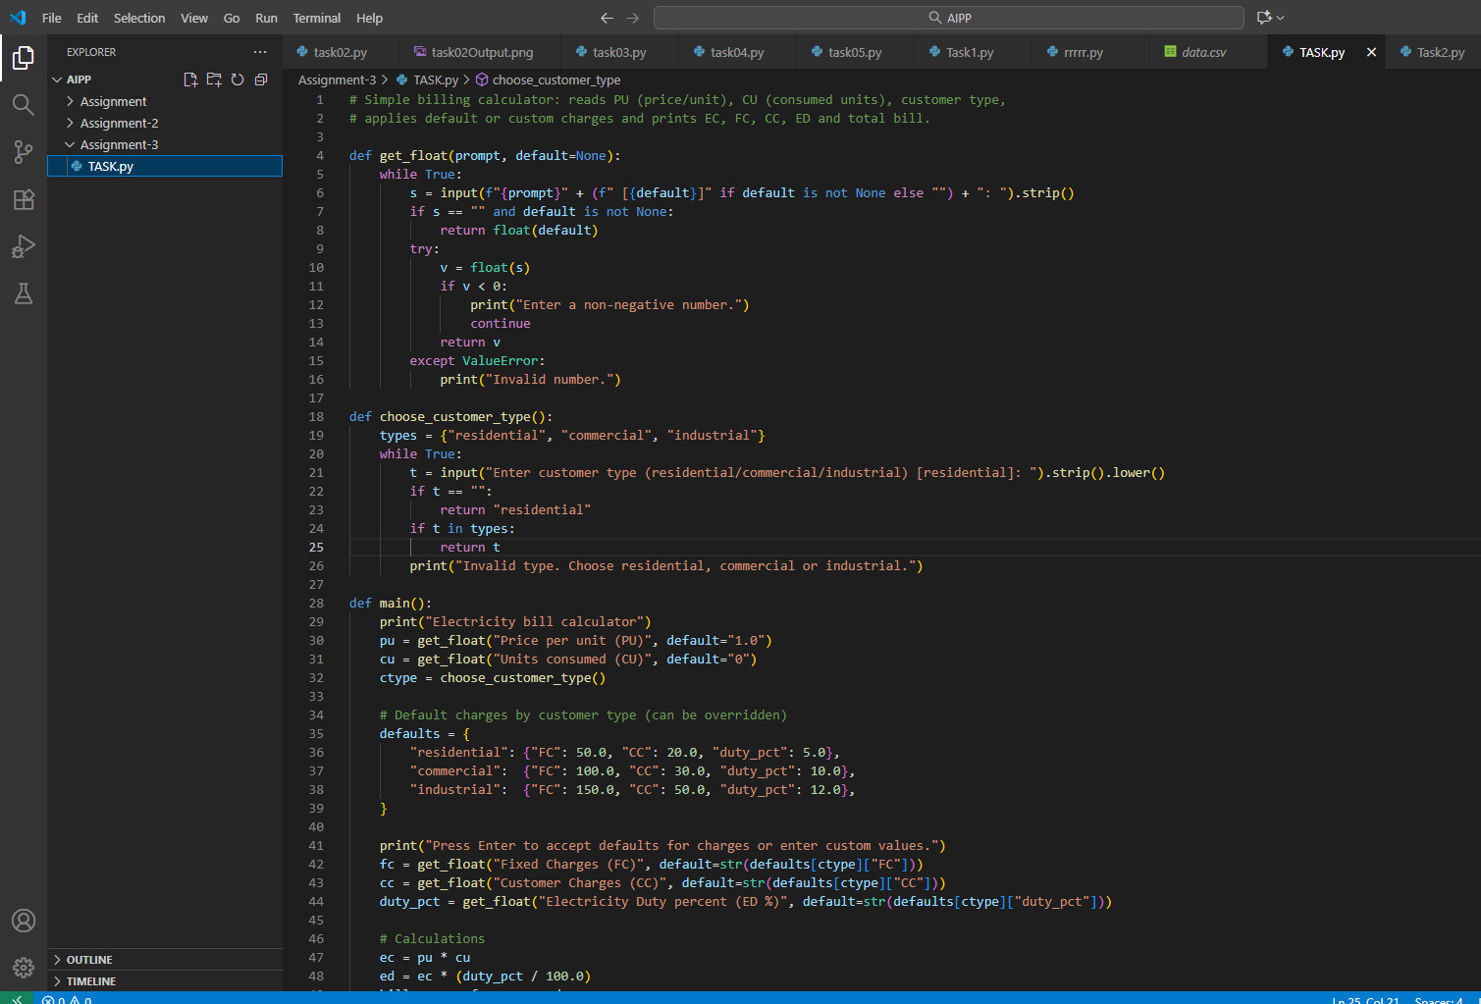  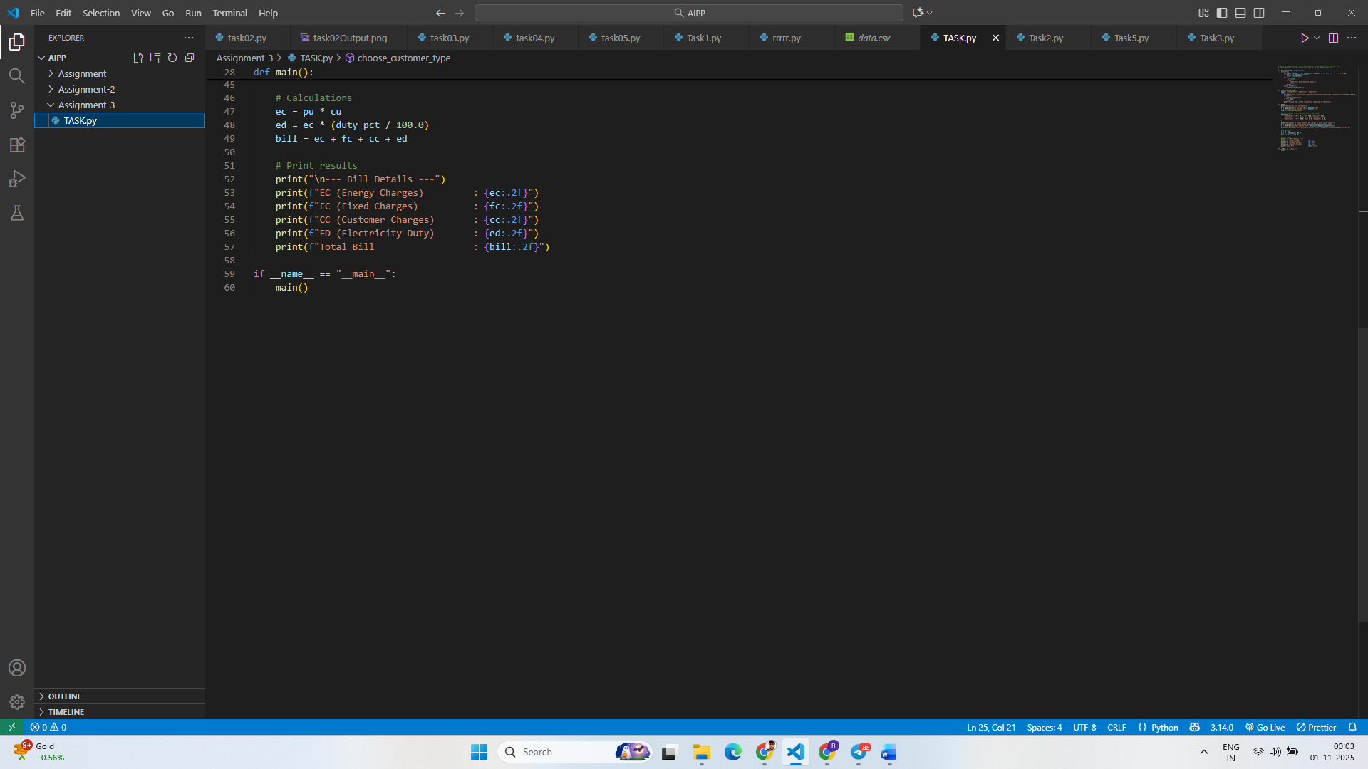  Deliverables:  - Print energy bill for given inputs and verify with bill taken by students  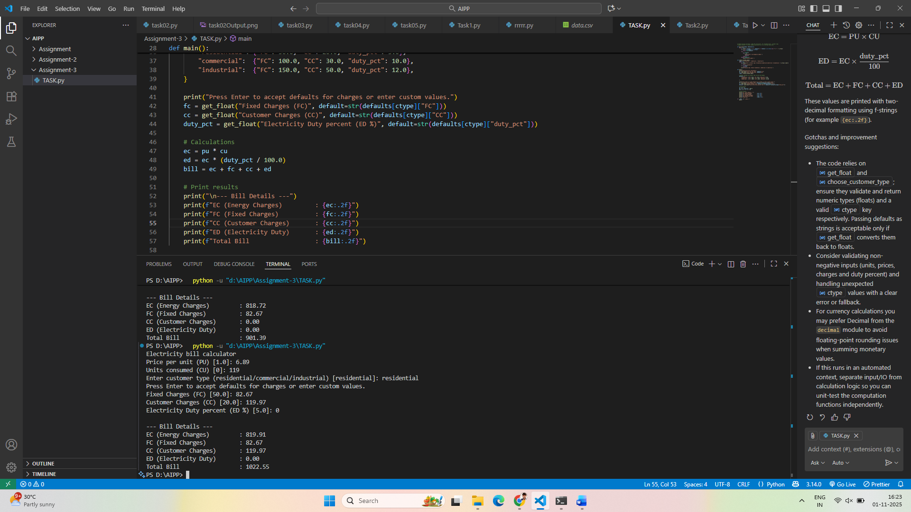  Student bill taken from home :  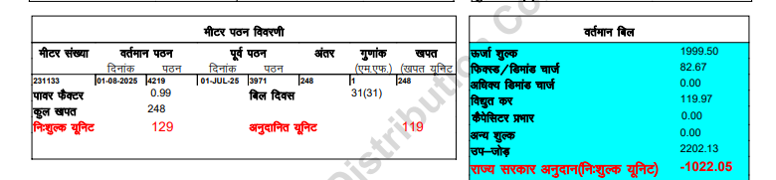  Verified :  The program matches the actual bill value with rounding off difference.  The values from the python program closely matches the electric bill. |  |  |  |  |  | Week2 - Wednesday

