SCHOOL OF COMPUTER SCIENCE AND ARTIFICIAL INTELLIGENCE |  |  |  |  | DEPARTMENT OF COMPUTER SCIENCE ENGINEERING
ProgramName:B. Tech |  |  |  | Assignment Type: Lab |  |  | AcademicYear:2025-2026
CourseCoordinatorName |  |  |  | Venkataramana Veeramsetty
Instructor(s)Name
  Dr. V. Venkataramana (Co-ordinator)
  Dr. T. Sampath Kumar
  Dr. Pramoda Patro
  Dr. Brij Kishor Tiwari
  Dr.J.Ravichander
  Dr. Mohammand Ali Shaik
  Dr. Anirodh Kumar
  Mr. S.Naresh Kumar
  Dr. RAJESH VELPULA
  Mr. Kundhan Kumar
  Ms. Ch.Rajitha
  Mr. M Prakash
  Mr. B.Raju
  Intern 1 (Dharma teja)
  Intern 2 (Sai Prasad)
  Intern 3 (Sowmya)
  NS_2 ( Mounika)
CourseCode |  |  | 24CS002PC215 | CourseTitle |  | AI Assisted Coding
Year/Sem |  |  | II/I | Regulation |  | R24
Date and Day  of Assignment |  |  | Week3 - Wednesday | Time(s)
Duration |  |  | 2 Hours | Applicableto  Batches
AssignmentNumber:6.3(Present assignment number)/24(Total number of assignments)
 | Q.No. | Question |  |  |  |  |  | ExpectedTime  to complete
 | 1 | Lab 6: AI-Based Code Completion – Classes, Loops, and Conditionals  Lab Objectives:  - To explore AI-powered auto-completion features for core Python constructs.  - To analyze how AI suggests logic for class definitions, loops, and conditionals.  - To evaluate the completeness and correctness of code generated by AI assistants.  Lab Outcomes (LOs):  After completing this lab, students will be able to:  - Use AI tools to generate and complete class definitions and methods.  - Understand and assess AI-suggested loops for iterative tasks.  - Generate conditional statements through prompt-driven suggestions.  - Critically evaluate AI-assisted code for correctness and clarity.  Task Description#1 (Classes)  - Use AI to complete a Student class with attributes and a method.  - Check output  - Analyze the code generated by AI tool  Prompt : Complete a Student class with attributes and a method, Class with constructor and display_details() method in python.  Expected Output#1  - Class with constructor and display_details() method  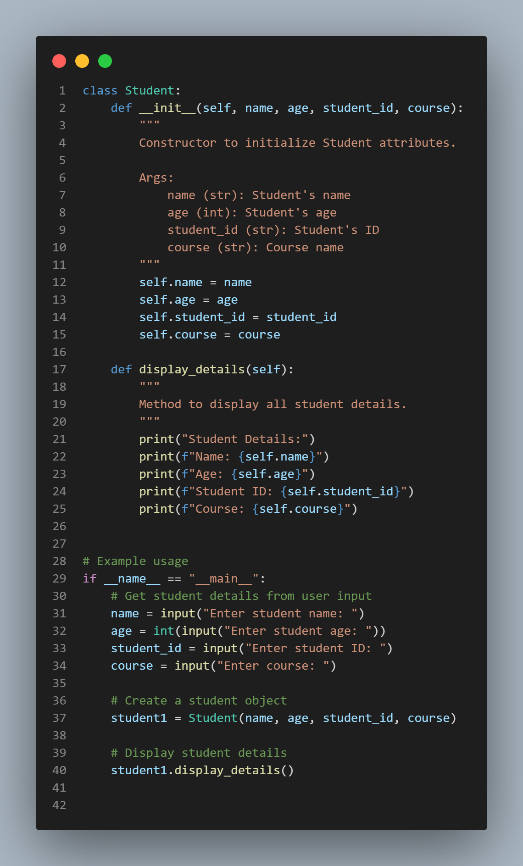  Output :  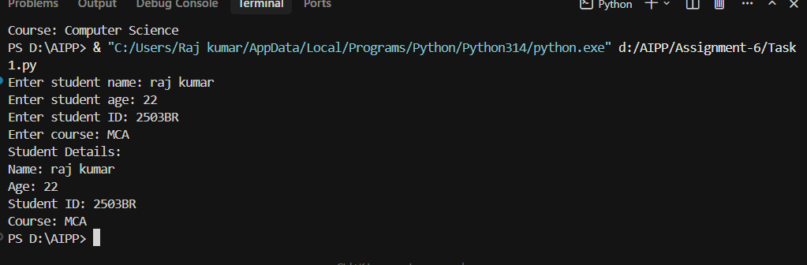  Task Description#2 (Loops)  - Prompt AI to complete a function that prints the first 10 multiples of a number using a loop.  - Analyze the generated code  - Ask AI to generate code using other controlled looping.  Prompt : Create python functions that print the first 10 multiples of a number using different loop types.  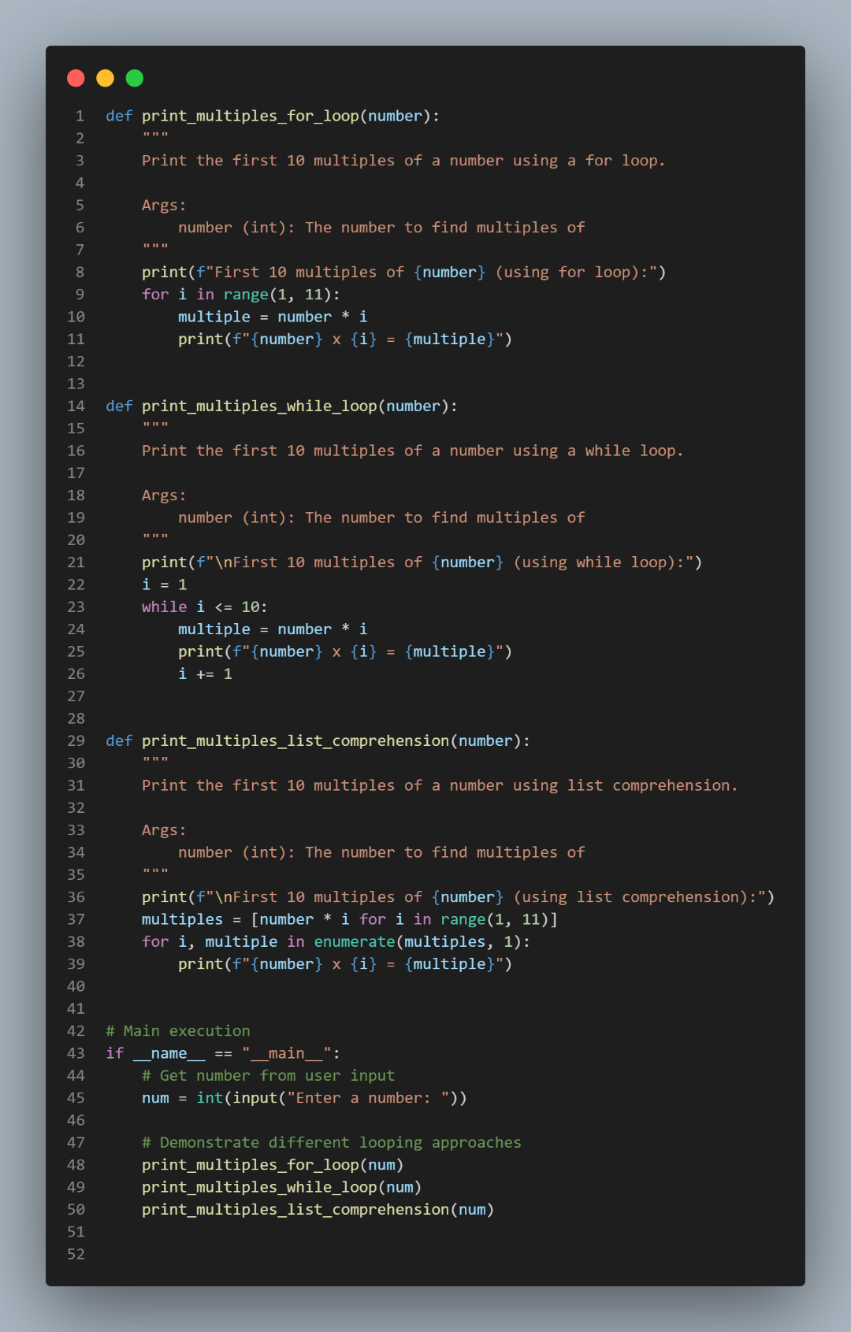  Expected Output#2  - Correct loop-based implementation  Output :  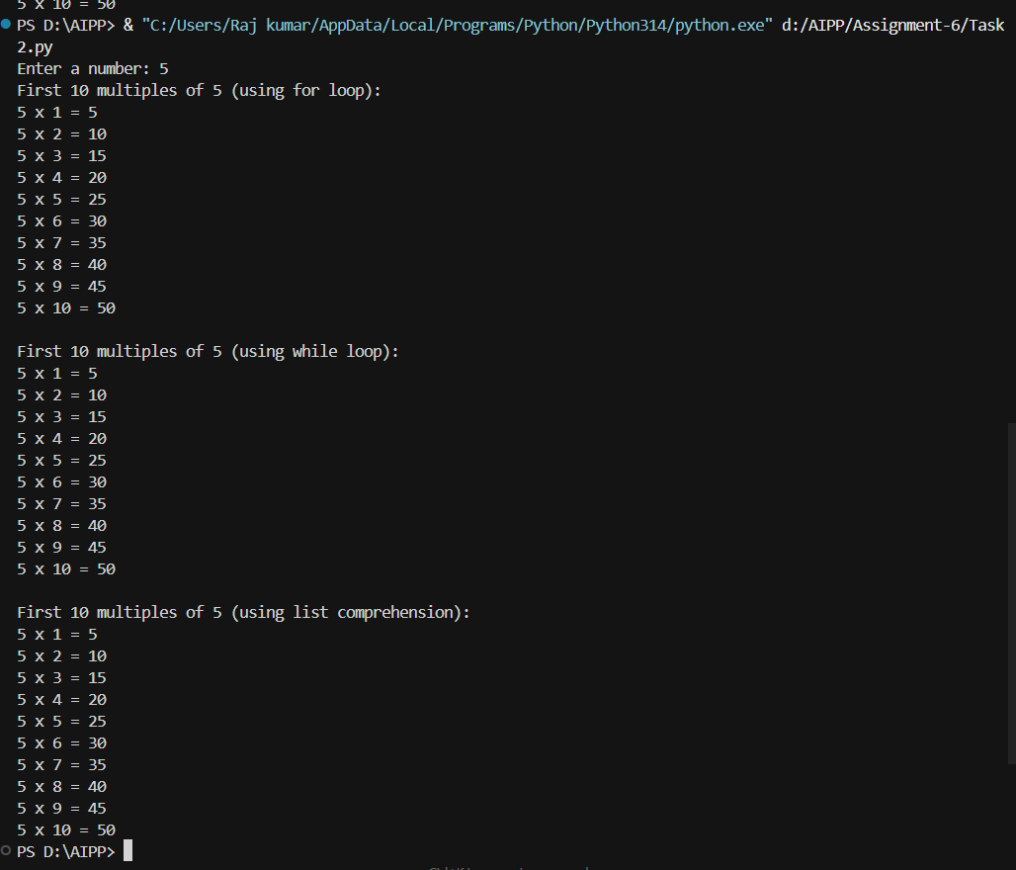  Task Description#3 (Conditional Statements)  - Ask AI to write nested if-elif-else conditionals to classify age groups.  - Analyze the generated code.  - Ask AI to generate code using other conditional statements  Prompt : Write nested if-elif-else conditionals to classify age groups from user input in python.  Also generate python code using other conditional statements from user input.  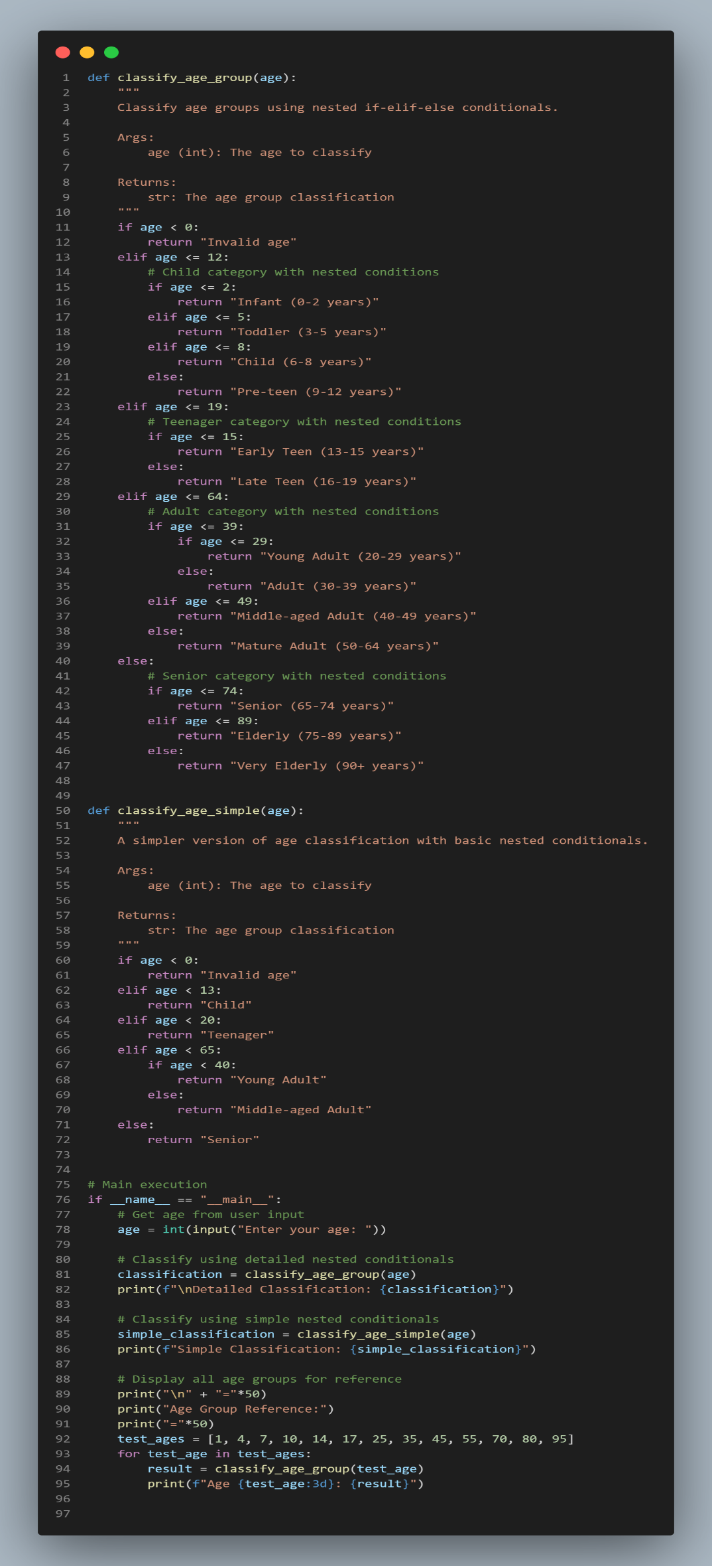  Expected Output#3  - Age classification function with appropriate conditions and with explanation.  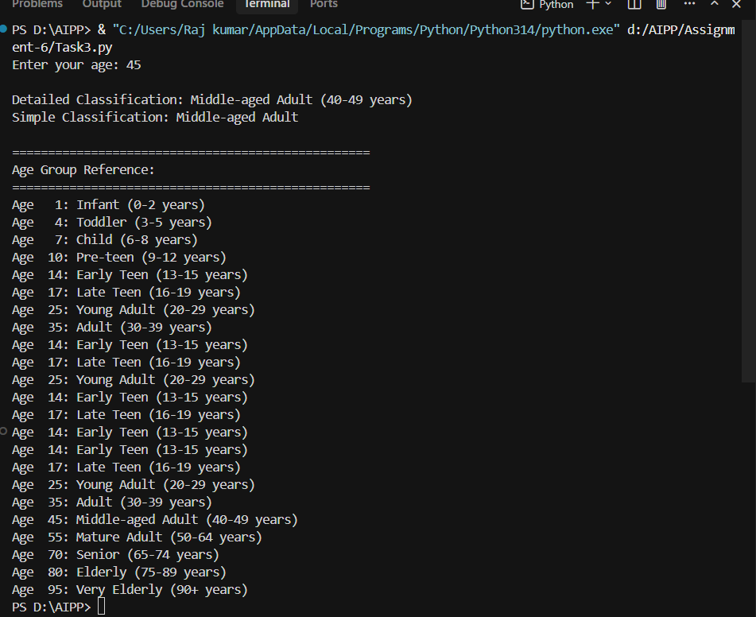  Generated Code using other conditional statements : (Task 3.1 file)  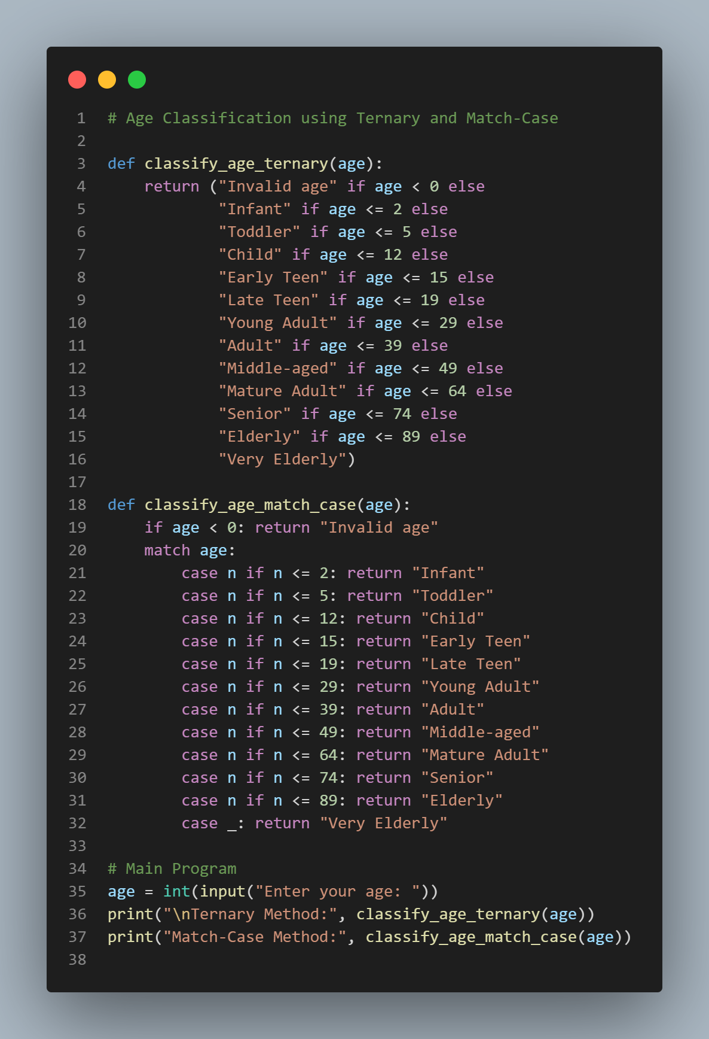  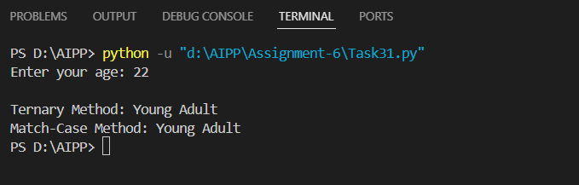  EXPLANATION :  The program classifies ages using nested if-elif-else statements.  - classify_age_group(age): gives detailed categories (Infant → Very Elderly).  - classify_age_simple(age): gives simple categories (Child → Senior).  It takes user input, shows both results, and prints a sample age group table.  Task Description#4 (For and While loops)  - Generate a sum_to_n() function to calculate sum of first n numbers  - Analyze the generated code  - Get suggestions from AI with other controlled looping  Prompt : Generate a sum_to_n() function in python to calculate sum of first n numbers using for and while loop.  Expected Output#4  - Python code with explanation.  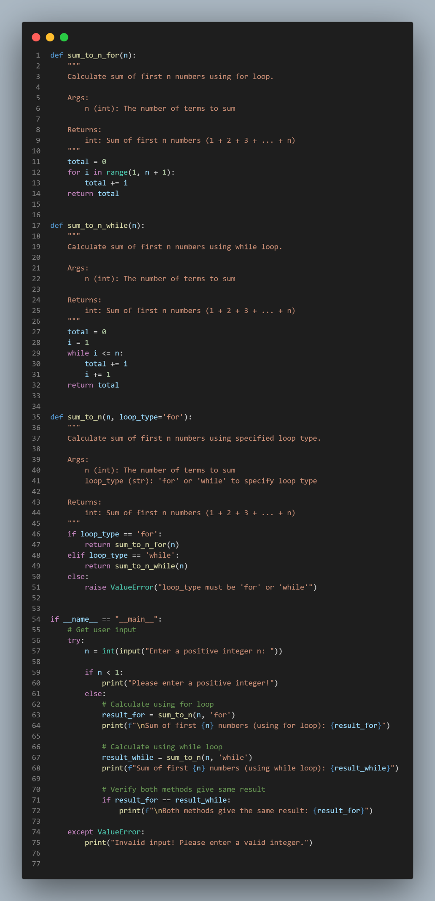  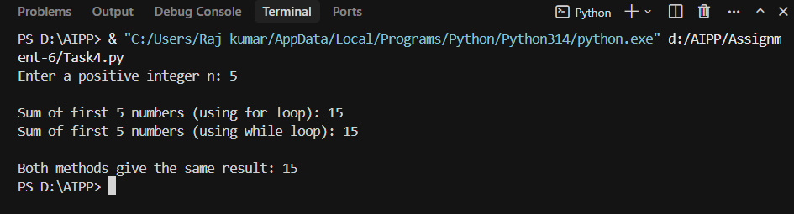  Explanation :  The program finds the sum of first n numbers using both for and while loops.  - sum_to_n_for(n): uses a for loop.  - sum_to_n_while(n): uses a while loop.  - sum_to_n(n, loop_type): selects loop type.  It takes user input, calculates by both methods, and checks if results match.  Task Description#5 (Class)  - Use AI to build a BankAccount class with deposit, withdraw, and balance methods.  - Analyze the generated code  - Add comments and explain code  Prompt : Build a BankAccount class with deposit, withdraw, and balance methods in python. Add comments and explain code.  Expected Output#5  - Python code with explanation  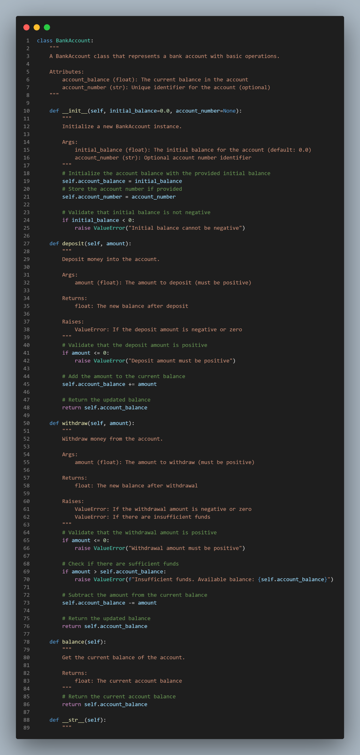  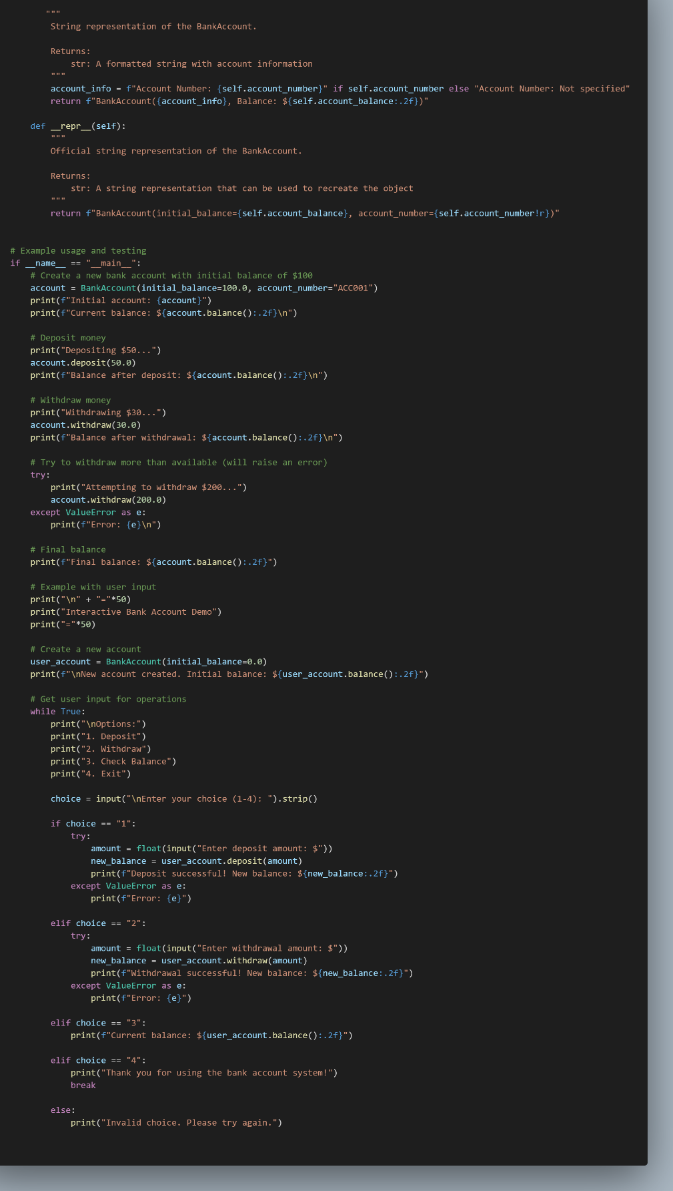  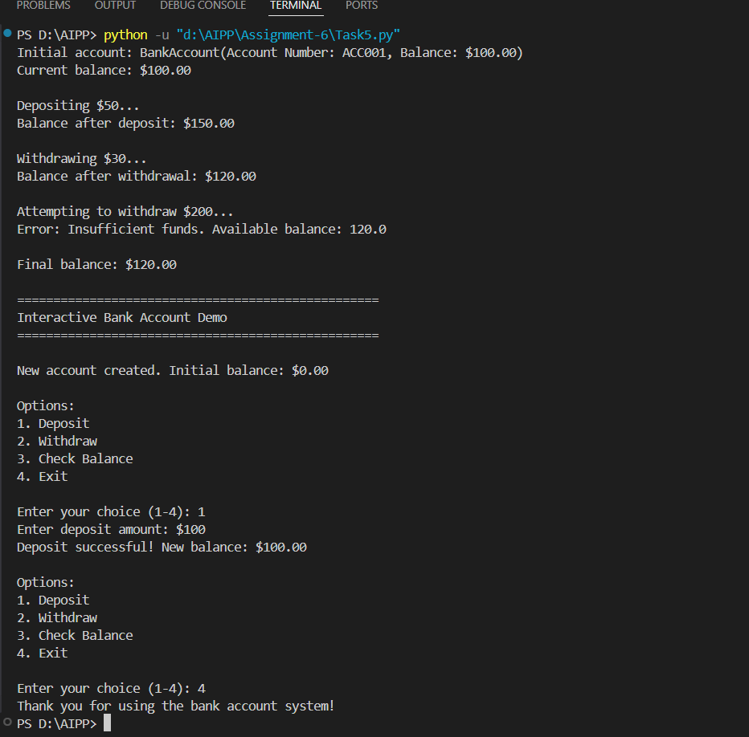  Explanation :  The program defines a BankAccount class to manage basic banking operations.  - __init__ → Creates an account with an initial balance and optional account number.  - deposit(amount) → Adds money (must be positive).  - withdraw(amount) → Removes money if funds are sufficient.  - balance() → Shows current balance.  - __str__ / __repr__ → Display account details.  In the main part, it creates an account, performs deposits and withdrawals, handles errors, and provides an interactive menu for user operations (deposit, withdraw, check balance, exit).  Note: Report should be submitted a word document for all tasks in a single document with prompts, comments & code explanation, and output and if required, screenshots  Evaluation Criteria: |  |  |  |  |  | Week3 - Wednesday
  Criteria | Max Marks
  Class | 1.0
  Loops | 1.0
  Conditional Statements | 0.5
  Total | 2.5 Marks

