NAME- RAJ KUMAR
COURSE- MCA
ENROLLMENT NO- 2503B09910

Set 2
3. Q1. Write a Python function `is_prime(n)` to check if a number is prime. Use an AI
coding tool to generate and justify a set of test cases before implementation. Pass all
generated test cases.
(Each question carries 5 marks)
Prompt : Write a Python function is_prime(n) that checks if a number is prime and make it user input.
Before writing the function, generate a set of meaningful test cases with justification
for why each test case is necessary. Then implement the function so that it passes all
test cases. Include edge cases, negative numbers, zero, and one. Use assert statements
to show tests.
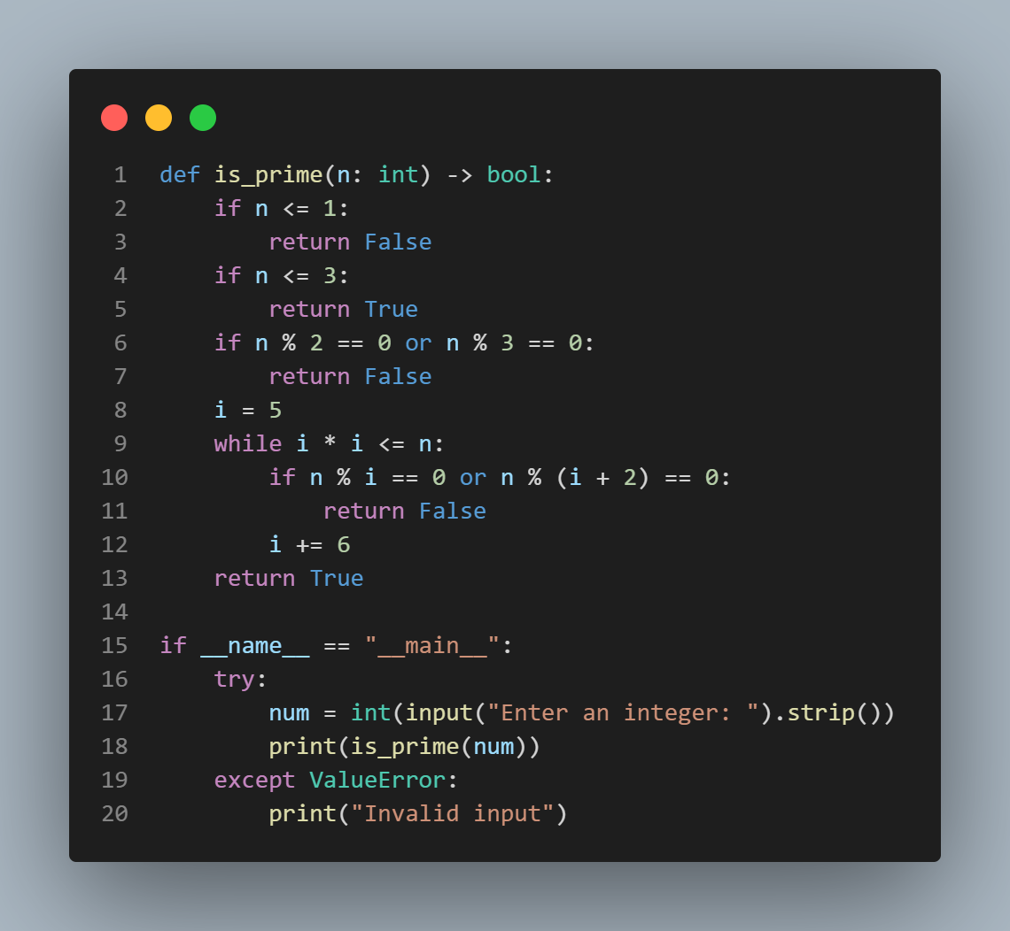
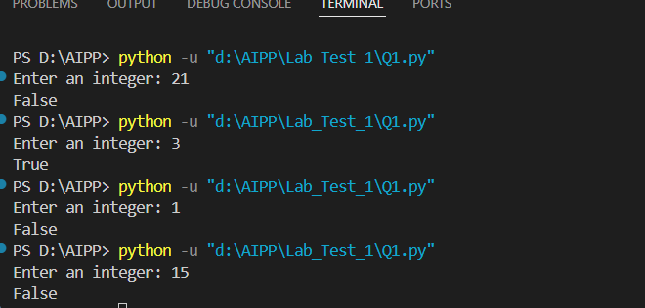
Test cases Implementation :
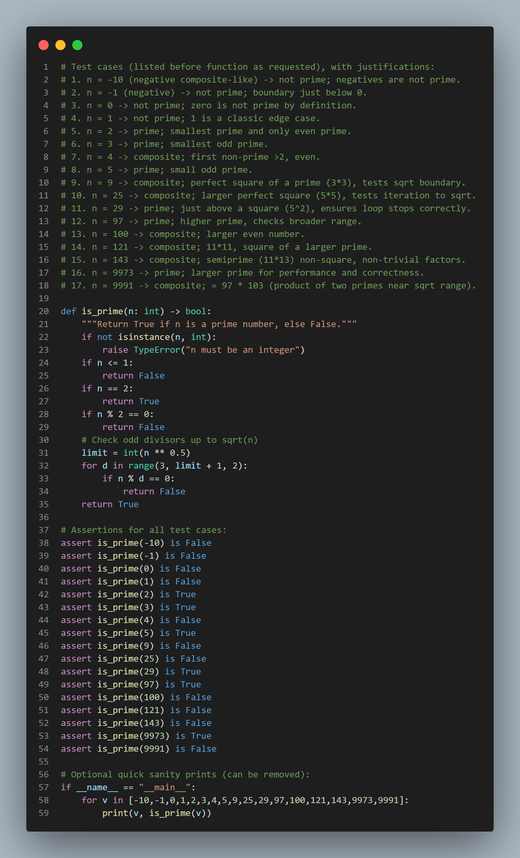
OUTPUT of test cases :
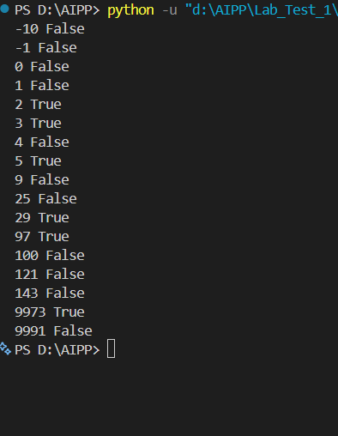
4. Q2. Develop a Python class `Rectangle` with methods for area and perimeter. Use an AI
assistant for auto-generating docstrings and inline comments. Compare them with your
manual documentation.
(Each question carries 5 marks)
Prompt : . Develop a Python class `Rectangle` with methods for area and perimeter in Python and also it takes user input. Also generate docstrings and inline comments.
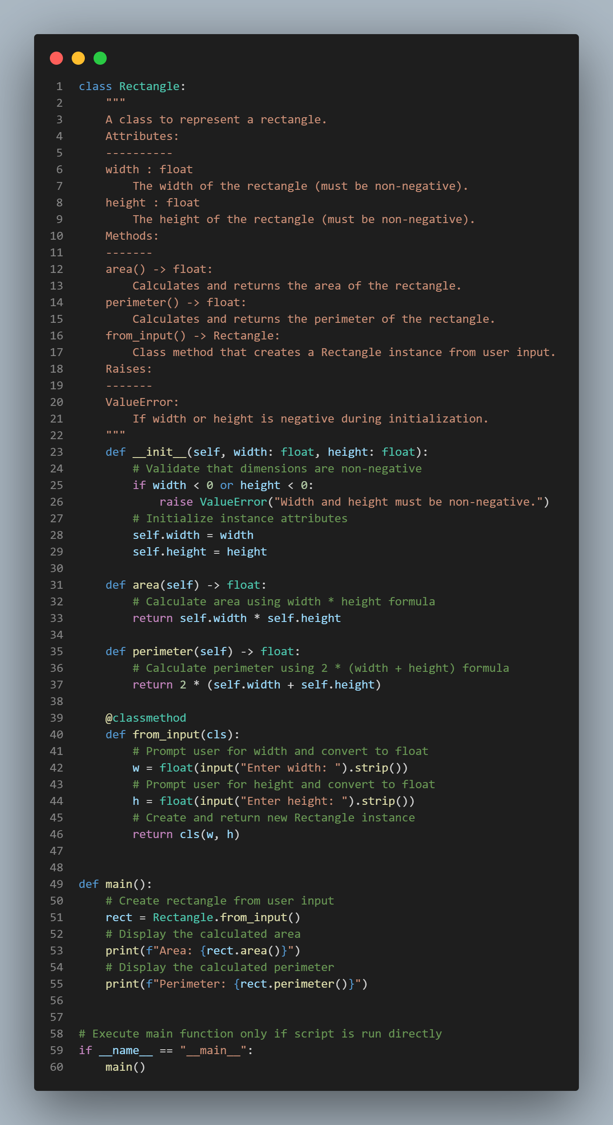
OUTPUT :
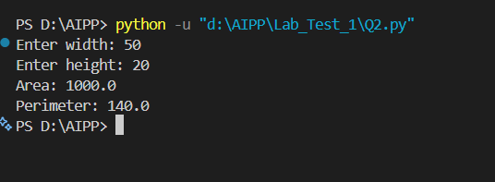
Manual Docstring Code :
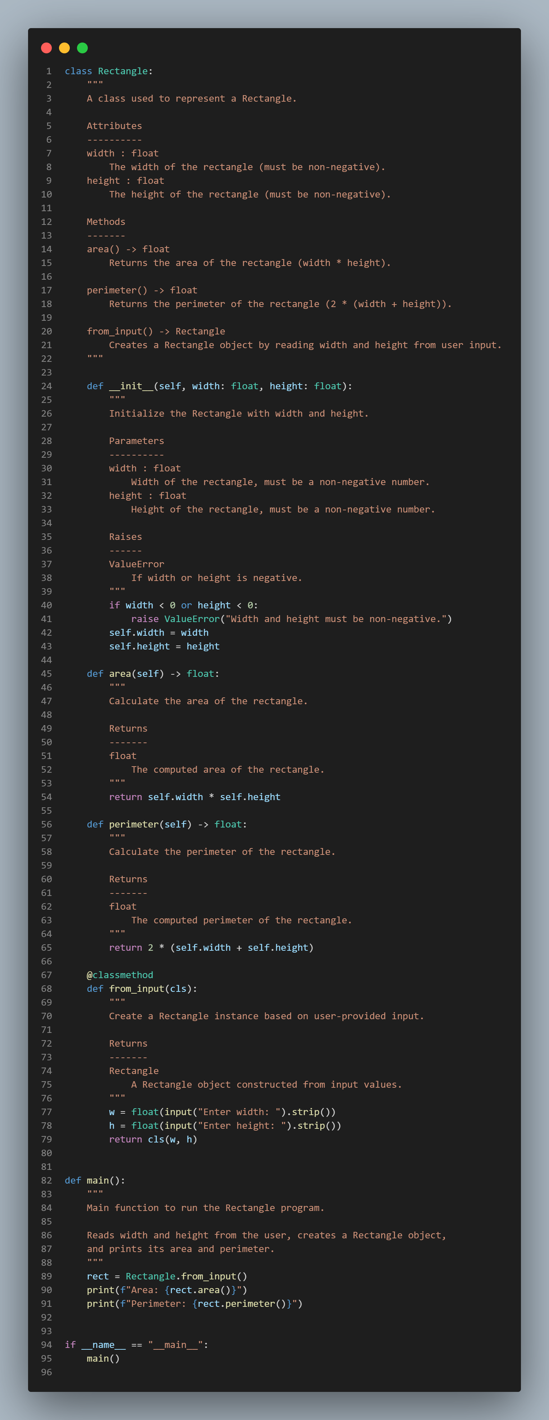
Comparison :
Copilot generated only an overall class-level docstring, while the improved version includes detailed manual docstrings for each method, making the documentation clearer, professional, and suitable for assignments or software engineering standards.

