Write a C++ program to implement Dijkstra’s Single Source Shortest Path Algorithm for a graph represented using an adjacency matrix.
Number of vertices: 5
Edges:
0 1 4
0 2 8
1 4 6
2 3 2
3 4 10
Source vertex: 0
------------------------------------------------------------------------------------------------------------------

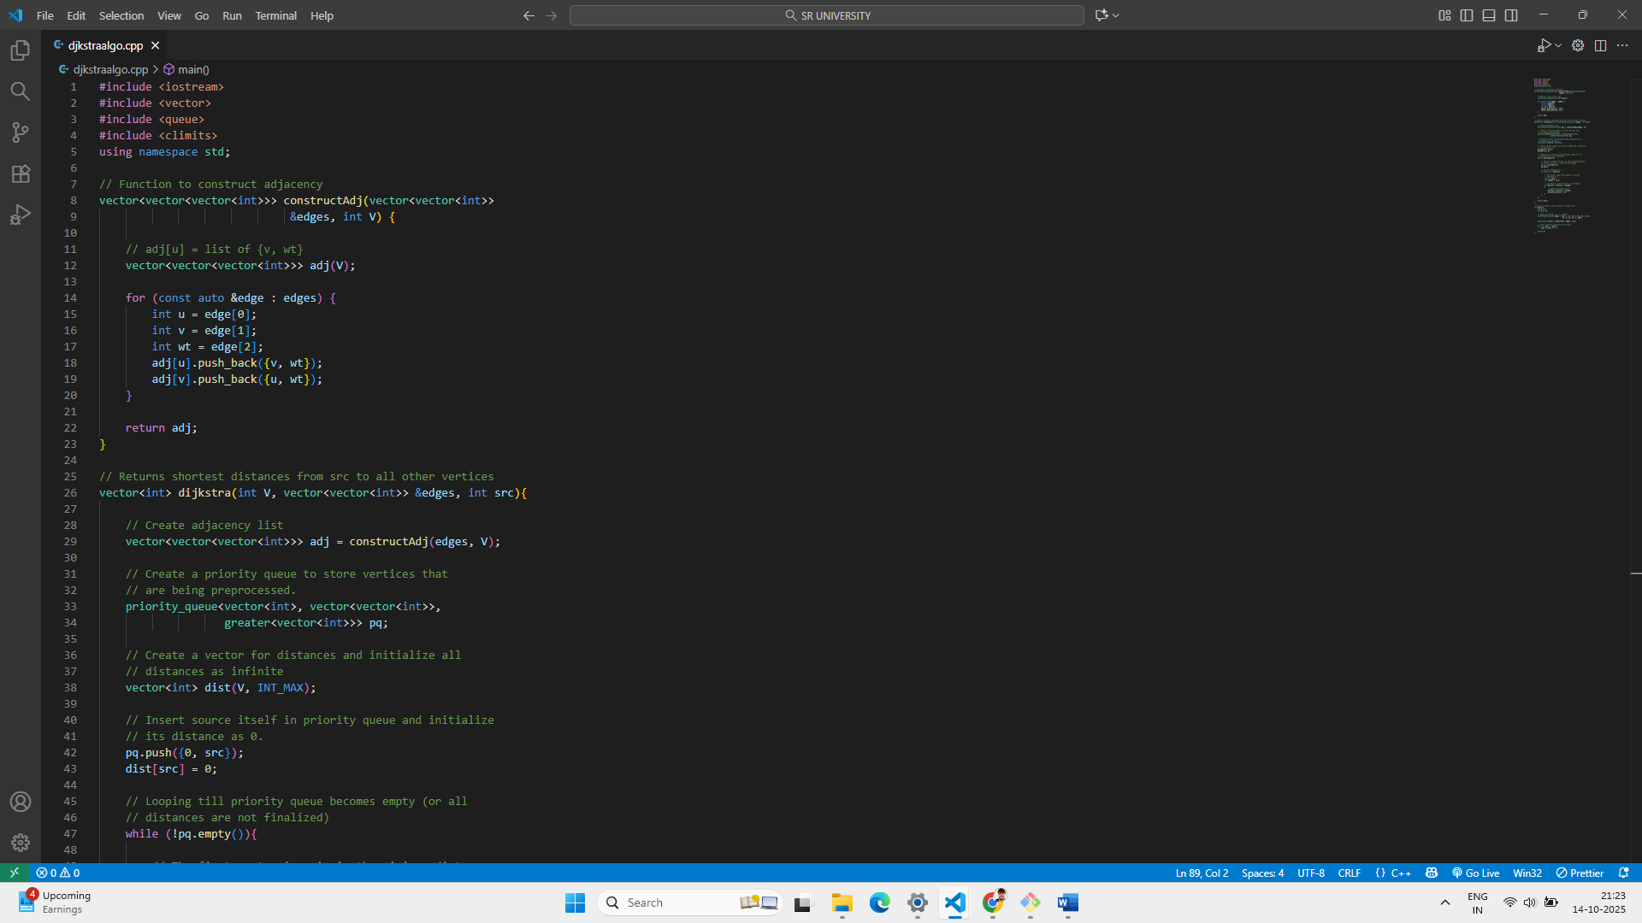
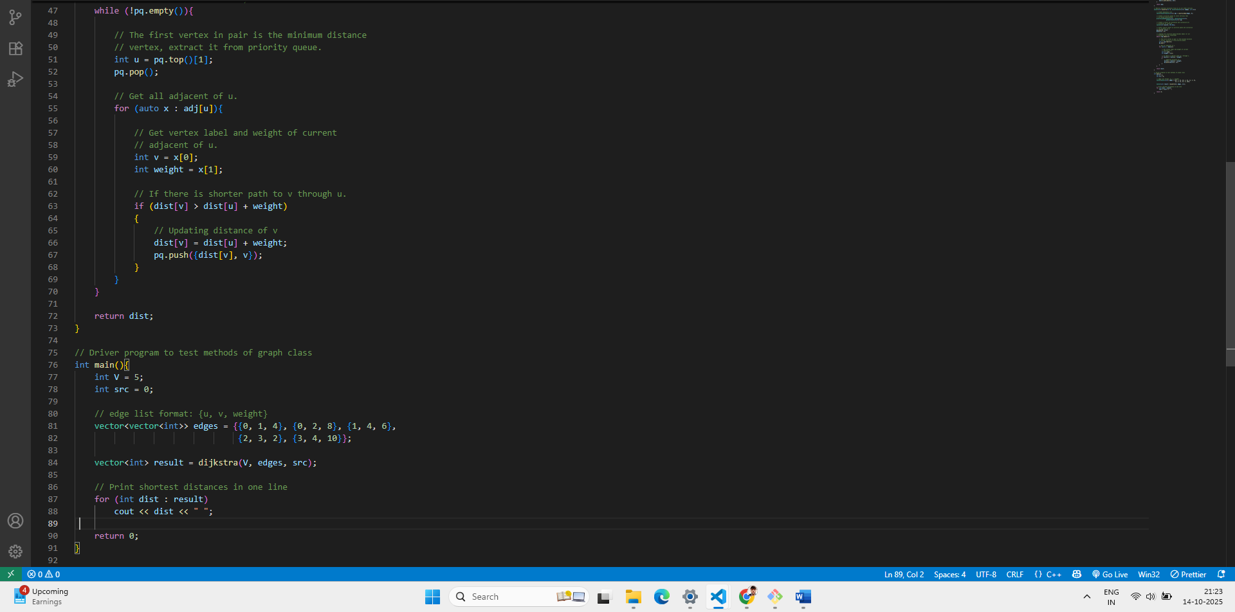

OUTPUT: