ASSIGNMENT-1
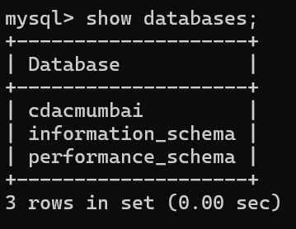

- create table salespeople(snum int, sname varchar(10), city varchar(10), comm float(3,2));
- insert into salespeople (Snum, Sname, City, Comm) values
- (1001, 'Peel', 'London', 0.12),
- (1002, 'Serres', 'San Jose', 0.13),
- (1004, 'Motika', 'London', 0.11),
- (1007, 'Rifkin', 'Barcelona', 0.15),
- (1003, 'Axelrod', 'New York', 0.10);
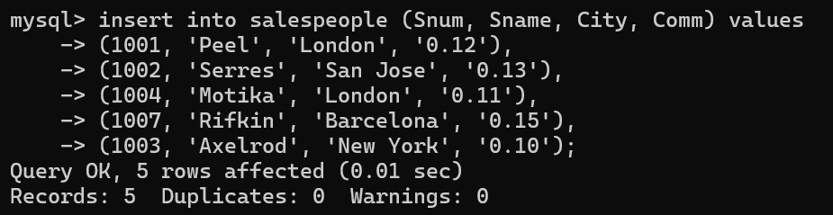
- create table customers (cnum int, cname varchar(10), city varchar(10), rating int, snum int);
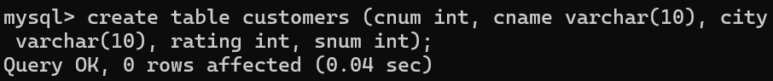
- insert into customers (cnum, cname, city, rating, snum) values
- (2001, 'hoffman', 'london', 100, 1001),
- (2002, 'giovanni', 'rome', 200, 1003),
- (2003, 'liu', 'san jose', 200, 1002),
- (2004, 'grass', 'berlin', 300, 1002),
- (2006, 'clemens', 'london', 100, 1001),
- (2008, 'cisneros', 'san jose', 300, 1007),
- (2007, 'pereira', 'rome', 100, 1004);
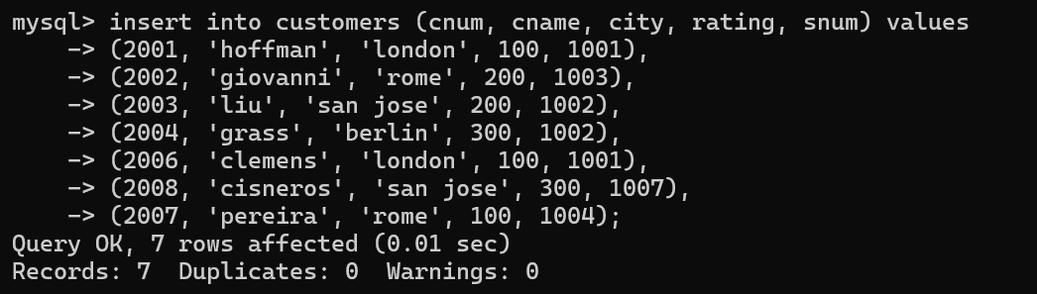
- create table orders (onum int, amt float(7,2), odate date, cnum int, snum int);
- insert into orders (Onum, Amt, Odate, Cnum, Snum) values
- (3001, 18.69, '1990-10-03', 2008, 1007),
- (3003, 767.19, '1990-10-03', 2001, 1001),
- (3002, 1900.10, '1990-10-03', 2007, 1004),
- (3005, 5160.45, '1990-10-03', 2003, 1002),
- (3006, 1098.16, '1990-10-03', 2008, 1007),
- (3009, 1713.23, '1990-10-04', 2002, 1003),
- (3007, 75.75, '1990-10-04', 2004, 1002),
- (3008, 4723.00, '1990-10-05', 2006, 1001),
- (3010, 1309.95, '1990-10-06', 2004, 1002),
- (3011, 9891.88, '1990-10-06', 2006, 1001);
