Assignment –4
Retrieving Information from Tables.
1) Write a select command that produces the order number, amount, and date for all rows in the Orders table.
-> mysql> select onum,amt,odate from orders;
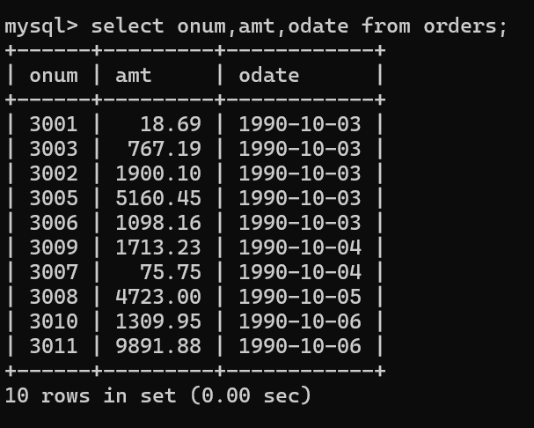
2) Write a query that produces all rows from the Customers table for which the salesperson’s number is 1001.
-> mysql> select * from customers
-> where snum = 1001;
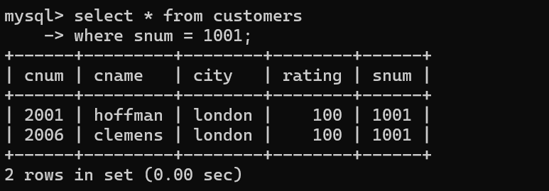
3) Write a query that displays the Salespeople table with the columns in the following order: city, sname, snum, comm.
-> mysql> select city,sname,snum,comm from salespeople;
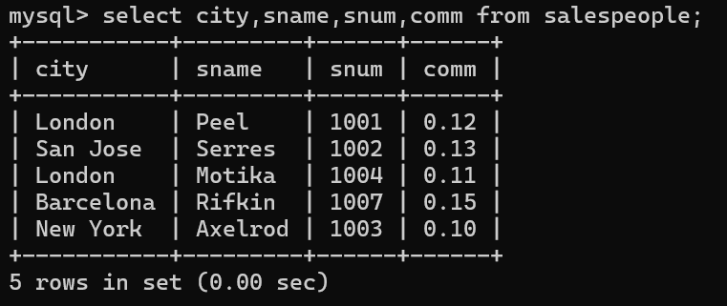
4) Write a select command that produces the rating followed by the name of each customer in San Jose.
-> mysql> select rating,cname from customers
-> where city = 'san jose';
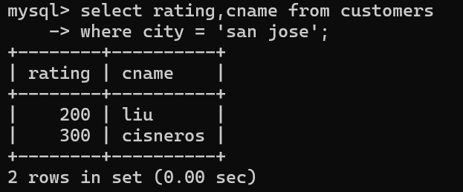

5) Write a query that will produce the snum values of all salespeople (suppress the duplicates) with orders in the Orders table.
-> mysql> select distinct SNUM from Salespeople order by snum;
