Assignment –5
Relational and Logical Operators.

1) Write a query that will give you all orders for more than Rs. 1,000.
- mysql> select * from orders;
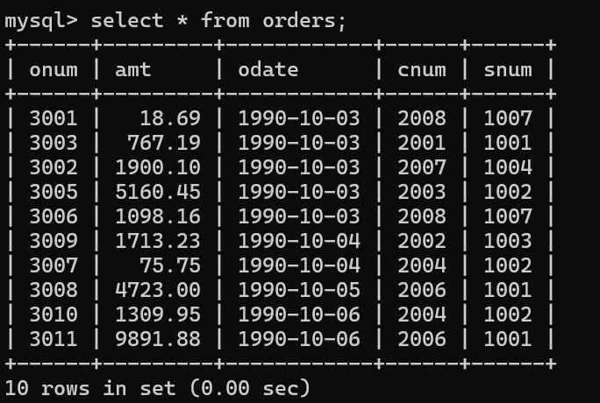
- mysql> select * from orders where amt > 1000;
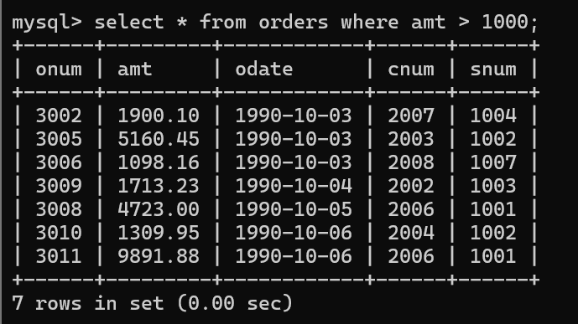

2) Write a query that will give you the names and cities of all salespeople in
London with a commission above .10.
- mysql> select * from salespeople;
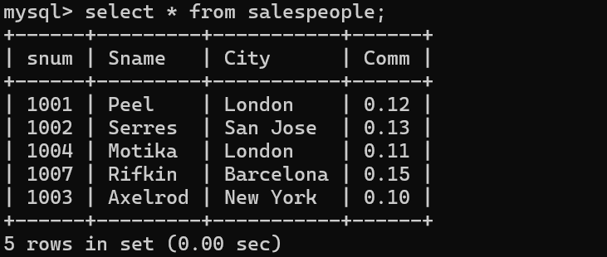
- mysql> select * from salespeople where Comm > 0.10;
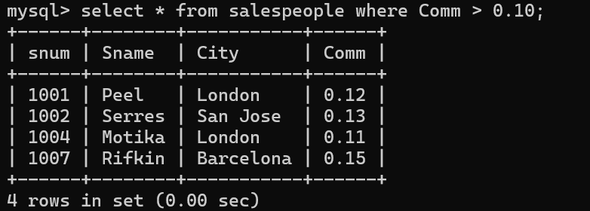

3) Write a query on the Customers table whose output will exclude all customers
with a rating <= 100, unless they are located in Rome.
- mysql> select * from customer;
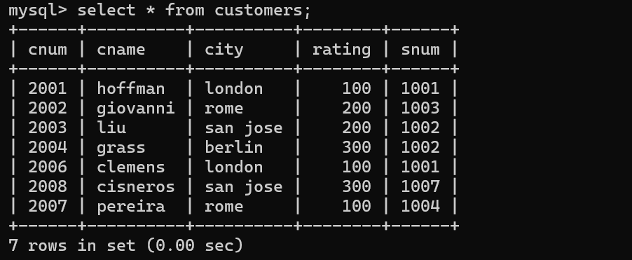
- mysql> select * from customers where rating > 100 and city != 'Rome';
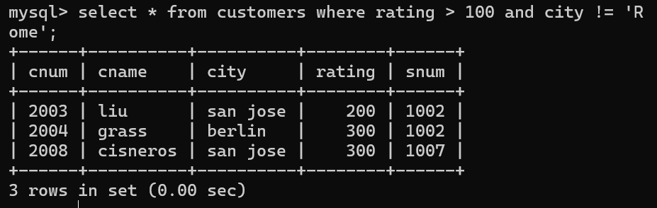

4) What will be the output from the following query?

Select * from Orders
where (amt < 1000 OR
NOT (odate = ‘1990-10-03’
AND cnum > 2003));
- mysql> Select * from Orders
- -> where (amt < 1000 OR
- -> NOT (odate = '1990-10-03'
- -> AND cnum > 2003));
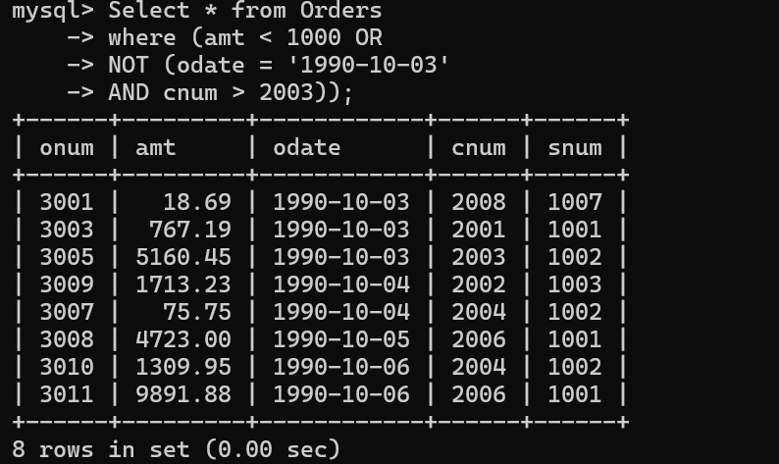

5) What will be the output of the following query?
Select * from Orders
where NOT ((odate = ‘1990-10-03’ OR snum
>1006) AND amt >= 1500);
- mysql> Select * from Orders
- -> where NOT ((odate = '1990-10-03' OR snum
- -> >1006) AND amt >= 1500);
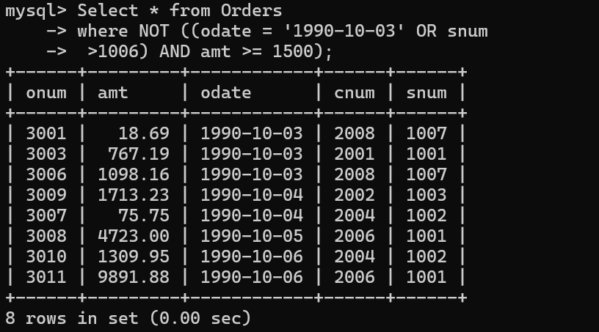

6) What is a simpler way to write this query?

Select snum, sname, city, comm From Salespeople
where (comm > .12 OR comm <.14);
- mysql> select * from salespeople where comm > 0.12 or comm < 0.14;
