Assignment –6
Using Special Operators in Conditions.
1) Write two different queries that would produce all orders taken on October 3rd or 4th, 1990.
- mysql> select * from orders;
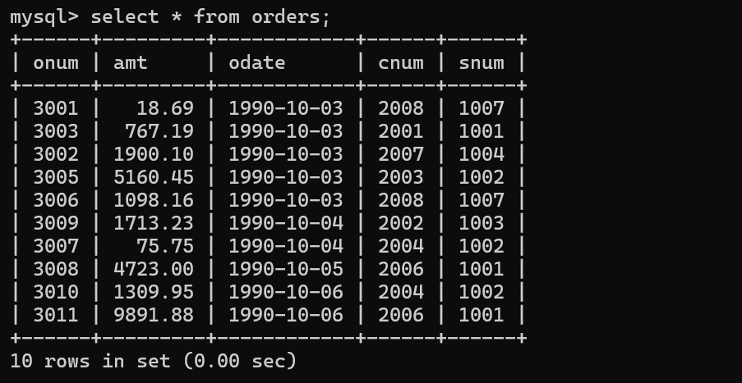
- mysql> select * from orders
-> where odate = '1990-10-03’
-> or odate = '1990-10-04';
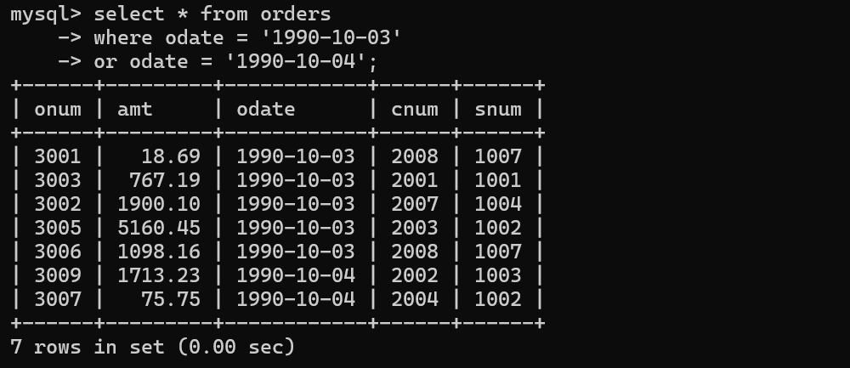

- mysql> select * from orders
-> having odate = '1990-10-04'
-> or odate = '1990-10-03';
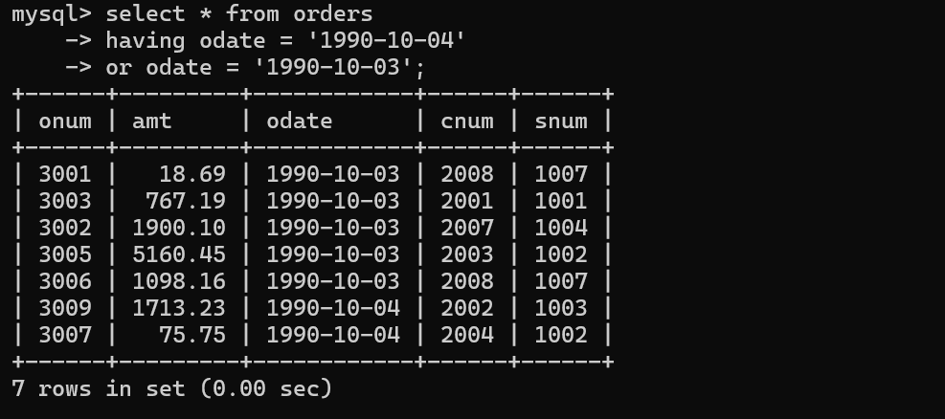
2) Write a query that selects all of the customers serviced by Peel or Motika.
- mysql> select * from customers
-> where snum = 1001 or snum = 1004;
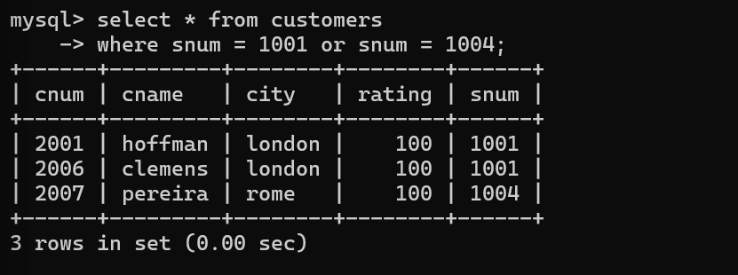
(Hint: the snum field relates the two tables to one another).

3) Write a query that will produce all the customers whose names begin with a letter from ‘A’ to ‘G’.
- mysql> select * from customers
-> where cname like 'A%' or cname like 'G%';
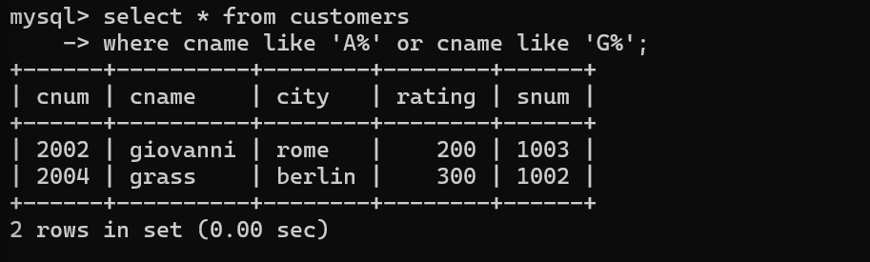
4) Write a query that selects all customers whose names begin with the letter ‘C’.
- mysql> select * from customers
-> where cname like 'C%';
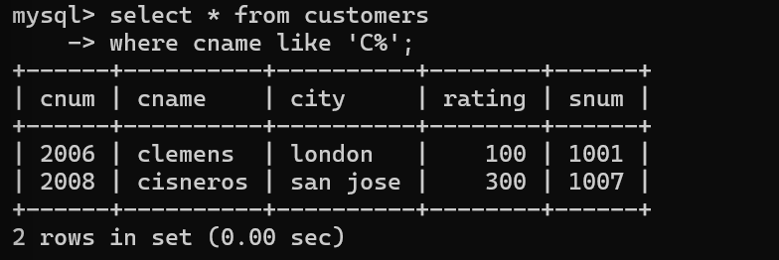
5) Write a query that selects all orders except those with zeroes or NULLs in the amt field
- mysql> select * from orders
-> where amt != 0 or amt != null;
