Assignment –7
Summarizing Data with Aggregate Functions.
1) Write a query that counts all orders for October 3.
-> select count(*)
-> from orders
-> where odate='1990-10-03';
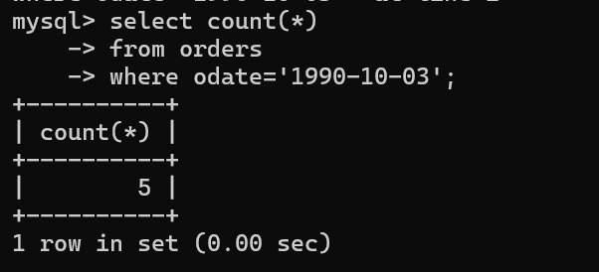
2) Write a query that counts the number of different non-NULL city values in the Customers table.
-> select count(distinct(city))
-> from customers
-> where city is not NULL;
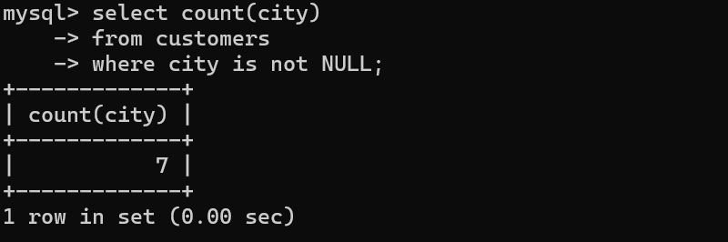

3) Write a query that selects each customer’s smallest order.
-> select cnum ,min(amt)
->from orders
->group by cnum;
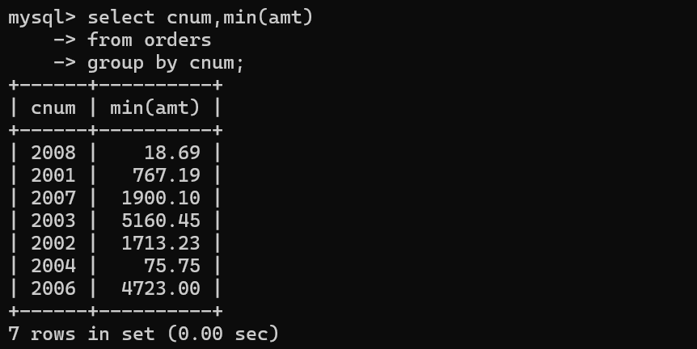
4) Write a query that selects the first customer, in alphabetical order, whose name begins with G.
-> select cname
->from customers
->where cname like 'G%'
->order by cname limit 1;


5) Write a query that selects the highest rating in each city.
-> select city, max(rating) as 'HIGHEST RATING'
-> from customers
->group by city;
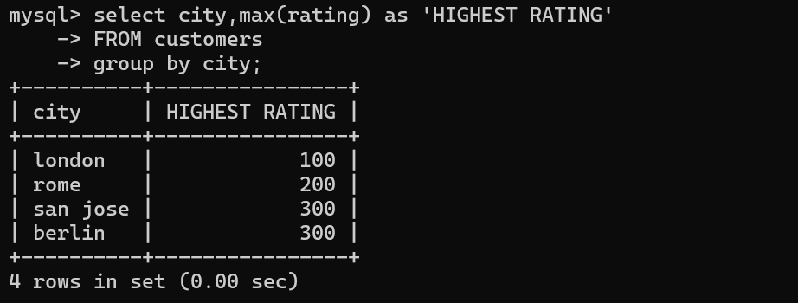
6) Write a query that counts the number of salespeople registering orders for each
day. (If a salesperson has more than one order on a given day, he or she should be
counted only once.)
->select odate, snum, count(distinct odate)
->from orders
->group by odate,snum;
