Assignment –8
Formatting Query output.
1) Assume each salesperson has a 12% commission. Write a query on the orders table that will produce the order number, the salesperson number, and the amount of the salesperson’s commission for that order.
-> select onum, snum, amt*0.12 as COMM_AMT
->from orders;
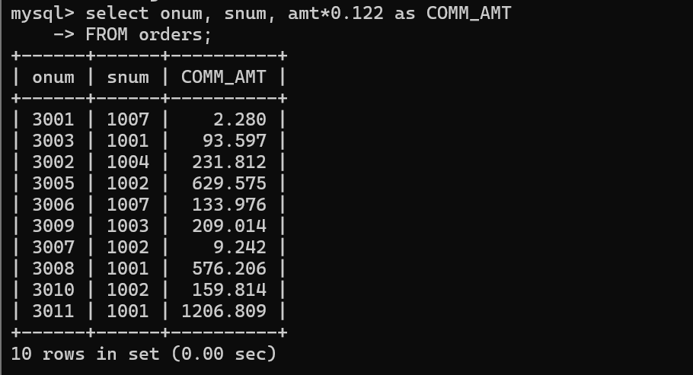
2) Write a query on the Customers table that will find the highest rating in each city. Put the output in this form: For the city (city), the highest rating is : (rating).
-> select city , max(rating) as HIGHEST_RATING
->from customers
->group by city;
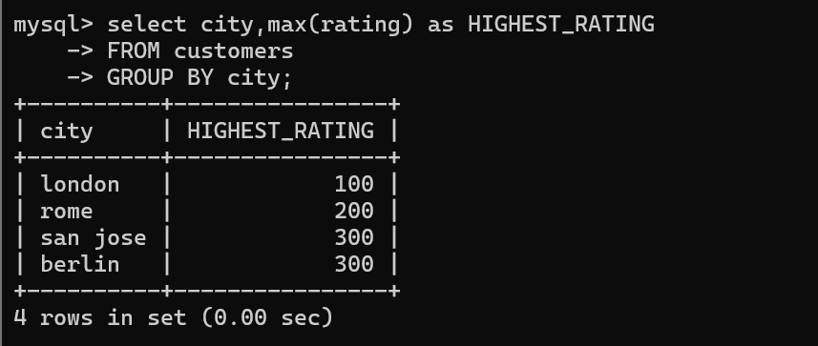
3) Write a query that lists customers in descending order of rating. Output the rating field first, followed by the customer’s name and number.
-> select rating, cname, cnum
-> from customers
-> order by RATING desc;

4) Write a query that totals the orders for each day and places the results in descending order
-> select odate, count(onum) as ONUM
-> FROM orders
-> GROUP BY odate
-> ORDER BY ONUM desc;
