**TASK FORM**

**1.HTML , CSS and JS**

1.Camp Registration Page

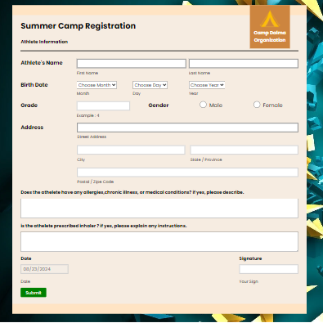

2.Calculator

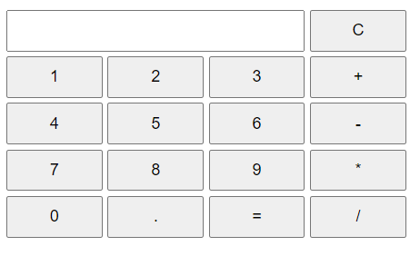

3.Temprature Conversion

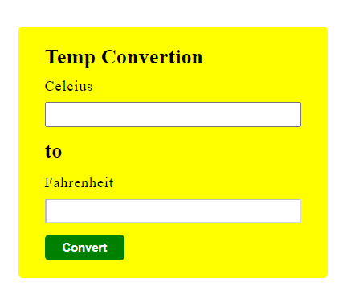

4.Form Validation

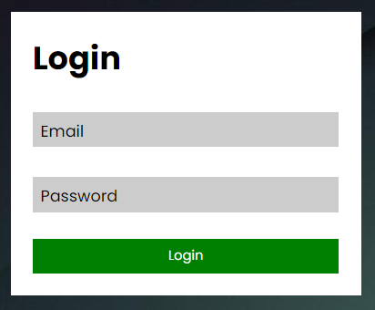

5.Array Manipulation

6.local storage

**2.JQuery**

1.Registration Page

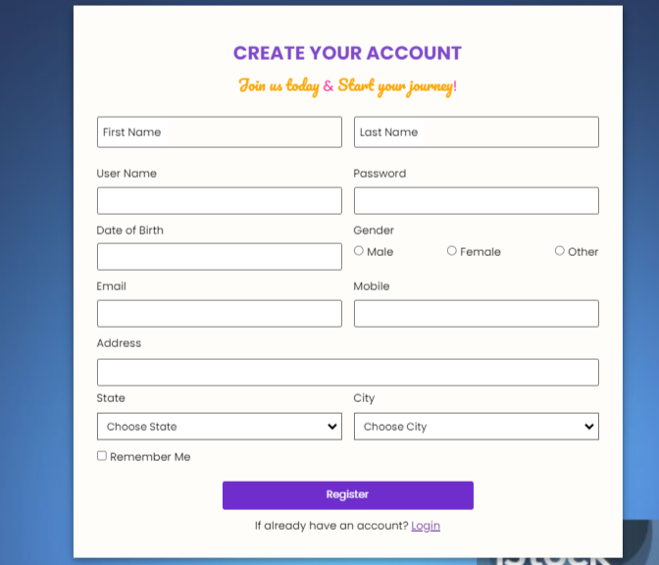

2.Local Storage

3.Ajax

4.Login Page

