Trader Performance vs. Market Sentiment
Hyperliquid Historical Trader Data × Bitcoin Fear & Greed Index
Analysis period: May 2023 – Apr 2025 (sentiment-matched subset: 166,146 of 211,224 trades, 78.7% coverage)

Executive Summary
Across 32 trading accounts and 166K sentiment-matched trades on Hyperliquid, profitability is not flat across the market sentiment cycle. Traders are profitable in every sentiment regime, but efficiency, position sizing, and directional bias all shift meaningfully with the crowd's mood.
- Profitability efficiency (PnL earned per dollar traded) rises steadily from Extreme Fear (2.0¢ per $) to Extreme Greed (5.3¢ per $) — a 2.7x improvement.
- Win rate is highest in Extreme Greed (88.3%) and lowest in Extreme Fear (80.0%), though win rate differences are modest compared to the swing in total dollar profitability.
- These traders are strongly net-long during Fear (73% of trades) and shift toward balance/net-short during Greed (only 42–46% long) — a contrarian, buy-the-dip positioning pattern rather than momentum-chasing.
- Average trade size is ~40-50% larger during Fear regimes ($4.6K–$4.7K) than during Neutral/Greed regimes ($3.0K–$3.7K), suggesting higher conviction — or higher desperation — sizing when sentiment is negative.
- At the daily level, the correlation between the Fear & Greed Index and same-day PnL is weak (r ≈ -0.07) and win rate correlation is similarly weak (r ≈ 0.06) — sentiment shapes trading behavior and multi-week outcomes more than it predicts any single day's results.

1. Total Profitability by Sentiment Regime
Total realized (closed) PnL was highest during Greed ($2.57M) and Extreme Greed ($2.42M), followed closely by Fear ($2.38M). Neutral and Extreme Fear periods produced meaningfully less profit, with Extreme Fear the smallest at $0.63M — though this regime also had the fewest calendar days (11) in the sample.
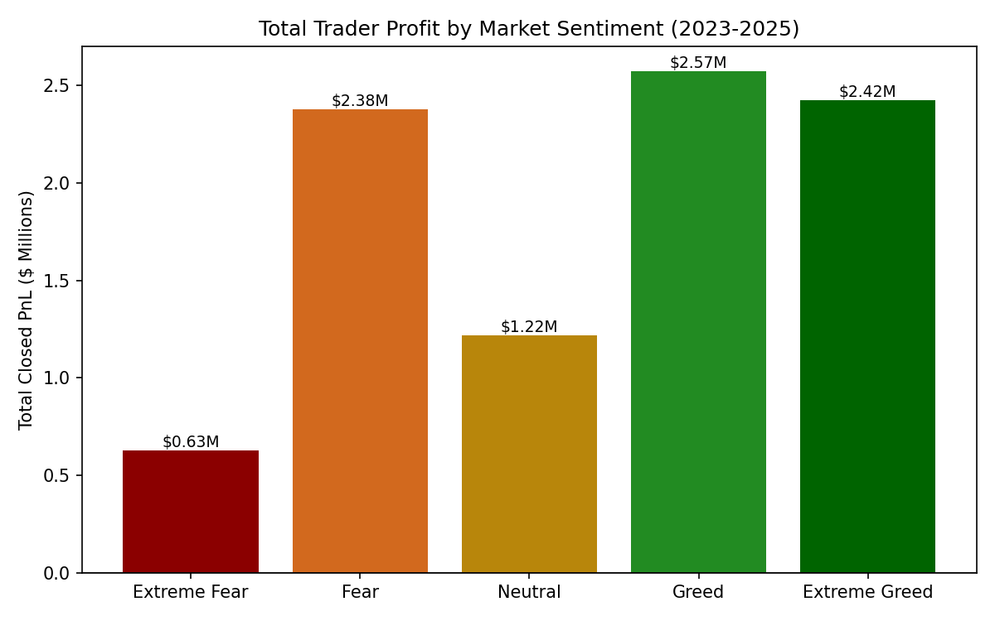
Sentiment | Closing Trades | Total PnL | Avg PnL/Trade | Win Rate | Days in Sample
Extreme Fear | 6,458 | $626,563 | $97.02 | 80.0% | 11
Fear | 22,492 | $2,378,236 | $105.74 | 86.7% | 81
Neutral | 16,020 | $1,217,063 | $75.97 | 84.6% | 69
Greed | 20,496 | $2,571,354 | $125.46 | 84.8% | 202
Extreme Greed | 16,295 | $2,423,251 | $148.71 | 88.3% | 93

2. Profit Efficiency & Win Rate
Raw totals are shaped by how much volume traded and how many days fell into each regime. Normalizing PnL by dollar volume traded reveals a much clearer pattern: capital is deployed most efficiently as sentiment moves from Fear toward Greed. Extreme Greed generates 5.3 cents of profit per dollar traded — roughly 2.7x the rate seen in Extreme Fear (2.0 cents).
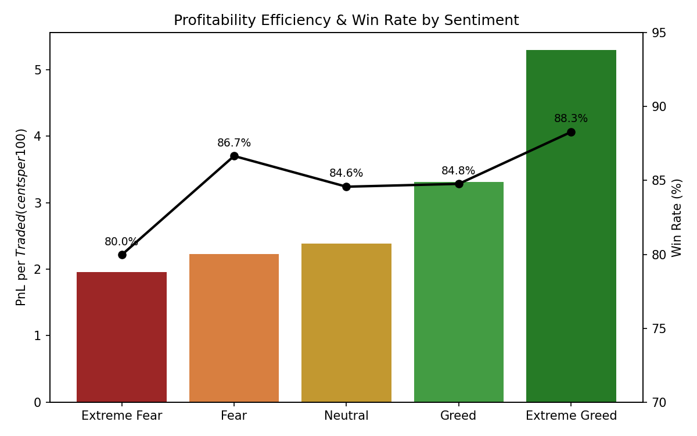
Win rate tells a gentler version of the same story: traders win more often as sentiment improves, from 80.0% in Extreme Fear to 88.3% in Extreme Greed. But the efficiency gap (2.7x) is far larger than the win-rate gap (~8 percentage points) — meaning the bigger driver of the sentiment effect is how much is won/lost per trade, not just how often traders win.

3. Positioning: Long vs. Short Bias
Directional positioning shifts sharply with sentiment. During Extreme Fear and Fear, roughly 73% of trades are long-biased (opening/adding to long positions or buying) versus only 27% short-biased. That ratio nearly inverts in Greed, where only 42% of trades are long-biased and 58% short-biased.
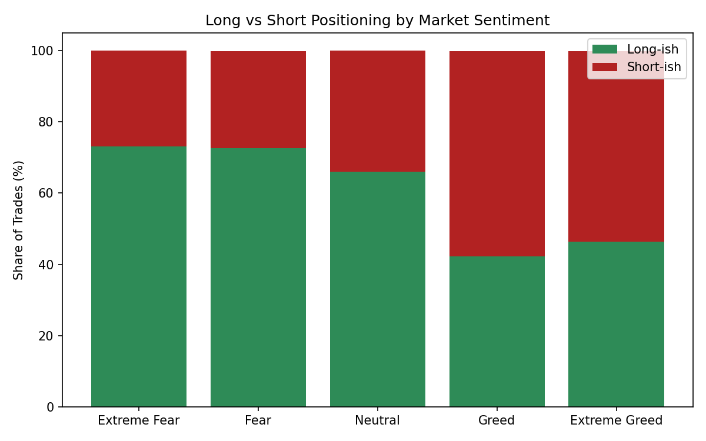
This is a contrarian pattern: these traders lean into long exposure when the market is fearful (effectively buying weakness) and pull back / add shorts as greed builds (fading strength or taking profit into rallies). Combined with the efficiency data above, it suggests the long positions initiated during Fear are what pay off as sentiment later recovers into Greed — profits are being harvested in a different regime than where the position was built.

4. Position Sizing by Sentiment
Average trade size is notably larger in Fear regimes ($4,696 in Fear, $4,577 in Extreme Fear) than in Neutral or Greed regimes ($3,062–$3,749). Traders appear to size up when sentiment is negative — consistent with either higher-conviction dip-buying or fear-driven larger, more urgent orders.
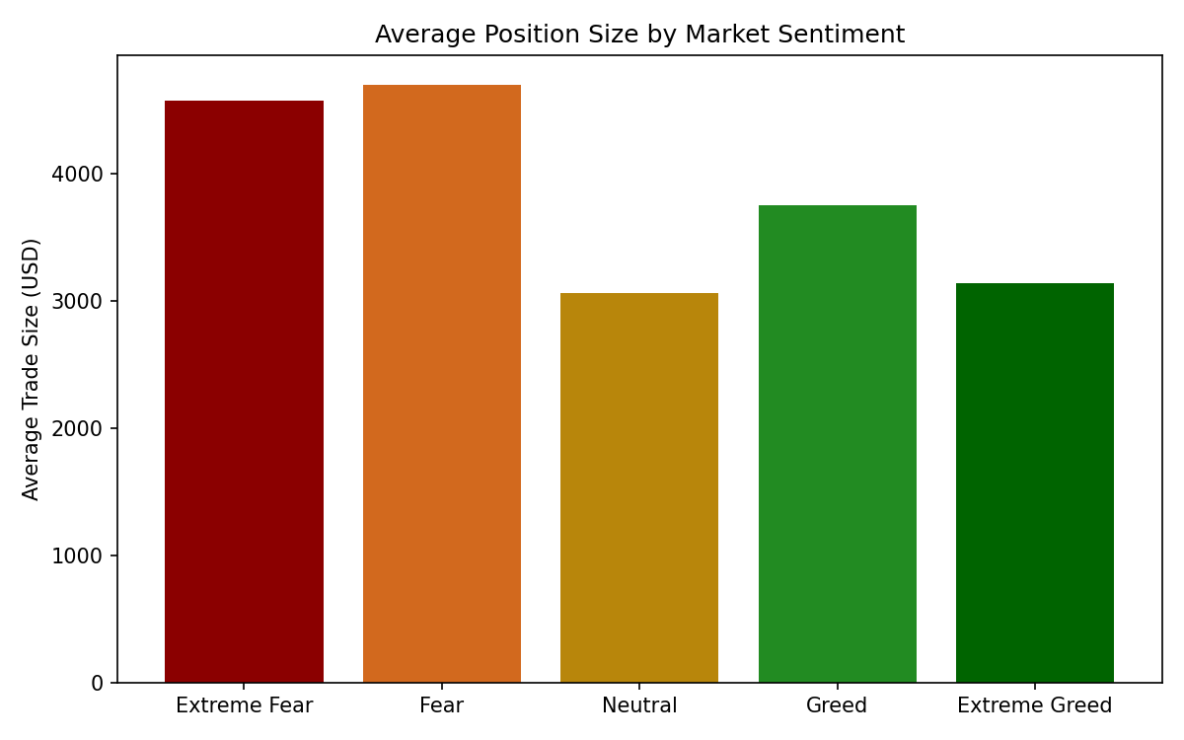

5. Daily PnL vs. Fear & Greed Index
Plotting each day's total closed PnL against that day's Fear & Greed Index shows a very weak linear relationship (correlation ≈ -0.07) at the daily granularity — day-to-day results are noisy and driven by many factors beyond sentiment alone. The regime-level effects in Sections 1–4 are therefore best read as behavioral/structural patterns that play out over weeks, not a same-day sentiment-to-PnL signal.
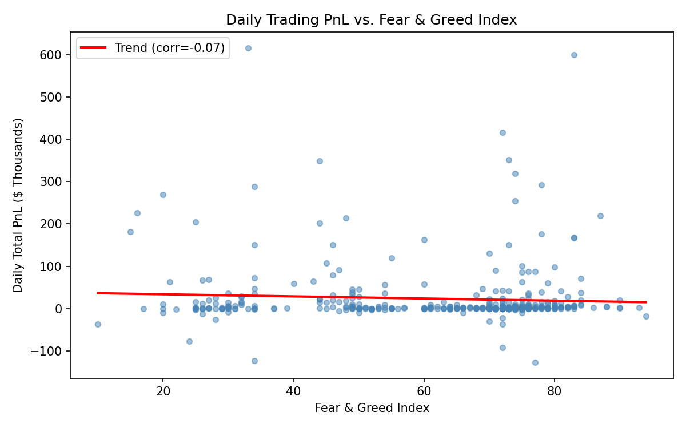

6. Account & Coin-Level Highlights
Performance concentration: the top account (0xb1231a4a2d…) accounts for $2.04M of total realized PnL, more than 3x the next-largest account, and is the top performer specifically during Neutral, Greed, and Extreme Greed regimes. A different account (0xbaaaf6571a…) leads specifically during Extreme Fear, and another (0x083384f897…) leads during Fear — suggesting different traders specialize in, or are simply more active during, different sentiment regimes.
By asset, ETH and HYPE were consistently profitable across nearly every sentiment regime (including Extreme Fear), acting as reliable contributors regardless of mood. @107 and SUI were dramatically more profitable in Greed/Extreme Greed than in Fear (with @107 even net-negative during Extreme Fear/Fear), indicating momentum-sensitive, sentiment-dependent performance for certain tokens.
Coin | Extreme Fear | Fear | Neutral | Greed | Extreme Greed
ETH | $195,380 | $405,996 | $176,771 | $350,427 | -$45,633
HYPE | $493,887 | $777,876 | $296,946 | $230,938 | $69,659
SOL | -$9,865 | $524,557 | $119,725 | $400,495 | $37,248
@107 | -$113,805 | -$25,083 | $226,067 | $835,137 | $1,865,569
BTC | -$12,305 | $98,688 | $32,897 | $83,572 | $83,594

7. Strategic Takeaways
- Capital efficiency, not just win rate, is where sentiment matters most — deploying capital during Greed/Extreme Greed produces meaningfully higher return per dollar traded. A sentiment-aware sizing rule (scale up exposure as the index rises above ~55) could improve capital efficiency for similar strategies.
- The dataset's traders already behave contrarian at the position-opening stage (long-heavy in Fear). The data suggests this pays off — but the payoff is realized later, during Greed, not immediately. This implies patience/holding-period matters more than sentiment timing alone.
- Coin selection should be sentiment-aware: ETH and HYPE are stable performers, while @107 and similar higher-beta / narrative-driven tokens are highly sentiment-dependent and carry more regime risk.
- Extreme Fear is a small-sample regime in this dataset (11 days) — conclusions about it should be treated as directional, not statistically conclusive, until more Extreme Fear days accumulate.

Data & Methodology Notes
- Trader data: Hyperliquid historical trades, 211,224 rows, 32 accounts, 246 coins, May 2023 – May 2025.
- Sentiment data: hourly Bitcoin Fear & Greed Index (0-100), averaged to a daily value and joined to trades by calendar date. Standard bands applied: Extreme Fear (0-24), Fear (25-44), Neutral (45-55), Greed (56-75), Extreme Greed (76-100).
- 45,078 trades (21.3%) fell after the sentiment dataset's coverage window (post Apr 7, 2025) and were excluded from sentiment-based analysis.
- "Closing trades" = trades with non-zero Closed PnL, used for win rate and PnL-per-trade metrics. All trades (including opens) were used for volume, sizing, and positioning metrics.
- The Hyperliquid dataset did not include a leverage field, so leverage-specific analysis was not possible with the provided data.

