SYNOPSIS

Time:- 2 hr Semester:-V

Class:-TYDS Marks:-30

Subject:-Marketing and Retail Analytics (MRA)

SET A
Q1)Collect Marketing Dataset Using Python
Code:
import pandas as pd
data = {
"Product": ["Soap", "Shampoo", "Cream", "Soap"],
"Sales": [5000, 8000, 6000, 4500],
"Advertising": [500, 800, 600, 400]
}
df = pd.DataFrame(data)
print(df)

Output:
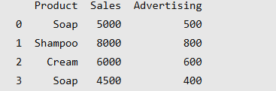

Q2)Analyze Advertising Expenditure and Sales
Code:
import pandas as pd
data = {
"TV": [1000, 2000, 3000, 4000],
"SocialMedia": [500, 800, 1000, 1500],
"Sales": [5000, 7000, 9000, 12000]
}
df = pd.DataFrame(data)
print(df)
print("\nAverage Sales:", df["Sales"].mean())
print("Total Sales:", df["Sales"].sum())

Output:
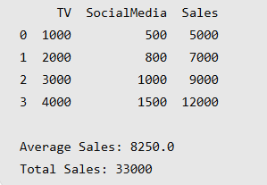

SET B

Q1)Preprocess Marketing Dataset Using Pandas
Code:
import pandas as pd
data = {
"Product": ["Soap", "Shampoo", "Cream", "Soap"],
"Sales": [5000, None, 6000, 5000]
}
df = pd.DataFrame(data)
print("Original Dataset:")
print(df)
df = df.drop_duplicates()
df["Sales"] = df["Sales"].fillna(0)
print("\nCleaned Dataset:")
print(df)

Output:
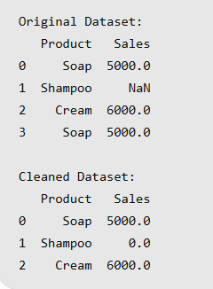

Q2)Implement A/B Testing for Marketing Campaigns
Code:
import pandas as pd
data = {
"Campaign": ["A", "B"],
"Visitors": [100, 120],
"Conversions": [10, 18]
}
df = pd.DataFrame(data)
df["ConversionRate"] = (
df["Conversions"] / df["Visitors"]
) * 100
print(df)
print("\nBetter Campaign:")
print(df.loc[df["ConversionRate"].idxmax(), "Campaign"])

Output:
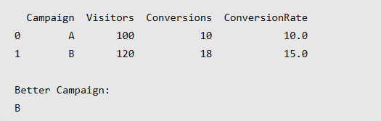

SET C

Q1)Perform Exploratory Data Analysis (EDA) on Sales Data
Code:
import pandas as pd

data = {
"Product": ["Soap", "Shampoo", "Cream", "Oil"],
"Sales": [5000, 8000, 6000, 4000]
}
df = pd.DataFrame(data)
print("Sales Dataset:")
print(df)
print("\nTotal Sales:", df["Sales"].sum())
print("Average Sales:", df["Sales"].mean())
print("Maximum Sales:", df["Sales"].max())
print("Minimum Sales:", df["Sales"].min())

Output:
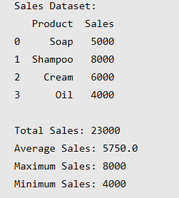

Q2)Analyze Retail Sales and Profit
Code:
import pandas as pd
data = {
"Category": ["Clothing", "Electronics", "Food", "Clothing"],
"Sales": [5000, 10000, 3000, 4000],
"Profit": [1000, 2500, 600, 800]
}
df = pd.DataFrame(data)

result = df.groupby("Category")[["Sales", "Profit"]].sum()
print(result)

Output:
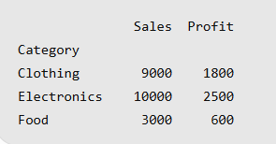

SET D

Q1)Perform RFM Analysis on Customer Data
Code:

import pandas as pd
data = {
"Customer": ["Amit", "Neha", "Raj", "Priya"],
"Recency": [5, 10, 2, 20],
"Frequency": [4, 2, 6, 1],
"Monetary": [5000, 2000, 8000, 1000]
}
df = pd.DataFrame(data)
print("RFM Analysis:")
print(df)

Output:
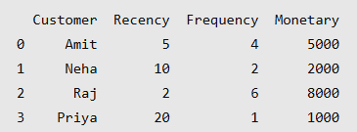

Q2)Perform Market Basket Analysis Using Apriori
Code:
import pandas as pd
from mlxtend.frequent_patterns import apriori
data = {
"Bread": [1, 1, 1, 0],
"Milk": [1, 1, 0, 1],
"Butter":[1, 0, 1, 0]
}
df = pd.DataFrame(data)

result = apriori(
df,
min_support=0.5,
use_colnames=True
)
print(result)

Output:
