MUTUAL FUND ANALYTICS PLATFORM
Bluestock Fintech Capstone Project
Final Project Report
Prepared By: Ampolu Raj Kumar
Internship: Bluestock Fintech
Project Duration: 7 Days
Technology Stack: Python, Pandas, NumPy, SQLite, Power BI, Matplotlib, Seaborn

Executive Summary
The Mutual Fund Analytics Platform was developed as part of the Bluestock Fintech Capstone Project to provide a comprehensive solution for analyzing mutual fund performance, investor behavior, portfolio allocation, and risk metrics. The financial industry generates massive volumes of investment data that require effective processing, visualization, and analysis for informed decision-making.
This project integrates data engineering, analytics, database management, and business intelligence techniques to create a complete analytics platform. The platform ingests raw mutual fund datasets, performs cleaning and transformation, stores structured data in SQLite, generates analytical insights through Python, and visualizes results through interactive Power BI dashboards.
The project demonstrates the end-to-end lifecycle of a data analytics solution, including ETL pipelines, database design, exploratory data analysis, performance measurement, risk analytics, dashboard development, and reporting.

1. Introduction
The Indian mutual fund industry has witnessed significant growth in recent years due to increasing financial awareness, digital investment platforms, and systematic investment plans (SIPs). Investors require reliable tools to compare funds, evaluate performance, understand risks, and make informed investment decisions.
Traditional methods of analyzing mutual funds often rely on scattered information sources and manual calculations. This project addresses these challenges by creating a centralized analytics platform capable of processing large datasets and generating actionable insights.
The platform aims to help analysts, investors, and financial institutions evaluate mutual funds using performance metrics, risk indicators, portfolio analysis, and investor behavior patterns.

2. Problem Statement
Investors face several challenges while selecting mutual funds:
- Difficulty comparing multiple funds simultaneously.
- Lack of consolidated risk and performance metrics.
- Limited visibility into investor behavior and SIP trends.
- Inability to analyze portfolio diversification effectively.
- Challenges in tracking industry-wide growth and market trends.
The project seeks to solve these problems by developing a centralized Mutual Fund Analytics Platform capable of delivering data-driven insights.

3. Project Objectives
The primary objectives of this project are:
- Build an ETL pipeline for mutual fund datasets.
- Design a scalable SQLite database.
- Perform comprehensive exploratory data analysis.
- Calculate advanced performance metrics.
- Develop interactive dashboards using Power BI.
- Perform risk analytics using VaR and CVaR.
- Build a simple recommendation engine.
- Generate professional reports and presentations.

4. Data Sources

The Mutual Fund Analytics Platform was developed using ten carefully selected datasets representing different aspects of the Indian mutual fund ecosystem. These datasets collectively provide information related to fund characteristics, historical performance, investor behavior, portfolio composition, market benchmarks, and industry growth trends.
The integration of these datasets enabled comprehensive analysis across multiple dimensions, including fund performance evaluation, risk assessment, investor analytics, portfolio diversification, and dashboard reporting.
The datasets were organized in CSV format and processed using Python and Pandas before being loaded into a SQLite database for analytical purposes.
These datasets were integrated using common identifiers such as AMFI Code, enabling cross-dataset analysis and the creation of a unified Mutual Fund Analytics Platform.
The combined dataset environment supported the implementation of:
- Exploratory Data Analysis (EDA)
- Performance Analytics
- Risk Analytics
- Investor Behavior Analysis
- Portfolio Concentration Analysis
- Dashboard Development
- Fund Recommendation System
The availability of diverse datasets allowed the project to simulate a real-world mutual fund analytics environment and generate meaningful insights for investors, analysts, and financial institutions.

4.1 Fund Master Dataset
The Fund Master Dataset serves as the primary reference dataset for the Mutual Fund Analytics Platform. It contains detailed information about all mutual fund schemes included in the project and acts as the central dimension table for linking multiple datasets through the AMFI Code.
Each mutual fund scheme is uniquely identified using an AMFI Code, which enables integration with NAV history, scheme performance, investor transactions, portfolio holdings, and benchmark datasets. The dataset provides important metadata about schemes such as fund house, category, benchmark, expense ratio, risk level, and fund manager details.
This dataset was extensively used throughout the project for data integration, dashboard filtering, performance analysis, and fund recommendation logic.
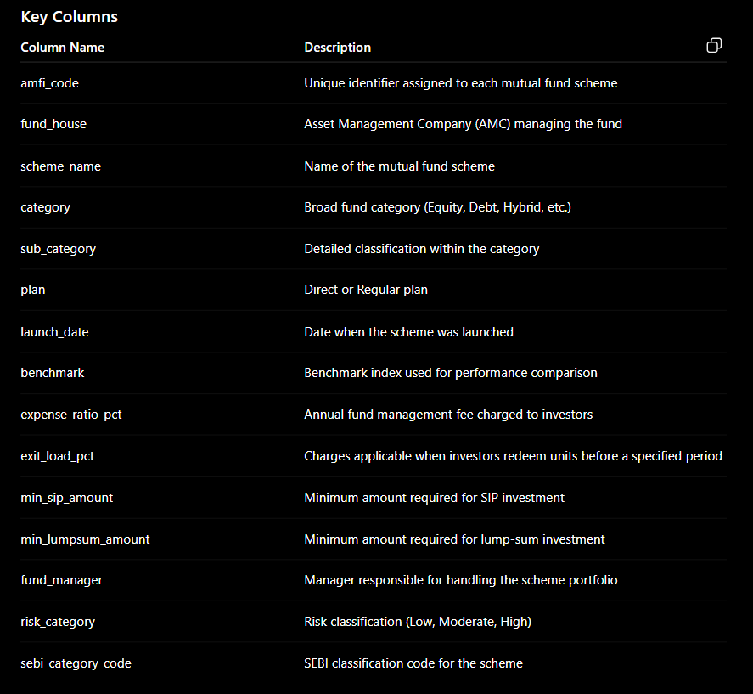
4.2 NAV History Dataset
The NAV (Net Asset Value) History Dataset is one of the most critical datasets used in this project. It contains daily NAV values for all mutual fund schemes included in the Fund Master dataset. NAV represents the per-unit market value of a mutual fund scheme and serves as the primary indicator of fund performance over time.
The dataset spans multiple years and provides sufficient historical observations for calculating performance metrics such as daily returns, CAGR, Sharpe Ratio, Sortino Ratio, Alpha, Beta, Maximum Drawdown, Value at Risk (VaR), and Conditional Value at Risk (CVaR).
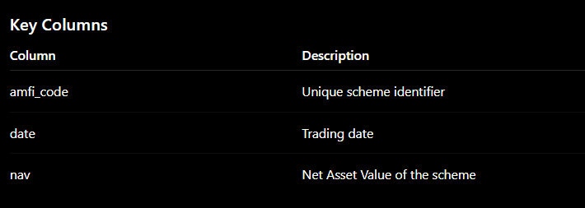
Project Usage
The NAV dataset was used for:
- Daily return calculations
- Fund performance analysis
- CAGR computation
- Risk metric calculation
- Benchmark comparison
- Correlation analysis
- Rolling Sharpe Ratio analysis
- VaR and CVaR calculations

Importance
The NAV History dataset forms the foundation of the entire analytics platform because most performance and risk calculations originate from historical NAV movements.
4.3 AUM Dataset
The Assets Under Management (AUM) Dataset contains the total value of assets managed by different mutual fund houses over time. AUM is one of the most widely used indicators of investor confidence and fund house growth.
The dataset provides yearly and monthly AUM values, enabling analysis of industry expansion and comparative performance among Asset Management Companies (AMCs).
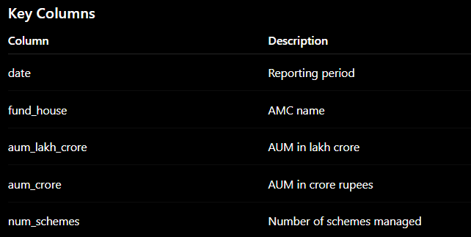
Project Usage
The dataset was utilized for:
- Industry growth analysis
- AUM trend visualization
- AMC comparison
- Power BI KPI creation
- Market share analysis
Key Finding
Analysis revealed that SBI Mutual Fund consistently maintained the highest AUM among all fund houses, demonstrating strong investor trust and market leadership.

4.4 SIP Inflow Dataset
The SIP (Systematic Investment Plan) Inflow Dataset captures monthly SIP investments made by investors across the mutual fund industry.
SIP inflows are an important measure of retail investor participation and long-term investment behavior.
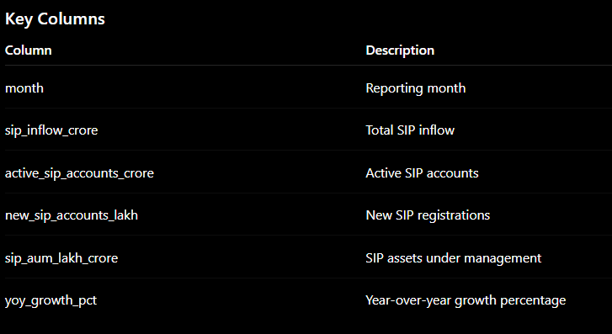
Project Usage
The dataset was used for:
- Monthly SIP trend analysis
- Industry participation analysis
- Growth rate calculations
- Dashboard KPI generation
- Market trend visualization

Key Finding
The analysis showed a steady increase in SIP participation, with December 2025 recording an all-time high SIP inflow of ₹31,002 Crore.
4.5 Category Inflows Dataset
The Category Inflows Dataset records net inflows and outflows for different mutual fund categories such as Equity, Debt, Hybrid, and Other schemes.
This dataset helps identify investor preferences and market sentiment across various investment categories.
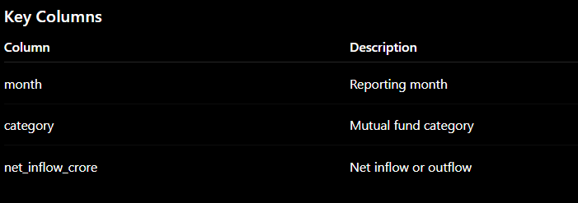
Project Usage
The dataset was used for:
- Heatmap generation
- Category comparison
- Investor preference analysis
- Industry trend analysis
Key Finding
Equity-oriented schemes consistently attracted higher inflows than debt and hybrid categories, indicating a strong preference for long-term wealth creation.
4.6 Folio Count Dataset
The Folio Count Dataset tracks the number of investor folios maintained across the mutual fund industry.
A folio represents an investor account and is commonly used as an indicator of industry penetration and investor participation.
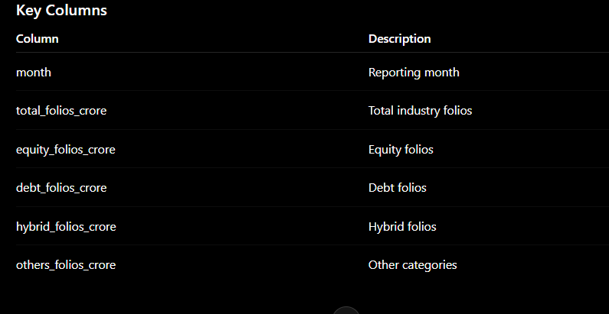
Project Usage
The dataset was used for:
- Industry growth measurement
- Folio trend analysis
- Dashboard KPIs
- Participation analysis
Key Finding
Industry folios increased from approximately 13.26 Crore in 2022 to 26.12 Crore by 2025, reflecting significant growth in mutual fund adoption.

4.7 Scheme Performance Dataset
The Scheme Performance Dataset contains return and risk characteristics of mutual fund schemes.
This dataset provides a quick overview of scheme performance without requiring detailed NAV calculations.
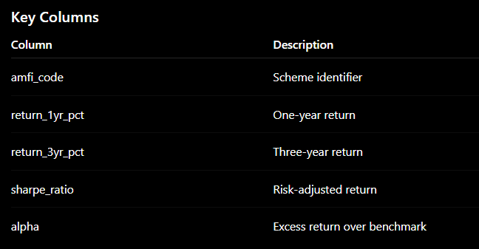
Project Usage
The dataset was used for:
- Fund ranking
- Scorecard generation
- Risk-adjusted performance analysis
- Dashboard reporting
Key Finding
Funds with higher Sharpe Ratios consistently achieved superior risk-adjusted performance compared to peers.

4.8 Investor Transactions Dataset
The Investor Transactions Dataset contains detailed transaction records for individual investors.
This dataset enables behavioral analysis and provides insights into investor demographics, geographic distribution, and investment patterns.
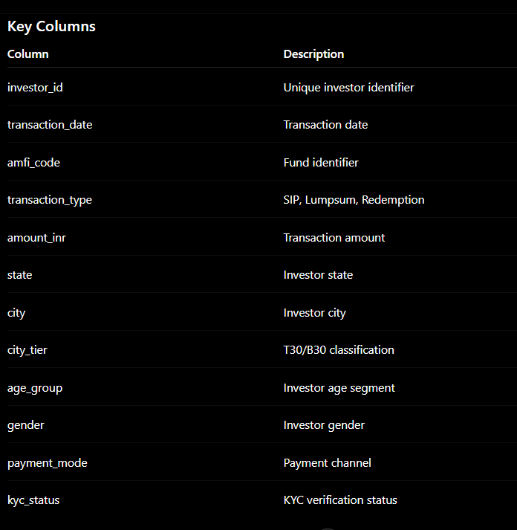
Project Usage
The dataset was used for:
- Investor demographic analysis
- Geographic analysis
- SIP continuity analysis
- Cohort analysis
- Dashboard visualizations
Key Findings
- Investors aged 26–35 contributed the highest investment volume.
- T30 cities generated the majority of transaction activity.
- UPI emerged as the preferred payment method.

4.9 Portfolio Holdings Dataset
The Portfolio Holdings Dataset contains the underlying securities held by each mutual fund scheme.
It provides visibility into sector allocation, diversification, and concentration risk.
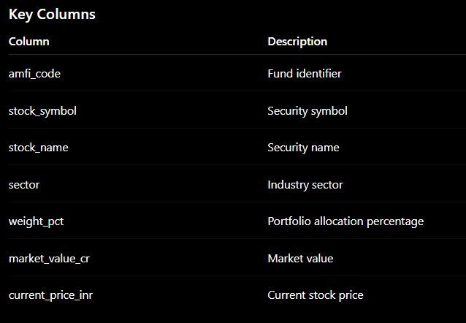
Project Usage
The dataset was used for:
- Sector allocation analysis
- Diversification assessment
- HHI calculation
- Concentration risk analysis
Key Finding
Sector concentration varied significantly across funds, with some schemes exhibiting high exposure to IT and Banking sectors.
4.10 Benchmark Indices Dataset
The Benchmark Dataset contains historical index values for Nifty 50 and Nifty 100 indices.
Benchmarks serve as reference points for evaluating mutual fund performance and market exposure.
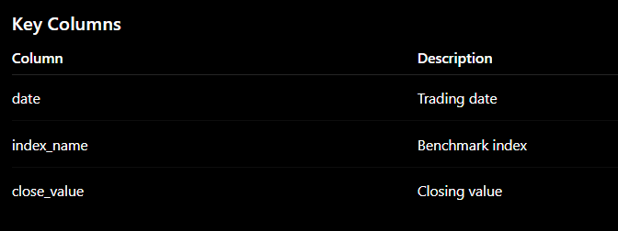
Project Usage
The dataset was used for:
- Alpha calculation
- Beta calculation
- Benchmark comparison
- Performance attribution
- Dashboard visualization
Key Finding
Several high-performing funds generated positive Alpha, indicating their ability to outperform benchmark indices on a risk-adjusted basis.

5. System Architecture
The Mutual Fund Analytics Platform follows a layered architecture approach, ensuring clear separation of responsibilities between data storage, processing, analytics, and visualization components. This architecture improves scalability, maintainability, and analytical efficiency while enabling smooth data flow from raw datasets to business insights.
The system is divided into five major layers:
5.1 Data Layer
The Data Layer serves as the foundation of the platform and contains all raw datasets collected for analysis.
The project utilizes ten CSV datasets covering multiple dimensions of the mutual fund ecosystem, including scheme information, NAV history, investor transactions, portfolio holdings, benchmark indices, SIP inflows, and industry statistics.
Responsibilities
- Store raw CSV files
- Maintain original data integrity
- Provide input for ETL processing
- Support future data refreshes
Datasets Included
- Fund Master
- NAV History
- AUM Data
- SIP Inflows
- Category Inflows
- Folio Count
- Scheme Performance
- Investor Transactions
- Portfolio Holdings
- Benchmark Indices

5.2 ETL Layer (Extract, Transform, Load)
The ETL Layer is responsible for transforming raw datasets into clean, structured, and analysis-ready formats.
Data processing was performed using Python and Pandas libraries.
ETL Activities
Extraction
- Read CSV files using Pandas
- Validate file structure
- Verify dataset availability
Transformation
- Handle missing values
- Remove duplicate records
- Standardize date formats
- Validate transaction amounts
- Standardize transaction types
- Calculate derived metrics
- Clean categorical variables
Loading
- Export processed datasets
- Store cleaned files in the processed folder
- Load analytical datasets into SQLite database
Benefits
- Improved data quality
- Faster analytical processing
- Reduced inconsistencies
- Better reporting accuracy

5.3 Database Layer
- The Database Layer provides structured storage for cleaned and transformed datasets.
- SQLite was selected because it is lightweight, portable, and ideal for analytical applications.

Database Design
- The platform follows a Star Schema architecture consisting of:

Dimension Tables
- dim_fund
- Stores scheme-level metadata.

Fact Tables
- fact_nav
- Stores daily NAV values.
- fact_transactions
- Stores investor transaction records.
- fact_performance
- Stores performance metrics.
- fact_aum
- Stores Assets Under Management information.
Advantages
- Faster query execution
- Better analytical performance
- Reduced redundancy
- Easier dashboard integration

5.4 Analytics Layer
The Analytics Layer generates insights from processed data using statistical and financial analysis techniques.
Python libraries such as Pandas, NumPy, Matplotlib, and Seaborn were used extensively.
Exploratory Data Analysis
Performed analyses including:
- NAV trends
- AUM growth
- SIP inflows
- Investor demographics
- Geographic distribution
- Correlation analysis
- Sector allocation
Performance Analytics
Calculated:
- CAGR
- Sharpe Ratio
- Sortino Ratio
- Alpha
- Beta
- Maximum Drawdown
- Fund Scorecard
Advanced Analytics
Implemented:
- Value at Risk (VaR)
- Conditional VaR (CVaR)
- Rolling Sharpe Ratio
- Investor Cohort Analysis
- SIP Continuity Analysis
- Sector HHI Analysis
- Fund Recommendation Engine
5.5 Visualization Layer
The Visualization Layer transforms analytical results into interactive business dashboards.
Microsoft Power BI was used to develop professional dashboards that allow users to explore mutual fund performance and investor trends.
Dashboard Pages
Page 1: Industry Overview
- Total AUM
- Total SIP Inflows
- Total Folios
- Number of Schemes
- Industry Growth Trends
Page 2: Fund Performance
- Risk vs Return Analysis
- Fund Scorecards
- Benchmark Comparison
- Performance Rankings
Page 3: Investor Analytics
- State-wise Investments
- Age Group Analysis
- Gender Distribution
- Transaction Analysis

Page 4: SIP & Market Trends
- SIP Growth Trends
- Category Inflows
- Market Benchmark Trends
- Investor Participation Metrics
Benefits
- Interactive analysis
- Real-time filtering
- Business-friendly reporting
- Enhanced decision making
Overall Architecture Flow

6. ETL Pipeline Design
The ETL process consists of:
Extraction
CSV files loaded using Pandas.
Transformation
Operations performed:
- Missing value handling
- Duplicate removal
- Data type standardization
- Date conversion
- Validation checks
Loading
Cleaned data loaded into SQLite database.
Benefits:
- Faster querying
- Structured storage
- Improved scalability
7. Database Design
A star schema architecture was implemented.
Dimension Tables
dim_fund
Stores fund metadata.
Fact Tables
fact_nav
Daily NAV records.
fact_transactions
Investor transaction data.
fact_performance
Performance metrics.
fact_aum
Assets Under Management data.
Advantages:
- Efficient querying
- Analytical flexibility
- Improved maintainability

8. Exploratory Data Analysis
EDA was performed to understand trends and relationships within the data.
NAV Trend Analysis
Daily NAV values were analyzed from 2022–2026.
Observations:
- Strong growth during 2023.
- Market correction observed during 2024.
- Recovery visible in later periods.

AUM Analysis
AUM growth across fund houses was examined.
Key finding:
SBI Mutual Fund consistently maintained the highest AUM.

SIP Inflow Analysis
Monthly SIP inflows showed steady growth.
Important observation:
December 2025 recorded a record SIP inflow of ₹31,002 Crore.

Investor Demographics
Analysis included:
- Age group distribution
- Gender split
- Geographic participation

Geographic Distribution
State-level investment patterns revealed concentration in major metropolitan regions.

Correlation Analysis
Correlation matrices demonstrated strong relationships among funds belonging to similar categories.

9. Performance Analytics
Several metrics were computed.
CAGR
Compound Annual Growth Rate measures annualized growth.
Sharpe Ratio
Measures risk-adjusted returns.
Formula:
Sharpe Ratio = (Return − Risk Free Rate) / Standard Deviation
Sortino Ratio
Considers downside risk only.
Alpha
Measures excess return compared to benchmark.
Beta
Measures market sensitivity.
Maximum Drawdown
Represents the largest historical decline.
Fund Scorecard
Composite score combining:
- Returns
- Sharpe Ratio
- Alpha
- Expense Ratio
- Drawdown
This score helps rank funds objectively.

10. Advanced Analytics
Historical VaR
Value at Risk estimates potential losses at a 95% confidence level.
Conditional VaR
Measures expected losses beyond VaR threshold.
Rolling Sharpe Ratio
Tracks risk-adjusted performance over rolling windows.
Investor Cohort Analysis
Investors grouped by first transaction year.
Insights:
- 2024 cohort contributed the highest total investment volume.
- Newer cohorts displayed higher average transaction sizes.
SIP Continuity Analysis
Investors were classified as:
- Healthy
- At Risk
based on contribution frequency.
Sector Concentration Analysis
Herfindahl-Hirschman Index (HHI) calculated for diversification assessment.
Lower HHI indicates better diversification.

11. Dashboard Development
Four Power BI pages were created.
Page 1: Industry Overview
KPIs:
- Total AUM
- Total SIP
- Total Folios
Total Schemes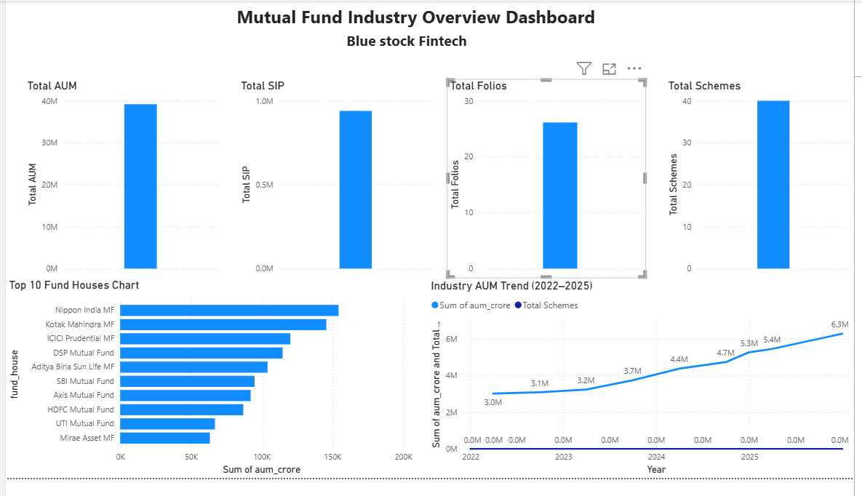
Page 2: Fund Performance
Visuals:
- Return vs Risk Scatter Plot
- Fund Scorecard
- Benchmark Comparison
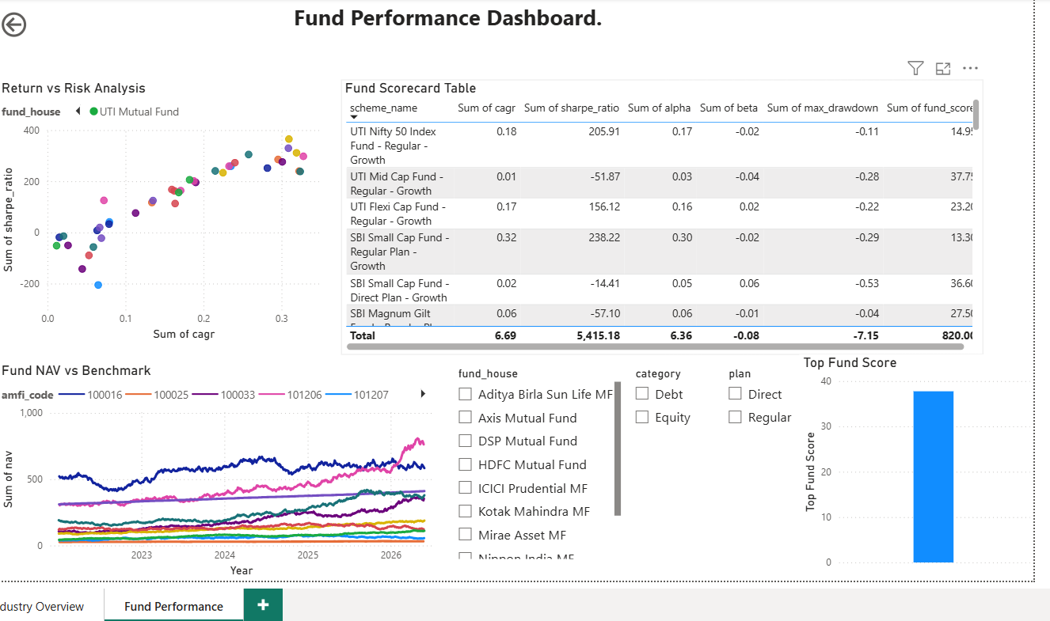
Page 3: Investor Analytics
Visuals:
- State-wise investments
- Age group analysis
- Transaction type distribution
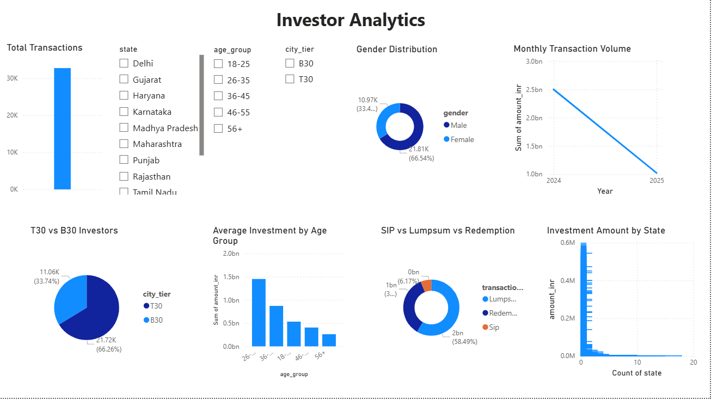
Page 4: SIP & Market Trends
Visuals:
- SIP vs Nifty
- Category heatmaps
- SIP growth KPIs
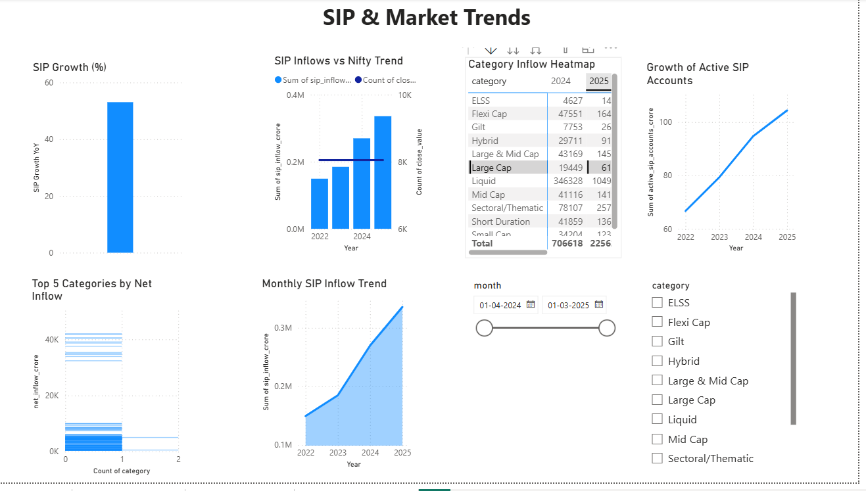

12. Key Findings
- SBI Mutual Fund maintained industry-leading AUM.
- Equity funds dominated investor preference.
- SIP inflows increased steadily from 2022–2025.
- December 2025 recorded all-time high SIP inflows.
- Younger investors represented the largest investment segment.
- UPI emerged as the preferred payment method.
- Diversified portfolios showed lower concentration risk.
- Risk-adjusted returns varied significantly across schemes.
- Fund performance strongly correlated within categories.
- Investor participation continued expanding across regions.

13. Recommendations
- Investors should prioritize funds with higher Sharpe Ratios.
- Portfolio diversification should be monitored regularly.
- SIP continuity programs should target at-risk investors.
- Fund houses should expand outreach in B30 cities.
- Risk metrics should complement return-based evaluations.

14. Limitations
- Synthetic datasets used.
- No real-time market integration.
- Recommendation engine uses rule-based logic.
- External macroeconomic variables excluded.

15. Future Enhancements
Potential improvements include:
- Machine learning fund recommendations.
- Real-time NAV integration via APIs.
- Predictive performance forecasting.
- Cloud deployment.
- Automated reporting pipelines.

16. Conclusion
The Mutual Fund Analytics Platform successfully demonstrates the application of data analytics, financial modeling, and business intelligence techniques in the mutual fund industry. Through ETL pipelines, database design, advanced analytics, and dashboard visualization, the project provides a robust foundation for investment analysis and decision-making. The solution delivers meaningful insights into fund performance, investor behavior, portfolio diversification, and industry growth trends while showcasing practical skills in Python, SQL, Power BI, and data engineering.

