**Code2Diagram comparison with Draw.IO**

1. Draw.io now known as app.diagrams.net is excellent online drawing tool for architecture diagram

2. simple drag and drop options with various latest technologies including AWS, Azure, GCP, Kubernetes etc

3. Both has its own advantages, but for quick and user friendly app.diagrams.net is at top.

3. Same AWS – Clustered webservice diagram created using apps.diagrams.net (<https://app.diagrams.net> )

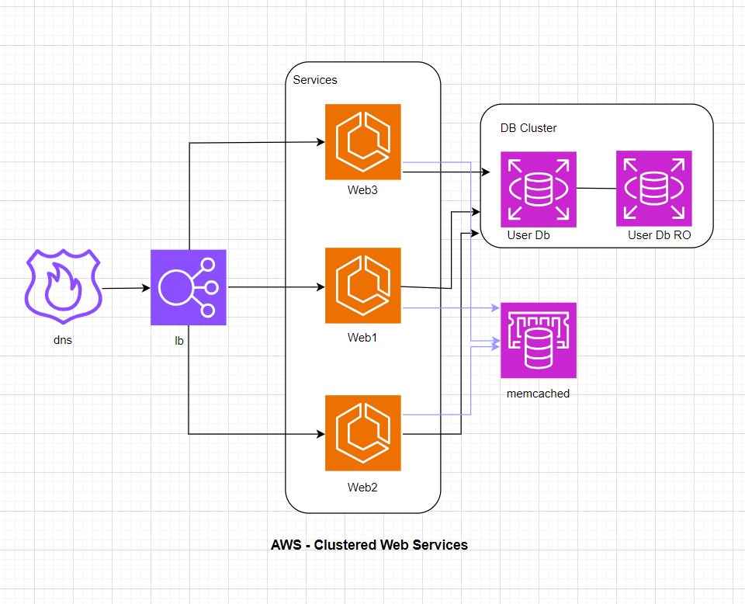

4. Did save above file in xml format as below

|  |
| --- |
| <?xml version="1.0" encoding="UTF-8"?>  <mxfile host="Electron" modified="2023-12-13T22:19:03.722Z" agent="Mozilla/5.0 (Windows NT 10.0; Win64; x64) AppleWebKit/537.36 (KHTML, like Gecko) draw.io/22.1.2 Chrome/114.0.5735.289 Electron/25.9.4 Safari/537.36" etag="ILJkOQNo4ft2CJpO5X8E" version="22.1.2" type="device">  <diagram name="Page-1" id="cJJ_JDOKCapy0wbAYn9Q">  <mxGraphModel dx="1278" dy="746" grid="1" gridSize="10" guides="1" tooltips="1" connect="1" arrows="1" fold="1" page="1" pageScale="1" pageWidth="850" pageHeight="1100" math="0" shadow="0">  <root>  <mxCell id="0" />  <mxCell id="1" parent="0" />  <mxCell id="CGFZlGt8bTxQuPZLs0Rw-14" value="" style="rounded=1;whiteSpace=wrap;html=1;" parent="1" vertex="1">  <mxGeometry x="540" y="220" width="240" height="148" as="geometry" />  </mxCell>  <mxCell id="CGFZlGt8bTxQuPZLs0Rw-12" value="" style="rounded=1;whiteSpace=wrap;html=1;rotation=90;" parent="1" vertex="1">  <mxGeometry x="186.5" y="329" width="465" height="160" as="geometry" />  </mxCell>  <mxCell id="CGFZlGt8bTxQuPZLs0Rw-1" value="" style="sketch=0;outlineConnect=0;fontColor=#232F3E;gradientColor=none;fillColor=#8C4FFF;strokeColor=none;dashed=0;verticalLabelPosition=bottom;verticalAlign=top;align=center;html=1;fontSize=12;fontStyle=0;aspect=fixed;pointerEvents=1;shape=mxgraph.aws4.route_53_resolver_dns_firewall;" parent="1" vertex="1">  <mxGeometry x="70" y="368" width="80" height="80" as="geometry" />  </mxCell>  <mxCell id="CGFZlGt8bTxQuPZLs0Rw-3" value="" style="sketch=0;points=[[0,0,0],[0.25,0,0],[0.5,0,0],[0.75,0,0],[1,0,0],[0,1,0],[0.25,1,0],[0.5,1,0],[0.75,1,0],[1,1,0],[0,0.25,0],[0,0.5,0],[0,0.75,0],[1,0.25,0],[1,0.5,0],[1,0.75,0]];outlineConnect=0;fontColor=#232F3E;fillColor=#ED7100;strokeColor=#ffffff;dashed=0;verticalLabelPosition=bottom;verticalAlign=top;align=center;html=1;fontSize=12;fontStyle=0;aspect=fixed;shape=mxgraph.aws4.resourceIcon;resIcon=mxgraph.aws4.ecs;" parent="1" vertex="1">  <mxGeometry x="380" y="220" width="78" height="78" as="geometry" />  </mxCell>  <mxCell id="CGFZlGt8bTxQuPZLs0Rw-4" value="" style="sketch=0;points=[[0,0,0],[0.25,0,0],[0.5,0,0],[0.75,0,0],[1,0,0],[0,1,0],[0.25,1,0],[0.5,1,0],[0.75,1,0],[1,1,0],[0,0.25,0],[0,0.5,0],[0,0.75,0],[1,0.25,0],[1,0.5,0],[1,0.75,0]];outlineConnect=0;fontColor=#232F3E;fillColor=#ED7100;strokeColor=#ffffff;dashed=0;verticalLabelPosition=bottom;verticalAlign=top;align=center;html=1;fontSize=12;fontStyle=0;aspect=fixed;shape=mxgraph.aws4.resourceIcon;resIcon=mxgraph.aws4.ecs;" parent="1" vertex="1">  <mxGeometry x="380" y="368" width="78" height="78" as="geometry" />  </mxCell>  <mxCell id="CGFZlGt8bTxQuPZLs0Rw-5" value="" style="sketch=0;points=[[0,0,0],[0.25,0,0],[0.5,0,0],[0.75,0,0],[1,0,0],[0,1,0],[0.25,1,0],[0.5,1,0],[0.75,1,0],[1,1,0],[0,0.25,0],[0,0.5,0],[0,0.75,0],[1,0.25,0],[1,0.5,0],[1,0.75,0]];outlineConnect=0;fontColor=#232F3E;fillColor=#ED7100;strokeColor=#ffffff;dashed=0;verticalLabelPosition=bottom;verticalAlign=top;align=center;html=1;fontSize=12;fontStyle=0;aspect=fixed;shape=mxgraph.aws4.resourceIcon;resIcon=mxgraph.aws4.ecs;" parent="1" vertex="1">  <mxGeometry x="380" y="520" width="78" height="78" as="geometry" />  </mxCell>  <mxCell id="CGFZlGt8bTxQuPZLs0Rw-6" value="" style="sketch=0;points=[[0,0,0],[0.25,0,0],[0.5,0,0],[0.75,0,0],[1,0,0],[0,1,0],[0.25,1,0],[0.5,1,0],[0.75,1,0],[1,1,0],[0,0.25,0],[0,0.5,0],[0,0.75,0],[1,0.25,0],[1,0.5,0],[1,0.75,0]];outlineConnect=0;fontColor=#232F3E;fillColor=#8C4FFF;strokeColor=#ffffff;dashed=0;verticalLabelPosition=bottom;verticalAlign=top;align=center;html=1;fontSize=12;fontStyle=0;aspect=fixed;shape=mxgraph.aws4.resourceIcon;resIcon=mxgraph.aws4.elastic_load_balancing;" parent="1" vertex="1">  <mxGeometry x="200" y="370" width="78" height="78" as="geometry" />  </mxCell>  <mxCell id="CGFZlGt8bTxQuPZLs0Rw-7" value="" style="sketch=0;points=[[0,0,0],[0.25,0,0],[0.5,0,0],[0.75,0,0],[1,0,0],[0,1,0],[0.25,1,0],[0.5,1,0],[0.75,1,0],[1,1,0],[0,0.25,0],[0,0.5,0],[0,0.75,0],[1,0.25,0],[1,0.5,0],[1,0.75,0]];outlineConnect=0;fontColor=#232F3E;fillColor=#C925D1;strokeColor=#ffffff;dashed=0;verticalLabelPosition=bottom;verticalAlign=top;align=center;html=1;fontSize=12;fontStyle=0;aspect=fixed;shape=mxgraph.aws4.resourceIcon;resIcon=mxgraph.aws4.elasticache;" parent="1" vertex="1">  <mxGeometry x="561" y="424.5" width="78" height="78" as="geometry" />  </mxCell>  <mxCell id="CGFZlGt8bTxQuPZLs0Rw-8" value="" style="sketch=0;points=[[0,0,0],[0.25,0,0],[0.5,0,0],[0.75,0,0],[1,0,0],[0,1,0],[0.25,1,0],[0.5,1,0],[0.75,1,0],[1,1,0],[0,0.25,0],[0,0.5,0],[0,0.75,0],[1,0.25,0],[1,0.5,0],[1,0.75,0]];outlineConnect=0;fontColor=#232F3E;fillColor=#C925D1;strokeColor=#ffffff;dashed=0;verticalLabelPosition=bottom;verticalAlign=top;align=center;html=1;fontSize=12;fontStyle=0;aspect=fixed;shape=mxgraph.aws4.resourceIcon;resIcon=mxgraph.aws4.rds;" parent="1" vertex="1">  <mxGeometry x="561" y="269" width="78" height="78" as="geometry" />  </mxCell>  <mxCell id="CGFZlGt8bTxQuPZLs0Rw-9" value="" style="sketch=0;points=[[0,0,0],[0.25,0,0],[0.5,0,0],[0.75,0,0],[1,0,0],[0,1,0],[0.25,1,0],[0.5,1,0],[0.75,1,0],[1,1,0],[0,0.25,0],[0,0.5,0],[0,0.75,0],[1,0.25,0],[1,0.5,0],[1,0.75,0]];outlineConnect=0;fontColor=#232F3E;fillColor=#C925D1;strokeColor=#ffffff;dashed=0;verticalLabelPosition=bottom;verticalAlign=top;align=center;html=1;fontSize=12;fontStyle=0;aspect=fixed;shape=mxgraph.aws4.resourceIcon;resIcon=mxgraph.aws4.rds;" parent="1" vertex="1">  <mxGeometry x="680" y="268" width="78" height="78" as="geometry" />  </mxCell>  <mxCell id="75nrew8zYTis-OmsZ6d_-13" value="" style="endArrow=classic;html=1;rounded=0;" edge="1" parent="1" target="CGFZlGt8bTxQuPZLs0Rw-6">  <mxGeometry width="50" height="50" relative="1" as="geometry">  <mxPoint x="150" y="410" as="sourcePoint" />  <mxPoint x="200" y="360" as="targetPoint" />  </mxGeometry>  </mxCell>  <mxCell id="75nrew8zYTis-OmsZ6d_-14" value="" style="endArrow=classic;html=1;rounded=0;entryX=0.499;entryY=0.744;entryDx=0;entryDy=0;entryPerimeter=0;" edge="1" parent="1" target="CGFZlGt8bTxQuPZLs0Rw-12">  <mxGeometry width="50" height="50" relative="1" as="geometry">  <mxPoint x="280" y="408.5" as="sourcePoint" />  <mxPoint x="330" y="407.5" as="targetPoint" />  </mxGeometry>  </mxCell>  <mxCell id="75nrew8zYTis-OmsZ6d_-17" value="" style="endArrow=classic;html=1;rounded=0;exitX=0.5;exitY=1;exitDx=0;exitDy=0;exitPerimeter=0;" edge="1" parent="1" source="CGFZlGt8bTxQuPZLs0Rw-6">  <mxGeometry width="50" height="50" relative="1" as="geometry">  <mxPoint x="330" y="610" as="sourcePoint" />  <mxPoint x="380" y="560" as="targetPoint" />  <Array as="points">  <mxPoint x="239" y="560" />  </Array>  </mxGeometry>  </mxCell>  <mxCell id="75nrew8zYTis-OmsZ6d_-21" value="" style="endArrow=classic;html=1;rounded=0;entryX=0;entryY=0.5;entryDx=0;entryDy=0;entryPerimeter=0;" edge="1" parent="1" target="CGFZlGt8bTxQuPZLs0Rw-3">  <mxGeometry width="50" height="50" relative="1" as="geometry">  <mxPoint x="240" y="370" as="sourcePoint" />  <mxPoint x="290" y="320" as="targetPoint" />  <Array as="points">  <mxPoint x="240" y="260" />  </Array>  </mxGeometry>  </mxCell>  <mxCell id="75nrew8zYTis-OmsZ6d_-22" value="lb" style="text;html=1;strokeColor=none;fillColor=none;align=center;verticalAlign=middle;whiteSpace=wrap;rounded=0;" vertex="1" parent="1">  <mxGeometry x="200" y="449" width="60" height="30" as="geometry" />  </mxCell>  <mxCell id="75nrew8zYTis-OmsZ6d_-23" value="dns" style="text;html=1;strokeColor=none;fillColor=none;align=center;verticalAlign=middle;whiteSpace=wrap;rounded=0;" vertex="1" parent="1">  <mxGeometry x="80" y="448" width="60" height="30" as="geometry" />  </mxCell>  <mxCell id="75nrew8zYTis-OmsZ6d_-26" value="" style="endArrow=classic;html=1;rounded=0;entryX=0.042;entryY=0.473;entryDx=0;entryDy=0;entryPerimeter=0;" edge="1" parent="1" target="CGFZlGt8bTxQuPZLs0Rw-14">  <mxGeometry width="50" height="50" relative="1" as="geometry">  <mxPoint x="460" y="290" as="sourcePoint" />  <mxPoint x="510" y="240" as="targetPoint" />  </mxGeometry>  </mxCell>  <mxCell id="75nrew8zYTis-OmsZ6d_-27" value="" style="endArrow=classic;html=1;rounded=0;entryX=0;entryY=0.75;entryDx=0;entryDy=0;" edge="1" parent="1" target="CGFZlGt8bTxQuPZLs0Rw-14">  <mxGeometry width="50" height="50" relative="1" as="geometry">  <mxPoint x="458" y="408" as="sourcePoint" />  <mxPoint x="508" y="358" as="targetPoint" />  <Array as="points">  <mxPoint x="510" y="410" />  <mxPoint x="510" y="331" />  </Array>  </mxGeometry>  </mxCell>  <mxCell id="75nrew8zYTis-OmsZ6d_-32" value="Services" style="text;html=1;strokeColor=none;fillColor=none;align=center;verticalAlign=middle;whiteSpace=wrap;rounded=0;" vertex="1" parent="1">  <mxGeometry x="340" y="180" width="60" height="30" as="geometry" />  </mxCell>  <mxCell id="75nrew8zYTis-OmsZ6d_-33" value="Web3" style="text;html=1;strokeColor=none;fillColor=none;align=center;verticalAlign=middle;whiteSpace=wrap;rounded=0;" vertex="1" parent="1">  <mxGeometry x="389" y="294" width="60" height="30" as="geometry" />  </mxCell>  <mxCell id="75nrew8zYTis-OmsZ6d_-34" value="Web1" style="text;html=1;strokeColor=none;fillColor=none;align=center;verticalAlign=middle;whiteSpace=wrap;rounded=0;" vertex="1" parent="1">  <mxGeometry x="389" y="446" width="60" height="30" as="geometry" />  </mxCell>  <mxCell id="75nrew8zYTis-OmsZ6d_-36" value="Web2" style="text;html=1;strokeColor=none;fillColor=none;align=center;verticalAlign=middle;whiteSpace=wrap;rounded=0;" vertex="1" parent="1">  <mxGeometry x="389" y="600" width="60" height="30" as="geometry" />  </mxCell>  <mxCell id="75nrew8zYTis-OmsZ6d_-37" value="" style="endArrow=classic;html=1;rounded=0;entryX=-0.005;entryY=0.899;entryDx=0;entryDy=0;entryPerimeter=0;" edge="1" parent="1" target="CGFZlGt8bTxQuPZLs0Rw-14">  <mxGeometry width="50" height="50" relative="1" as="geometry">  <mxPoint x="460" y="560" as="sourcePoint" />  <mxPoint x="510" y="510" as="targetPoint" />  <Array as="points">  <mxPoint x="520" y="560" />  <mxPoint x="520" y="353" />  </Array>  </mxGeometry>  </mxCell>  <mxCell id="75nrew8zYTis-OmsZ6d_-38" value="" style="endArrow=classic;html=1;rounded=0;fillColor=#EA6B66;strokeColor=#9999FF;" edge="1" parent="1" target="CGFZlGt8bTxQuPZLs0Rw-7">  <mxGeometry width="50" height="50" relative="1" as="geometry">  <mxPoint x="460" y="280" as="sourcePoint" />  <mxPoint x="560" y="470" as="targetPoint" />  <Array as="points">  <mxPoint x="530" y="280" />  <mxPoint x="530" y="380" />  <mxPoint x="530" y="464" />  </Array>  </mxGeometry>  </mxCell>  <mxCell id="75nrew8zYTis-OmsZ6d_-41" value="" style="endArrow=classic;html=1;rounded=0;strokeColor=#9999FF;" edge="1" parent="1">  <mxGeometry width="50" height="50" relative="1" as="geometry">  <mxPoint x="460" y="540" as="sourcePoint" />  <mxPoint x="560" y="470" as="targetPoint" />  <Array as="points">  <mxPoint x="530" y="540" />  <mxPoint x="530" y="470" />  </Array>  </mxGeometry>  </mxCell>  <mxCell id="75nrew8zYTis-OmsZ6d_-45" value="" style="endArrow=classic;html=1;rounded=0;strokeColor=#9999FF;" edge="1" parent="1">  <mxGeometry width="50" height="50" relative="1" as="geometry">  <mxPoint x="460" y="430" as="sourcePoint" />  <mxPoint x="560" y="430" as="targetPoint" />  </mxGeometry>  </mxCell>  <mxCell id="75nrew8zYTis-OmsZ6d_-46" value="&lt;font style=&quot;font-size: 14px;&quot;&gt;&lt;b&gt;AWS - Clustered Web Services&lt;/b&gt;&lt;/font&gt;" style="text;html=1;strokeColor=none;fillColor=none;align=center;verticalAlign=middle;whiteSpace=wrap;rounded=0;" vertex="1" parent="1">  <mxGeometry x="291" y="660" width="270" height="30" as="geometry" />  </mxCell>  <mxCell id="75nrew8zYTis-OmsZ6d_-47" value="memcached" style="text;html=1;strokeColor=none;fillColor=none;align=center;verticalAlign=middle;whiteSpace=wrap;rounded=0;" vertex="1" parent="1">  <mxGeometry x="570" y="502.5" width="60" height="30" as="geometry" />  </mxCell>  <mxCell id="75nrew8zYTis-OmsZ6d_-48" value="DB Cluster" style="text;html=1;strokeColor=none;fillColor=none;align=center;verticalAlign=middle;whiteSpace=wrap;rounded=0;" vertex="1" parent="1">  <mxGeometry x="550" y="230" width="80" height="30" as="geometry" />  </mxCell>  <mxCell id="75nrew8zYTis-OmsZ6d_-54" value="" style="endArrow=none;html=1;rounded=0;" edge="1" parent="1">  <mxGeometry width="50" height="50" relative="1" as="geometry">  <mxPoint x="639" y="306.5" as="sourcePoint" />  <mxPoint x="680" y="307" as="targetPoint" />  </mxGeometry>  </mxCell>  <mxCell id="75nrew8zYTis-OmsZ6d_-56" value="User Db" style="text;html=1;strokeColor=none;fillColor=none;align=center;verticalAlign=middle;whiteSpace=wrap;rounded=0;" vertex="1" parent="1">  <mxGeometry x="560" y="340" width="60" height="30" as="geometry" />  </mxCell>  <mxCell id="75nrew8zYTis-OmsZ6d_-57" value="User Db RO" style="text;html=1;strokeColor=none;fillColor=none;align=center;verticalAlign=middle;whiteSpace=wrap;rounded=0;" vertex="1" parent="1">  <mxGeometry x="680" y="340" width="90" height="30" as="geometry" />  </mxCell>  </root>  </mxGraphModel>  </diagram>  </mxfile> |