Network => group of interconnected systems
Networking => how communication happens in the group of interconnected systems

Networking terminology
Ip => Internet Protocol => what is the usecase of ip address
Mac =>
Router
Switch => hardware
Hub =>
Latency
Access point
Bandwidth

Network categories => Ranges
PAN => personal area network -> 10m
Lan => Local area network => wired, upto 1km
Can => Campus Area network (CAN) => ranges upto 4 -5 km
Man => Metropolitan Area network (MAN) => ranges 5 to 50km [ eg: cable tv ]
Wan => Wide area network => global

Network model
Client – server
Peer to peer
Centralized model

Topology => layout
Network topology => it’s a physical or logical arrangement of devices
Types => physical and logical

Physical topology
Bus
Ring
Star
Mesh

Logical topology
Logical bus => physically as star topology but logically working as bus topology
Logical star => physically bus topology but works as star topology

Data transmission methods
- Simplex => data travels in only one direction ,, eg: cable tv
- Half-duplex => data travles in both directions,but only one at a time , Eg: walkie-talkie
- Full-duplex => data travels in both directions simultaneously , ex: phone calls
Media access methods (traffic rules )
CSMA/CD (Carrier sense Multiple Access with Collision Detection) - Wired medium
CSMA/CA (collision avoidance) -> wireless medium
Token passing => legacy method

Signalling method
1s and 0s
Baseband => the entire bandwidth of the cable is used to transmist a single digital signal
Broadband => the bandwidth is split into multiple, distinct frequency

Network media and hardware
Bounded network media (guided media) – wired
Twisted pair cable (Ethernet) => copper wries are twisted
Coaxial cable => central copper core surrounded by metal shied
Fiber optic cable => light , thin-hair like cable

Unbounded network media (Unguided medium)
Means the data travels freely through the air or space

Radio waves (Wi-fi , Bluetooth) => travel in all direction , penetrate walls
Microwaves (Satellite, cell Towers) => travels in straight line ,
Infrared => very short-range communication , strict line of sight , do not penetrate

Noise control (for handle Interference) => Electromagnetic Interference (EMI) or Noise

How we control it :
Twisting the wires
Shielding
Light

Network connectivity devices (Hardware)
Hub
Switch
Router

Ethernet Networks(wired)
Twiste pair copper (cat5e or cat 6) ending in RJ45 connectors
Reliaiblity
Speed & Realibility => full-duplex
Security => highly secure
Media access => mac address

Wireless Networks (Wi-Fi) – (unbounded medium)
Radio waves
Wireless Access Point (WAP)
Mobility
Interference & Speed
Security => WPA3 , WEP , WPA2
Media access => CSMA / CA

Network models
OSI model => Open Systems Interconnection
ISO => International Organization for Standardization -> 1984

OSI has 7 layers
Application layer => http, smtp, ftp
Presentation layer => data formatting , compresses , encryption => SSL (Secure socketlayer)
Session => create session between two devices -> API
Transport => breaks large data into smaller segments
Network => routing & ip address
Data link => (Mac address, switches)
Physical => converts data into electrical, light or radio waves

TCP/IP model
Application layer (combine layers 5, 6, 7)
Transport layer => three way handshake
Internet layer => layer 3
Network access layer (Combine layers 2, 1)

Types of Address In network
Ip address
Mac address
DNS => Domain name server

Ip address = >ISP
Ip types
Ipv4 => 192.168.1.0 => 4.3 billion (Decimal)
4 octet => 32 bits
1 octet = 8 bits

1 byte = 8 bits
1 bit = 0 or 1

Ipv6 => 128 bits => unlimited (Hexademical)

IPv4 | IPV6
Normal | Faster
Less security | High security
Need NAT | No need for NAT
Manual /DHCP | Auto configuration

Ip ranges = (0-255)

192.168.1.0
2^7 | 2^6 | 2^5 | 2^4 | 2^3 | 2^2 | 2^1 | 2^0
128 | 64 | 32 | 16 | 8 | 4 | 2 | 1

1100 0000. 1010 1000 . 0000 0001. 0000 0000

172.16.9.0
254.255.230.40
45.67.89.0
0.255.0.254
0.0.0.255
132.156.18.90

Ipv4 => 4 octet => 192.168.1.0 => 32 bits
1 octet = 8 bits

Ipv4 class
Class A => 0-127 => 1-126
Class B => 128-191
Class C => 192-223 => most common
Class D => 224 – 239 => Mulicast(many to many)
Class E => 240 – 255 => Research & Development

Hexadecimal -> ipv6 => 128 bits

1 to 16
10- A
11 – B
12 – C
13 -D
14-E
15-F

3F:5B:BB3 -> 315 : 511 :11113

Mac address => physical address => 48 bits
NIC => Network interface card
It has 12 hexa digit

6 digit => OUI (Organizally unique identifier)
6 digit => device unique
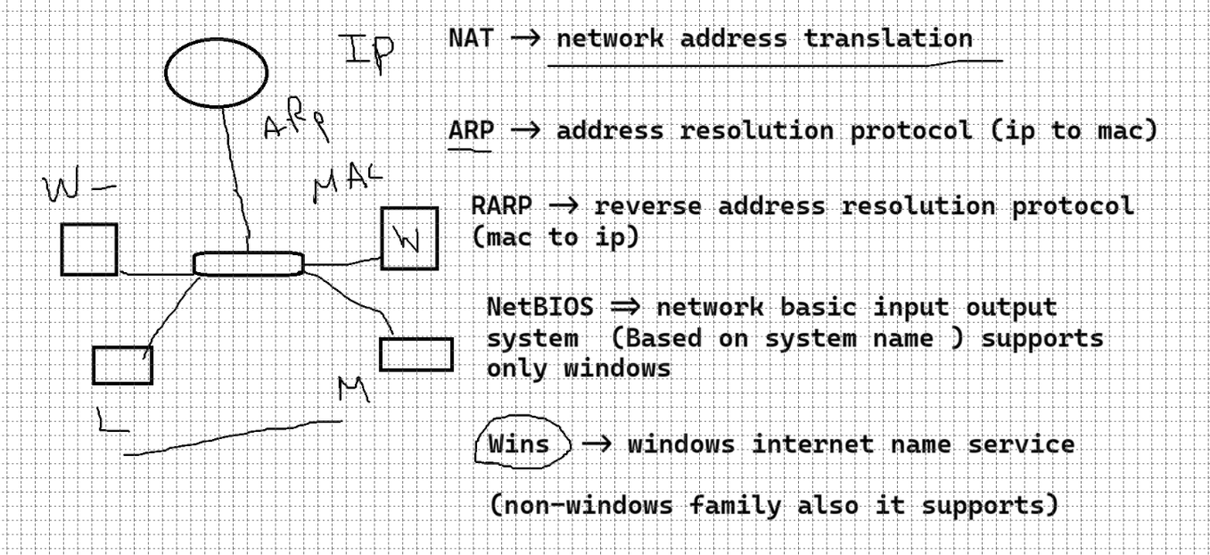

Subnetting => process of splitting into multiple smaller network

IP class | Subnet mask | Network formula | Host formula
Class A | N.H.H.H | N = (2^n) -2 | H = (2^H)-2
Class B | N.N.H.H | N = (2^n) | H = (2^H)-2
Class C | N.N.N.H | N = (2^n) | H = (2^H)-2

N => 8 bit => 256
H => 24 bit => 16777216

N => 16 bit => 65536
H => 16 bit => 65536

N => 24 bit => 16777216
H => 8 bit => 256

Subnetting
Classful subnetting => FLSM (Full length subnet mask)
Classless Subnetting => VLSM (Variable length subnet mask) (CIDR) (Classless inter-domain routing)

192.168.1.0 => class C
N.N.N.H
Network has fully 1 => 1111 1111 => 256
Subnet mask : 255.255.255.0

Inverse mask = Network range – subnet mask
255.255.255.255 - 255.255.255.0
Inverse mask => 0.0.0.255

Range = inverse mask + network id
0.0.0.255 + 192.168.1.0
Range => 192.168.1.255 (Broadcast)

Network id => 192.168.1.0
Broadcast => 192.168.1.255
Usable host ip => 192.168.1.1 to 192.168.1.254
H = (2^H) -2
= (2^8)-2 => 256 -2 => 254

172.16.0.0 => Class B => N.N.H.H
Subnet mask = 255.255.0.0

Inverse mask = network range – subnet mask
= 255.255.255.255 - 255.255.0.0
= 0.0.255.255

Ranges = IM + NI
0.0.255.255 + 172.16.0.0
Range = 172.16.255.255 (Broadcast)

Network id => 172.16.0.0
Broadcast => 172.16..255.255
Usable host ip => 172.16.0.1 to 172.16.255.254

H = (2^H) -2
H = (2^ 16 )-2
= 65536 -2 => 65534

2^7 | 2^6 | 2^5 | 2^4 | 2^3 | 2^2 | 2^1 | 2^0
128 | 64 | 32 | 16 | 8 | 4 | 2 | 1

1 = 128
2 = 192
3 = 224
4 = 240
5 = 248
6 = 252
7 = 254
8 = 255

VLSM (Variable length subnet mask )

172.16.0.0 required host = 100

2^7 = 128
2^ 8 = 256

Host = (2 ^ H) -2
= (2 ^ 7) -2 => 126

Network bit – no of host bit
= 32 – 7
= 25 // slash value

= 8.8.8.1
Subnet mask = 255.255.255.128

Inverse mask = network range – subnet mask
255.255.255.255 – 255.255.255.128
= 0.0.0.128
Range = IM + NI
= 0.0.0.128 + 172.16.0.0
= 172.16.0.128 (Broadcast)

Network id : 172.16.0.0
Broadcast id :172.16.0.128
Usable host ip : 172.16.0.1 to 172.16.0.127

192.168.1.0 => required host 50

CIDR => 192.168.0.0 / 16

Split => 8.8.0.0
Subnet mask = 255.255.0.0

IM = 0.0.255.255
Range = 192.168.255.255 (Broadcast)
Network id: 192.168.0.0
Boardcast : 192.168.255.255
Usable host ip : 192.168.0.1 to 192.168.255.254

Subnet problem
10.0.0.0 /8 => required subnet 4

Steps
- Separete the host bits
- Write a host bit place value left to right
- Based on requirement move a line

10 .
128 | 64 | 32 | 16 | 8 | 4 | 2 | 1
128 | 64 | 32 | 16 | 8 | 4 | 2 | 1
.
128 | 64 | 32 | 16 | 8 | 4 | 2 | 1

Lan infrastructure

Switching
Enable static routing
Dynamic routing
Virtual lans =>
Soho network (small office / Home office )

Wan infrastructure

Wan connectivity methods
Leased line (Dedicated) => high security, hight speed, very expensive, eg.. Banks use this
Packet Switching => cost-effective , MPLS
VPN => Virtual private network => remote worker (WFH)

VoIP => voice over IP
Microphone (Analog signal)
Converts your voice into digital 1s and 0s
Split into packets sent over the ip network (UDP)
Packets are reassembled into audio
SIP (Session initiation protocol) => this is a ringng phase
RTP (Real-time transport protocol)

Remote networking
Remote access Implementations
Client-site VPN => used for remote workers , a single laptop install a vpn client and connect
Site-to-site vpn => Chennai to Bangalore

System security
Firewall => config set of rules
IDS (Instruction Detection System)
IPS (instruction Prevention System)

Authentication vs authorization

Authentication (MFA) => authenticator app

Encryption methods
Symmetric Encryption (one key) (AES)
Asymmentric Encryption (Two keys) (RSA)
Public key
Private key

SSL/TLS => application layer (layer 7)

Network perimeter security

Firewall & ACL (Access control lists )
It checks source ip, destination ip and port number , either permits or denies the packet

DMZ (demilitarized zone )

