Procedure for ReadTheDoc Conversion

Step 1 : Clone the repository to your local machine.  
Step 2 : Download,Copy and Paste the doc folder and readthedocs.yaml file.  
 Folder Link: [Nexus-ReadTheDoc](https://gajanrapyutarobotics-my.sharepoint.com/:f:/g/personal/rajkumar_subbiaya-intern_rapyuta-robotics_com/Egc5Sp6gxOJBvkBsRofJ0y8BXnuzh1vfhYR26FN0jTapKw?email=Dinesh.Kumar%40rapyuta-robotics.com&e=x5oz0l)

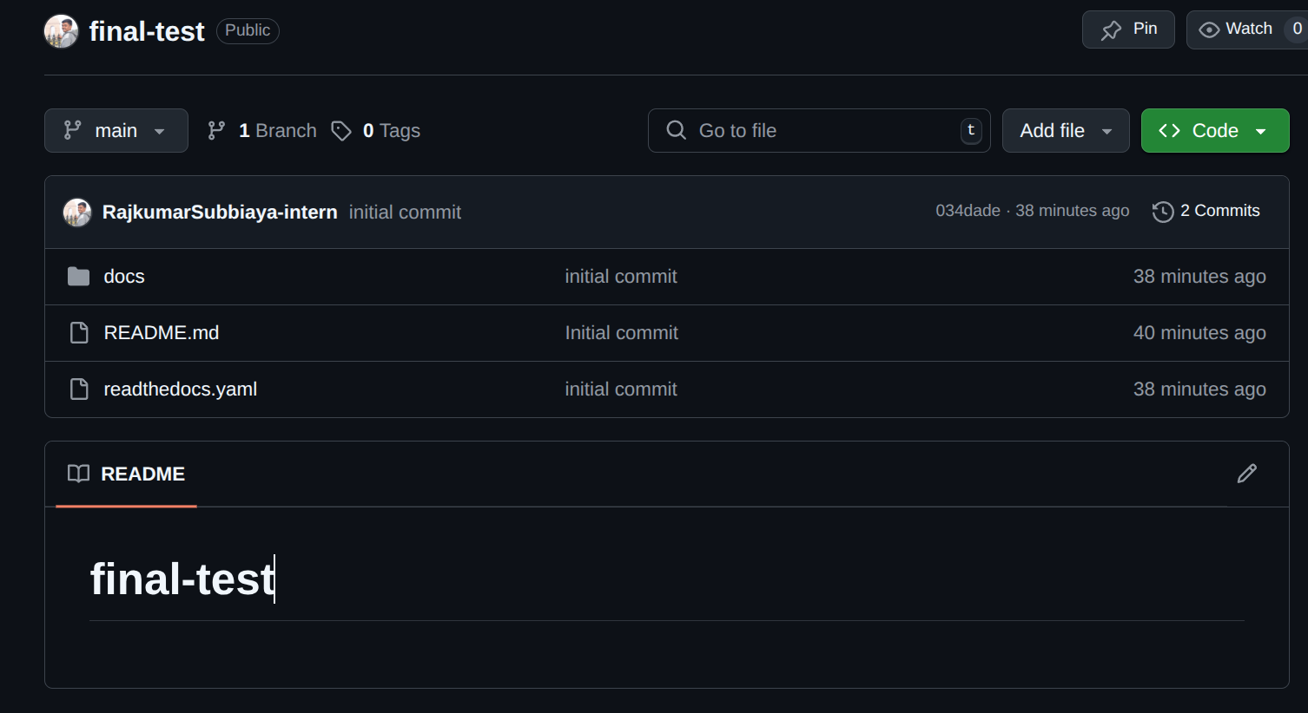

Step 3: Push the changes to GitHub.  
Step 4: Log in to Read the Docs: <https://app.readthedocs.org/dashboard/>

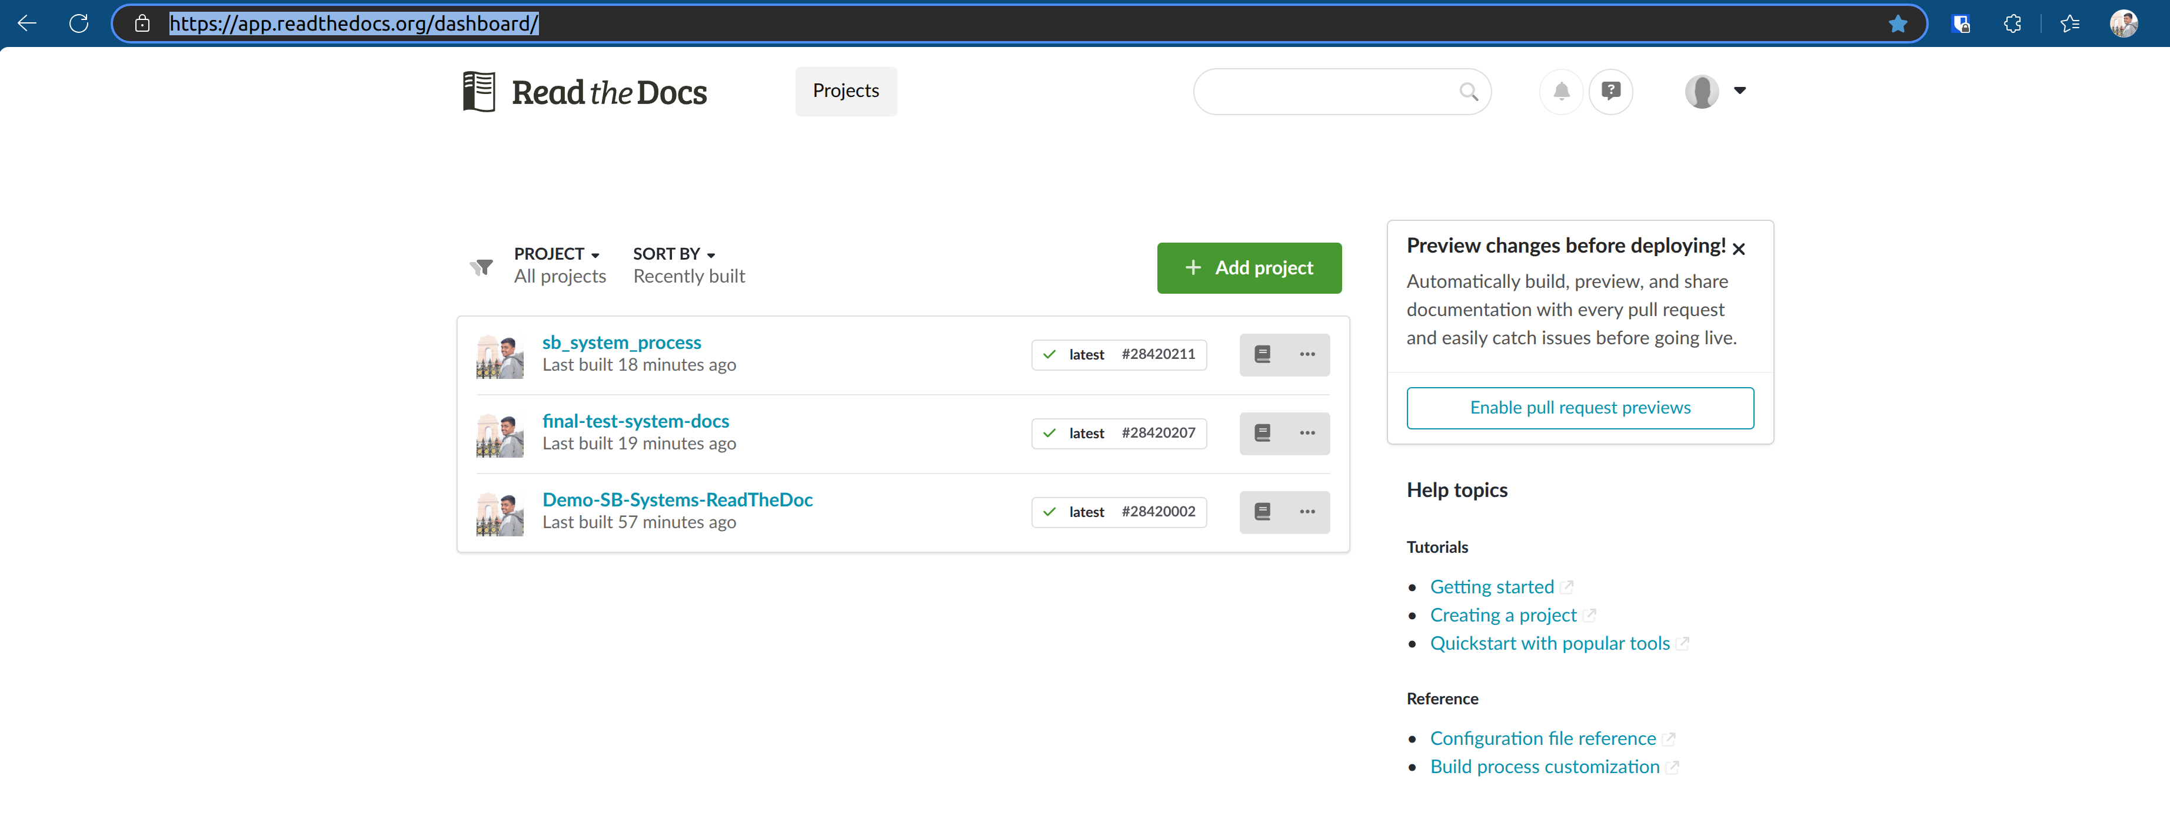

**Step 5:** Click on **“+ Add Project”**

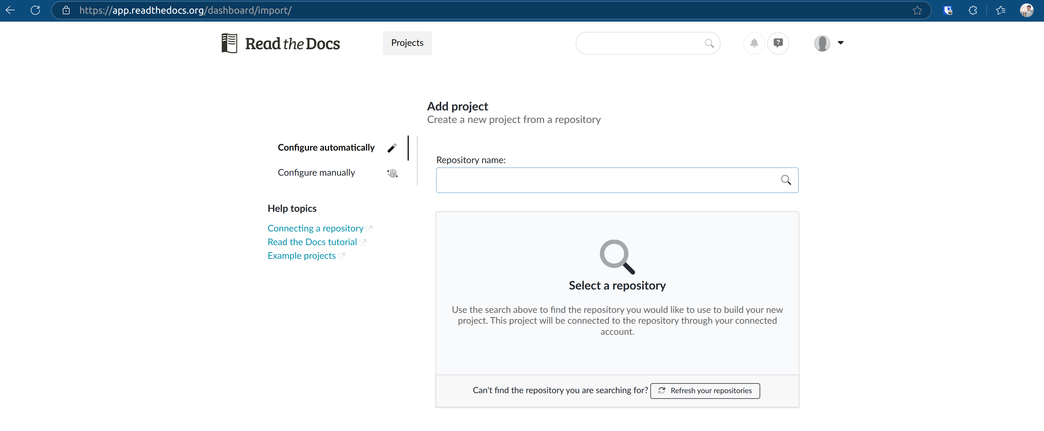

**Step 6:** Search for the repository name.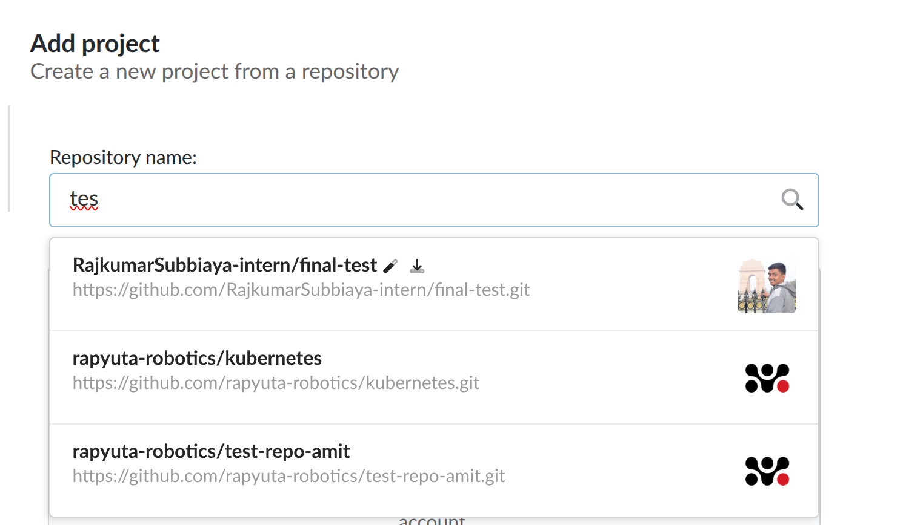

**Step 7:** Enter the name for the Read the Docs project.  
 **Note:** This name will be part of the project's URL.

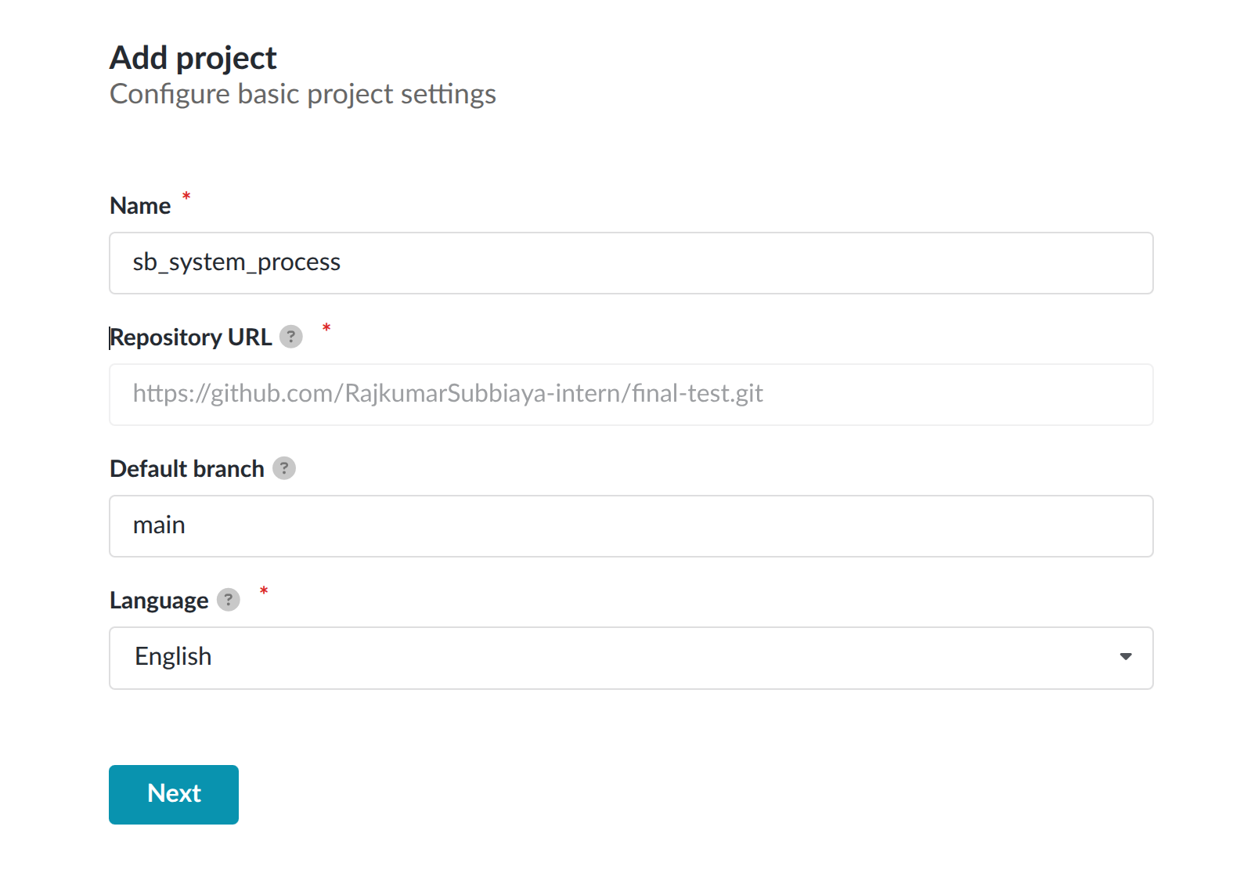

**Step 8:** **Start Build** to begin the documentation build process.

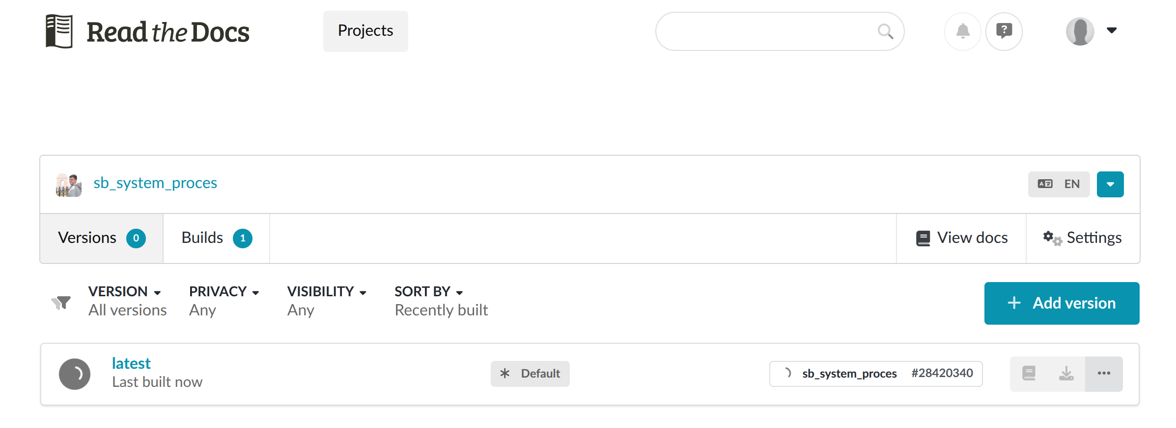

**Step 9:** Ensure the build completes successfully.

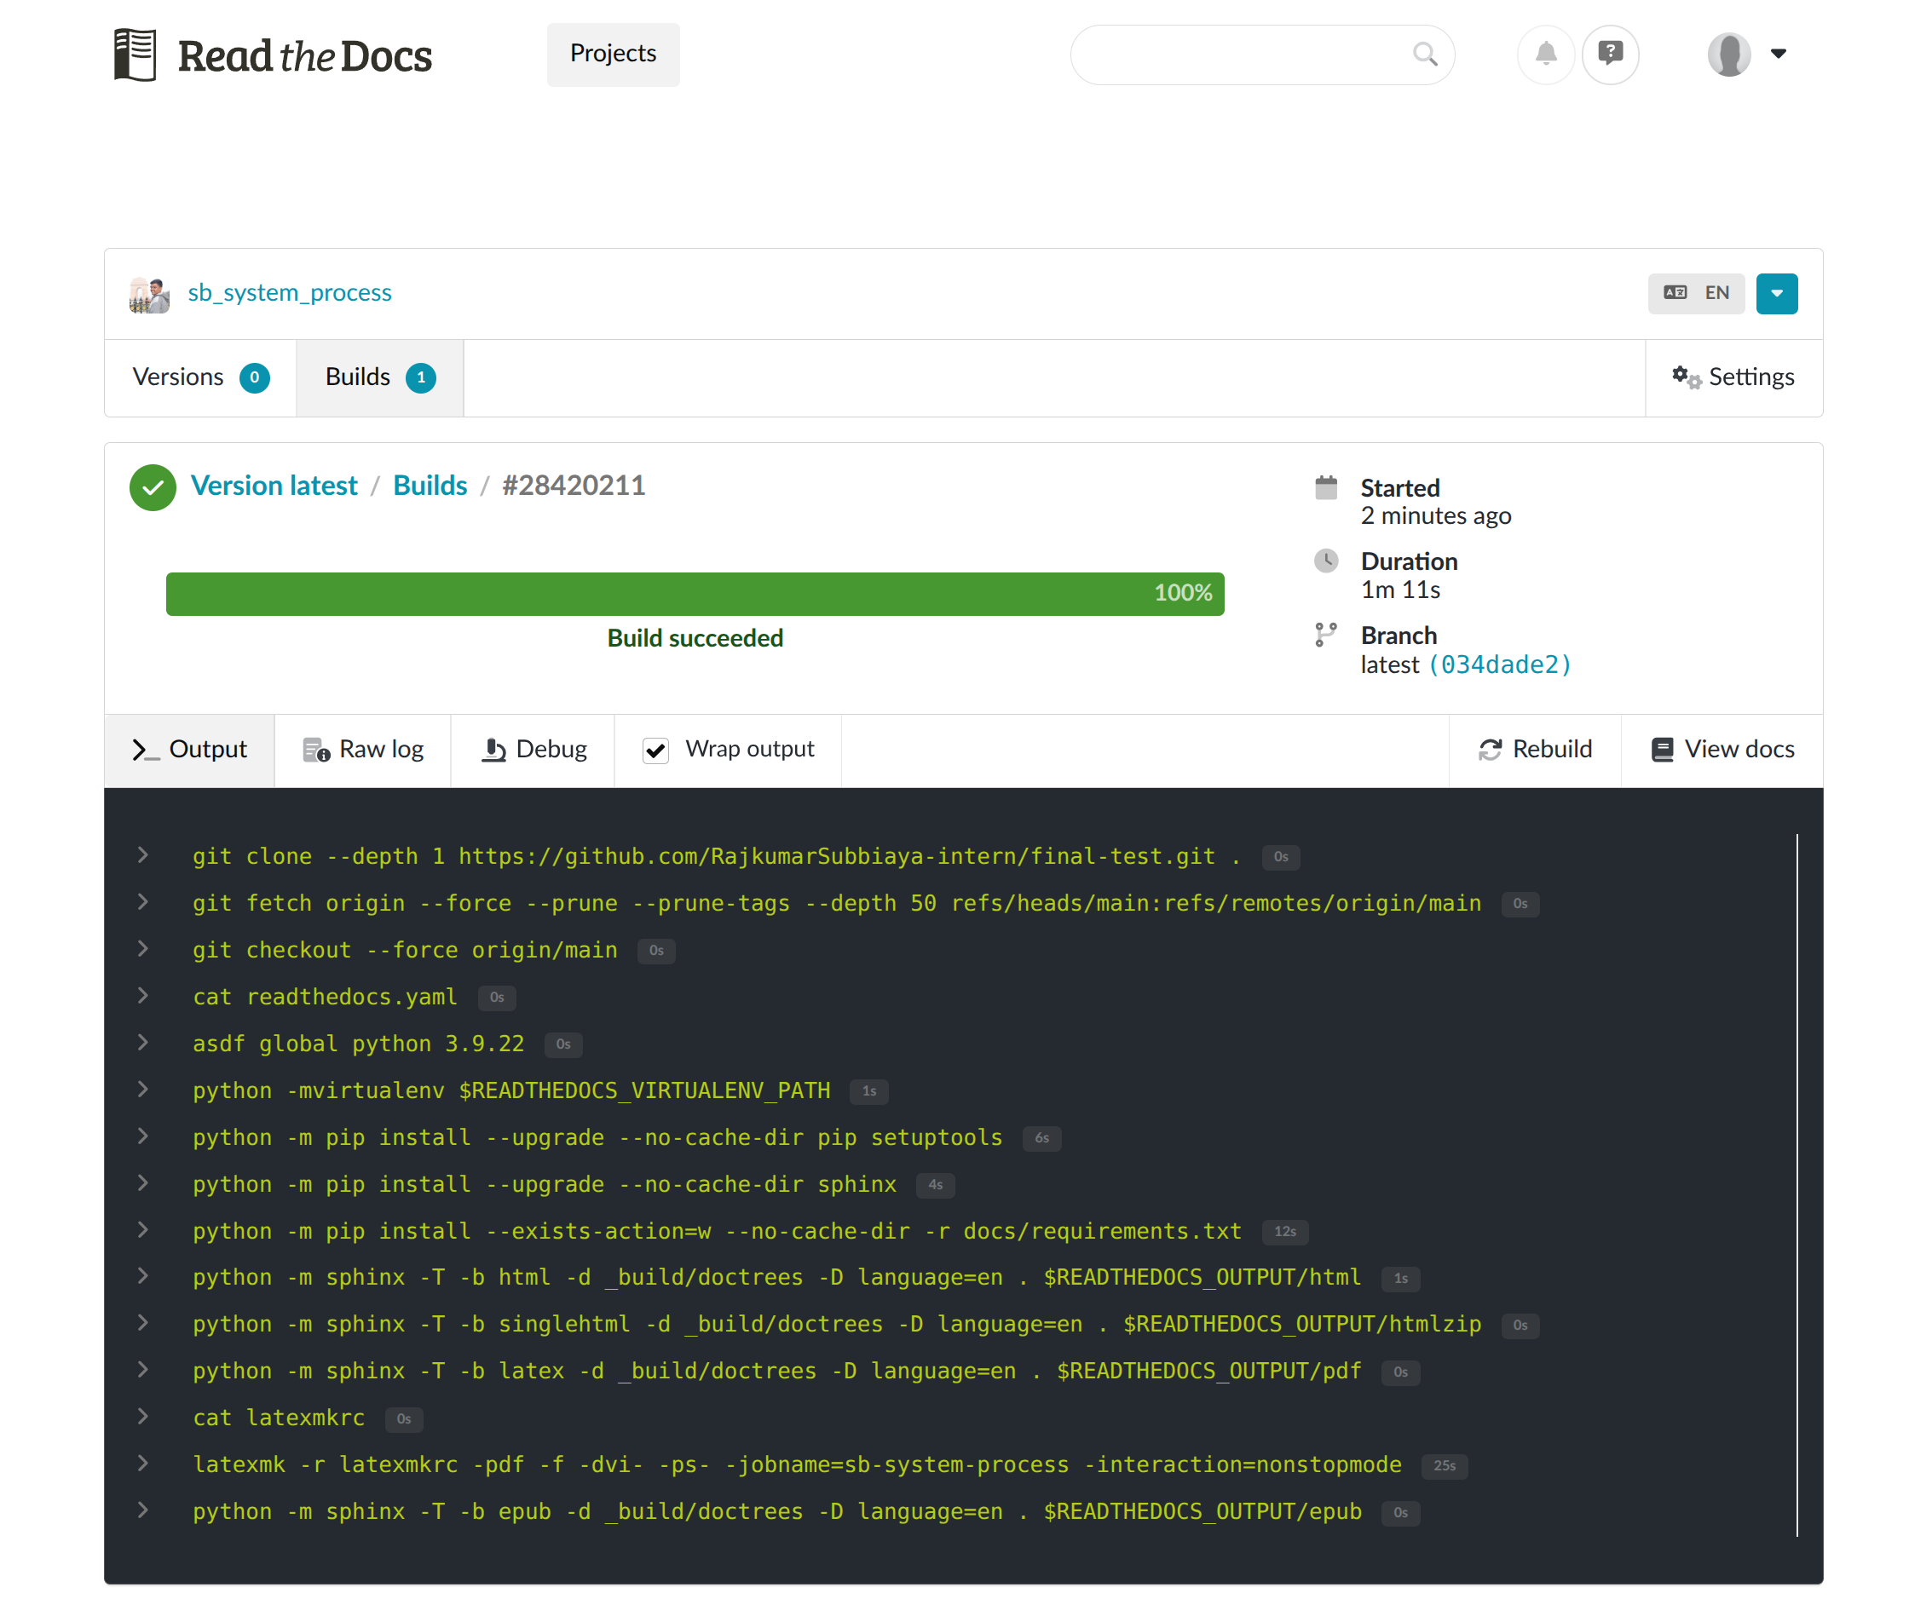

**More Reference :**

* [Rapyuta Document : Create/Import a New Project on Readthedocs](https://rr-docs.readthedocs-hosted.com/en/latest/howto/create_rtd_project.html)
* [Youtube : Host your documentation on ReadTheDocs : Step-by-step guide](https://youtu.be/PO4Zd-6a6fA?si=shA_q0qFi7gDEuh1)
* <https://sphinx-tutorial.readthedocs.io/start/>