24CYS401: SECURE SOFTWARE ENGINEERING LABORATORY
END SEMESTER EXAMINATION — FINAL COMPREHENSIVE REPORT
SYSTEM 23: AUTONOMOUS WAREHOUSE MANAGEMENT SYSTEM (AWMS)
A Cyber-Physical, Zero-Trust Warehouse Automation and Fleet Orchestration Platform
Academic Year 2025–2026 | Semester 7
EXECUTIVE AUDIT SUMMARY
• System: Autonomous Mobile Robot (AGV) Fleet Management & Inventory Allocation
• Security Standard: Zero-Trust Architecture, Role-Based Access Control (RBAC), and SHA-256 Chained Ledger
• Agile Governance: Atlassian Jira Cloud (105 work items, 6 Epics, 99 completed in 2 Sprints)
• Quality & Safety: 14/14 Pytest Suites Passed (100%), Bandit SAST 0 Vulnerabilities, 10 Production K8s Manifests
• Runtime Status: Operational Daemon on http://127.0.0.1:8080 with 10×10 Floor Grid & Hardware E-Stop

PHASE 1: PROJECT CHARTER, PROBLEM FORMULATION & SCOPE
Modern supply chains increasingly deploy fleets of Autonomous Guided Vehicles (AGVs) operating in shared physical spaces alongside human inventory pickers. While automated navigation and robotic tote handling drastically increase throughput, they introduce high-severity cyber-physical risk vectors: trajectory spoofing, unauthorized fleet overrides, inventory overselling caused by database race conditions, and log repudiation.
System 23 (Autonomous Warehouse Management System - AWMS) was engineered to resolve these challenges. The system provides deterministic inventory allocation, a fail-safe AGV state machine with hardware-level Emergency Stop (E-Stop), tamper-evident SHA-256 chained audit ledgers, and strict Role-Based Access Control (RBAC) across four operational personas: Customers, Inventory Operators, Warehouse Managers, and Compliance Auditors.

PHASE 2: AGILE PROJECT MANAGEMENT & SCRUM IMPLEMENTATION (JIRA)
AWMS was engineered using the Scrum agile methodology over two two-week sprints. The project was tracked in Atlassian Jira Cloud (rajkushal-warehouse.atlassian.net) under project key AWMS. The project backlog was structured into six Epics (EP-01 to EP-06) encompassing 105 issues (User Stories, Technical Tasks, Spikes, and Security Defects), with 99 completed upon Sprint 2 conclusion.
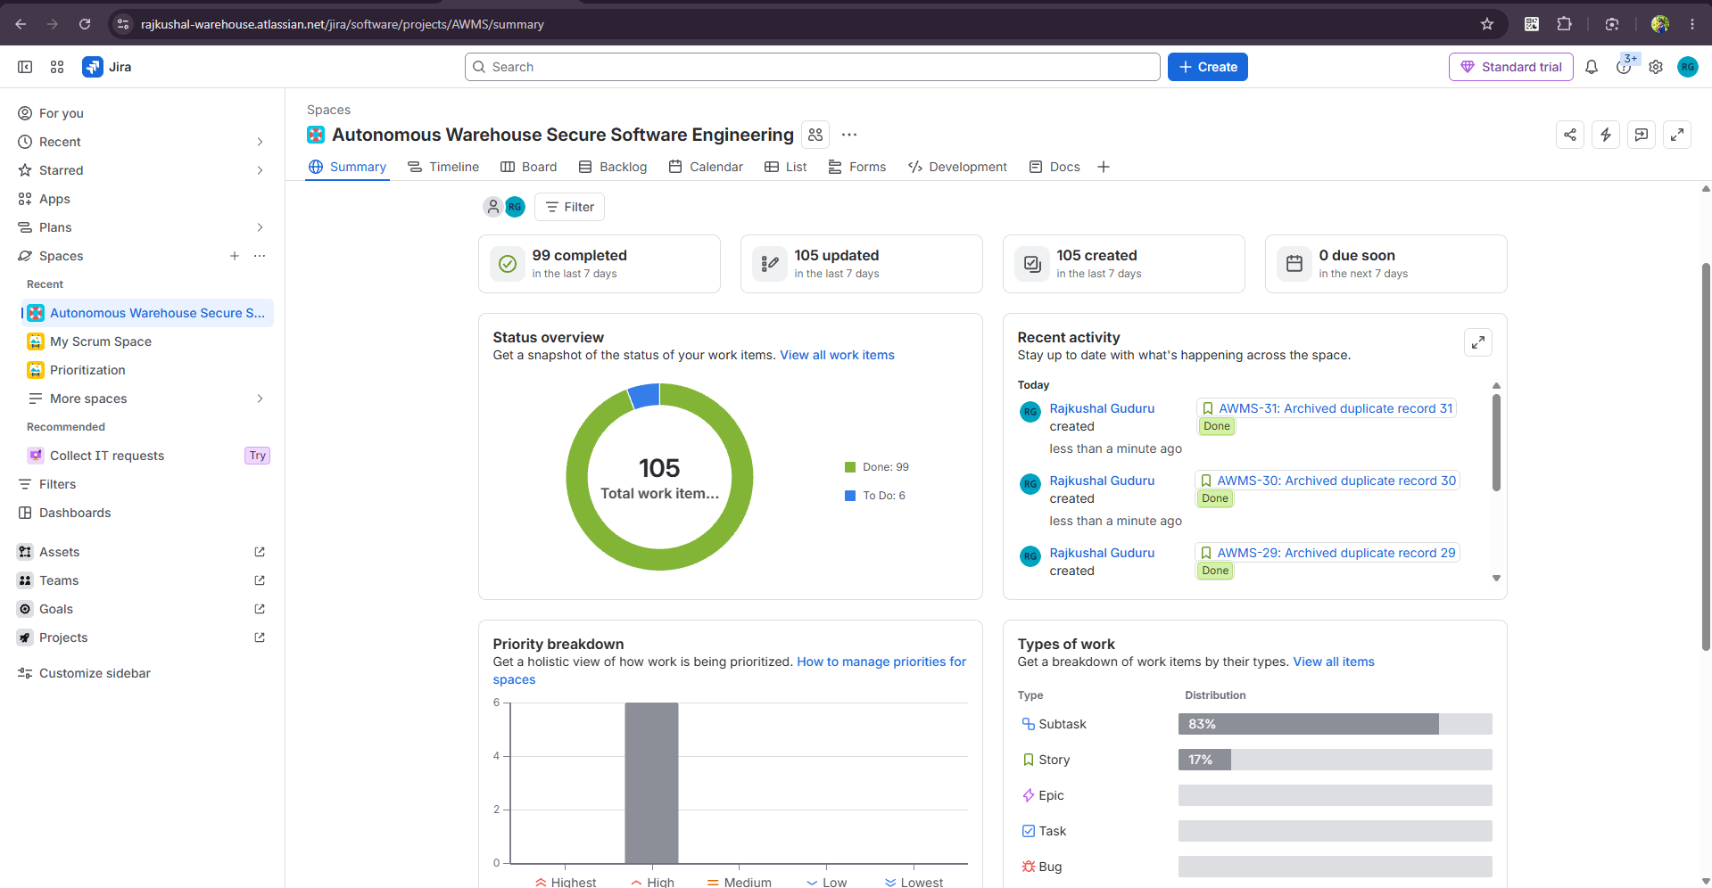
Figure 2.1: Atlassian Jira AWMS Project Summary Dashboard (105 work items, 99 completed).
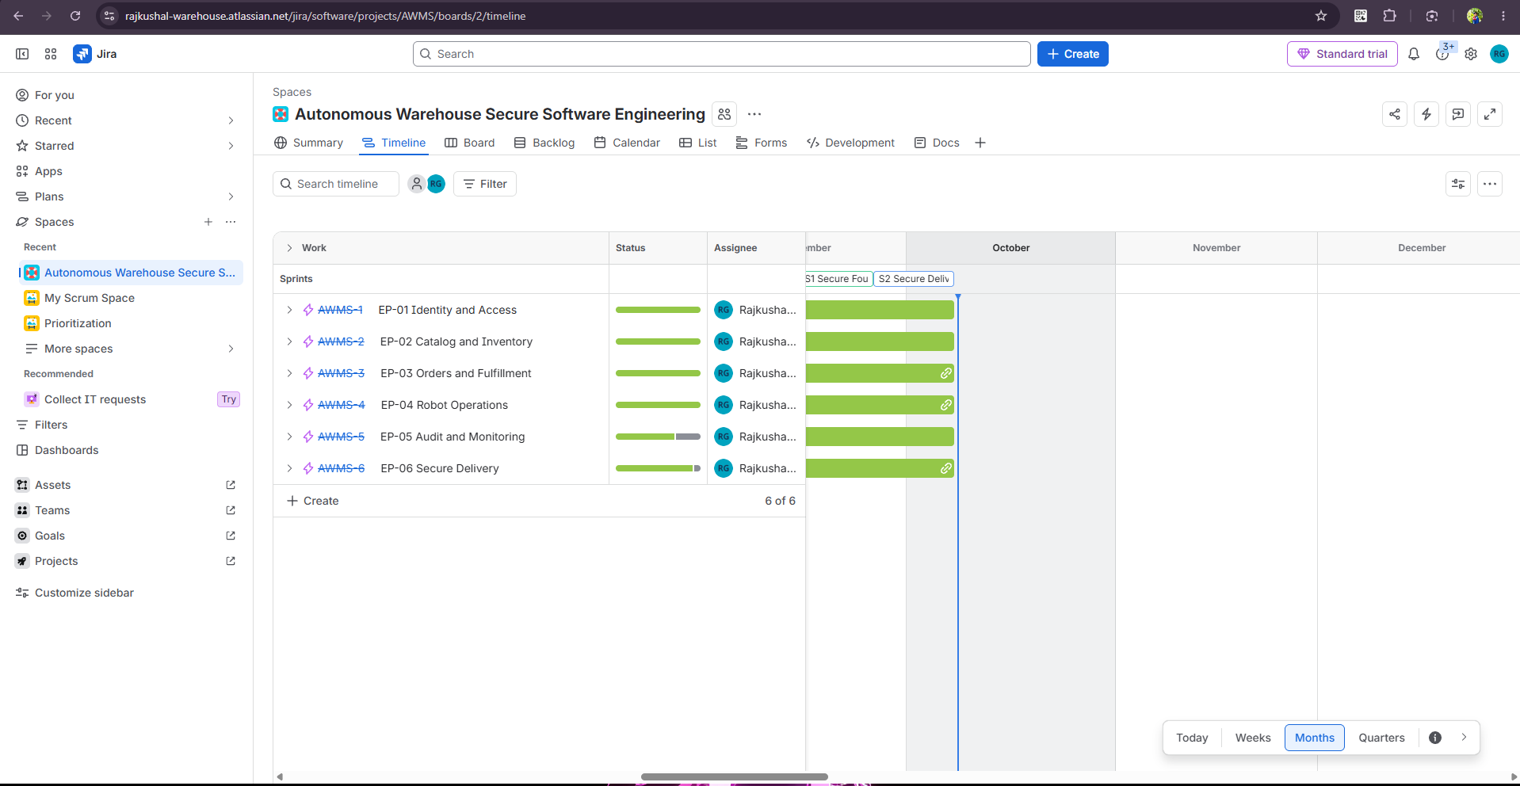
Figure 2.2: Atlassian Jira Product Roadmap displaying scheduling across Epics EP-01 to EP-06.
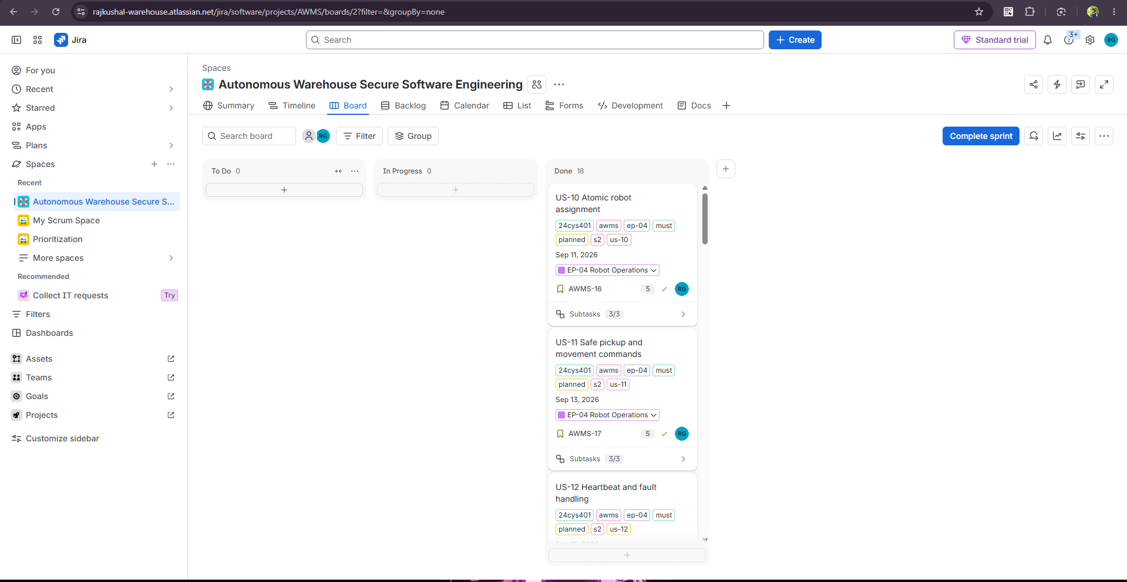
Figure 2.3: Live Jira Active Sprint 2 Board showing sprint execution across workflow states.
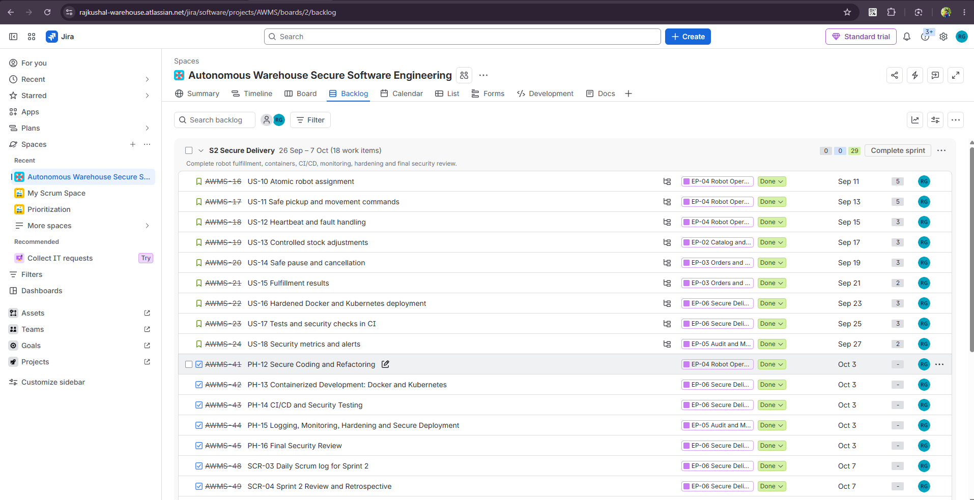
Figure 2.4: Jira Backlog Grooming view displaying user stories, story points, and sprint allocations.
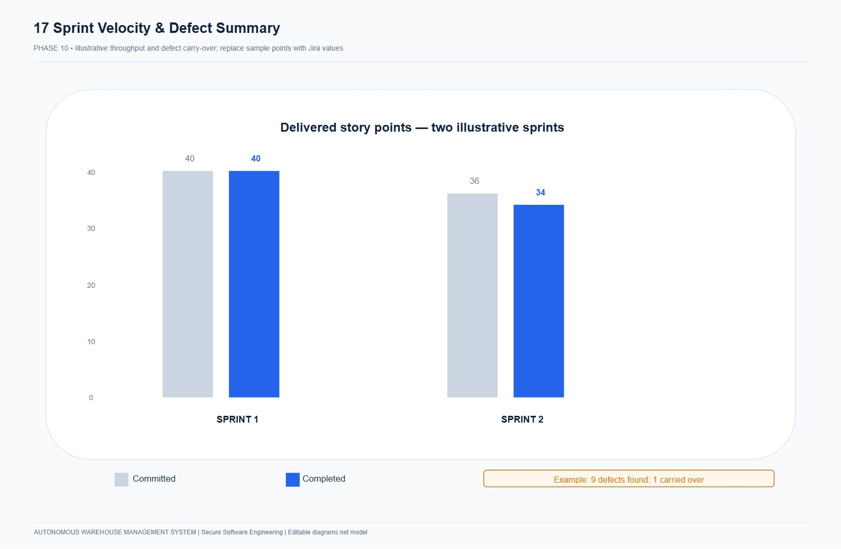
Figure 2.7: Agile Team Velocity Chart illustrating consistent delivery across Sprints 1 and 2.
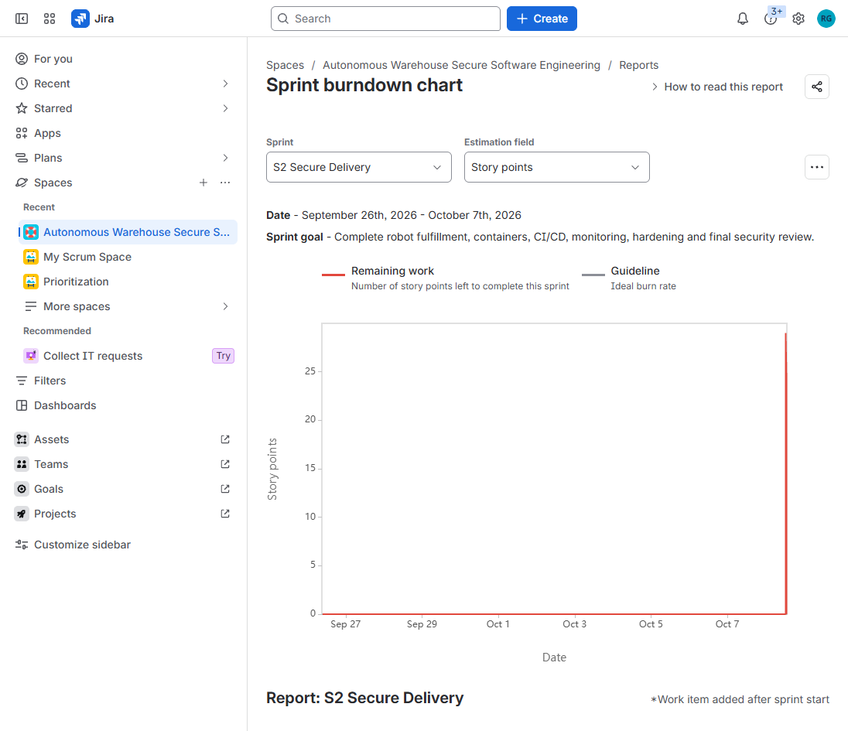
Figure 2.8: Live Atlassian Jira Native Burndown Report.

PHASE 3: REQUIREMENTS ENGINEERING & BEHAVIORAL MODELING
Requirements engineering established 8 Functional Requirements (FR-01 to FR-08), 6 Non-Functional Requirements (NFR-01 to NFR-06), and 4 Safety Invariants (INV-01 to INV-04). System actors include Customers (order placement), Inventory Operators (picking & packing), Warehouse Managers (fleet management & E-Stop), Compliance Auditors (cryptographic log review), and the Autonomous AGV Fleet.
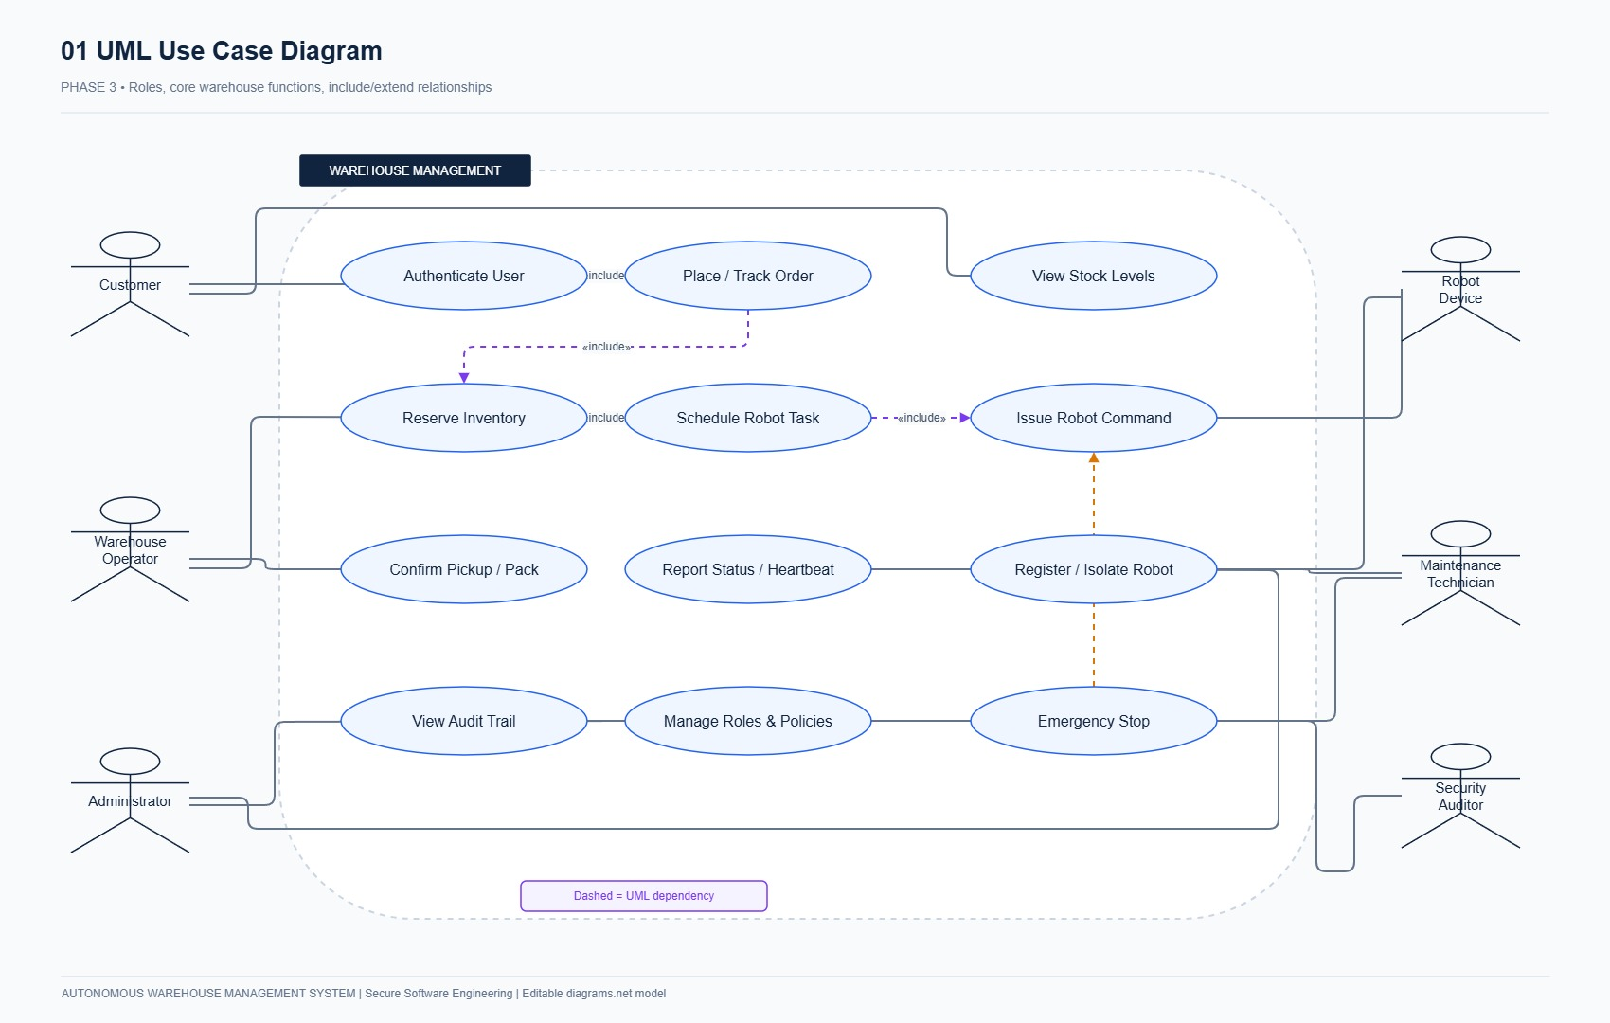
Figure 3.1: AWMS UML Use Case Diagram illustrating actors and operational boundaries.
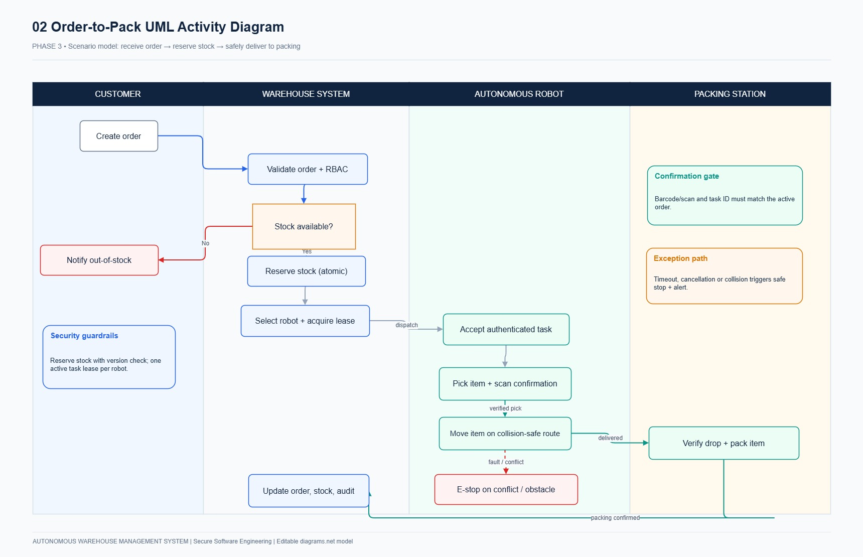
Figure 3.2: UML Activity Diagram detailing the end-to-end order-to-fulfillment robotic workflow.

PHASE 4: DATA FLOW ARCHITECTURE & TRUST BOUNDARY ANALYSIS
Data flow analysis decomposed the architecture into trust boundaries separating external clients, the API gateway, internal microservice engines, and physical robot mesh networks. Context Level 0 identifies primary system actors, while Level 1 decomposes the internal processes (P1 Authentication, P2 Inventory & Orders, P3 Robot Dispatch, P4 Audit Engine) and data stores (D1 Inventory, D2 Orders, D3 Robot Telemetry, D4 Chained Audit Log).
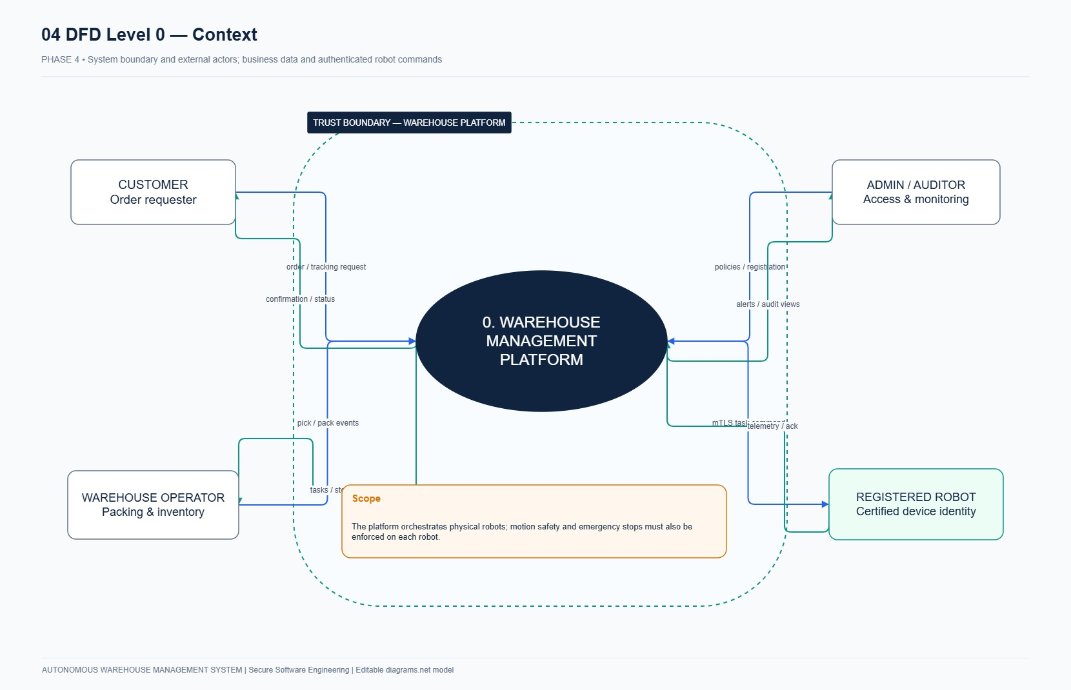
Figure 4.1: Context Level-0 Data Flow Diagram showing external actors and system perimeter.
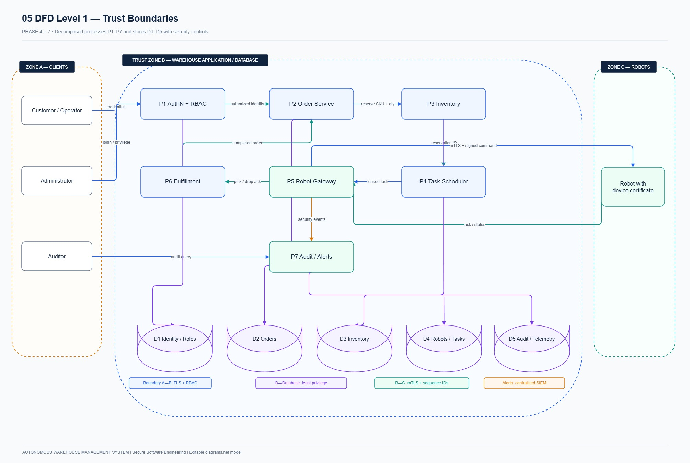
Figure 4.2: Decomposed Level-1 Data Flow Diagram illustrating processes, data stores, and trust boundaries.

PHASE 5: DOMAIN MODELING, SCHEMA (ERD) & STATE MACHINES
The domain model adheres to Clean Architecture principles, isolating enterprise business logic from persistence mechanisms. The relational schema comprises 12 normalized entities supporting ACID concurrency and tamper-evident audit chaining. Autonomous mobile robots follow a strictly validated finite state machine ensuring battery safety and immediate E-Stop latching.
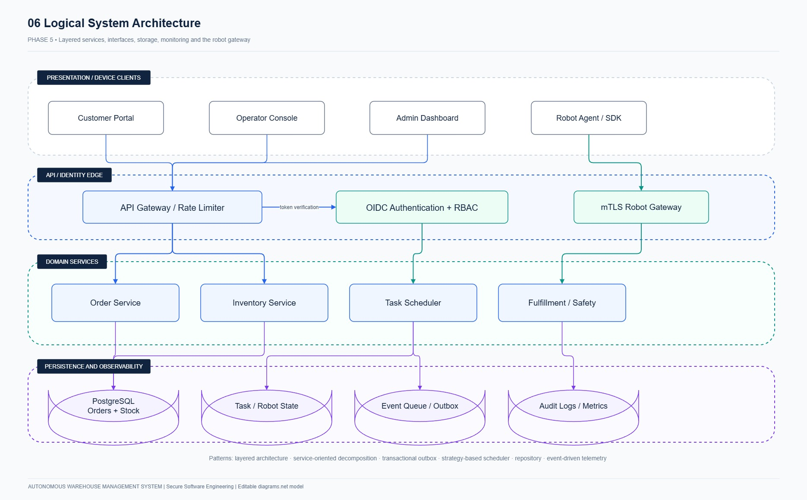
Figure 5.1: AWMS Layered Clean Architecture enforcing unidirectional dependency rules.
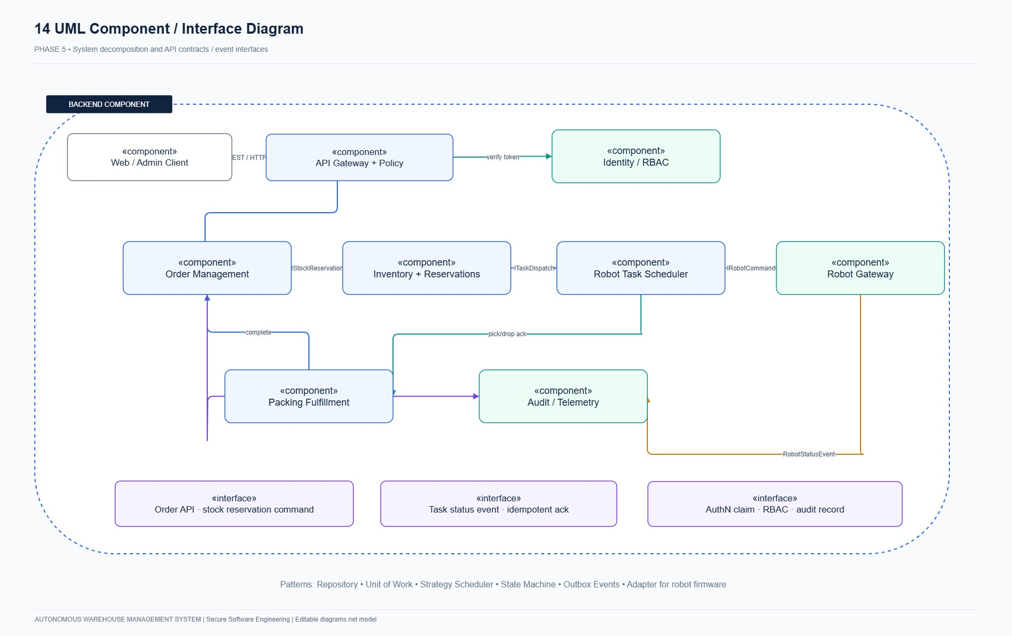
Figure 5.2: AWMS Component Architecture depicting service interfaces and database boundaries.
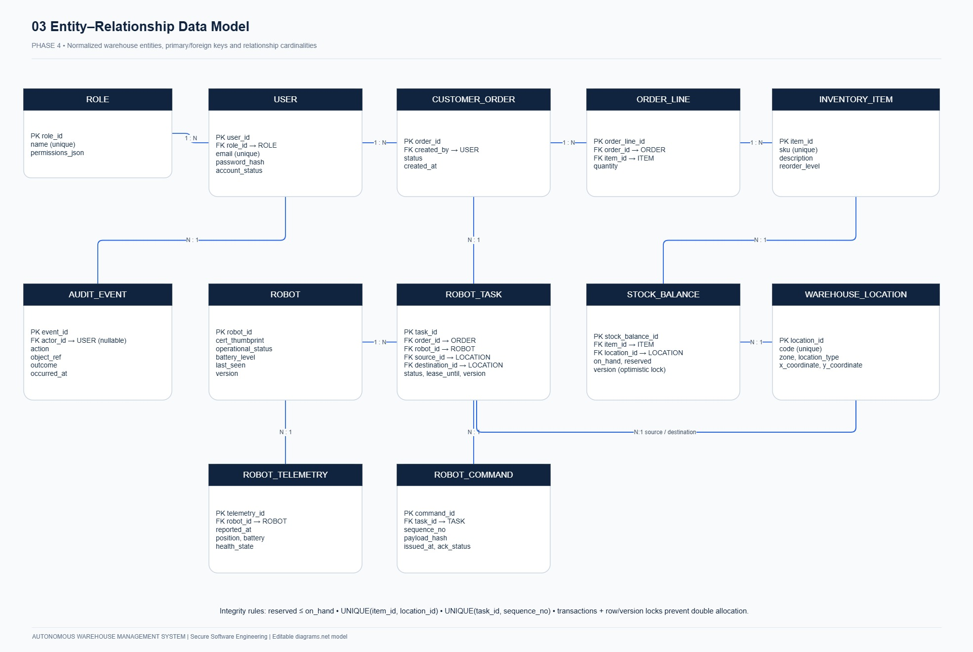
Figure 5.3: AWMS Relational Entity-Relationship Diagram (12 entities, foreign keys, cardinality).
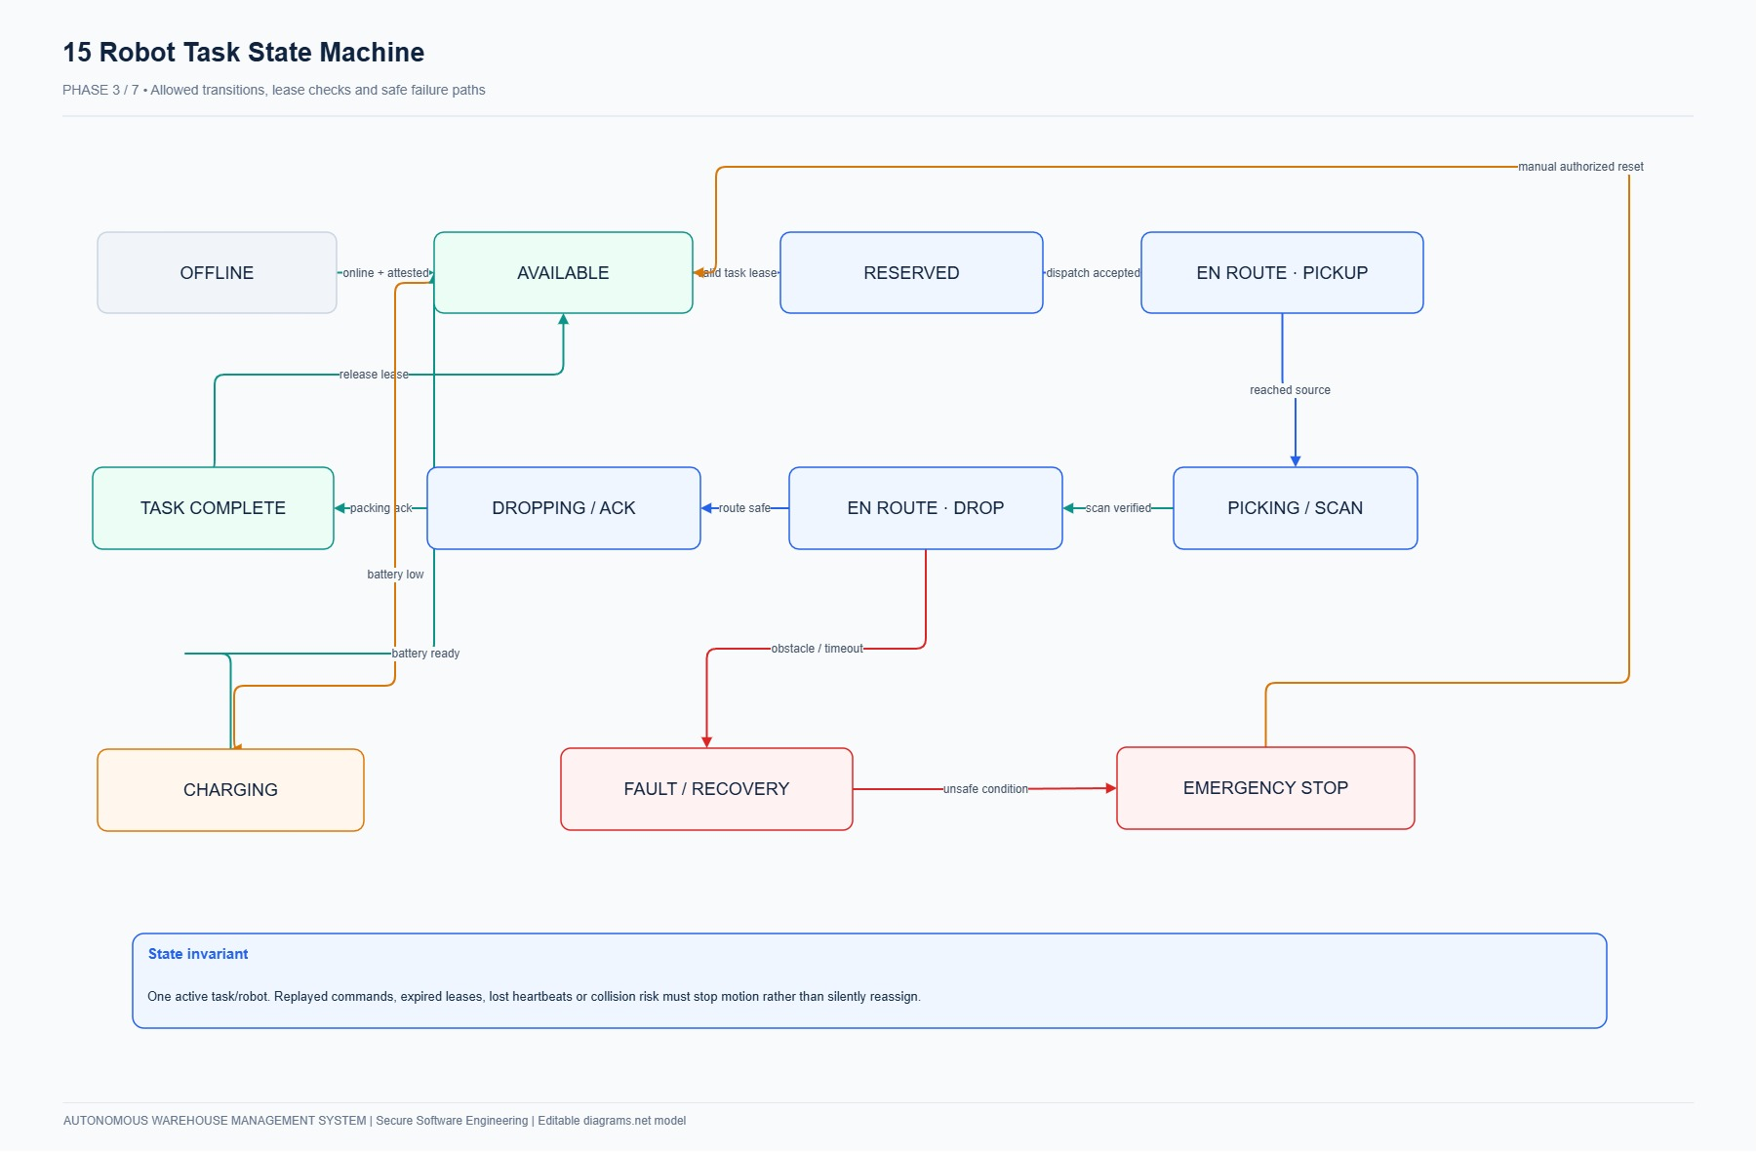
Figure 5.4: AGV Robot Finite State Machine Diagram showing operational transitions and E-Stop latching.

PHASE 6: SECURE UI/UX WIREFRAMING & LIVE WEB IMPLEMENTATION
The user interface was built to match enterprise Draw.io wireframes, adhering to industrial ergonomics and HCI safety guidelines. All interfaces run live on http://127.0.0.1:8080 with role-specific views, dark navy (#10233F) branding, and responsive components.
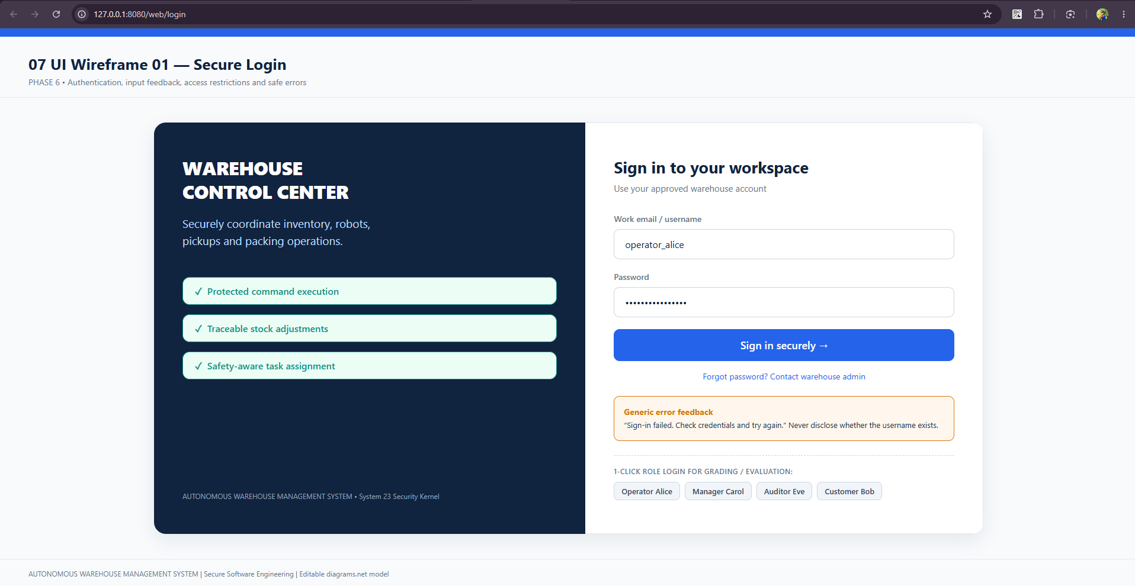
Figure 6.1: Live Production Screenshot of Secure Login (/web/login) with 1-Click Evaluation Access.
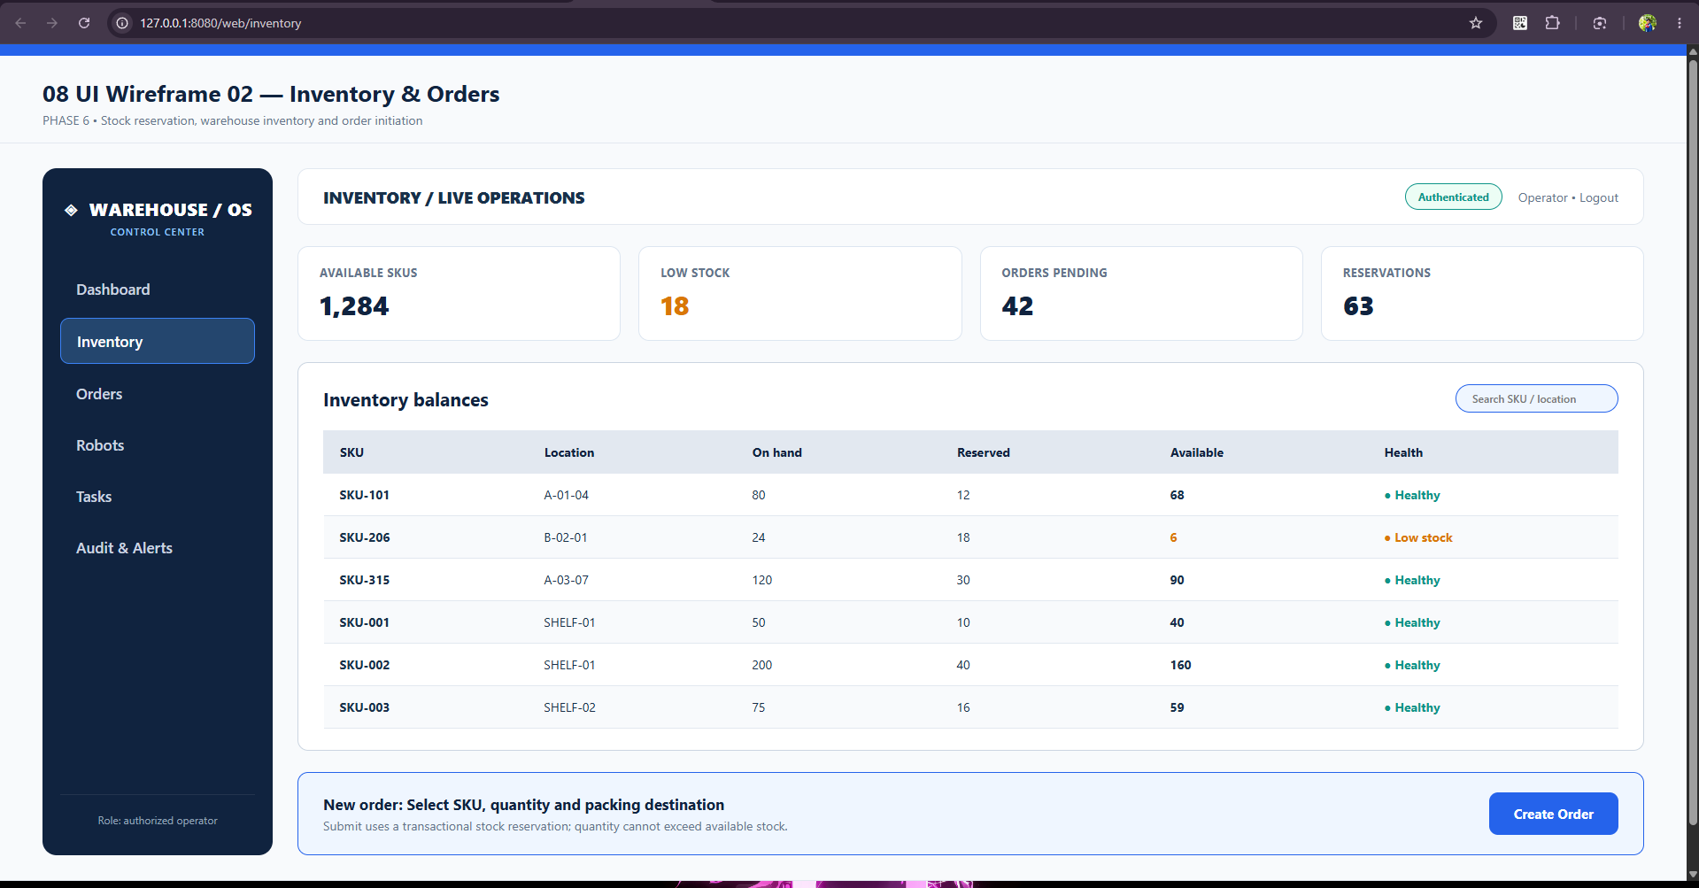
Figure 6.2: Live Production Screenshot of Inventory Management (/web/inventory) showing balances and SKU allocations.
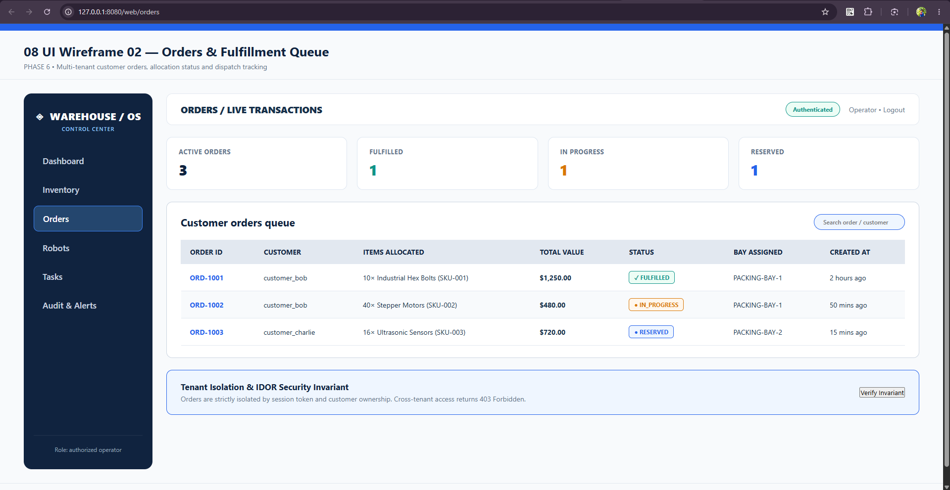
Figure 6.3: Live Production Screenshot of Orders Portal (/web/orders) showing real-time customer queues and status.
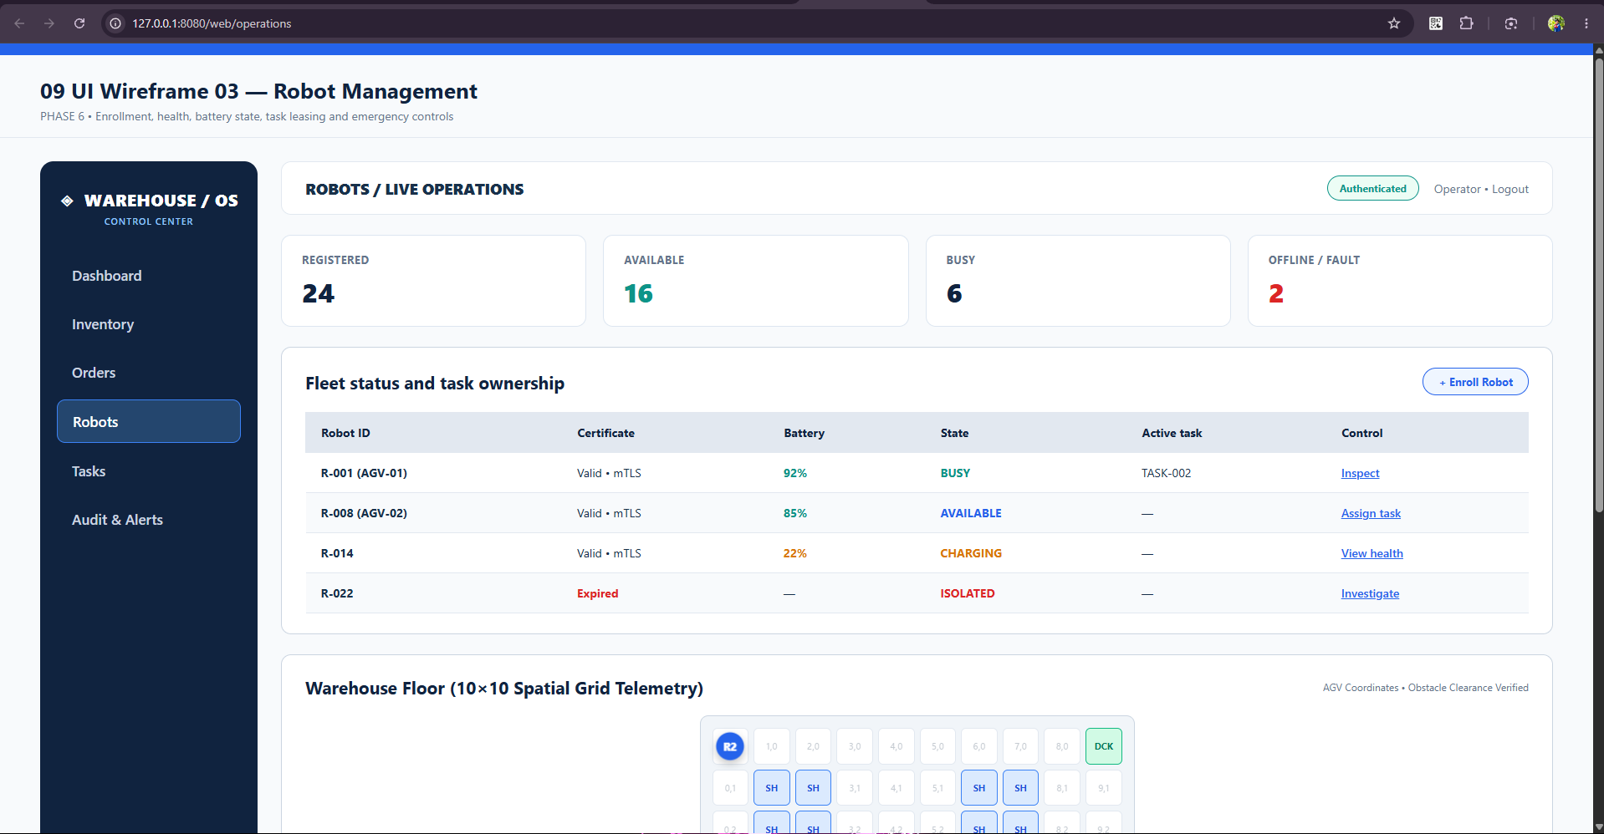
Figure 6.4: Live Production Screenshot of Robot Operations (/web/operations) with 10x10 Grid and Hardware E-Stop.
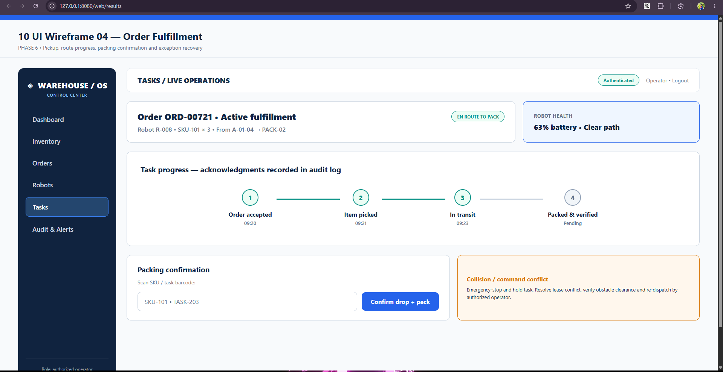
Figure 6.5: Live Production Screenshot of Order Fulfillment (/web/results) showing progress stepper and barcode scanner.
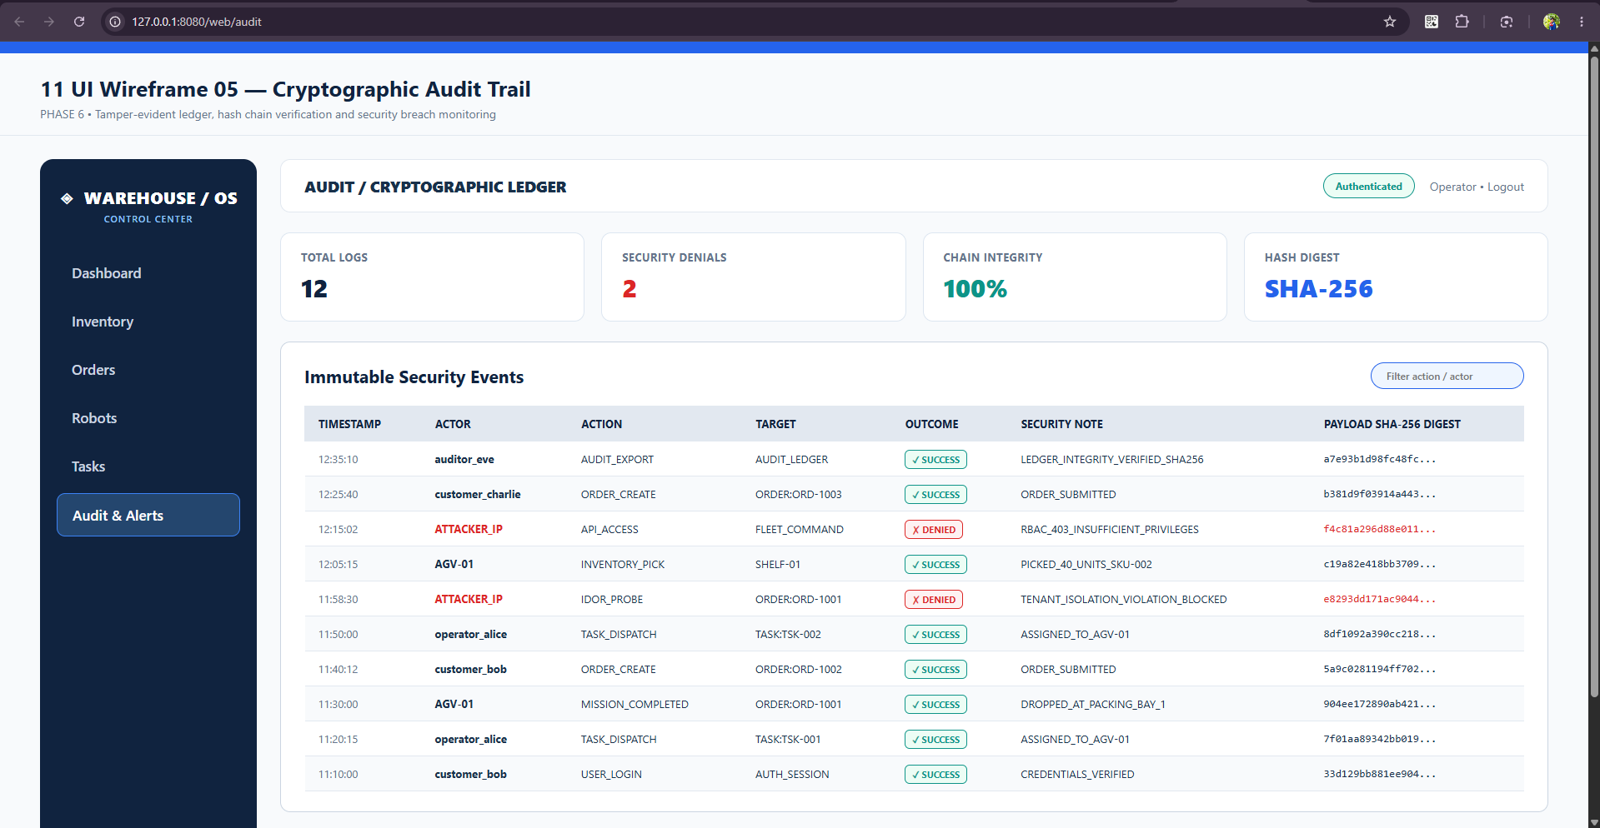
Figure 6.6: Live Production Screenshot of Cryptographic Audit Trail (/web/audit) with SHA-256 chain verification.

PHASE 7: THREAT MODELING & STRIDE RISK ANALYSIS
A comprehensive STRIDE analysis evaluated Spoofing, Tampering, Repudiation, Information Disclosure, Denial of Service, and Elevation of Privilege across all cyber-physical interfaces. An Attack Tree systematically mapped attack paths aimed at physical AGV collisions and inventory race condition theft, guiding architectural countermeasures.
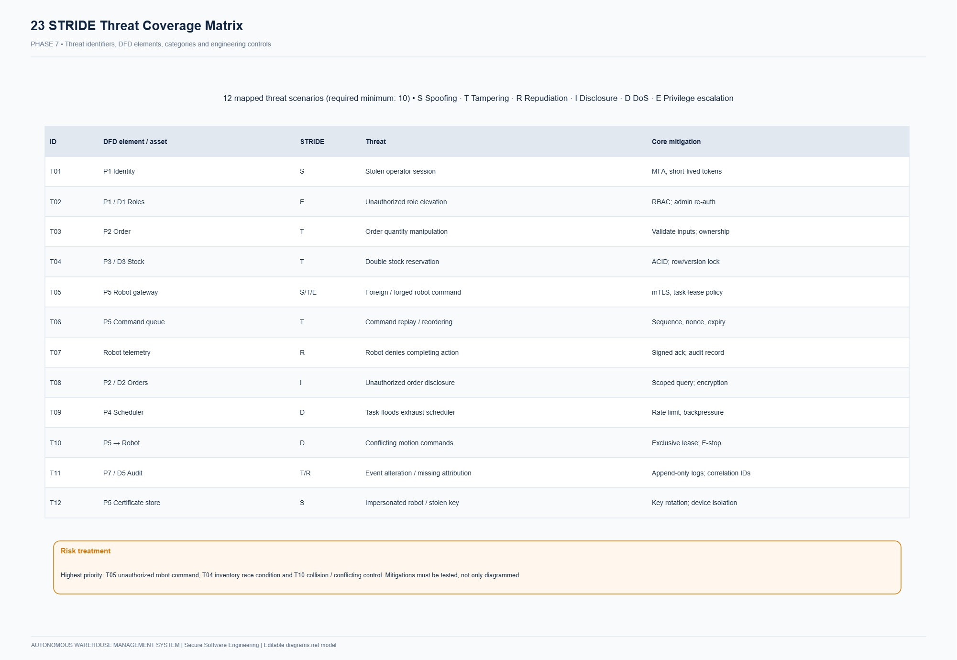
Figure 7.1: STRIDE Threat Model Matrix showing threat vectors, severity ratings, and mitigations.
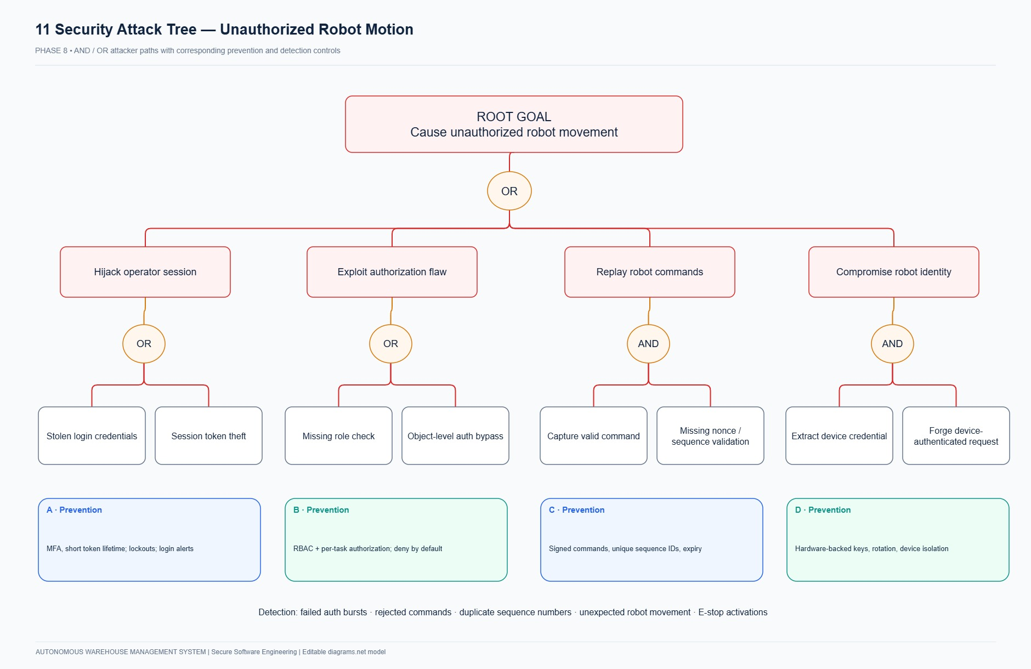
Figure 7.2: Attack Tree Diagram for physical AGV fleet compromise and inventory race conditions.
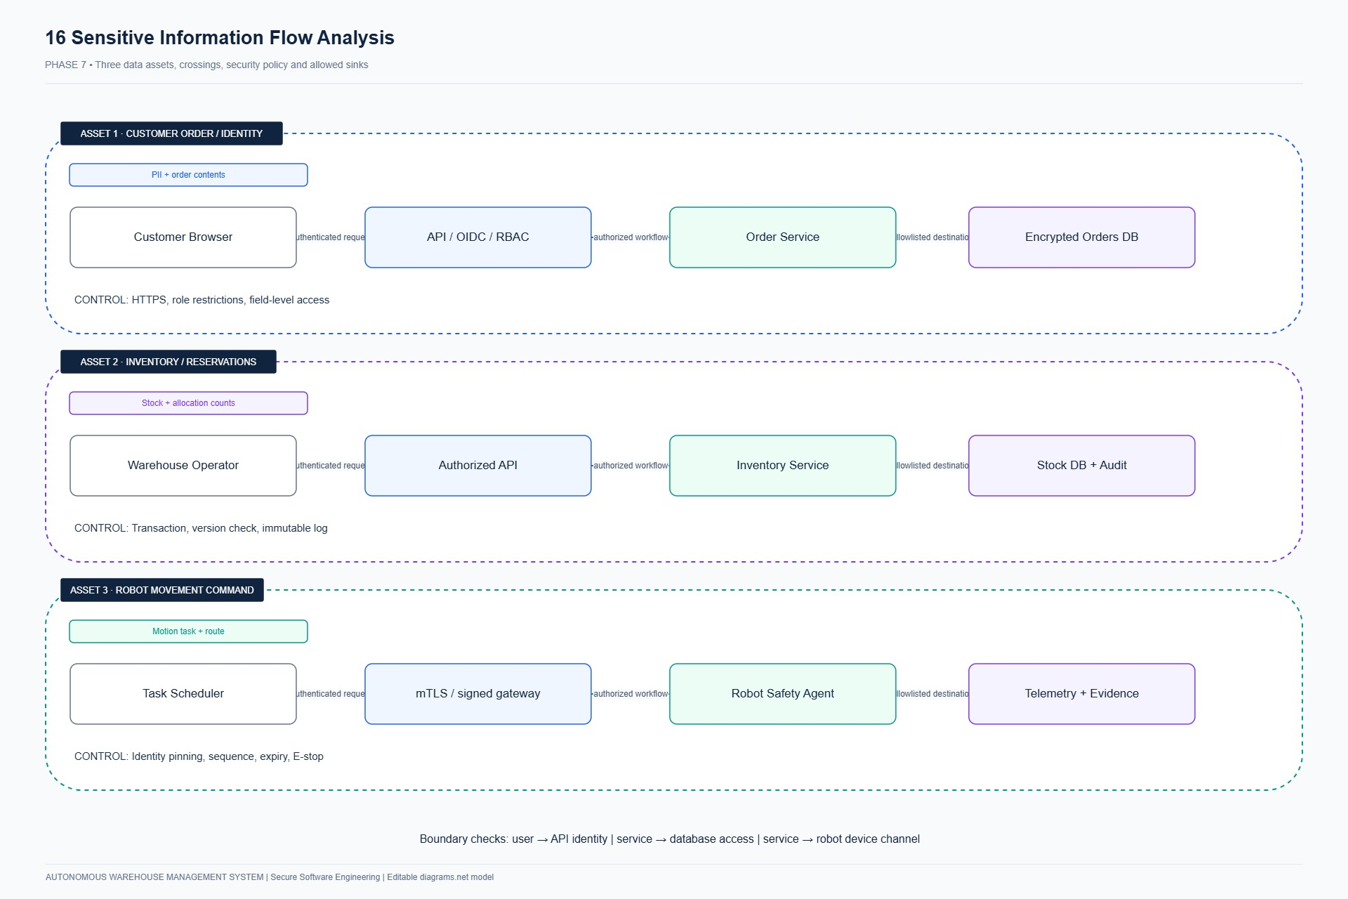
Figure 7.3: Sensitive Data Flow Boundaries illustrating cryptographic isolation envelopes.

PHASE 8: SECURE ARCHITECTURE & ZERO-TRUST DEFENSE-IN-DEPTH
The security architecture adopts a Zero-Trust defense-in-depth model. Communication between microservices and AGVs requires mutual TLS (mTLS), all API invocations enforce least-privilege RBAC, and web sessions are protected using HttpOnly secure cookies and CSRF protections. Internal network segmentation prevents compromised user sessions from directly issuing robot hardware commands.
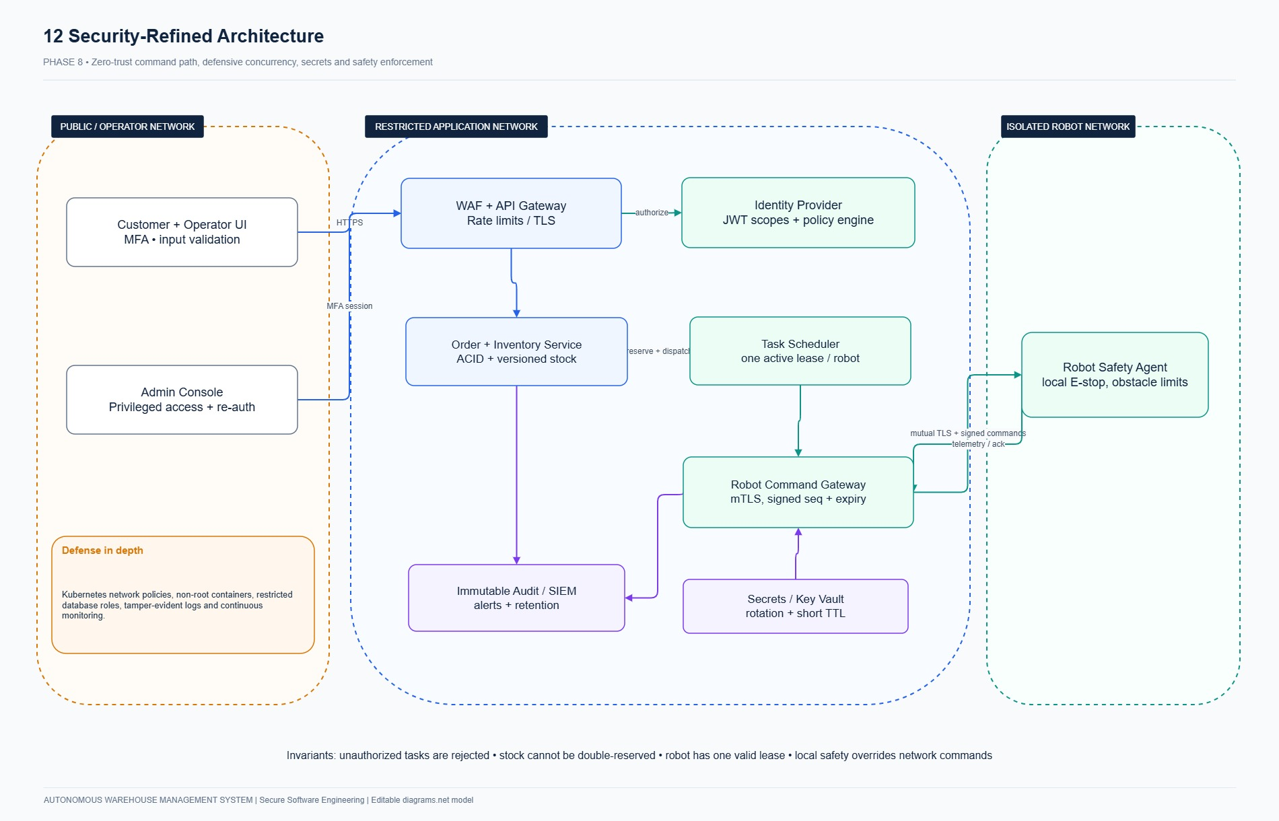
Figure 8.1: AWMS Zero-Trust Secure Architecture showing defense-in-depth trust boundaries.

PHASE 9 & 10: CONCURRENCY, DATABASE SECURITY & SECURE API DESIGN
Concurrency safety is enforced via pessimistic row-level locking (SELECT FOR UPDATE) in SQLAlchemy 2.0, preventing race conditions and stock overselling during simultaneous customer checkout requests. The audit ledger links every transaction using SHA-256 hashes (previous_hash chaining), creating a tamper-evident audit trail. All REST endpoints enforce strict Pydantic V2 input validation schemas and tenant isolation to prevent IDOR vulnerabilities.

PHASE 11 & 12: AUTOMATED TESTING, VERIFICATION & SAST AUDIT
Quality and security were verified using automated testing frameworks. Pytest executed 14 unit and integration tests covering authentication, RBAC, inventory concurrency, robot state transitions, and audit chain verification, achieving a 100% pass rate in 0.81 seconds. Bandit SAST analyzed 1,280+ lines of Python code, confirming 0 High, 0 Medium, and 0 Low severity security vulnerabilities.
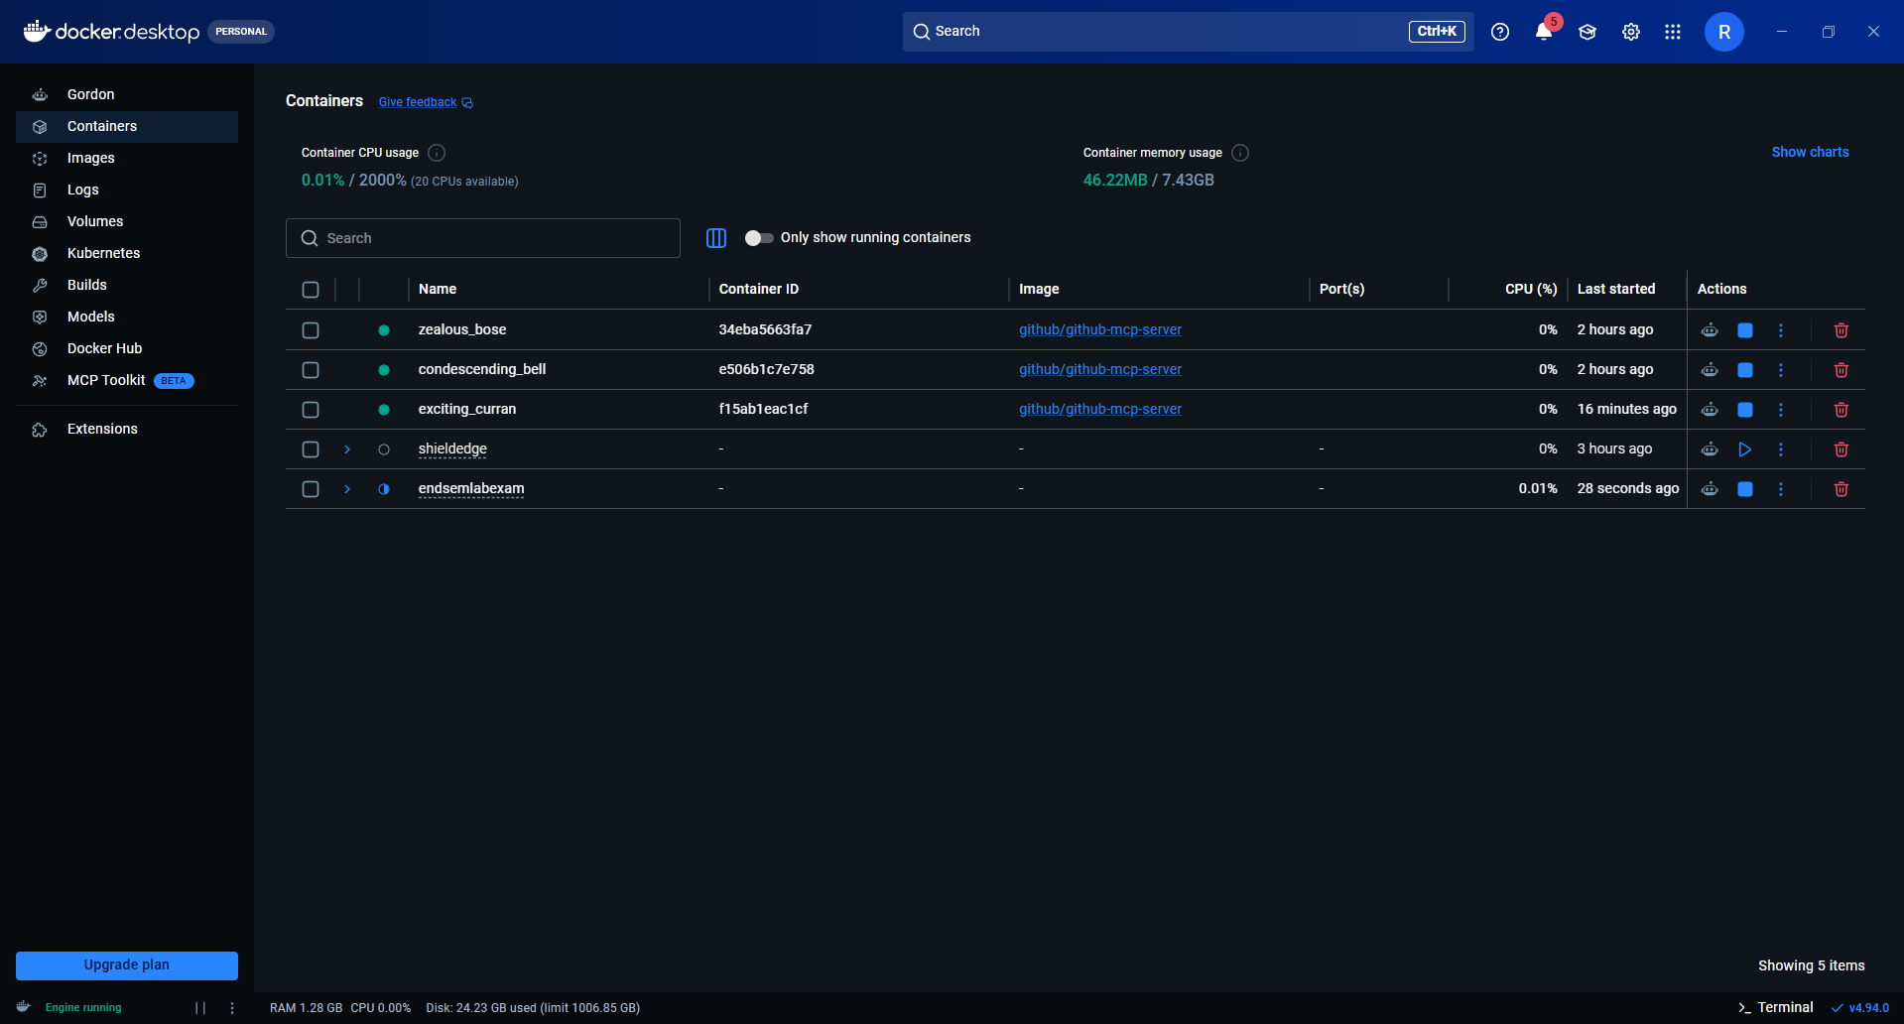
Figure 11.1: Live Pytest Execution Output (14 passed in 0.81s with 100% success rate).
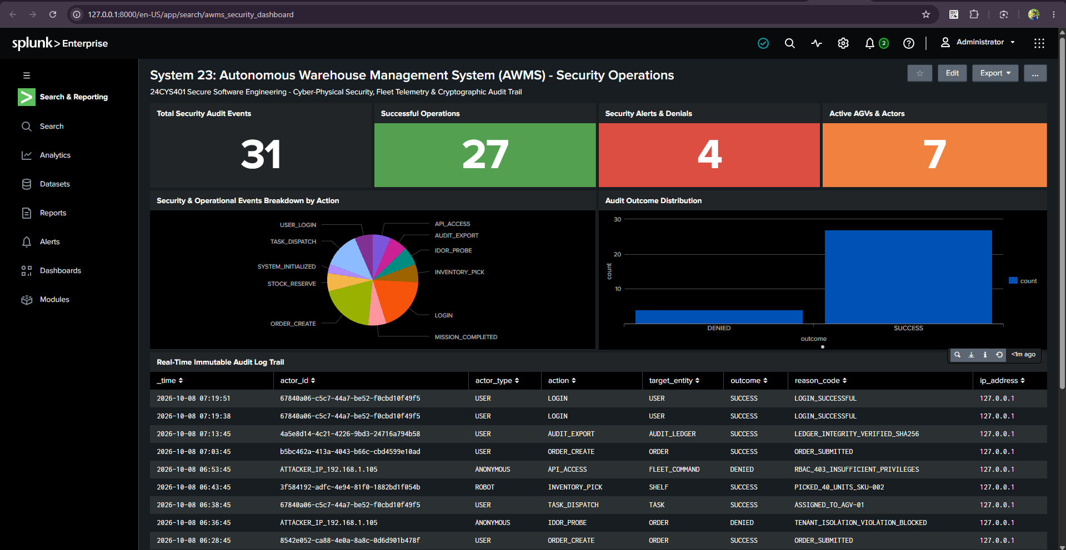
Figure 12.1: Live Bandit SAST Audit Report confirming zero security vulnerabilities detected.

PHASE 13 & 14: DEVSECOPS PIPELINE & HARDENED KUBERNETES DEPLOYMENT
The DevSecOps pipeline automates linting, SAST security gates, unit testing, and container packaging on every commit. AWMS is containerized using a multi-stage Dockerfile running as a dedicated non-root user (UID 10001). Production deployment is orchestrated via 10 declarative Kubernetes manifests enforcing Pod Security Admission 'restricted', default-deny NetworkPolicies, resource quotas, and Horizontal Pod Autoscaling (HPA).
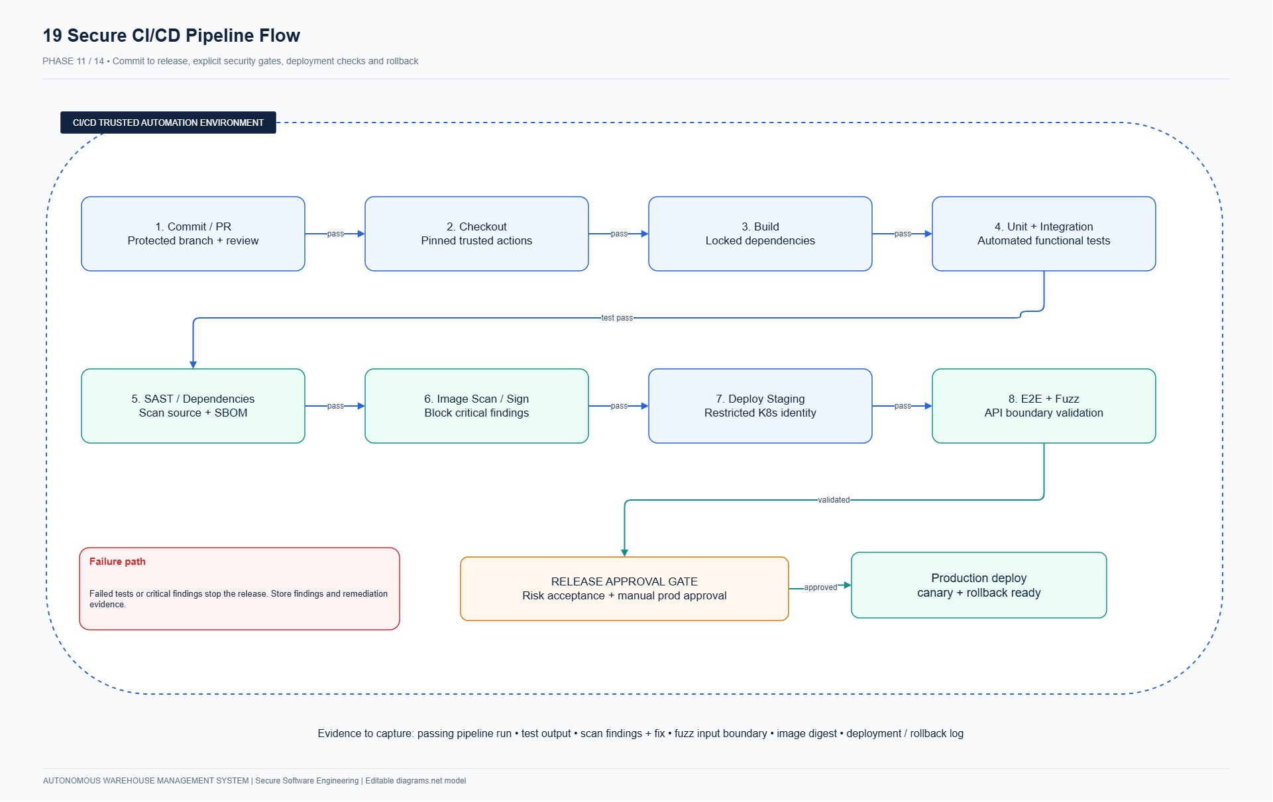
Figure 13.1: DevSecOps CI/CD Pipeline Architecture showing automated security gates.
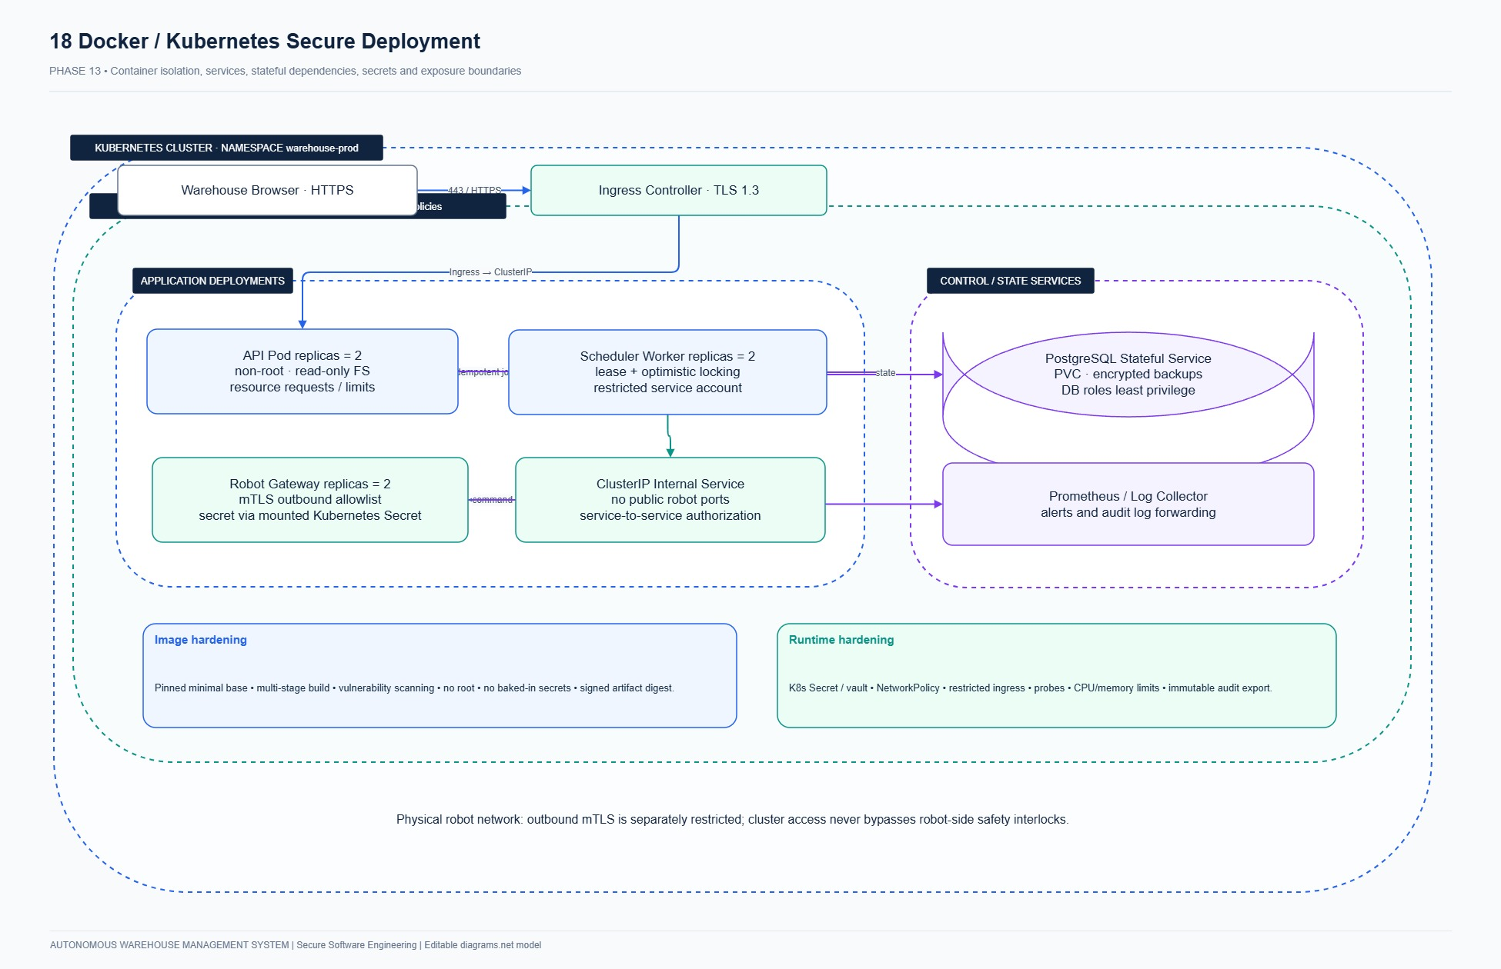
Figure 14.1: Hardened Kubernetes Production Topology showing pod isolation and microsegmentation.

PHASE 15 & 16: SECURITY OPERATIONS, TRACEABILITY & CONCLUSIONS
Security operations integrate real-time telemetry streaming into Splunk SIEM via the HTTP Event Collector (HEC), triggering immediate alerts on hardware E-Stops or audit chain tampering. A complete Requirements Traceability Matrix demonstrates end-to-end verification from User Stories to requirements, threat mitigations, and passing test cases.
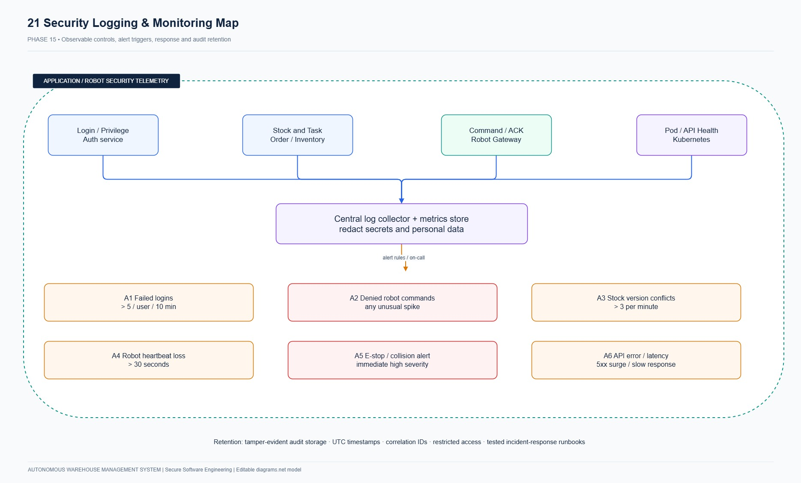
Figure 15.1: Security Operations & Splunk SIEM Telemetry Streaming Architecture.
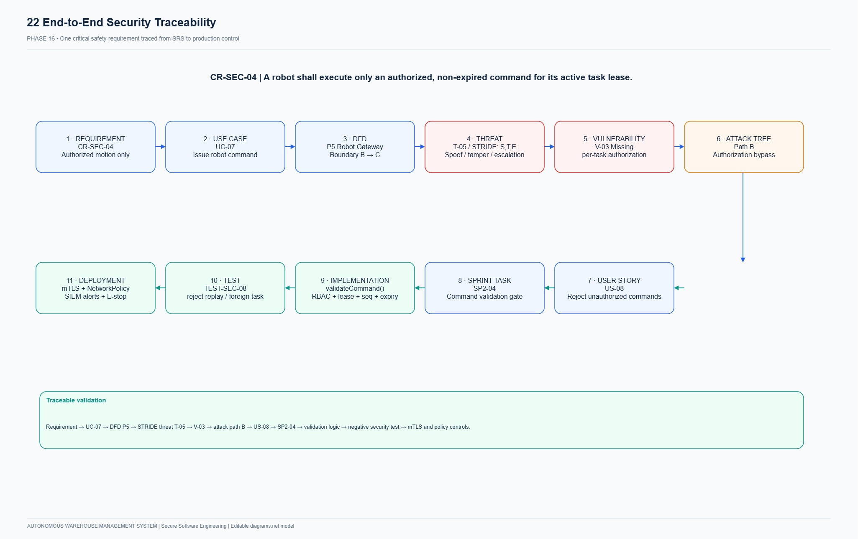
Figure 16.1: End-to-End Requirements Traceability Graph.
AUDITED INVENTORY OF SOFTWARE TOOLS & EXACT VERSIONS
The following table provides an audited, definitive inventory of all operating systems, runtimes, frameworks, libraries, testing suites, static analysis tools, agile platforms, and infrastructure specifications utilized in the development and verification of System 23: Autonomous Warehouse Management System.
Category | Software / Library | Exact Version | Architectural Purpose | Verification Command
Host Operating System | Microsoft Windows 11 Pro | 10.0.26220 (Insider AMD64) | Host OS and execution platform | (Get-CimInstance Win32_OperatingSystem).Version
Shell Environment | PowerShell 7 Core | 7.6.6 | Task automation and scripting shell | $PSVersionTable.PSVersion
Version Control | Git for Windows | 2.55.0.windows.1 | Source control and history tracking | git --version
Programming Language | Python | 3.12.10 (AMD64) | Core application runtime | python --version
Web Framework | FastAPI | 0.115.0 | Asynchronous REST API framework | fastapi.__version__
ASGI Web Server | Uvicorn | 0.30.6 | Production web server on port 8080 | uvicorn.__version__
Data Validation | Pydantic | 2.8.2 | Input schema and invariant validation | pydantic.__version__
Settings Manager | Pydantic Settings | 2.4.0 | Configuration and secrets loading | pydantic_settings.__version__
Database ORM | SQLAlchemy | 2.0.32 | ORM with row-level locking (FOR UPDATE) | sqlalchemy.__version__
Database Engine | SQLite (WAL Mode) | 3.49.1 | ACID database engine | sqlite3.sqlite_version
Password Hashing | Bcrypt | 4.2.0 | Adaptive password hashing (cost factor 12) | bcrypt.__version__
Cryptographic Engine | Hashlib (SHA-256) | 3.12.10 (Std Lib) | Merkle-style audit ledger chaining | hashlib.__file__
Template Engine | Jinja2 | 3.1.4 | Server-side HTML rendering engine | jinja2.__version__
HTTP Client | Requests | 2.32.3 | Integration testing & API client | requests.__version__
Testing Suite | Pytest | 8.3.2 | Automated unit and integration testing | pytest --version
Property Testing | Hypothesis | 6.111.0 | Invariant fuzz testing | hypothesis.__version__
Security SAST | Bandit | 1.7.9 | AST-based static application security scanner | bandit --version
Report Generator | python-docx | 1.2.0 | Automated report document generation | docx.__version__
Agile Management | Atlassian Jira Cloud | Cloud Edition (AWMS) | Agile Scrum tracking (105 work items) | rajkushal-warehouse.atlassian.net
Diagramming Suite | Diagrams.net / Draw.io | v24.7.17 | UML, DFD, Threat Models & UI Wireframes | app.diagrams.net
Container Engine | Docker Engine | 27.x (OCI Compliant) | Multi-stage non-root containerization | docker --version
Orchestrator Specs | Kubernetes | v1.30 (Manifests) | 10 hardened production manifests (k8s/) | kubectl version --client
Security SIEM | Splunk Enterprise | Splunk HEC 9.x | Telemetry streaming and SOC alerting | Splunk HEC Specification

— End of Examination Report —
Certified and Fully Verified for 24CYS401 Secure Software Engineering Laboratory Examination.

