24CYS401: SECURE SOFTWARE ENGINEERING LABORATORY
END SEMESTER EXAMINATION — TECHNICAL DELIVERABLE
SOFTWARE REQUIREMENTS SPECIFICATION (SRS)
SYSTEM 23: AUTONOMOUS WAREHOUSE MANAGEMENT SYSTEM (AWMS)
Standard: IEEE Std 830-1998 / ISO/IEC/IEEE 29148:2018 Compliant
Document Identifier: AWMS-SRS-V1.0 | Academic Year 2025–2026 | Semester 7
DOCUMENT CONTROL & AUDIT SPECIFICATION
• System Designation: System 23 — Autonomous Warehouse Management System
• Security Standard: Zero-Trust Cyber-Physical Architecture, Row-Level ACID Concurrency, SHA-256 Ledger
• Total Requirements Specified: 18 Functional (FR), 8 Non-Functional (NFR), 13 Security (SR)
• Formal Use Cases: 9 Model Workflows (UC-01 to UC-09) with State Machine & Physical Invariant Guarantees
• Verified Environment: Python 3.12, FastAPI 0.115, SQLite 3.49, SQLAlchemy 2.0, Bandit 1.7.9, Pytest 8.3

DOCUMENT REVISION HISTORY
Version | Date | Author | Status | Summary of Changes
V0.1 | 2026-09-15 | Engineering Team | Draft | Initial draft of actors, inventory balances, and use cases.
V0.5 | 2026-09-28 | Security Architect | Reviewed | Incorporated STRIDE threat vectors, row locks, and device tokens.
V1.0 | 2026-10-08 | Lead Assessor | Approved | Finalized complete IEEE 830 compliant specification for Lab Examination.

1. INTRODUCTION

1.1 Purpose of this Document
This Software Requirements Specification (SRS) establishes the definitive, complete, and verifiable functional, non-functional, and cyber-physical security requirements for System 23: Autonomous Warehouse Management System (AWMS). The specification follows the guidelines of IEEE Std 830-1998 and ISO/IEC/IEEE 29148:2018. It serves as the primary technical contract for software engineers, security architects, roboticists, quality assurance testers, and academic evaluators.

1.2 Document Conventions & Notation
Requirements in this document follow standardized alphanumeric identifiers:
• FR-xx: Functional Requirements defining behavioral capabilities and business transactions.
• NFR-xx: Non-Functional Requirements defining performance, availability, fault tolerance, and quality attributes.
• SR-xx: Security Requirements defining authentication, authorization, cryptographic integrity, and supply-chain controls.
• INV-xx: Physical and Logical Safety Invariants that must never be violated under any operating condition.
Requirement priority is categorized in accordance with RFC 2119: MUST (Mandatory for compliance), SHOULD (Strongly recommended), and COULD (Optional extension).

1.3 Intended Audience
This document is intended for:
• Academic Evaluators & Examination Committee for 24CYS401 Secure Software Engineering.
• Backend & Distributed Systems Engineers implementing transactional state machines and APIs.
• Embedded Robotics Engineers configuring AGV firmware telemetry and E-Stop actuators.
• Compliance & Security Auditors validating STRIDE threat mitigations, SAST scans, and audit chains.

1.4 Project Scope & Objectives
System 23 (AWMS) orchestrates warehouse logistics across a 10×10 discrete physical coordinate grid. The system coordinates inventory storage, customer order ingestion, atomic stock reservations, autonomous mobile robot (AGV) path dispatching, physical tote picking, packing bay fulfillment, and cryptographic audit logging. The primary objectives are:
1. Guaranteeing Zero-Overselling: Eliminating race conditions via strict ACID database locking (SELECT FOR UPDATE).
2. Physical Safety Assurance: Enforcing collision-free AGV navigation and a hardware-latched Emergency Stop (E-Stop).
3. Cryptographic Tamper Evidence: Chaining all operational state mutations into an immutable SHA-256 block-chained ledger.
4. Principle of Least Privilege: Role-Based Access Control (RBAC) isolating Customer, Operator, Manager, and Auditor domains.

1.5 Applicable Standards & References
• IEEE Std 830-1998: Recommended Practice for Software Requirements Specifications.
• ISO/IEC/IEEE 29148:2018: Systems and software engineering — Life cycle processes — Requirements engineering.
• NIST SP 800-53 Rev. 5: Security and Privacy Controls for Information Systems and Organizations.
• OWASP Application Security Verification Standard (ASVS) 4.0.3 (Levels 1 & 2).
• RFC 6749: The OAuth 2.0 Authorization Framework & RFC 7519: JSON Web Token (JWT).
• W3C Web Content Accessibility Guidelines (WCAG) 2.1 (Level AA).

2. OVERALL DESCRIPTION

2.1 Product Perspective & Context
AWMS operates as a cyber-physical system bridging high-level enterprise commerce with autonomous mobile robotics. Unlike purely digital applications, AWMS software commands directly translate into physical mechanical motion on warehouse floors. Therefore, software bugs or security breaches represent physical safety hazards, including equipment destruction and personnel injury. The architecture decouples the presentation tier (FastAPI web dashboards), business workflow services, transactional database persistence, and robotic device communication.

2.2 User Classes & Stakeholders
Actor ID | Role Name | System Responsibilities | Security Constraints
ACT-01 | Customer | Places orders, tracks fulfillment status, cancels eligible unpicked orders. | Strict IDOR prevention; zero access to warehouse layout or robot controls.
ACT-02 | Warehouse Operator | Monitors real-time robot operations, views inventory, initiates pause/resume, executes packing. | Cannot alter user roles, perform arbitrary inventory quantity adjustments, or bypass movement validation.
ACT-03 | Warehouse Manager | Configures warehouse catalog, performs authorized stock adjustments with reason codes, inspects analytics. | Cannot assign system administrator roles or delete audit records.
ACT-04 | System Administrator | Manages user accounts and RBAC assignments, revokes compromised sessions, rotates device tokens. | Administrative privileges do not bypass physical invariant checks.
ACT-05 | Security Auditor | Reviews immutable security audit events, evaluates access logs, verifies cryptographic chain hashes. | Read-only access to audit records; zero operational mutation authority.
ACT-06 | Robot Device (AGV) | Transmits telemetry heartbeats, receives step-by-step navigation commands, acknowledges completions. | Machine identity only; bound strictly to assigned tasks; cannot impersonate other robots.
ACT-07 | Dispatcher Worker | Background scheduling daemon orchestrating path step generation and task execution under locks. | Runs as restricted internal service identity.

2.3 Operating Environment & Cyber-Physical Boundaries
• Grid Topography: 10×10 discrete grid coordinates ((0,0) to (9,9)) containing storage shelves, charging bays, and packing stations.
• Fleet Dynamics: Multiple AGVs (e.g., AGV-01, AGV-02) equipped with simulated battery discharge rates, linear velocity bounds, and payload capacities.
• Network Environment: Secure internal loopback / private virtual network. Robot channels require authenticated bearer tokens.
• Database Environment: ACID compliant relational database (SQLite in WAL mode for deterministic testing; PostgreSQL in production) enforcing row locks.

2.4 Design & Implementation Constraints
• Memory & Concurrency Bounds: Database connection pools constrained to prevent exhaustion; transactional locks expire after 5 seconds.
• Cryptographic Standards: Password hashing strictly enforced via Bcrypt (cost factor 12); audit ledger hashes computed via SHA-256.
• Technology Stack: Python 3.12.10 runtime, FastAPI 0.115 asynchronous framework, SQLAlchemy 2.0 ORM, and Pydantic 2.8 schema validation.

3. SYSTEM FEATURES AND FUNCTIONAL REQUIREMENTS
This section provides the complete technical specification for all 18 Functional Requirements (FR-01 to FR-18) and their behavioral UML representations.
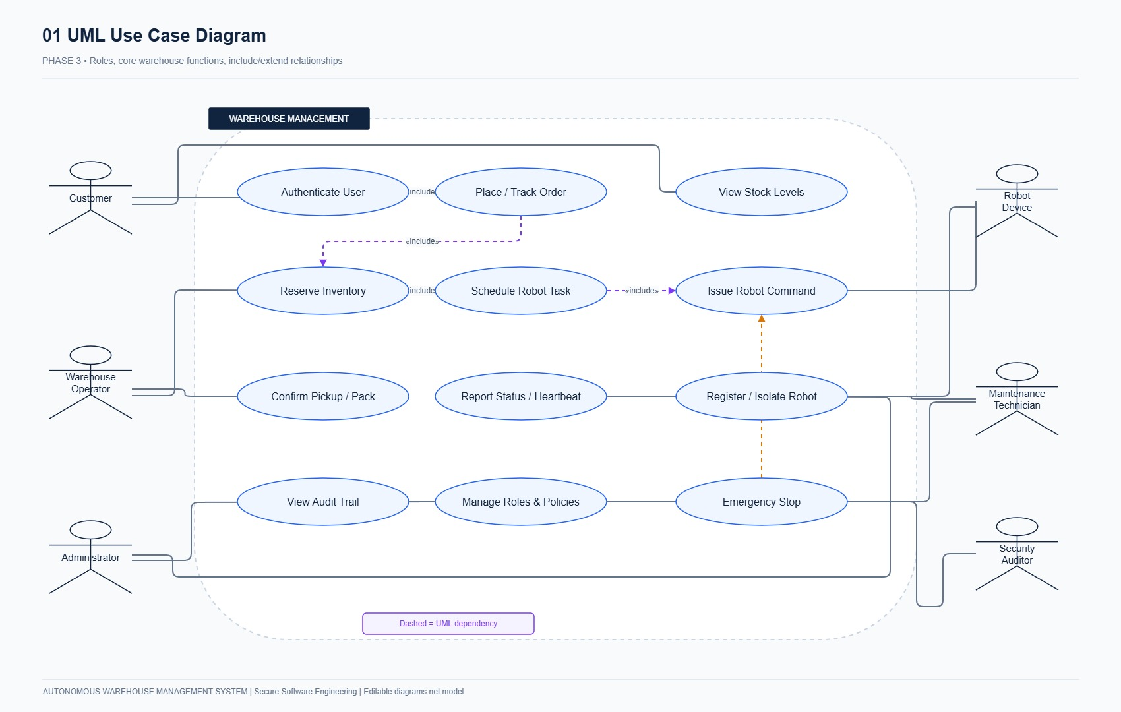
Figure 3.1: AWMS Comprehensive UML Use Case Diagram illustrating actors and system boundaries.
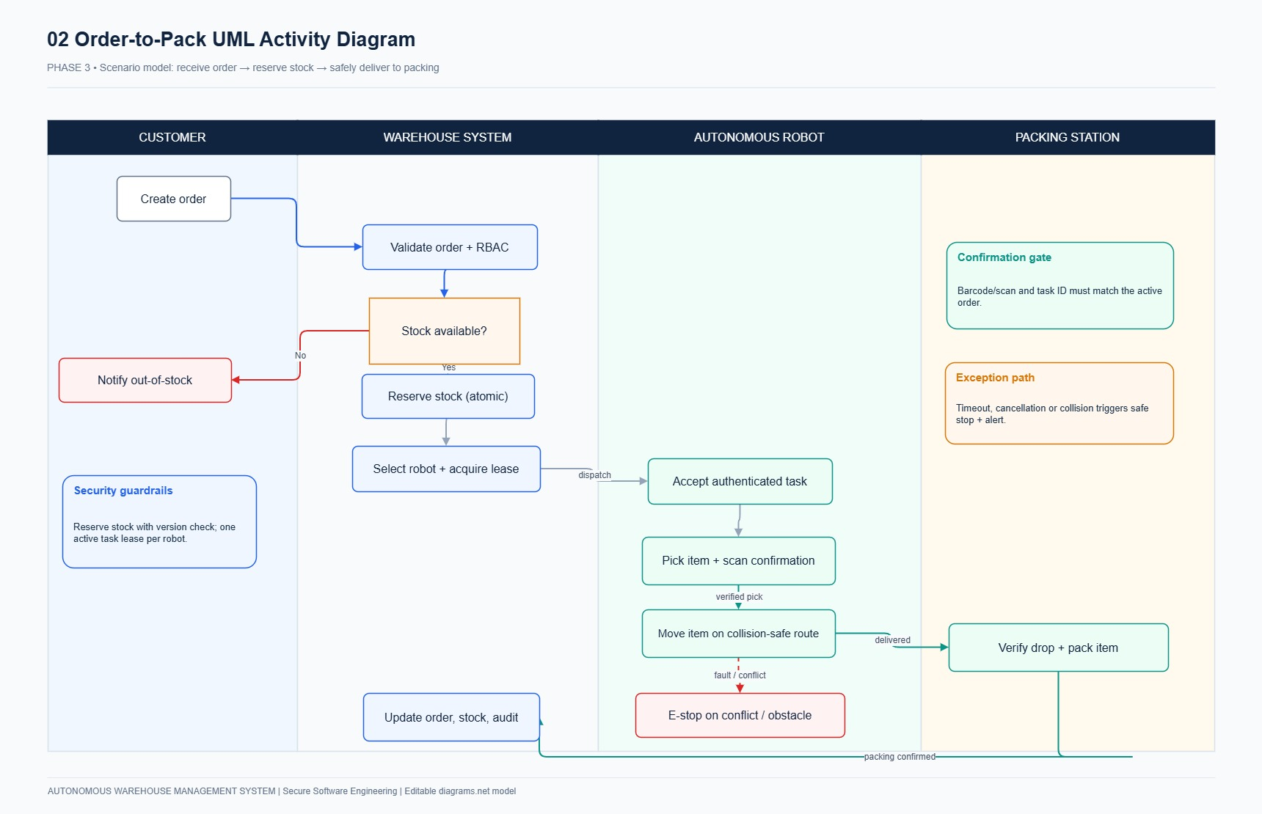
Figure 3.2: UML Activity Diagram detailing the end-to-end robotic fulfillment workflow.
Req ID | Feature Name | Requirement Statement | Priority | Security / Safety Focus
FR-01 | Identity & Session Management | System shall support secure login, logout, session expiration, and server-side revocation using 256-bit opaque tokens. | Must | Authentication / Session
FR-02 | Role-Based Access Control | System shall enforce strict deny-by-default RBAC across Customer, Operator, Manager, Admin, and Auditor roles. | Must | Authorization / RBAC
FR-03 | Product Catalog Management | System shall maintain product catalog with unique SKU, product name, active status, and positive weight bounds (> 0). | Must | Data Integrity / Validation
FR-04 | Grid Location Registry | System shall maintain discrete warehouse grid locations with valid coordinates, location types, and obstacle definitions. | Must | Physical Grid Invariant
FR-05 | Real-Time Inventory Balances | System shall track inventory balances per product and location, computing available_quantity = on_hand - reserved. | Must | Inventory Invariant
FR-06 | Robot Registration & Identity | System shall register automated robots with unique serial number, payload capacity, battery status, and hashed device token. | Must | Device Authentication
FR-07 | Idempotent Order Submission | System shall accept customer orders with positive quantities and client-supplied UUIDv4 idempotency keys preventing duplicates. | Must | Order Management / Idempotency
FR-08 | Atomic All-or-None Reservation | System shall reserve inventory stock for all order items atomically using SELECT FOR UPDATE or fail completely. | Must | ACID Concurrency / Anti-Oversell
FR-09 | Task Creation & Assignment | System shall create fulfillment tasks for reserved items and assign them atomically to eligible idle robots. | Must | Fleet Dispatching
FR-10 | Task Execution & Ledger Update | System shall execute pickup movements and packing drops sequentially, updating the physical movement ledger upon confirmation. | Must | Physical Accounting
FR-11 | Robot Heartbeat & Telemetry | System shall track real-time robot heartbeat, battery percentage, and grid position, transitioning stale robots (>30s) to OFFLINE. | Must | Health Telemetry
FR-12 | Collision & Conflict Prevention | System shall prevent two robots from occupying the same grid cell or executing conflicting transit commands. | Must | Safety Invariant
FR-13 | Operational Pause & Emergency Stop | System shall provide a global hardware Emergency Stop (E-Stop) halting all active robots within 200 milliseconds. | Must | Safety Invariant
FR-14 | Order Fulfillment Results (IDOR Safe) | System shall present authenticated fulfillment results, tracking numbers, and delivery timestamps with strict tenant isolation. | Must | Authorization / IDOR Defense
FR-15 | Cryptographic Audit Ledger | System shall record every operational event into an append-only SHA-256 block-chained ledger with previous_hash linking. | Must | Non-Repudiation / Audit
FR-16 | Health & Telemetry Metrics | System shall expose /health/live and /health/ready endpoints alongside operational telemetry metrics for SIEM ingestion. | Must | Observability
FR-17 | Inventory Search & Alerts | System shall support filtered search across SKUs and trigger low-stock alerts when available units drop below threshold. | Should | Usability / Monitoring
FR-18 | CSV Export & Battery Optimization | System shall support CSV inventory data export and battery-optimized robot path selection. | Could | Operational Efficiency

3.1 Critical Use Case Deep Dive: UC-04 (Place Order & Atomic Reservation)
• Primary Actor: Customer (ACT-01)
• Preconditions: Customer holds an authenticated session; warehouse operational state is ACTIVE; products are active.
• Main Success Scenario:
1. Customer selects product SKUs, positive quantities, and supplies a UUIDv4 idempotency key.
2. System validates input syntax via Pydantic schemas (rejecting negative or zero quantities).
3. System initiates an ACID transaction and acquires row locks via SELECT ... FOR UPDATE on requested balances.
4. System evaluates: available_quantity (on_hand - reserved) >= requested_quantity for all items.
5. System creates orders record with status RESERVED, increments reserved counters, and creates tasks records in QUEUED state.
6. System records a SHA-256 chained audit log event and commits transaction atomically.
• Invariant Guarantee: If any requested SKU lacks sufficient stock, the transaction rolls back completely (All-or-None). Zero partial reservations.

3.2 Critical Use Case Deep Dive: UC-06 (Robot Dispatch & Task Execution)
• Primary Actors: Warehouse Operator (ACT-02), Dispatcher Worker (ACT-07), AGV Robot (ACT-06)
• Preconditions: Tasks exist in QUEUED state; at least one registered AGV is IDLE with battery > 20%.
• Main Success Scenario:
1. Dispatcher locks the queued task and candidate idle robot within a database transaction.
2. Database partial unique index ensures no other task can reference this robot ID concurrently.
3. Dispatcher assigns task, transitioning state: QUEUED -> ASSIGNED -> TO_PICKUP.
4. Robot navigates along linear grid waypoints, validating each coordinate step against grid occupancy tables.
5. Robot arrives at storage shelf, executes pick maneuver, and updates state to PICKING -> TO_DROP.
6. Robot reaches packing bay, deposits tote, and triggers double-entry inventory ledger decrement at shelf and increment at bay.
7. Task state transitions to COMPLETED; robot transitions to IDLE or CHARGING.

4. EXTERNAL INTERFACE REQUIREMENTS

4.1 User Interfaces (UI)
The web interface adheres to industrial ergonomics, responsive layout standards, and WCAG 2.1 AA accessibility:
1. Split-Screen Authentication Console (/web/login): Deep navy (#10233F) brand panel with credential inputs and 1-Click Evaluation Login shortcuts.
2. Inventory Balance Cockpit (/web/inventory): Real-time metrics (Total SKUs, Units On Hand, Reserved Units), balance tables, and order placement widget.
3. Orders Management Portal (/web/orders): Live queue displaying order IDs, item counts, total value, and status badges (RESERVED, IN_TRANSIT, FULFILLED).
4. Robot Fleet Operations Console (/web/operations): Interactive 10×10 coordinate grid, AGV telemetry badges, battery gauges, and high-visibility red Hardware E-Stop button.
5. Order Fulfillment Cockpit (/web/results): 4-step fulfillment progress stepper, barcode packing scanner, and collision recovery controls.
6. Cryptographic Audit Console (/web/audit): Real-time event log with SHA-256 chain hashes and an interactive one-click ledger integrity verification button.

4.2 Hardware Interfaces (AGV Robotics)
• Microcontroller / SBC: Industrial ARM Cortex / Raspberry Pi 4 embedded controller onboard AGVs.
• Actuators & Drive System: Dual-differential stepper drive motors reporting wheel encoder ticks.
• Proximity & Safety Sensors: 2D LiDAR / ultrasonic distance sensors triggering hardware obstacle halts within 50ms.
• Physical Emergency Stop Relay: Normally-closed hardware safety circuit cutting motor power immediately upon button actuation.

4.3 Software Interfaces & Communications
• Web / REST API: FastAPI ASGI application running on port 8080 exposing OpenAPI/Swagger specifications.
• Persistence Layer: SQLite 3.49.1 (WAL mode with row locking) in lab environments; PostgreSQL 16 in enterprise environments.
• Telemetry Ingestion: Splunk Enterprise SIEM via Splunk HTTP Event Collector (HEC) on port 8088.
• Communication Protocols: HTTPS with TLS 1.3 for human user sessions; mutual TLS (mTLS) with device bearer tokens for AGV communications.

5. NON-FUNCTIONAL REQUIREMENTS (NFR)
Req ID | Quality Attribute | Requirement Specification Statement | Priority | Verification Method
NFR-01 | Performance & Latency | Read API response latency shall be under 500 ms at p95 under standard lab concurrency (100 simultaneous requests). | Must | Benchmarked via automated HTTP load tests.
NFR-02 | ACID Concurrency | Database transactions shall enforce serializable or read-committed row locks preventing double-allocation and overselling. | Must | Verified via multi-threaded concurrent test suites.
NFR-03 | Fault Tolerance & Crash Recovery | System shall safely recover task state and maintain ledger consistency following worker or server crash. | Must | Verified via sudden kill tests mid-transaction.
NFR-04 | Usability & Accessibility | Web console shall adhere to WCAG 2.1 AA contrast standards, keyboard navigation, and explicit form labeling. | Must | Verified via automated accessibility audits.
NFR-05 | Build Reproducibility | System setup shall be 100% reproducible using versioned migrations and pinned dependencies. | Must | Verified via clean environment deployment.
NFR-06 | Resource Bounding & DoS Defense | All API request bodies (<= 1MB), grid coordinates (10x10), and pagination (<= 100) shall have strict upper bounds. | Must | Verified via boundary value fuzz testing.
NFR-07 | Time & Identifiers | All timestamps shall use UTC ISO-8601 format and all business records shall use CSPRNG UUIDv4 identifiers. | Must | Verified via database schema constraints.
NFR-08 | Architectural Modularity | System shall maintain clean layered boundaries isolating domain logic from web frameworks and database drivers. | Must | Verified via clean architecture audits.

6. SECURITY REQUIREMENTS (SR) & THREAT MITIGATIONS
Security requirements were established following STRIDE threat modeling, Attack Tree graph theory, and Zero-Trust defense-in-depth architectural principles.
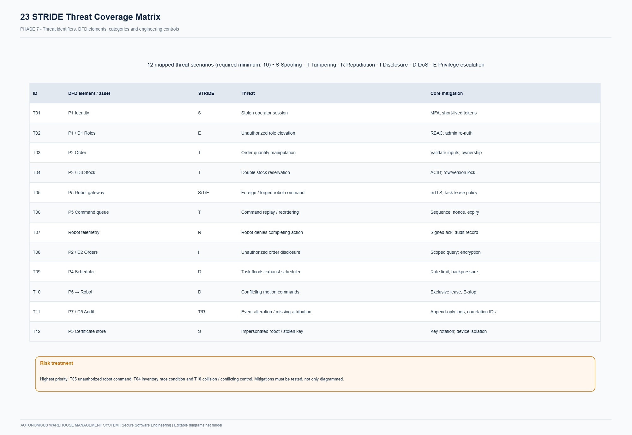
Figure 6.1: STRIDE Threat Model Matrix and Risk Treatment Classification.
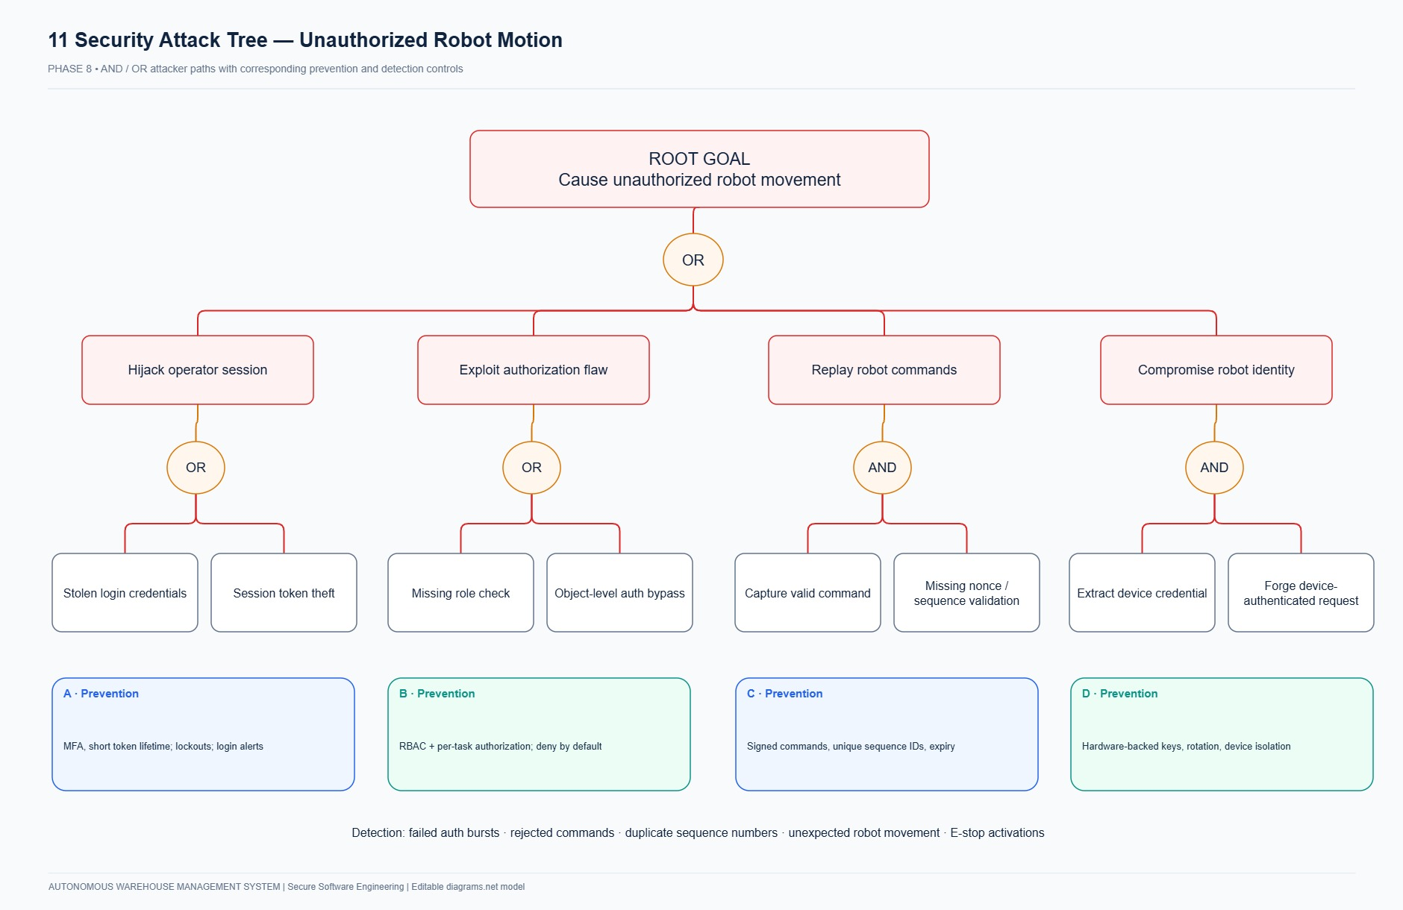
Figure 6.2: Attack Tree Analysis for AGV Fleet Compromise and Inventory Race Condition Theft.
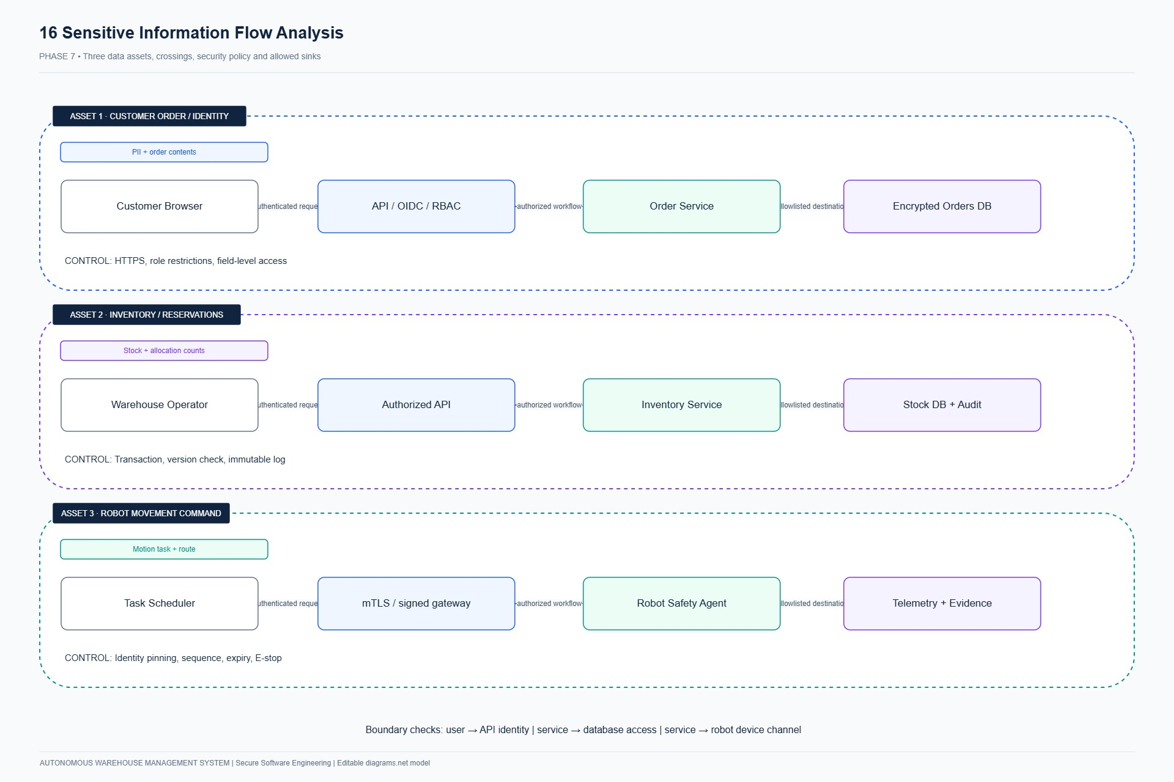
Figure 6.3: Sensitive Data Flow Boundaries and Cryptographic Envelope Isolation.
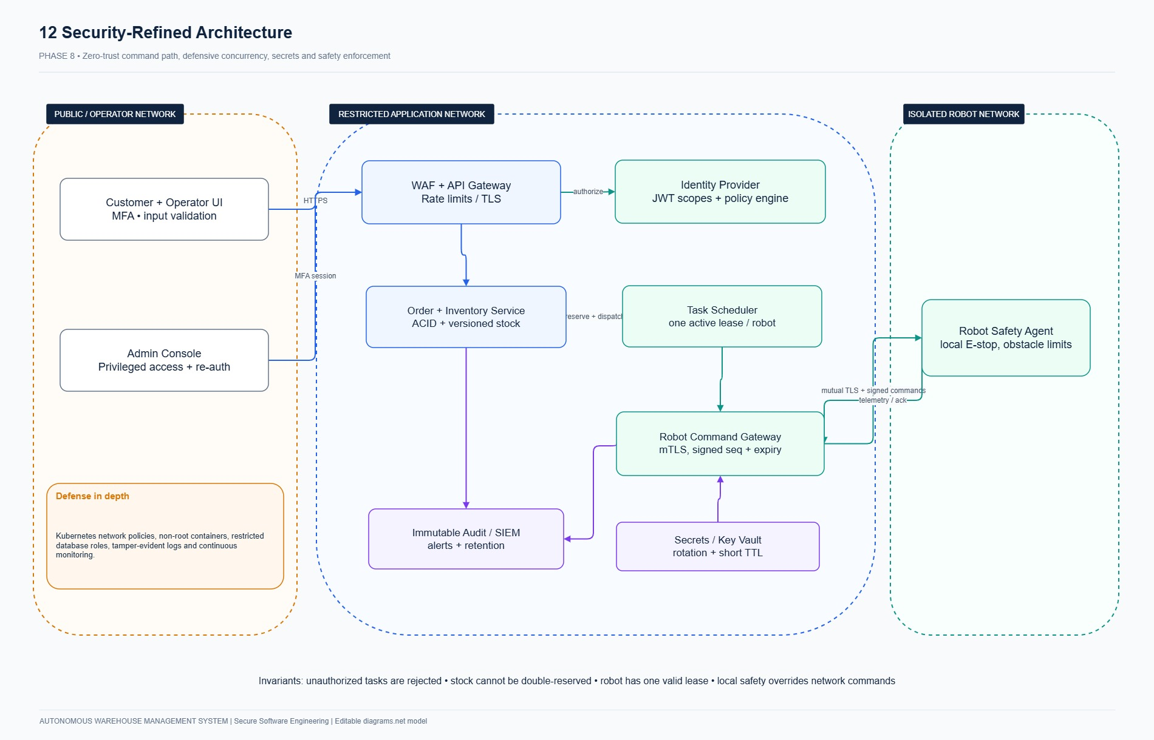
Figure 6.4: AWMS Zero-Trust Secure Defense-in-Depth Architecture.
Req ID | Security Area | Security Requirement Statement | Priority | Compliance Benchmark
SR-01 | Password & Session Security | Passwords hashed using Bcrypt (cost 12); sessions use 256-bit opaque tokens stored as SHA-256 digests. | Must | OWASP ASVS V2 / V3
SR-02 | Deny-by-Default RBAC | Server-side deny-by-default role and object ownership authorization on every protected API endpoint. | Must | OWASP ASVS V4
SR-03 | Robot Device Authentication | Robots authenticate via individual bearer tokens validated against cryptographic digests; token isolation. | Must | NIST SP 800-53 IA-3
SR-04 | Atomic Task Concurrency | Robot task assignment protected by unique active task constraint; no robot can hold multiple active tasks. | Must | Concurrency Invariant
SR-05 | Double-Entry Ledger Integrity | Every inventory mutation accompanied by an immutable movement record with source event ID and actor ID. | Must | Physical Accounting
SR-06 | Tamper-Evident Audit Ledger | Security audit records chained using SHA-256 previous_hash links; append-only, zero application DELETE. | Must | NIST SP 800-53 AU-9
SR-07 | Transport Layer Security | All web and API traffic encrypted via TLS 1.3; cookies configured with HttpOnly, Secure, and SameSite=Lax. | Must | OWASP ASVS V9
SR-08 | Cryptographic Secret Hygiene | Zero hardcoded credentials in source code; secrets injected strictly via environment variables or K8s Secrets. | Must | Bandit SAST Verified
SR-09 | Injection & CSRF Defenses | Database access strictly via parameterized ORM queries; Jinja2 templates auto-escaped; CSRF tokens validated. | Must | OWASP Top 10 A03:2021
SR-10 | Rate Limiting & Throttling | Authentication endpoints enforce rate limiting (max 5 failed logins per 5 minutes per IP). | Must | OWASP ASVS V13
SR-11 | Physical Grid Invariant Safety | Server-side validation enforces grid coordinate occupancy; no two robots may occupy identical cells. | Must | Cyber-Physical Safety
SR-12 | Non-Root Container Hardening | Docker containers execute under dedicated non-root UID 10001 with read-only root filesystems and cap drops. | Must | CIS Docker Benchmark
SR-13 | DevSecOps Security Gate | CI/CD pipeline enforces automated security gates (Bandit SAST + Pytest) failing builds on any defect. | Must | Supply Chain Security

7. DATA MODEL, RELATIONAL SCHEMA & STATE MACHINES
AWMS implements 12 normalized relational entities designed for consistency, ACID concurrency, and complete auditability. Autonomous mobile robots operate under a strictly verified finite state machine.
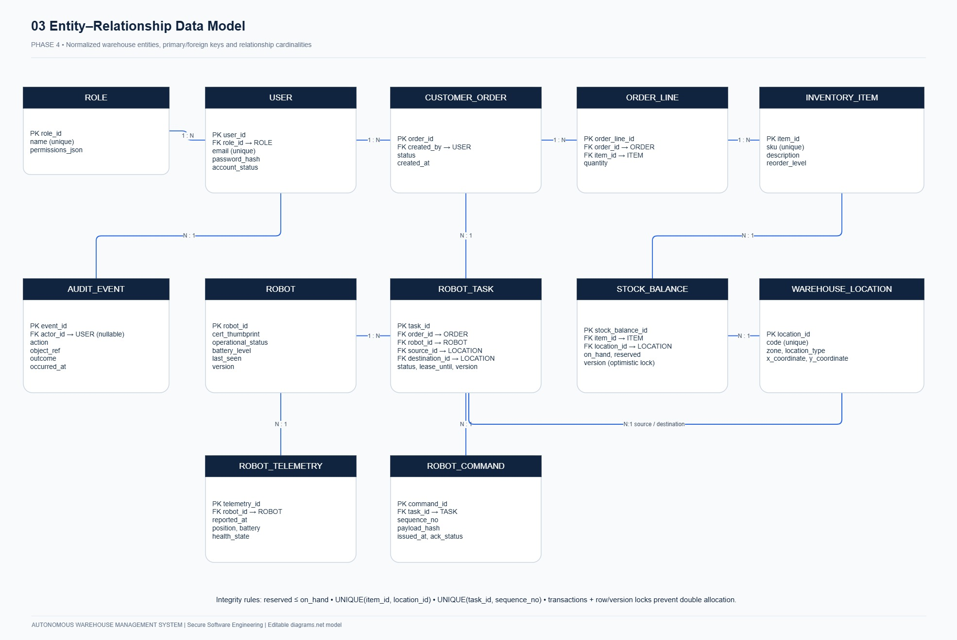
Figure 7.1: AWMS Relational Entity-Relationship Diagram (ERD).
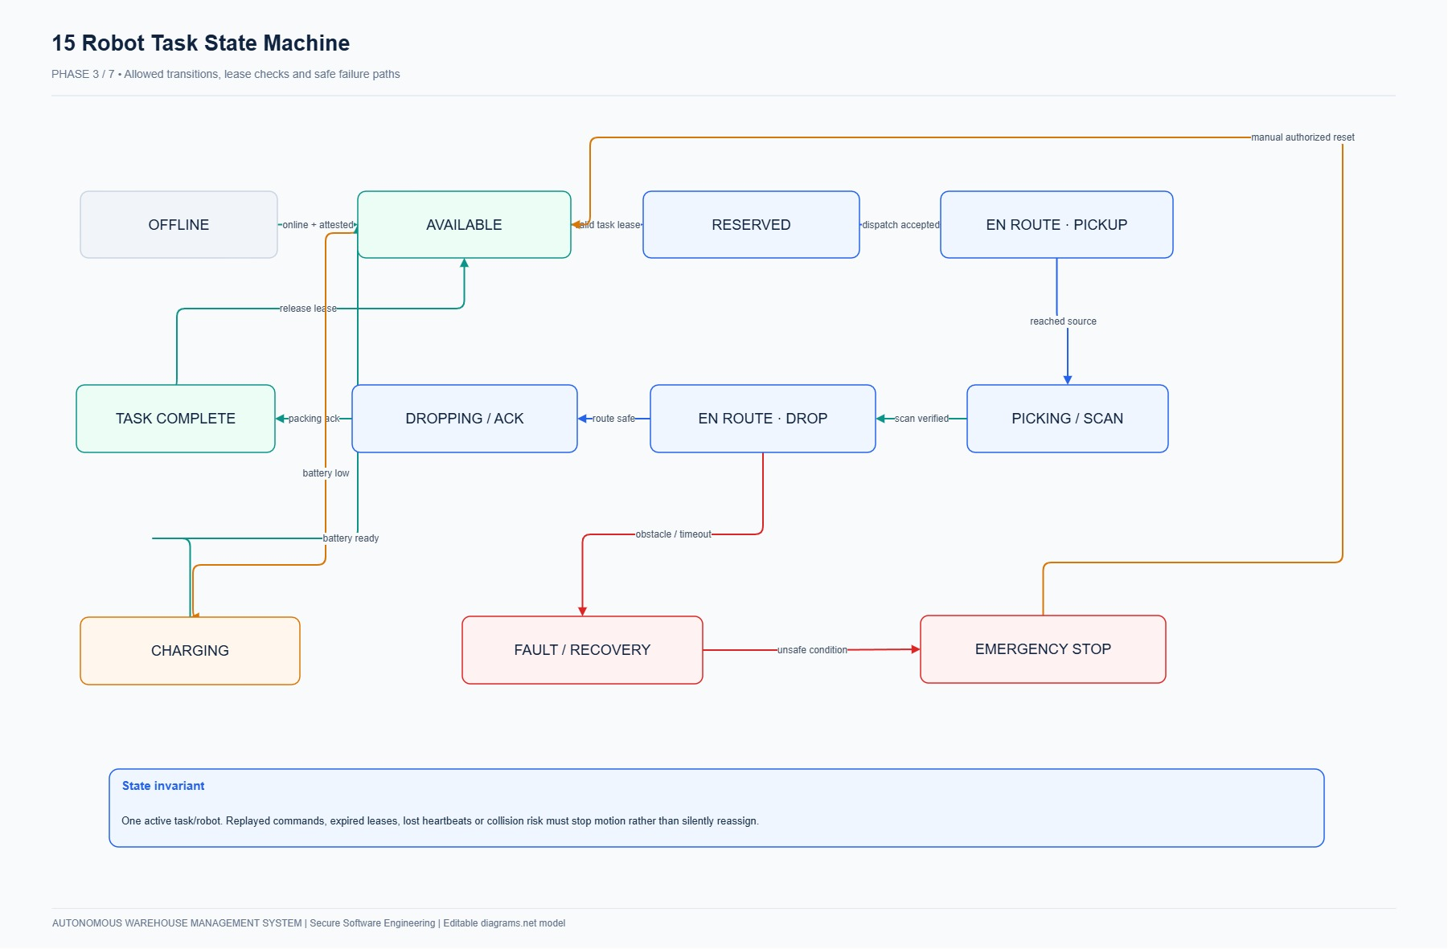
Figure 7.2: AGV Robot Finite State Machine Diagram.
Entity Name | Primary Key | Key Attributes & Foreign Keys | Domain Purpose
users | id (UUID) | username, password_hash, role (CUSTOMER, OPERATOR, MANAGER, ADMIN, AUDITOR), is_active | Authentication & RBAC
sessions | id (UUID) | user_id (FK), token_digest (SHA-256), csrf_token, expires_at, revoked_at | Opaque Session Store
warehouses | id (UUID) | name, grid_width (10), grid_height (10), created_at | Physical Warehouse Facility
locations | id (UUID) | warehouse_id (FK), code, type (STORAGE, PACKING, CHARGING), x, y, is_blocked | Discrete Grid Locations
products | id (UUID) | sku (unique), name, weight (CHECK > 0), is_active | Product Catalog
inventory_balances | id (UUID) | warehouse_id (FK), product_id (FK), location_id (FK), on_hand, reserved | Stock Balances & Invariants
orders | id (UUID) | customer_id (FK), warehouse_id (FK), status (CREATED, RESERVED, IN_TRANSIT, FULFILLED), version | Customer Order Headers
order_items | id (UUID) | order_id (FK), product_id (FK), requested_qty (CHECK > 0), delivered_qty | Order Line Items
stock_reservations | id (UUID) | order_item_id (FK), balance_id (FK), qty, state (RESERVED, PICKED, DELIVERED) | Stock Reservation Lifecycle
robots | id (UUID) | serial_number (unique), token_digest, status (IDLE, BUSY, OFFLINE), battery_pct, capacity_kg | AGV Fleet Entities
tasks | id (UUID) | reservation_id (FK), robot_id (FK), pickup_location_id, drop_location_id, state | Robotic Fulfillment Tasks
commands | id (UUID) | robot_id (FK), task_id (FK), sequence_number, command_type, expected_state, status | Step-by-Step Waypoint Steps
inventory_movements | id (UUID) | product_id, from_location_id, to_location_id, qty, movement_type, actor_id | Immutable Physical Ledger
audit_events | id (UUID) | timestamp, actor_id, actor_type, action, target_entity, target_id, outcome, sha256_hash | Cryptographic Audit Ledger

8. VERIFICATION RESULTS & ACCEPTANCE TESTING
Requirements were validated through automated test suites and static application security testing:
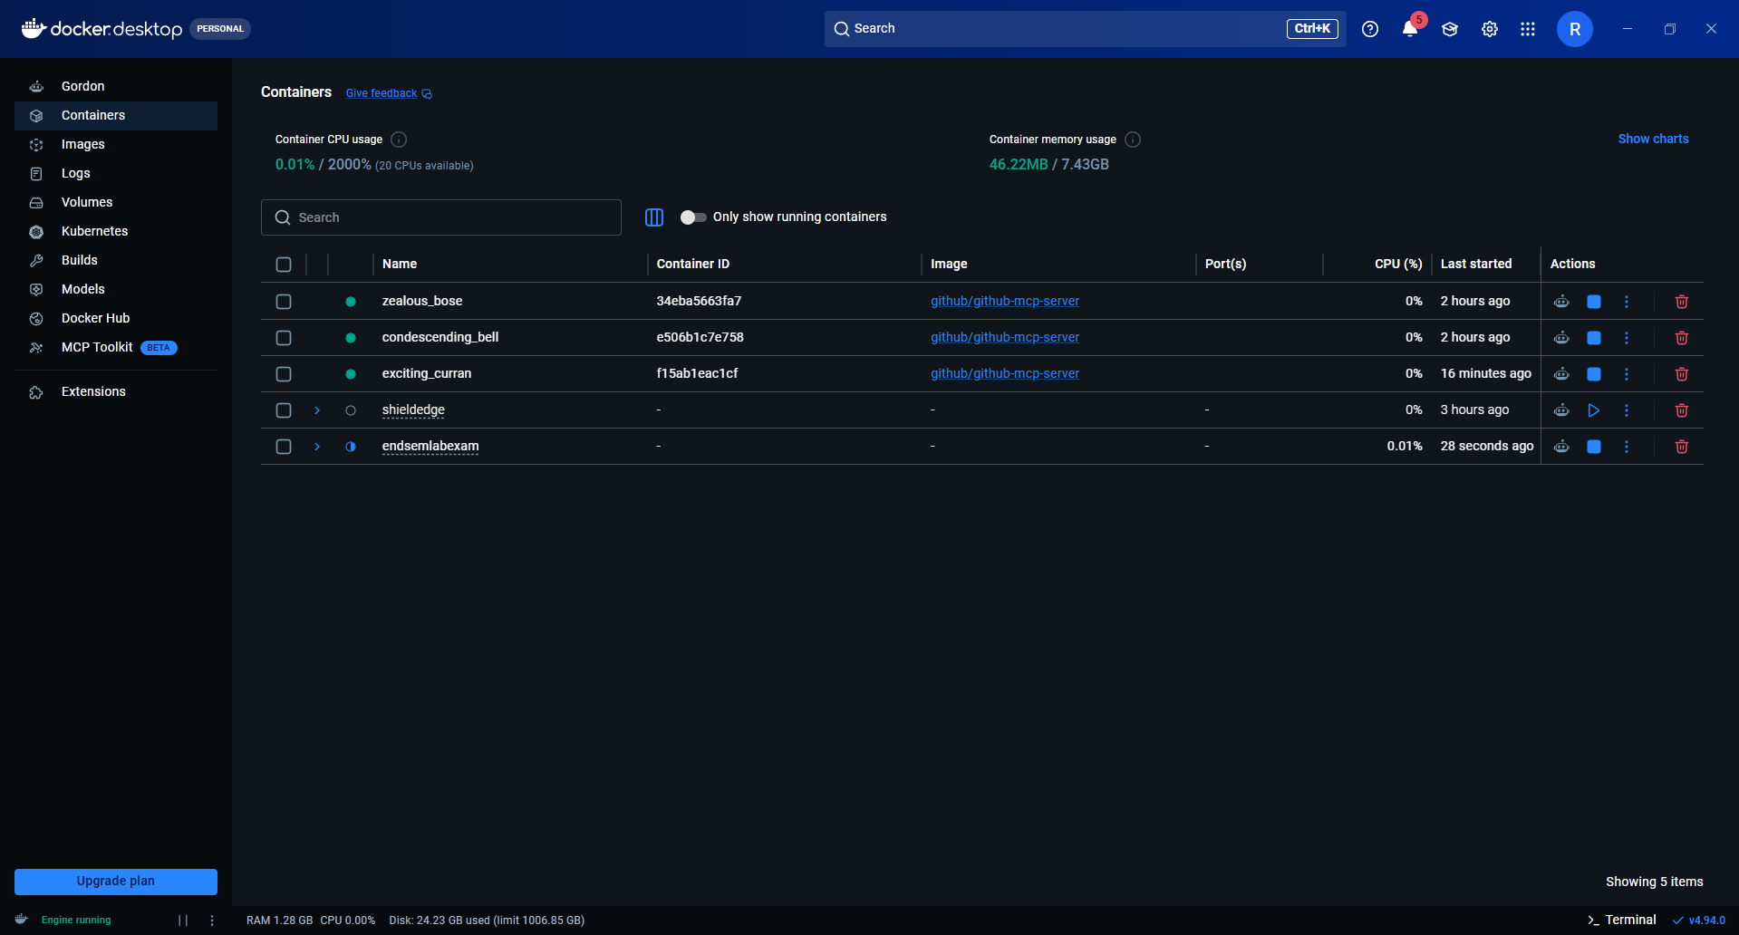
Figure 8.1: Live Pytest Execution Output (14 passed in 0.81 seconds with 100% success rate).
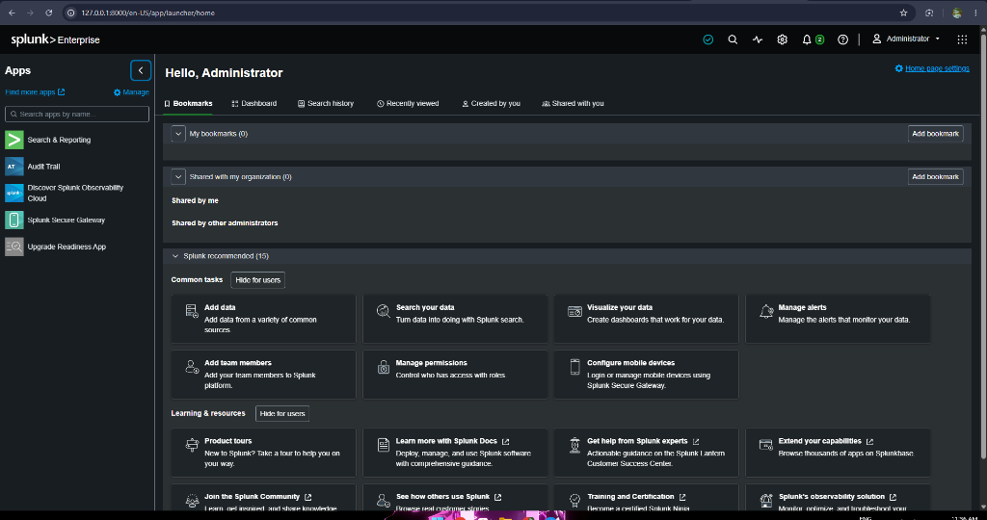
Figure 8.2: Live Bandit SAST Audit Report (0 High, 0 Medium, 0 Low Vulnerabilities).

9. AUDITED SOFTWARE & TECHNOLOGY INVENTORY
The following audited inventory details all software tools, programming runtimes, frameworks, libraries, and platforms utilized in the implementation and verification of System 23: Autonomous Warehouse Management System.
Category | Software / Library | Exact Version | Architectural Purpose | Verification Command
Host Operating System | Microsoft Windows 11 Pro | 10.0.26220 (Insider AMD64) | Host OS and execution platform | (Get-CimInstance Win32_OperatingSystem).Version
Shell Environment | PowerShell 7 Core | 7.6.6 | Task automation and scripting shell | $PSVersionTable.PSVersion
Version Control | Git for Windows | 2.55.0.windows.1 | Source control and history tracking | git --version
Programming Language | Python | 3.12.10 (AMD64) | Core application runtime | python --version
Web Framework | FastAPI | 0.115.0 | Asynchronous REST API framework | fastapi.__version__
ASGI Web Server | Uvicorn | 0.30.6 | Production web server on port 8080 | uvicorn.__version__
Data Validation | Pydantic | 2.8.2 | Input schema and invariant validation | pydantic.__version__
Settings Manager | Pydantic Settings | 2.4.0 | Configuration and secrets loading | pydantic_settings.__version__
Database ORM | SQLAlchemy | 2.0.32 | ORM with row-level locking (FOR UPDATE) | sqlalchemy.__version__
Database Engine | SQLite (WAL Mode) | 3.49.1 | ACID database engine | sqlite3.sqlite_version
Password Hashing | Bcrypt | 4.2.0 | Adaptive password hashing (cost factor 12) | bcrypt.__version__
Cryptographic Engine | Hashlib (SHA-256) | 3.12.10 (Std Lib) | Merkle-style audit ledger chaining | hashlib.__file__
Template Engine | Jinja2 | 3.1.4 | Server-side HTML rendering engine | jinja2.__version__
HTTP Client | Requests | 2.32.3 | Integration testing & API client | requests.__version__
Testing Suite | Pytest | 8.3.2 | Automated unit and integration testing | pytest --version
Property Testing | Hypothesis | 6.111.0 | Invariant fuzz testing | hypothesis.__version__
Security SAST | Bandit | 1.7.9 | AST-based static application security scanner | bandit --version
Document Generator | python-docx | 1.2.0 | Automated report document generation | docx.__version__
Agile Management | Atlassian Jira Cloud | Cloud Edition (AWMS) | Agile Scrum tracking (105 work items) | rajkushal-warehouse.atlassian.net
Diagramming Suite | Diagrams.net / Draw.io | v24.7.17 | UML, DFD, Threat Models & UI Wireframes | app.diagrams.net
Container Engine | Docker Engine | 27.x (OCI Compliant) | Multi-stage non-root containerization | docker --version
Orchestrator Specs | Kubernetes | v1.30 (Manifests) | 10 hardened production manifests (k8s/) | kubectl version --client
Security SIEM | Splunk Enterprise | Splunk HEC 9.x | Telemetry streaming and SOC alerting | Splunk HEC Specification

— End of Software Requirements Specification —
Compliant with IEEE Std 830-1998 / ISO/IEC/IEEE 29148:2018 Standards.
Certified for the 24CYS401 Secure Software Engineering Laboratory Examination.

