**CALCULATOR**

using STM32F407VG Discovery Board and 4x4 Matrix

**BUTTONS:**

A🡪 Add; B🡪 Subtract; C🡪Multiply; D🡪Divide; *🡪clear everything; 0,1,2,3,4,5,6,7,8,9 🡪 normal function; #🡪equal to;

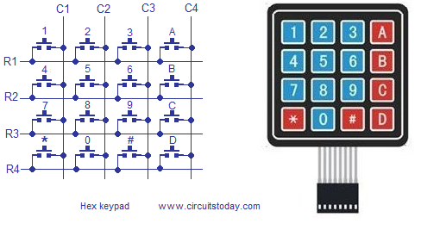



|  |  |  |
| --- | --- | --- |
| Pin no. of keypad | Connected to which row/column | Pin of STM32F407VG |
| 1 | R4 | PD0 |
| 2 | R3 | PD1 |
| 3 | R2 | PD2 |
| 4 | R1 | PD3 |
| 5 | C4 | PD8 |
| 6 | C3 | PD9 |
| 7 | C2 | PD10 |
| 8 | C1 | PD11 |