Name :- Nilesh Raj
Email: nileshraji811001@gamil.com

Exercise 1: Setting Up JUnit
Scenario: You need to set up JUnit in your Java project to start writing unit
tests.

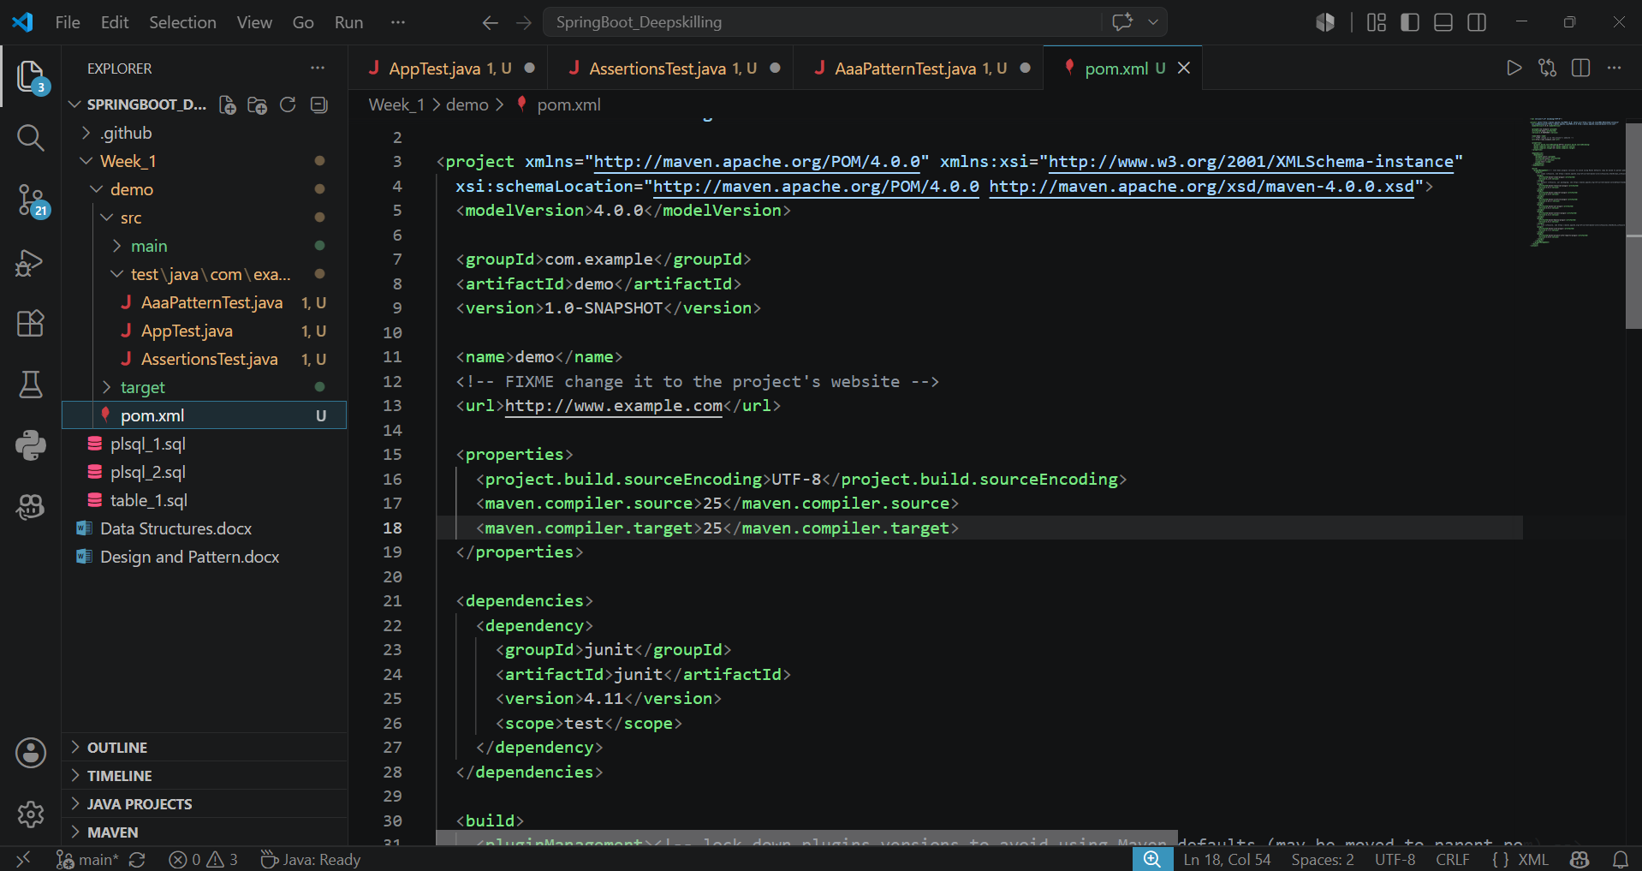

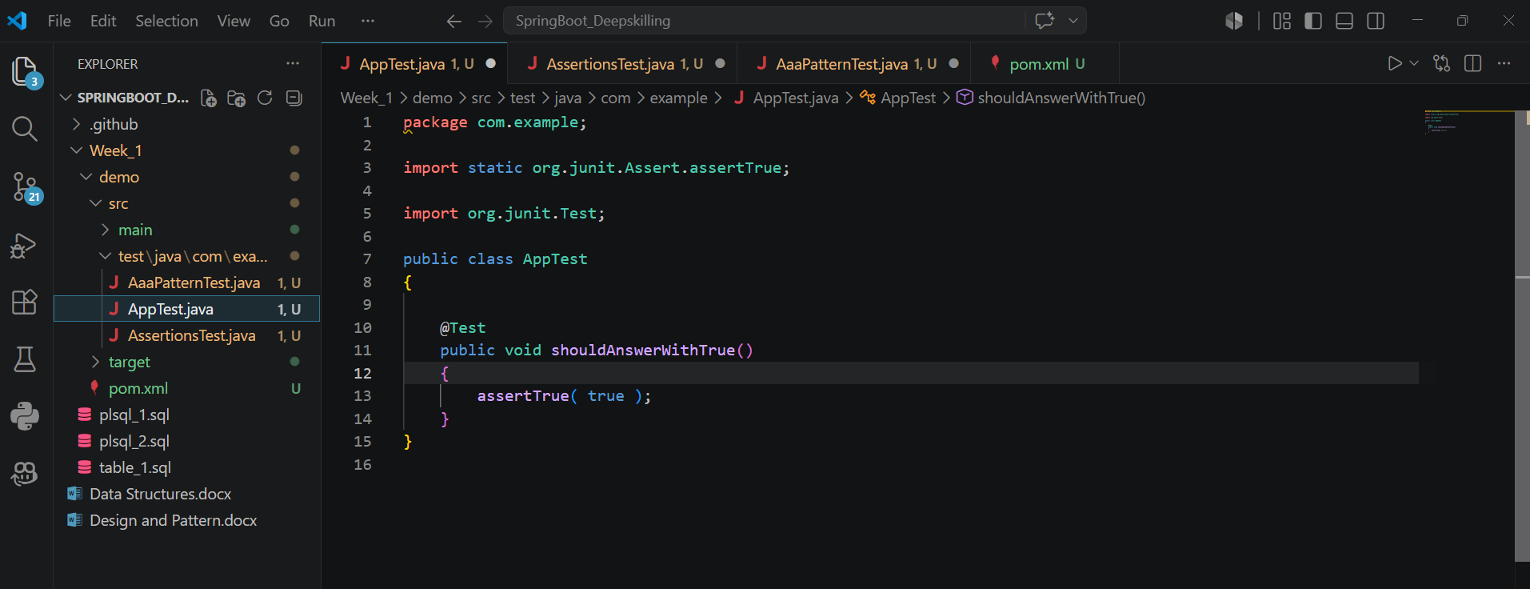
OUTPUT:
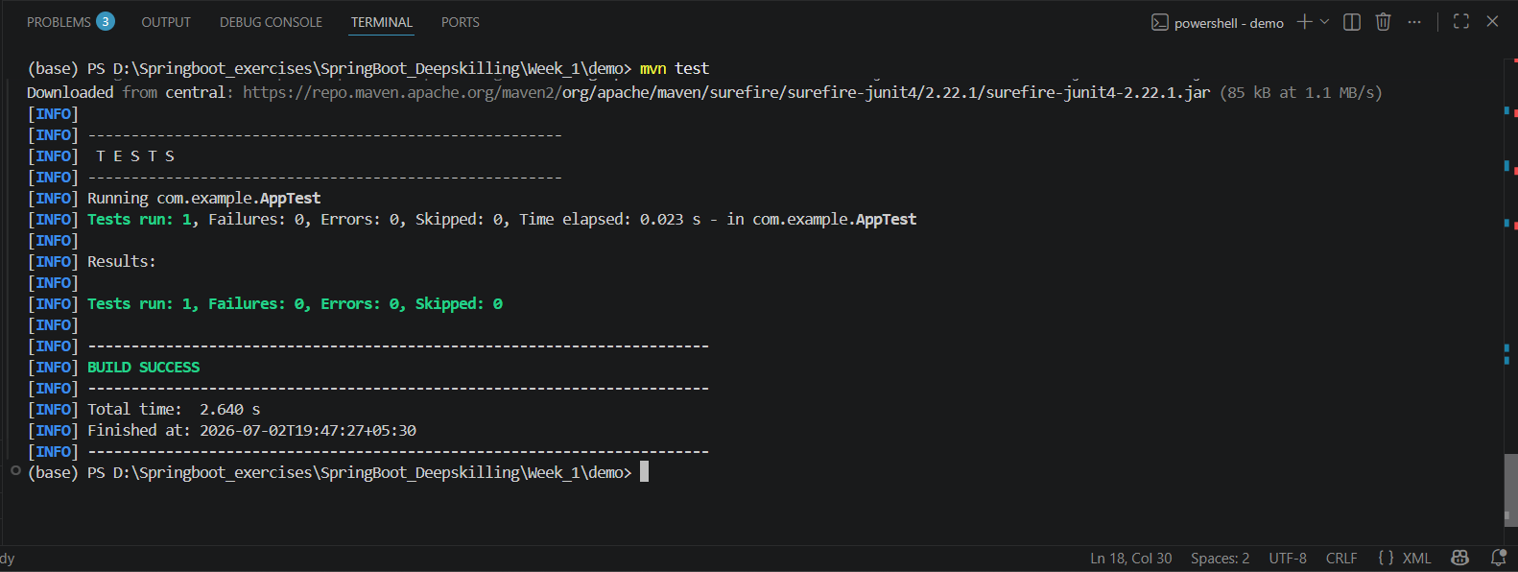

Exercise 3: Assertions in JUnit
Scenario: You need to use different assertions in JUnit to validate your test results.

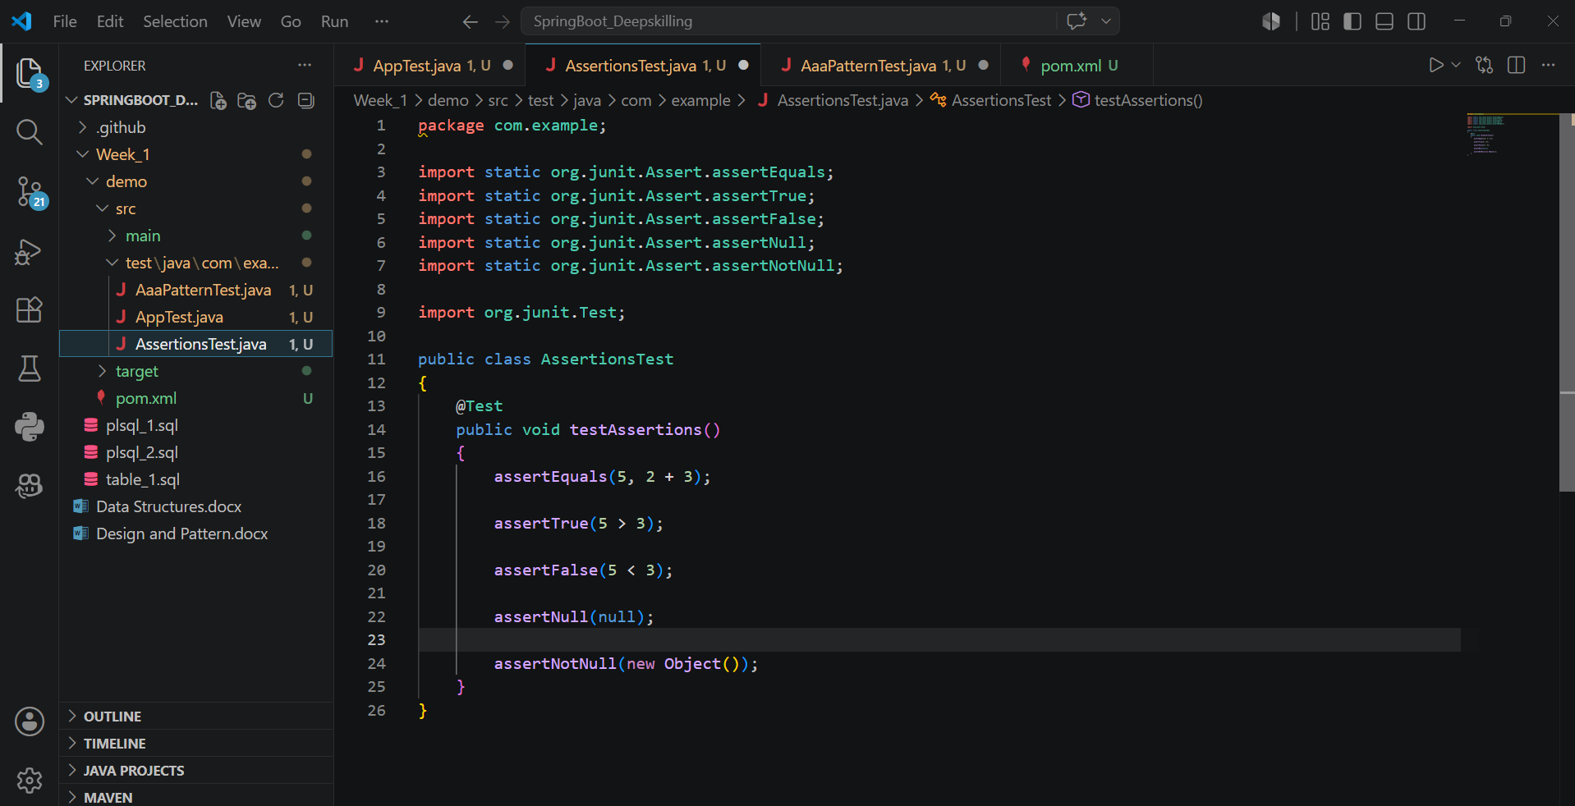
OUTPUT:
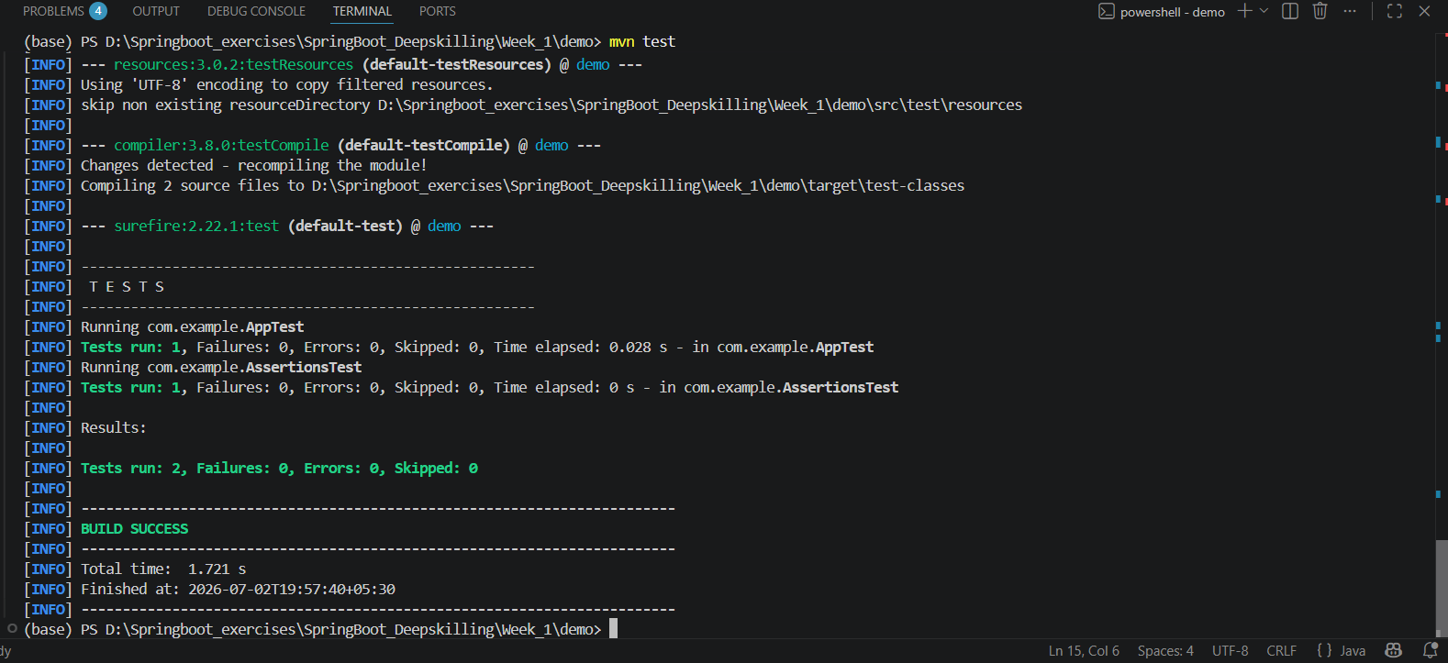

Exercise 4: Arrange-Act-Assert (AAA) Pattern, Test Fixtures, Setup and Teardown Methods in JUnit
Scenario: You need to organize your tests using the Arrange-Act-Assert (AAA) pattern and use setup and teardown methods.

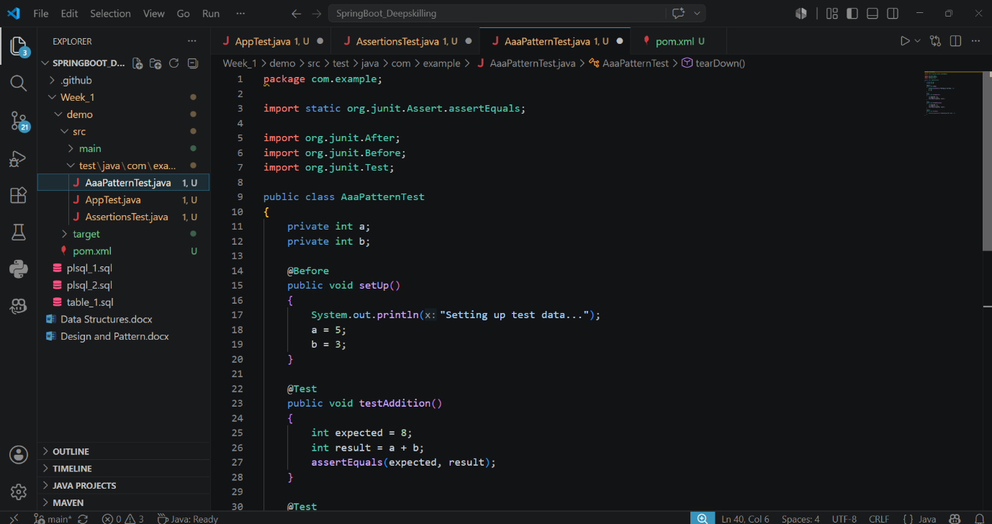
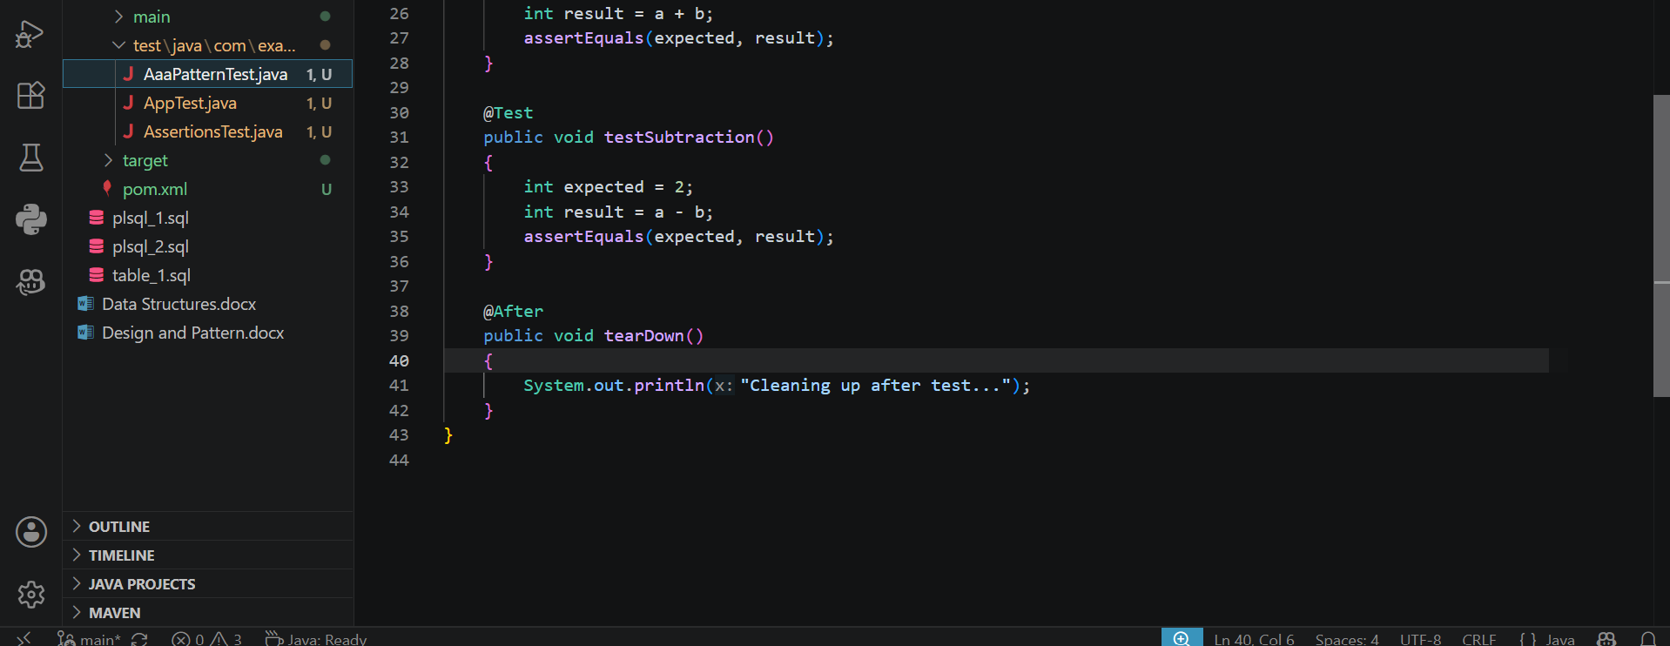

OUTPUT:
