Microbiology LIMS POC — Process Reference
Companion to microbio_lims_architecture.drawio
Rajneesh Tiwari
April 2026

What the system does
A subject-matter expert (SME) drops microbiology SOPs into S3. An agent pipeline, grounded in a hybrid retrieval substrate (BM25 + dense), reads them and emits two artifacts:
- Output A — Jira-ready Epic / Story tree for the dev team.
- Output B — One YAML configuration profile per culture (urine, blood, target-pathogen) carrying the concrete typed values.
The existing Cytology Jira backlog is used as a teaching corpus — example (SOP excerpt → Story) pairs the agent learns the house style from. It is not a registry to match against. The agent stops at Story; Tasks (test IDs, library versions, DB columns) are dev-authored once the team has codebase visibility.

Key terms (glossary)
Term | Meaning
SOP | Standard Operating Procedure — the source document the agent reads.
Epic | A capability domain. Maps to a Jira Epic. Example: Microbiology Specimen Receipt.
Story | A dev-actionable unit emitted by the agent. Each Story declares one of four shape values (see below). Maps to a Jira Story.
Shape | Categorization assigned to each Story at extraction time. Drives Validator routing and downstream interpretation. Four values: capability, workflow-stage-split, configuration-instance, cleanup.
Theme (G1–G8) | Eight content tags that span the LIMS workflow: G1 Pre-Analytic, G2 Analytic, G3 Post-Analytic, G4 Reporting, G5 QC, G6 Compliance, G7 Instrumentation, G8 Platform. Multi-label per chunk (a chunk can carry multiple themes with confidences).
Teaching corpus | The curated set of SME-validated (SOP excerpt → Story) pairs from Cyto. Used as few-shot exemplars at extraction time.
Retrieval slot | A parallel retrieval channel scoped to a particular discipline + theme combination (e.g. PRIMARY = Micro/active-themes, ANALOGY = Cyto/active-themes). The chat layer fires up to 5 slots per query.
Intent | The system’s structured interpretation of a user query: {action, themes, discipline, granularity, refs, confidence}.
τ (tau) | Intent-confidence threshold (default 0.7). Below this, the system asks a clarifying question rather than retrieving.
θ (theta) | Retrieval-relevance threshold (default 0.5). If every slot falls below this, the system refuses to generate.
Batch wait | The pipeline pause between Validator gate #1 and Cross-SOP Synthesis. Synthesis cannot run until every per-SOP Story has cleared gate #1, because cross-SOP recurrence cannot be detected mid-batch.

Agent pipeline — five agents, Validator gates twice
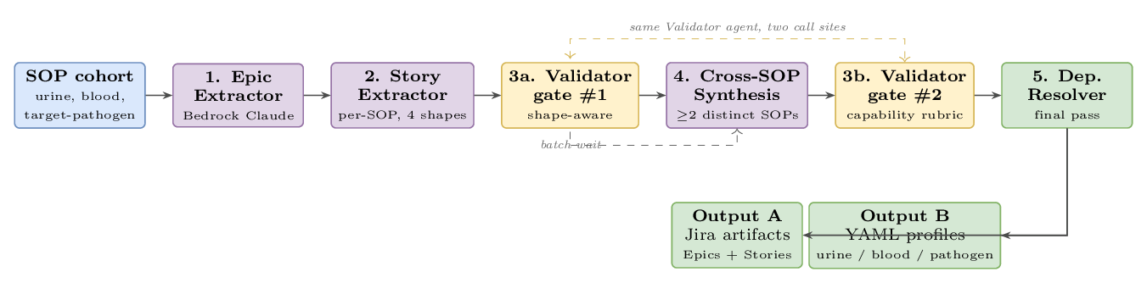
Agent pipeline. Five agents run as a single batch over the SOP cohort. The same Validator agent is invoked at two call sites — once per-SOP, once after synthesis.
What each box does and emits:
- Epic Extractor — identifies capability domains across the SOP cohort. Output: one Epic record per domain.
- Story Extractor — runs once per SOP. Emits Stories with the shape field declared per element (so different elements of the same SOP can take different shapes).
- Validator gate #1 — verifies the declared shape, then applies a shape-specific sub-rubric. Two revision rounds; on exhaustion, escalate to SME with the failed-checks list visible.
- Cross-SOP Synthesis — runs only after gate #1 has cleared the entire batch (the batch wait). Behavioral-similarity clustering over (title + AC + source excerpt). A cluster qualifies only if its members come from ≥ 2 distinct SOPs (two stories from the same SOP do not qualify). Lifts a capability-shaped Story per qualifying cluster, recording cross_links[] back to the contributing concretes. Concrete stories are kept; the capability story is added as a sibling, not a replacement.
- Validator gate #2 — same agent as 3a; capability rubric only. Synthesized stories are a new artifact, not a derivative of validated input, so they re-pass the bar.
- Dependency Resolver — final pass. Resolves story-to-story dependencies, stage-split sibling links, and capability-to-child links. Outputs Jira-ready artifacts.

Four story shapes — what “shape” means
A shape is the categorization the Story Extractor assigns to each Story. It tells the Validator which sub-rubric to apply, and tells downstream consumers (devs reading the backlog, the YAML emitter) how to interpret the AC. Per-SOP extraction picks one of four shapes per element. Cross-SOP synthesis only ever emits the capability shape.
Shape | Use when… | Validator rubric
capability | The SOP describes a configurable system feature you can imagine multiple labs/cultures parameterizing | MUST/SHALL on AC; testable; configurability boundaries explicit
workflow-stage-split | Same capability, but the SOP describes different behavior at different workflow stages (e.g. before / during / after results) | Stage explicit in title; sibling stories enumerated and cross-linked
configuration-instance | Concrete data values for one culture / lab. No new feature — just data. | Typed values (units / enums / nullable); SOP excerpt cited verbatim. MUST/SHALL not required.
cleanup | Modify or remove an existing artifact (field, screen, table, deprecated path). No new feature. | Target artifact named; before/after observable; regression risk acknowledged. MUST/SHALL not required.
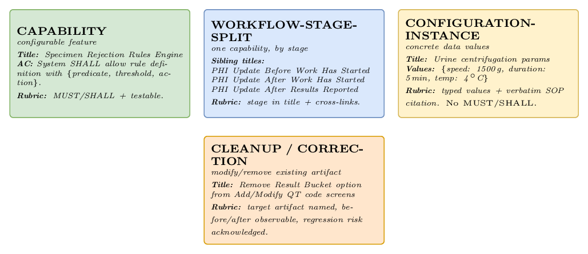
The four story shapes, with example title, AC snippet, and rubric pointer for each.

Schemas — deep dive
Code blocks below are illustrative JSON / YAML; the production representation is JSON-schema-validated before persistence.

Epic schema
{
"id": "EPIC-MICRO-001",
"title": "Microbiology Specimen Receipt",
"description": "All capabilities related to receiving and accepting microbiology specimens.",
"discipline": "microbiology",
"themes": ["G1", "G5"],
"cyto_epic_analog": "EPIC-CYTO-007"
}
Field | Type | Required | Notes
id | string | yes | Jira-shaped Epic ID.
title | string | yes | Short capability-domain name.
description | string | yes | One- to three-sentence scope statement.
discipline | enum | yes | microbiology | histology | cytology. Currently always microbiology for the POC.
themes[] | array of G1–G8 | yes | Multi-label; an Epic can span themes (e.g. G1 + G5).
cyto_epic_analog | string | optional | Cyto Epic ID this Epic is structurally analogous to (D13 annotation).

Story schema
{
"id": "STORY-MICRO-1042",
"epic_id": "EPIC-MICRO-001",
"shape": "capability",
"title": "Configurable specimen rejection rules engine",
"description": "As an admin, I want configurable specimen rejection rules so that each lab can codify its own acceptance criteria.",
"acceptance_criteria": [
{ "when": "rule is defined", "then": "rule has {predicate, threshold, action}" },
{ "when": "specimen received", "then": "applicable rules evaluated; rejection record emitted" }
],
"source_citations": [
{ "doc_id": "doc_micro_014_v3", "section": "Procedure §3.2", "line_range": [41, 43] }
],
"dependencies": ["STORY-MICRO-1018"],
"cross_links": ["STORY-MICRO-1043", "STORY-MICRO-1044", "STORY-MICRO-1045"],
"estimated_complexity": "M",
"edge_cases_handled": ["operator override", "rule conflict resolution"],
"status": "validated",
"source_chunks": ["chunk_001", "chunk_017"]
}
Field | Type | Required | Notes
id | string | yes | Jira-shaped Story ID.
epic_id | string | yes | FK to parent Epic.
shape | enum | yes | One of capability, workflow-stage-split, configuration-instance, cleanup. Drives Validator routing.
title | string | yes | Concrete and unambiguous. For stage-split, must name the stage.
description | string | yes | User story format preferred for capability/stage-split; descriptive prose for config-instance/cleanup.
acceptance_criteria[] | array of {when, then, expected_value?} | yes | Capability/stage-split use MUST/SHALL phrasing; config-instance carries expected_value; cleanup carries before/after.
source_citations[] | array of {doc_id, section, line_range} | yes | Must resolve to indexed chunks; verbatim excerpt for config-instance.
dependencies[] | array of Story IDs | optional | Stories that must complete before this one is workable.
cross_links[] | array of Story IDs | optional | Capability ↔ concrete contributors; stage-split sibling group. Backbone of the Story DAG.
technical_hints | string | optional | Dev-facing guidance (e.g. “consider extending the existing rules table”).
estimated_complexity | enum | yes | S | M | L. Heuristic, used for sprint sizing.
edge_cases_handled[] | array of strings | optional | Surfaced corner cases the SOP / rules engine should handle.
status | enum | yes | draft | validated | ready. Validated = passed the gate; ready = SME-accepted.
source_chunks[] | array of chunk IDs | yes | Audit trail back to retrieval-substrate chunks.

Cluster schema (intermediate, in Cross-SOP Synthesis)
Not persisted to Jira; lives only between gate #1 and gate #2 in memory.
{
"cluster_id": "clust_rejection_3sop",
"member_story_ids": ["STORY-MICRO-1043", "STORY-MICRO-1044", "STORY-MICRO-1045"],
"source_sops": ["doc_micro_014_v3", "doc_micro_022_v1", "doc_micro_037_v2"],
"centroid_summary": "Reject specimen on a culture-specific predicate (turbidity / hemolysis / container).",
"proposed_capability_title": "Configurable specimen rejection rules engine"
}
A cluster qualifies for lifting iff len(unique(source_sops)) >= 2. Two stories from the same SOP do not qualify, even if they cluster tightly.

Validator output schema (when a Story fails)
{
"story_id": "STORY-MICRO-1042",
"verdict": "revise",
"shape_declared": "capability",
"shape_verified": "capability",
"failed_checks": [
{ "rule": "must_shall_present", "severity": "error", "message": "AC 1 lacks MUST/SHALL phrasing." },
{ "rule": "ambiguous_quantifier", "severity": "error", "message": "AC 2 uses 'appropriate' — replace with concrete predicate." }
],
"attempt": 1
}

Story relationships (graph view)
The Story schema’s flat dependencies[] and cross_links[] arrays serialize a directed acyclic graph. Walking it answers operational questions like “what’s blocked by X?” or “if I deprecate the synthesized capability story, which concretes need merging?” Below is a worked sub-graph for one Epic.
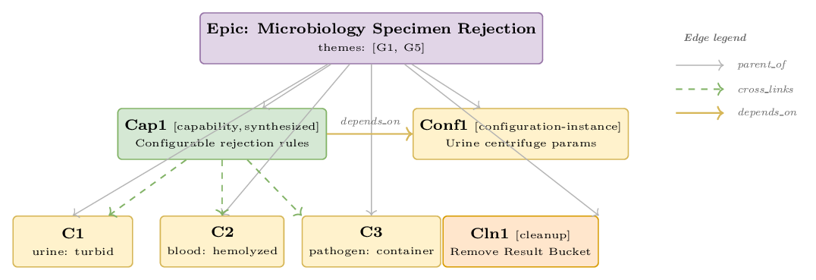
Worked example: one Epic with four Stories of different shapes, plus three concrete contributors to the synthesized capability. Edge types: parent_of (Epic→Story), cross_links (Cap1 → C1/C2/C3), depends_on (Cap1 → Conf1).
Edge semantics:
Edge | Direction | Meaning
parent_of | Epic → Story | Implicit Jira hierarchy (encoded in epic_id).
cross_links | Story ↔ Story | Bidirectional association. Used for capability ↔ concrete (synthesis) and stage-split sibling sets.
depends_on | Story → Story | Directed prerequisite. The Dependency Resolver uses it to topologically order the backlog for sprint planning.

Cross-SOP synthesis — recurrence becomes capability
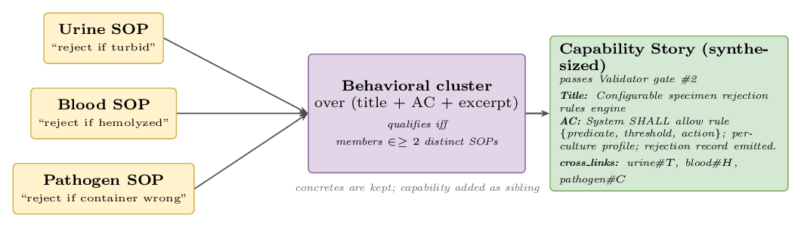
Three concrete rejection stories — one per SOP — cluster behaviorally and lift to a single capability story. Concrete stories remain in the backlog; the capability is added as a sibling with cross-links back.
The recurrence threshold (≥ 2 distinct SOPs) is tunable. With three SOPs in the POC, this means anything seen in two of three lifts. The synthesized capability story passes through Validator gate #2 before persistence.

Cyto → Micro lineage (graph view)
Three distinct mechanisms transfer information from Cyto to Micro. They operate at different times in the system’s life cycle.
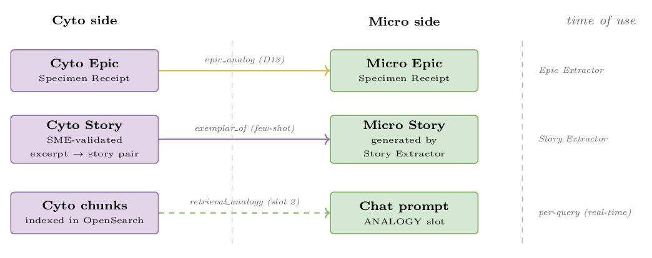
Three Cyto → Micro information transfer mechanisms, each operating at a different time of use.
Mechanism | Direction | When it fires | What flows
epic_analog | Cyto Epic → Micro Epic | Epic Extractor (annotation) | Just an ID reference — Cyto Epic is recorded on the Micro Epic for SME traceability (D13).
exemplar_of | Cyto Story → Micro Story | Story Extractor (few-shot prompt) | The Cyto (excerpt → Story) pair lands in the prompt as an in-context example.
retrieval_analogy | Cyto chunks → chat prompt | Per-query retrieval (slot 2 ANALOGY) | Retrieved Cyto excerpts populate the ANALOGY context section of the LLM prompt. Adapt, don’t copy.
The same Cyto material thus serves three roles: a curated few-shot teaching set, an indexed corpus for live retrieval, and a structural reference at the Epic level.

Ingestion substrate — S3 to indexed chunks
The substrate runs offline whenever a document lands in S3. It is the same substrate the agent pipeline above retrieves from at every step.
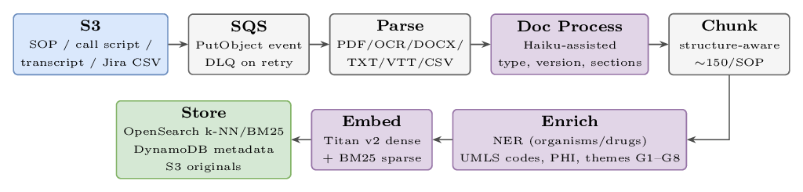
Ingestion pipeline: S3 → SQS → Parse → Doc Process → Chunk → Enrich → Embed → Store. Original documents stay in S3 as the citation target.
I/O trace — one document through the pipeline (SOP-MICRO-014_Gram-Stain_v3.docx):
Stage | Output
Parse | text: 28,420 chars / 18 pages; format: docx; ocr_used: false; parse_ms: 320
Doc Process | doc_id: doc_micro_014_v3_abc12; discipline: Microbiology; version: v3; section_map: {Purpose:[200,450], Procedure:[721,2400], AC:[2401,3100], QC:[3101,3650]}
Chunk | ~150 chunks; e.g. chunk_001: section=Procedure §3.1, tokens=287
Enrich (chunk_001) | entities: {organisms:["Gram-positive cocci"], specimens:["sputum"], codes:["87209"]}; phi_detected: false; themes: {G2: 0.84, G5: 0.41}
Embed (chunk_001) | dense_vector: [0.0234, -0.1849, ..., 0.2891] (1024-d, Bedrock Titan v2); bm25_tokens_enriched: ["slide","preparation","87209","smear","primary","source",...]
Store | PUT chunk_001 → OpenSearch k-NN (vector), OpenSearch BM25 (sparse), DynamoDB chunk_metadata (entities, themes, phi_status, version)

Retrieval substrate — per query, real-time
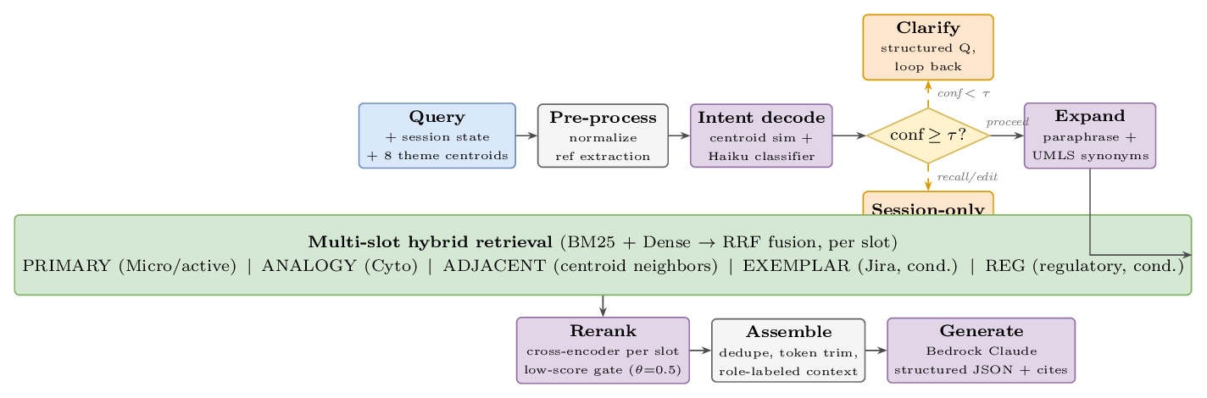
Per-query path: Query → Pre-process → Intent decode → confidence/action decision → Expand → multi-slot hybrid retrieve → Rerank → Assemble role-labeled context → Generate.
Two thresholds gate the chat to prevent hallucination:
- τ = 0.7 intent confidence — below this, ask a clarifying question instead of retrieving.
- θ = 0.5 retrieval relevance — if every slot falls below, refuse and offer the user three options (upload SOPs, draft from analogy with caveat, clarify scope).
I/O trace — one query: “Generate epics for specimen rejection in microbiology”
Stage | Output
Intent decode | centroid_dist: {G1: 0.81, G5: 0.18}; classifier: {action: generate, themes: [G1, G5], discipline: Micro, granularity: epic, refs: [], conf: 0.91}; decision: PROCEED (τ=0.7, 0.91 ≥ τ)
Retrieve | 48 candidate chunks across 5 slots — slot_1 PRIMARY (Micro/G1+G5): 20; slot_2 ANALOGY (Cyto/G1+G5): 10; slot_3 ADJACENT (Micro/G2 neighbors): 10; slot_4 EXEMPLAR (Jira, generate∧epic): 5; slot_5 REG (CLSI on G5): 3
Rerank + Assemble | trim: 8/4/3/3/2 = 20 chunks (all slots ≥ θ=0.5); prompt sections: PRIMARY, ANALOGY, ADJACENT, EXEMPLAR, REG + session drafts + output schema; total tokens: 6,840
Generate | structured JSON: { epic_id: epic_draft_3, title: "Specimen Rejection Workflow", theme: G1, citations: ["s3://.../SOP-MICRO-007 §AC", "s3://.../SOP-CYTO-021 §Procedure", "CLSI M22 §3.4"], stories: ["Validate transport temp", "Flag specimens older than 4h", ...] }

Validator — shape-aware revise/escalate flow
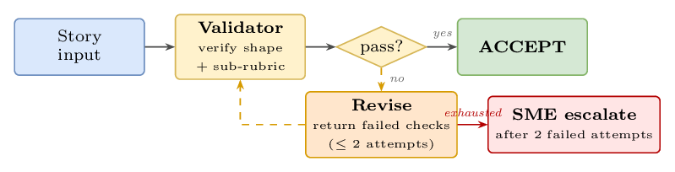
Validator flow: shape verification + sub-rubric → pass? → ACCEPT, or Revise (up to 2 attempts) → SME escalate on exhaustion. Same flow at both gates.
Sub-rubrics by shape (cheat sheet):
- Capability: MUST/SHALL on every AC; testable; no ambiguous quantifiers (appropriate, relevant, necessary); configurability boundaries called out; SOP citation present and resolves; complexity S/M/L; edge cases enumerated.
- Stage-split: stage explicit in title; entry/exit observable per stage; siblings enumerated and cross-linked; transition contract clear (what changes between stages); boundary cases handled.
- Configuration-instance: typed concrete values (units, enums, nullable rules); target table/profile named (e.g. cultures/urine.yaml#centrifugation); SOP excerpt cited verbatim; scope (culture/lab) stated. MUST/SHALL not required — this is data, not capability.
- Cleanup: target artifact named (id, screen path, file path); before/after observable (field present → absent, etc.); regression risk acknowledged (downstream readers); DoD includes a smoke test or QA path. MUST/SHALL not required.

What ships — Output A and Output B

Output A — Jira artifacts
A connected Epic / Story graph (the DAG above), pushed to Jira via REST. The graph is what the dev team works against; the YAML profile (Output B) is what their code consumes at runtime.

Output B — Per-culture YAML configuration profile
One YAML file per culture in scope. The profile carries the concrete typed values that configuration-instance Stories’ AC referenced. Profiles are versioned, dated, and cite back to the SOPs they draw from. The Story body never duplicates these values — it references them by related_story_ac, so a single source of truth is preserved.

Full profile structure
profile:
culture: urine # urine | blood | target_pathogen
version: 3 # bumps when any value changes
effective_date: 2026-04-15
source_sops: [doc_micro_014_v3, doc_micro_022_v1]
pre_analytic:
collection:
container: {value: "sterile cup", units: enum, citation: "doc_micro_014_v3 §1.2 L8"}
volume_min: {value: 10, units: mL, citation: "doc_micro_014_v3 §1.2 L11"}
transport:
temp_range: {min: 2, max: 8, units: degC, citation: "doc_micro_014_v3 §1.4 L18-19"}
time_max: {value: 4, units: h, citation: "doc_micro_014_v3 §1.4 L20"}
rejection_predicates:
- id: REJ_TURBID
condition: "turbidity > threshold"
threshold: {value: 200, units: NTU}
action: reject
citation: "doc_micro_014_v3 §1.5 L24"
analytic:
centrifugation:
speed: {value: 1500, units: g, citation: "doc_micro_014_v3 §3.2 L41-43"}
duration: {value: 5, units: min, citation: "doc_micro_014_v3 §3.2 L44"}
temp: {value: 4, units: degC, citation: "doc_micro_014_v3 §3.2 L45"}
inoculation:
media:
- {type: BAP, volume_uL: 10, citation: "doc_micro_014_v3 §4.1 L52"}
- {type: MAC, volume_uL: 10, citation: "doc_micro_014_v3 §4.1 L53"}
incubation: {temp: 35, atmosphere: "5% CO2", duration_h: 18, citation: "doc_micro_014_v3 §4.3 L60"}
post_analytic:
reporting:
cfu_threshold: {value: 100000, units: CFU_per_mL, citation: "doc_micro_014_v3 §6.1 L88"}
related_story_acs: # back-references to Stories that consume this profile
- STORY-MICRO-1042#AC-2 # Configurable rejection rules engine
- STORY-MICRO-1077#AC-1 # Centrifugation step

How a Story’s AC references the profile
A configuration-instance Story’s AC carries the citation; the profile is what gets read by code. Example — STORY-MICRO-1077 (urine centrifugation):
acceptance_criteria:
- when: "urine profile loaded"
then: "centrifuge step uses cultures/urine.yaml#analytic.centrifugation"
expected_value: "speed=1500g, duration=5min, temp=4degC"

Where to put a value: Story body vs. profile
If the value is… | Put it in…
The same across cultures and parameterizable in the rules engine | Story body as parameter spec (capability shape)
Different per culture / different per lab | YAML profile (configuration-instance shape)
A literal constant in the rejection logic | Profile, with the Story’s AC pointing at it

Cross-cutting
KMS encryption at rest and in transit; IAM least-privilege with VPC endpoints (Bedrock calls stay in-VPC); DLQ for parse / OCR / embed failures; CloudWatch metrics and alarms (e.g. OCR fail-rate > 5%); CloudTrail audit log on every API call; idempotent ingestion via content-hash dedupe.
Generalization: when Histology arrives, the same agents and the same retrieval substrate run — only the exemplar corpus and config priors get extended. No model retraining.

