What the system does
A subject-matter expert (SME) drops microbiology SOPs into S3. An agent-based pipeline, grounded in a hybrid retrieval substrate (BM25 + dense), reads them and emits three artifacts:
- Output A — Jira-ready Epic / Story tree for the dev team.
- Output B — One YAML configuration profile per culture (urine, blood, target-pathogen) carrying the concrete typed values.
- Output C — Versioned catalog artifacts (theme catalog, epic catalog, ANALOGY map) recording how this discipline’s structure relates to existing Cytology structure.
The existing Cytology Jira backlog is used as a teaching corpus — example (SOP excerpt → Story) pairs the agent learns the house style from. It is not a registry to match against. The agent stops at Story; Tasks (test IDs, library versions, DB columns) are dev-authored once the team has codebase visibility.
Core principle — Conditioned Discovery. Both the theme set and the epic catalog are warm-started from existing Cytology structure rather than generated from scratch. A pre-flight Theme Discovery agent bootstraps a discipline’s theme catalog by classifying its SOPs against the prior taxonomy and surfacing only the residual as novel. The Epic Extractor runs in conditioned mode, classifying drafts against the prior epic catalog (cyto_epic_v1) before clustering anything as new. Most themes and epics inherit by construction with explicit lineage; only genuinely-novel structure (backed by cluster evidence) goes to an SME for ratification. The dev team reads the output and immediately sees what’s reused vs. new without doing the mapping themselves.

Key terms (glossary)
Term | Meaning
SOP | Standard Operating Procedure — the source document the agent reads.
Epic | A capability domain. Maps to a Jira Epic. Example: Microbiology Specimen Receipt.
Story | A dev-actionable unit emitted by the agent. Each Story declares one of four shape values (see below). Maps to a Jira Story.
Shape | Categorization assigned to each Story at extraction time. Drives Validator routing and downstream interpretation. Four values: capability, workflow-stage-split, configuration-instance, cleanup.
Theme (G1–G8) | Eight content tags that span the LIMS workflow: G1 Pre-Analytic, G2 Analytic, G3 Post-Analytic, G4 Reporting, G5 QC, G6 Compliance, G7 Instrumentation, G8 Platform. Multi-label per chunk (a chunk can carry multiple themes with confidence scores).
Teaching corpus | The curated set of SME-validated (SOP excerpt → Story) pairs from Cyto. Used as few-shot exemplars at extraction time.
Retrieval slot | A parallel retrieval channel scoped to a particular discipline + theme combination (e.g. PRIMARY = Micro/active-themes, ANALOGY = Cyto/active-themes). The chat layer fires up to 5 slots per query.
Intent | The system’s structured interpretation of a user query: {action, themes, discipline, granularity, refs, confidence}.
τ (tau) | Intent-confidence threshold (default 0.7). Below this, the system asks a clarifying question rather than retrieving.
θ (theta) | Retrieval-relevance threshold (default 0.5). If every slot falls below this, the system refuses to generate.
Batch wait | The pipeline pause between Validator gate #1 and Cross-SOP Synthesis. Synthesis cannot run until every per-SOP Story has cleared gate #1, because cross-SOP recurrence cannot be detected mid-batch.
Conditioned discovery vocabulary:
Conditioned discovery A four-pass procedure (classify → cluster residual → SME ratify → re-tag) that warm-starts a new catalog against an existing prior, rather than clustering from scratch. Applied at both theme and epic levels.
Prior catalog The existing themes (or epics) that conditioned discovery treats as the structure-to-reuse. Cyto’s catalogs are the prior for both Micro and Histology bootstraps.
Residual Inputs whose classification confidence falls below τ_match in Pass 1. Only residuals are clustered for novelty.
τ_match Match-confidence threshold for Pass 1 (default 0.65). Distinct from the query-time τ above. Higher τ_match ⇒ eager-to-inherit.
ε_novelty Minimum cluster size in Pass 2 (default 3). Higher ⇒ stricter evidence bar before admitting a novel theme/epic.
G0 / E0 First-class unclassified bucket on every theme catalog (G0) and epic catalog (E0). 5% alarm threshold over a rolling window triggers re-running discovery.
Catalog versioning Theme catalogs are named <discipline>_v<N> (e.g. cyto_v1, histo_v1); epic catalogs are named <discipline>_epic_v<N> (e.g. cyto_epic_v1, micro_epic_v1). They version independently. Stories carry a theme_catalog_version field for theme resolution.
ANALOGY map Explicit cross-catalog link table. Each link typed: identical / partial / discarded_in_target / novel_in_target. Carried as a delivered artifact alongside the epic and theme catalogs.

Agent pipeline — five agents, Validator gates twice
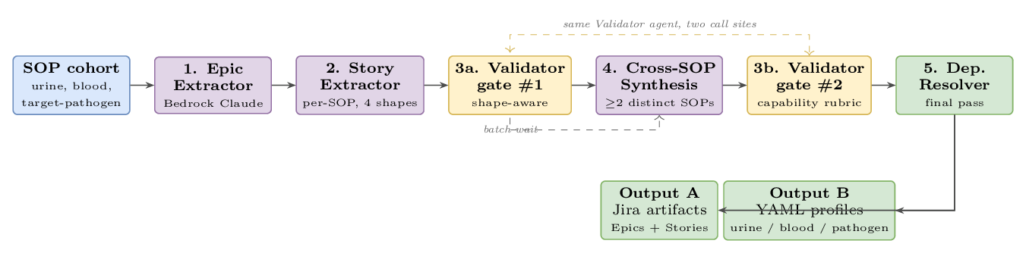
Agent pipeline. Five agents run as a single batch over the SOP cohort. The same Validator agent is invoked at two call sites — once per-SOP (gate #1), once after synthesis (gate #2).
Agent pipeline. Five agents run as a single batch over the SOP cohort. The same Validator agent is invoked at two call sites — once per-SOP (gate #1), once after synthesis (gate #2).
What each box does and emits:
- Epic Extractor (conditioned) — identifies capability domains across the SOP cohort. Each draft epic is classified against the prior epic catalog (cyto_epic_v1) at threshold τ_match first; matches inherit the existing epic ID and populate epic_analog by construction. Only the residual is clustered for novelty and routed through SME ratification. See the Epic Extractor (conditioned) section for the full flow. Output: one Epic record per domain (inherited or novel), all carrying explicit lineage.
- Story Extractor — runs once per SOP. Emits Stories with the shape field declared per element (so different elements of the same SOP can take different shapes).
- Validator gate #1 — verifies the declared shape, then applies a shape-specific sub-rubric. Two revision rounds; on exhaustion, escalate to SME with the failed-checks list visible.
- Cross-SOP Synthesis — runs only after gate #1 has cleared the entire batch (the batch wait). Behavioral-similarity clustering over (title + AC + source excerpt). A cluster qualifies only if its members come from ≥ 2 distinct SOPs (two stories from the same SOP do not qualify). Lifts a capability-shaped Story per qualifying cluster, recording cross_links[] back to the contributing concretes. Concrete stories are kept; the capability story is added as a sibling, not a replacement.
- Validator gate #2 — same Validator agent as gate #1, second call site; applies the capability rubric only. Synthesized stories are a new artifact (not a derivative of validated input), so they re-pass the bar.
- Dependency Resolver — final pass. Resolves story-to-story dependencies, stage-split sibling links, and capability-to-child links. Outputs Jira-ready artifacts.
A sixth agent — Theme Discovery — runs as pre-flight (one-time per discipline, not on the per-SOP critical path) before any of the above agents boot. It emits the versioned theme catalog (e.g. cyto_v1, histo_v1) that the rest of the system resolves themes against. The next section details it.

Theme Discovery — pre-flight, one-time per discipline
Theme Discovery runs before the main pipeline boots for a new discipline (and again only when the G0 alarm trips). Its job: emit a versioned theme catalog (e.g. histo_v1) by warm-starting against an existing prior (e.g. cyto_v1). Most themes inherit; novel ones must clear an evidence bar and an SME gate.
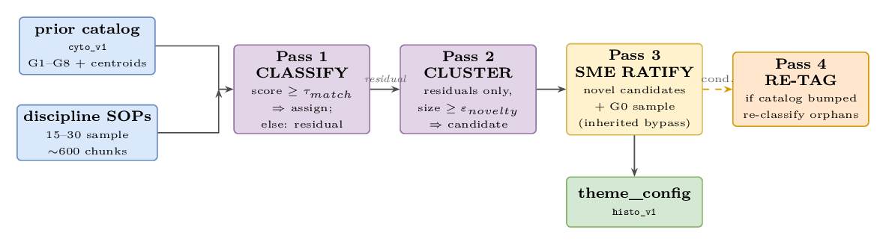
Theme Discovery — four passes, pre-flight per discipline. Pass 4 fires only when SME ratification changes the catalog (novel ratified or theme discarded).
Algorithm. Pass 1 scores each chunk against the prior centroids and assigns it if score ≥ τ_match (default 0.65); otherwise it joins the residual. Pass 2 clusters only the residuals (HDBSCAN); each cluster of size ≥ ε_novelty (default 3) becomes a candidate novel theme; smaller clusters fall to G0. Pass 3 routes the novel candidates and the G0 sample to SME — inherited themes bypass review. Pass 4 fires only when the catalog version bumps, re-classifying the previously-tagged corpus (including any chunks orphaned by a discarded theme) against catalog_v(N+1).
Two knobs control the bias. τ_match (higher ⇒ eager-to-inherit; risk of forced fits) and ε_novelty (higher ⇒ stricter evidence bar before admitting novelty). The user’s stated motive — “don’t just end up with entirely new ones” — corresponds to a high τ_match and a non-trivial ε_novelty.
Worked example — bootstrapping Histology from cyto_v1. Pass 1 classifies 460/600 chunks into G1–G8 (residual = 140, including 12 chunks that fit G7 above τ_match). Pass 2 finds 4 clusters above ε_novelty: H1 Tissue Processing (38), H2 Staining (32), H3 Block Archive (25), H4 Frozen Section (23); 22 chunks → G0 (3.7%, below alarm). Pass 3: SME confirms all 4 novel themes; flags G7 as redundant in histo (instrument concerns fold into H1) — discarded. Pass 4 re-classifies the 12 G7-orphaned chunks against the post-discard taxonomy (most land in H1, consistent with the ANALOGY map’s G7 → H1, partial link). Final histo_v1: 11 active themes (7 inherited + 4 novel; G7 recorded in ANALOGY map only). Reuse rate: 7/11 ≈ 64%; 7/8 of the prior themes (87.5%) survived.

Epic Extractor (conditioned) — match before generate
The Epic Extractor proposes draft epics per SOP and then immediately classifies each draft against the prior epic catalog (cyto_epic_v1). Drafts whose match_score clears τ_match inherit the existing epic ID and populate epic_analog by construction. Only the residual (drafts that don’t match anything in the prior) is pooled across SOPs and clustered for novelty; novel candidates with cluster size ≥ ε_novelty go through SME ratification.
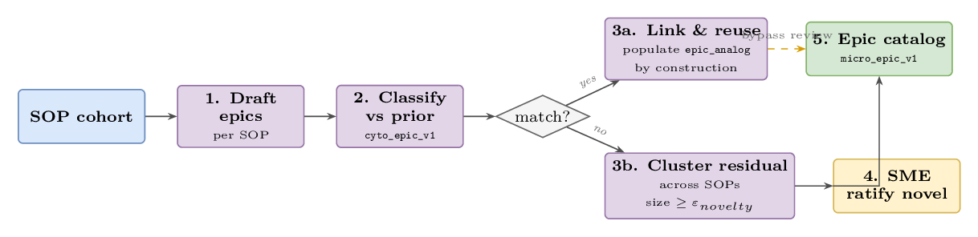
Conditioned Epic Extractor — the “match?” decision is algorithmic (not SME-gated; hence neutral coloring). Only the novel branch goes through SME ratification.
Result for the Micro POC. Most Micro epics inherit Cyto’s structure with explicit epic_analog populated by construction; only genuinely novel epics — e.g. Antibiotic Susceptibility Testing (AST), if it has no Cyto analog — emerge with cluster evidence. The dev team reads micro_epic_v1 and immediately sees what’s reused vs. new without having to do the mapping themselves.

Four story shapes — what “shape” means
A shape is the categorization the Story Extractor assigns to each Story. It tells the Validator which sub-rubric to apply, and tells downstream consumers (devs reading the backlog, the YAML emitter) how to interpret the AC. Per-SOP extraction picks one of four shapes per element. Cross-SOP synthesis only ever emits the capability shape.
Shape | Use when… | Validator rubric
capability | The SOP describes a configurable system feature you can imagine multiple labs/cultures parameterizing | MUST/SHALL on AC; testable; configurability boundaries explicit
workflow-stage-split | Same capability, but the SOP describes different behavior at different workflow stages (e.g. before / during / after results) | Stage explicit in title; sibling stories enumerated and cross-linked
configuration-instance | Concrete data values for one culture / lab. No new feature — just data. | Typed values (units / enums / nullable); SOP excerpt cited verbatim. MUST/SHALL not required.
cleanup | Modify or remove an existing artifact (field, screen, table, deprecated path). No new feature. | Target artifact named; before/after observable; regression risk acknowledged. MUST/SHALL not required.
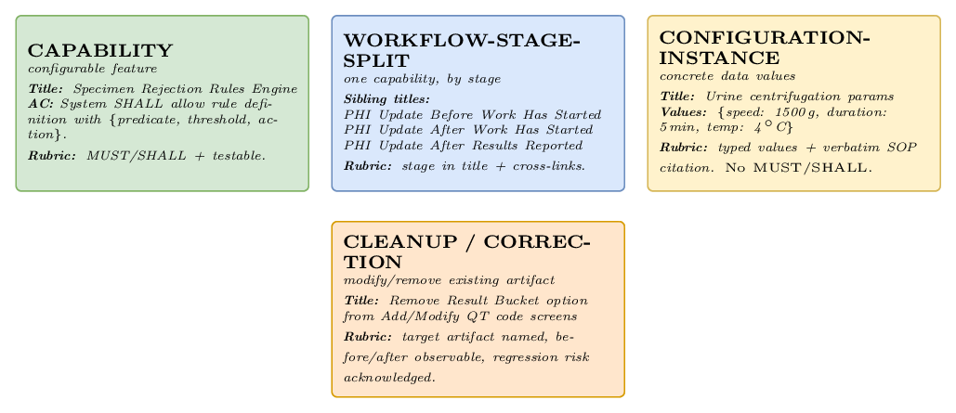
The four story shapes, with example title, AC snippet, and rubric pointer for each.
The four story shapes, with example title, AC snippet, and rubric pointer for each.

Schemas — deep dive
Code blocks below are illustrative JSON / YAML; the production representation is JSON-schema-validated before persistence. IDs come in two flavors: a draft ID assigned in-pipeline (e.g. epic_draft_3, story_draft_42) and a final Jira-shaped ID (e.g. EPIC-MICRO-001, STORY-MICRO-1042) assigned at Jira-push time by the Dependency Resolver.

Epic schema
{
"id": "EPIC-MICRO-001",
"title": "Microbiology Specimen Receipt",
"description": "All capabilities related to receiving and accepting microbiology specimens.",
"discipline": "microbiology",
"themes": ["G1", "G5"],
"theme_catalog_version": "cyto_v1",
"epic_analog": {
"catalog_id": "cyto_epic_v1",
"epic_id": "EPIC-CYTO-007",
"equivalence": "identical"
},
"inheritance_basis": {
"match_score": 0.78,
"shared_themes": ["G1"],
"auto_inherited": true
}
}
Field | Type | Required | Notes
id | string | yes | Final Jira-shaped Epic ID (or epic_draft_* while in-pipeline).
title | string | yes | Short capability-domain name.
description | string | yes | One- to three-sentence scope statement.
discipline | enum | yes | microbiology | histology | cytology. Currently always microbiology for the POC.
themes[] | array of G1–G8 | yes | Multi-label; an Epic can span themes (e.g. G1 + G5).
`theme_catalog_versio | n` string | yes | The theme catalog these tags resolve in (e.g. cyto_v1 for Micro POC, histo_v1 for Histology).
epic_analog | object | optional | Cross-catalog link {catalog_id, epic_id, equivalence}. Populated by the conditioned Epic Extractor when match_score ≥ τ_match.
inheritance_basis | object | optional | Provenance for inherited epics {match_score, shared_themes[], auto_inherited}. Absent for novel epics; those carry novelty_basis.

Story schema
{
"id": "STORY-MICRO-1042",
"epic_id": "EPIC-MICRO-001",
"shape": "capability",
"title": "Configurable specimen rejection rules engine",
"description": "As an admin, I want configurable specimen rejection rules so that each lab can codify its own acceptance criteria.",
"acceptance_criteria": [
{ "when": "rule is defined", "then": "rule has {predicate, threshold, action}" },
{ "when": "specimen received", "then": "applicable rules evaluated; rejection record emitted" }
],
"source_citations": [
{ "doc_id": "doc_micro_014_v3", "section": "Procedure §3.2", "line_range": [41, 43] }
],
"dependencies": ["STORY-MICRO-1018"],
"cross_links": ["STORY-MICRO-1043", "STORY-MICRO-1044", "STORY-MICRO-1045"],
"estimated_complexity": "M",
"edge_cases_handled": ["operator override", "rule conflict resolution"],
"status": "validated",
"source_chunks": ["chunk_001", "chunk_017"]
}
Field | Type | Required | Notes
id | string | yes | Final Jira-shaped Story ID (or story_draft_* while in-pipeline).
epic_id | string | yes | FK to parent Epic.
shape | enum | yes | One of capability, workflow-stage-split, configuration-instance, cleanup. Drives Validator routing.
title | string | yes | Concrete and unambiguous. For stage-split, must name the stage.
description | string | yes | User-story format preferred for capability/stage-split; descriptive prose for config-instance/cleanup.
acceptance_criteria[] | array of {when, then, expected_value?} | yes | Capability/stage-split use MUST/SHALL phrasing; config-instance carries expected_value; cleanup carries before/after.
source_citations[] | array of {doc_id, section, line_range} | yes | Must resolve to indexed chunks; verbatim excerpt for config-instance.
dependencies[] | array of Story IDs | optional | Stories that must complete before this one is workable.
cross_links[] | array of Story IDs | optional | Capability ↔ concrete contributors; stage-split sibling group. Backbone of the Story DAG.
technical_hints | string | optional | Dev-facing guidance (e.g. “consider extending the existing rules table”).
estimated_complexity | enum | yes | S | M | L. Heuristic, used for sprint sizing.
edge_cases_handled[] | array of strings | optional | Surfaced corner cases.
status | enum | yes | draft | validated | ready. Validated = passed the Validator gate; ready = SME-accepted.
source_chunks[] | array of chunk IDs | yes | Audit trail back to retrieval-substrate chunks.

Cluster schema (intermediate, in Cross-SOP Synthesis)
Not persisted to Jira; lives only between gate #1 and gate #2 in memory.
{
"cluster_id": "clust_rejection_3sop",
"member_story_ids": ["STORY-MICRO-1043", "STORY-MICRO-1044", "STORY-MICRO-1045"],
"source_sops": ["doc_micro_014_v3", "doc_micro_022_v1", "doc_micro_037_v2"],
"centroid_summary": "Reject specimen on a culture-specific predicate (turbidity / hemolysis / container).",
"proposed_capability_title": "Configurable specimen rejection rules engine"
}
A cluster qualifies for lifting iff len(unique(source_sops)) >= 2. Two stories from the same SOP do not qualify, even if they cluster tightly.

Validator output schema
{
"story_id": "STORY-MICRO-1042",
"verdict": "revise",
"shape_declared": "capability",
"shape_verified": "capability",
"failed_checks": [
{ "rule": "must_shall_present", "severity": "error", "message": "AC 1 lacks MUST/SHALL phrasing." },
{ "rule": "ambiguous_quantifier", "severity": "error", "message": "AC 2 uses 'appropriate' — replace with concrete predicate." }
],
"attempt": 1
}
Field | Type | Notes
story_id | string | The Story under review.
verdict | enum | accept (story passes), revise (return to extractor with failed_checks, attempt < 2), or escalate (after 2 failed revisions; routed to SME).
shape_declared | enum | The shape the Story Extractor assigned.
shape_verified | enum | The shape the Validator believes is correct. If it differs from shape_declared, the verdict is automatically revise.
failed_checks[] | array of {rule, severity, message} | Empty when verdict = accept.
attempt | integer | 1 or 2 (after 2, the verdict becomes escalate).

Theme catalog schema
catalog_id: histo_v1
parent_catalog: cyto_v1
discipline: histology
inherited_themes:
- { id: G1, name: Pre-Analytic, source: cyto_v1, match_count: 142 }
...
novel_themes:
- id: H1
name: Tissue Processing
source: histo_v1
cluster_evidence: { n_chunks: 38, sample_excerpts: [...] }
sme_confirmed: true
discarded_themes:
- { id: G7, reason: "Folded into H1 (partial)", chunks_re_tagged: 12 }
unclassified_bucket: { count: 22, pct_of_total: 3.7 }
Field | Type | Required | Notes
catalog_id | string | yes | <discipline>_v<N>. Stories reference this in theme_catalog_version.
parent_catalog | string | null | yes | The prior the discovery was conditioned on. null only for the very first ever (cyto_v1).
inherited_themes[] | array | yes | Themes that survived parent_catalog after Pass 1. Each has source: <parent> and a match_count.
novel_themes[] | array | yes | SME-ratified novelties from Pass 2. Each carries cluster_evidence. May be empty.
discarded_themes[] | array | optional | Parent themes the SME dropped. chunks_re_tagged records the Pass 4 fixup count.
unclassified_bucket | object | yes | G0 stats: {count, pct_of_total, sample_excerpts, next_review_due}. Always present. 5% alarm threshold.

Epic catalog schema
catalog_id: micro_epic_v1
parent_catalog: cyto_epic_v1
discipline: microbiology
inherited_epics:
- id: EPIC-MICRO-001
title: Specimen Receiving
epic_analog: { catalog_id: cyto_epic_v1, epic_id: EPIC-CYTO-014, equivalence: identical }
inheritance_basis: { match_score: 0.78, shared_themes: [G1], auto_inherited: true }
novel_epics:
- id: EPIC-MICRO-007
title: Antibiotic Susceptibility Testing (AST)
epic_analog: null
novelty_basis: { n_draft_epics: 4, sme_confirmed: true }
unclassified_drafts: { count: 3, pct_of_total: 4.1 }
The epic catalog versions independently from the theme catalog and uses the suffix _epic_ to make the naming distinction explicit. The epic_analog field, when populated, carries a struct (not a bare string) so the catalog the analog points into is unambiguous.

ANALOGY map schema
source_catalog: cyto_v1
target_catalog: histo_v1
theme_links:
- { source: G1, target: G1, equivalence: identical }
- { source: G7, target: H1, equivalence: partial,
note: "G7 has no top-level peer in histo_v1 (discarded);
concept partially absorbed by H1 for slide-prep instruments." }
- { source: null, target: H2, equivalence: novel_in_target }
... (H3, H4)
epic_links:
- { source: EPIC-CYTO-014, target: EPIC-HISTO-002, equivalence: identical }
equivalence | Meaning
identical | Full equivalence; match_score above τ_match, SME-confirmed by spot-check.
partial | Loose mapping or scope difference; SME-confirmed each individually. Carries a note.
discarded_in_target | Source has no top-level peer in target.
novel_in_target | Target has no source ancestor (encoded as source: null).
Convention. Each source theme appears at most once as source. “Discarded with partial mapping” is a single partial entry whose note explains the discard — not two contradictory entries (partial plus discarded_in_target). Similarly, a target theme covered by a partial link does not also need a separate novel_in_target entry; the partial link already records its origin.

Story relationships (graph view)
The Story schema’s flat dependencies[] and cross_links[] arrays serialize a directed acyclic graph. Walking it answers operational questions like “what’s blocked by X?” or “if I deprecate the synthesized capability story, which concretes need merging?” Below is a worked sub-graph for one Epic.
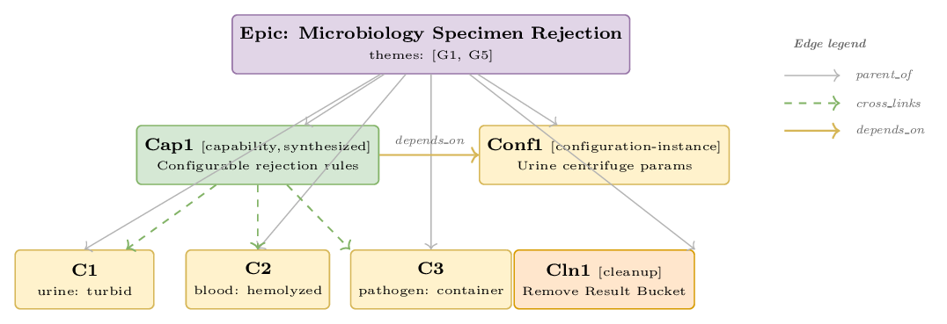
Worked example: one Epic with four Stories of different shapes, plus three concrete contributors to the synthesized capability. Edge types: parent_of (Epic→Story), cross_links (Cap1 → C1/C2/C3), depends_on (Cap1 → Conf1).
Worked example: one Epic with four Stories of different shapes, plus three concrete contributors to the synthesized capability. Edge types: parent_of (Epic→Story), cross_links (Cap1 → C1/C2/C3), depends_on (Cap1 → Conf1).
Edge semantics:
Edge | Direction | Meaning
parent_of | Epic → Story | Implicit Jira hierarchy (encoded in epic_id).
cross_links | Story ↔ Story | Bidirectional association. Used for capability ↔ concrete (synthesis) and stage-split sibling sets.
depends_on | Story → Story | Directed prerequisite. The Dependency Resolver uses it to topologically order the backlog for sprint planning.

Cross-SOP synthesis — recurrence becomes capability
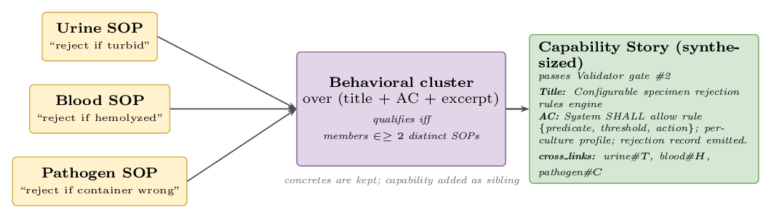
Three concrete rejection stories — one per SOP — cluster behaviorally and lift to a single capability story. Concrete stories remain in the backlog; the capability is added as a sibling with cross-links back.
Three concrete rejection stories — one per SOP — cluster behaviorally and lift to a single capability story. Concrete stories remain in the backlog; the capability is added as a sibling with cross-links back.
The recurrence threshold (≥ 2 distinct SOPs) is tunable. With three SOPs in the POC, this means anything seen in two of three lifts. The synthesized capability story passes through Validator gate #2 before persistence.

Cyto → Micro lineage (graph view)
Three distinct mechanisms transfer information from Cyto to Micro. They operate at different times in the system’s life cycle.
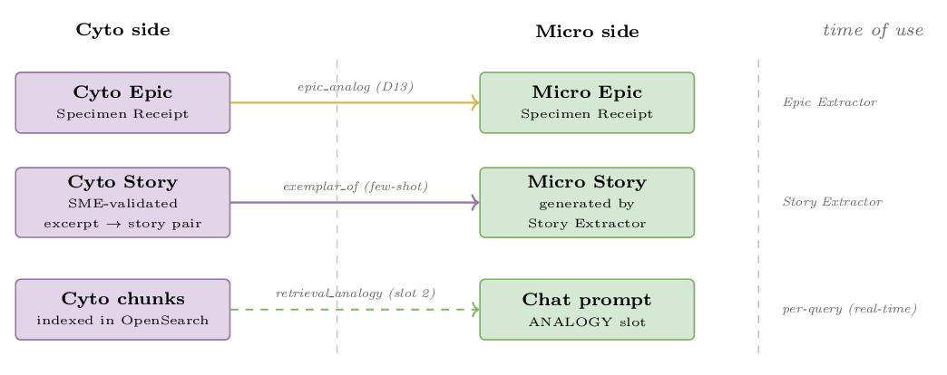
Three Cyto → Micro information transfer mechanisms, each operating at a different time of use.
Three Cyto → Micro information transfer mechanisms, each operating at a different time of use.
Mechanism | Direction | When it fires | What flows
epic_analog | Cyto Epic → Micro Epic | Epic Extractor (annotation) | Just an ID reference — Cyto Epic is recorded on the Micro Epic for SME traceability (D13).
exemplar_of | Cyto Story → Micro Story | Story Extractor (few-shot prompt) | The Cyto (excerpt → Story) pair lands in the prompt as an in-context example.
retrieval_analogy | Cyto chunks → chat prompt | Per-query retrieval (slot 2 ANALOGY) | Retrieved Cyto excerpts populate the ANALOGY context section of the LLM prompt. Adapt, don’t copy.
The same Cyto material thus serves three roles: a curated few-shot teaching set, an indexed corpus for live retrieval, and a structural reference at the Epic level.

ANALOGY map (graph view) — explicit cross-discipline links
When a discipline’s theme catalog diverges from its parent (Histology drops G7, adds H1–H4), the ANALOGY map records the cross-catalog correspondences explicitly. Each link is typed — the legend in the figure shows what each line style means.
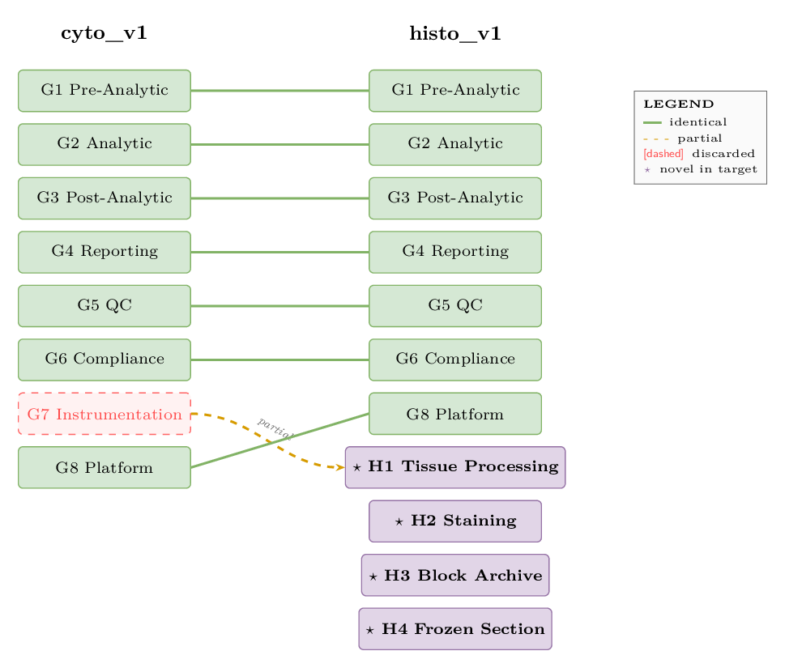
ANALOGY map (cyto_v1 ↔ histo_v1). 6 identical theme links, 1 partial (G7 → H1), 4 novel-in-target (H1–H4). H1 has no separate novel_in_target edge because the partial G7 → H1 link already records its origin.
The ANALOGY map drives the ANALOGY retrieval slot for cross-discipline queries: when a Histo question wants Cyto context, the map filters Cyto chunks down to themes that have a target-side correspondent.

Ingestion substrate — S3 to indexed chunks
The substrate runs offline whenever a document lands in S3. It is the same substrate the agent pipeline above retrieves from at every step.
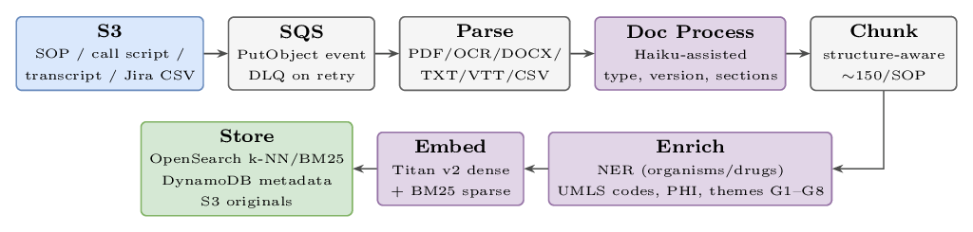
Ingestion pipeline: S3 → SQS → Parse → Doc Process → Chunk → Enrich → Embed → Store. Original documents stay in S3 as the citation target.
Ingestion pipeline: S3 → SQS → Parse → Doc Process → Chunk → Enrich → Embed → Store. Original documents stay in S3 as the citation target.
I/O trace — one document through the pipeline (SOP-MICRO-014_Gram-Stain_v3.docx):
Stage | Output
Parse | text: 28,420 chars / 18 pages; format: docx; ocr_used: false; parse_ms: 320
Doc Process | doc_id: doc_micro_014_v3_abc12; discipline: Microbiology; version: v3; section_map: {Purpose:[200,450], Procedure:[721,2400], AC:[2401,3100], QC:[3101,3650]}
Chunk | ~150 chunks; e.g. chunk_001: section=Procedure §3.1, tokens=287
Enrich (chunk_001) | entities: {organisms:["Gram-positive cocci"], specimens:["sputum"], codes:["87209"]}; phi_detected: false; themes: {G2: 0.84, G5: 0.41}
Embed (chunk_001) | dense_vector: [0.0234, -0.1849, ..., 0.2891] (1024-d, Bedrock Titan v2); bm25_tokens_enriched: ["slide","preparation","87209","smear","primary","source",...]
Store | PUT chunk_001 → OpenSearch k-NN (vector), OpenSearch BM25 (sparse), DynamoDB chunk_metadata (entities, themes, phi_status, version)

Retrieval substrate — per query, real-time
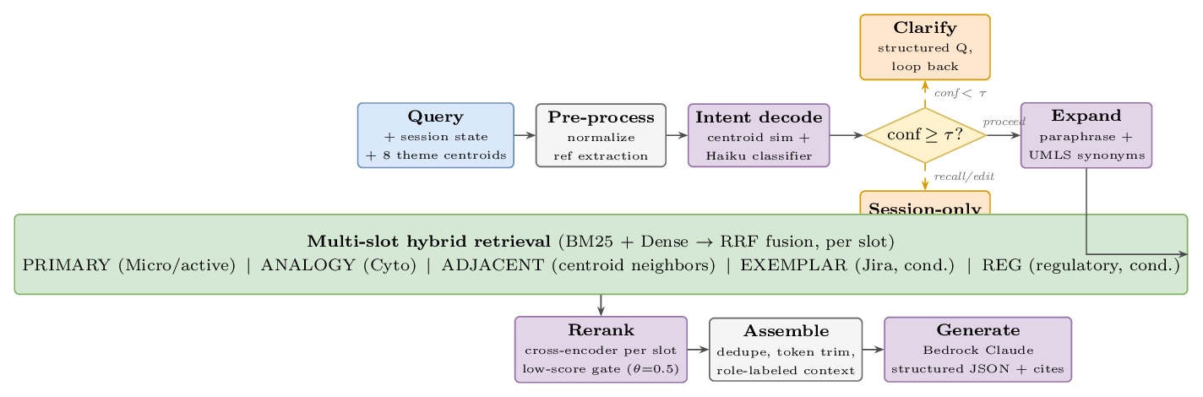
Per-query path: Query → Pre-process → Intent decode → confidence/action decision → Expand → multi-slot hybrid retrieve → Rerank → Assemble role-labeled context → Generate.
Per-query path: Query → Pre-process → Intent decode → confidence/action decision → Expand → multi-slot hybrid retrieve → Rerank → Assemble role-labeled context → Generate.
Two thresholds gate the chat to prevent hallucination:
- τ = 0.7 intent confidence — below this, ask a clarifying question instead of retrieving.
- θ = 0.5 retrieval relevance — if every slot falls below, refuse and offer the user three options (upload SOPs, draft from analogy with caveat, clarify scope).
I/O trace — one query: “Generate epics for specimen rejection in microbiology”
Stage | Output
Intent decode | centroid_dist: {G1: 0.81, G5: 0.18}; classifier: {action: generate, themes: [G1, G5], discipline: Micro, granularity: epic, refs: [], conf: 0.91}; decision: PROCEED (τ=0.7, 0.91 ≥ τ)
Retrieve | 48 candidate chunks across 5 slots — slot_1 PRIMARY (Micro/G1+G5): 20; slot_2 ANALOGY (Cyto/G1+G5): 10; slot_3 ADJACENT (Micro/G2 neighbors): 10; slot_4 EXEMPLAR (Jira, generate∧epic): 5; slot_5 REG (CLSI on G5): 3
Rerank + Assemble | trim: 8/4/3/3/2 = 20 chunks (all slots ≥ θ=0.5); prompt sections: PRIMARY, ANALOGY, ADJACENT, EXEMPLAR, REG + session drafts + output schema; total tokens: 6,840
Generate | structured JSON: { id: "epic_draft_3", title: "Specimen Rejection Workflow", themes: ["G1", "G5"], citations: ["s3://.../SOP-MICRO-007 §AC", "s3://.../SOP-CYTO-021 §Procedure", "CLSI M22 §3.4"], stories: [{title: "Validate transport temp", ...}, {title: "Flag specimens older than 4h", ...}] }. The id is a draft ID at this stage — the Dependency Resolver replaces it with the final EPIC-MICRO-* form before Jira push.

Validator — shape-aware revise/escalate flow
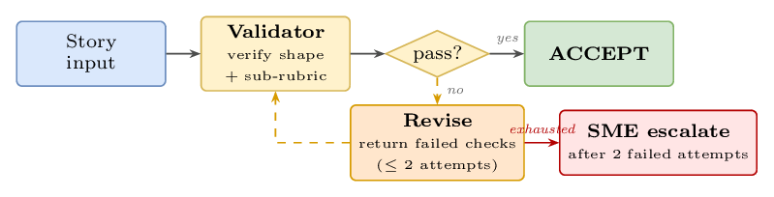
Validator flow: shape verification + sub-rubric → pass? → ACCEPT, or Revise (up to 2 attempts) → SME escalate on exhaustion. Same flow at both gates.
Validator flow: shape verification + sub-rubric → pass? → ACCEPT, or Revise (up to 2 attempts) → SME escalate on exhaustion. Same flow at both gates.
Sub-rubrics by shape (cheat sheet):
- Capability: MUST/SHALL on every AC; testable; no ambiguous quantifiers (appropriate, relevant, necessary); configurability boundaries called out; SOP citation present and resolves; complexity S/M/L; edge cases enumerated.
- Stage-split: stage explicit in title; entry/exit observable per stage; siblings enumerated and cross-linked; transition contract clear (what changes between stages); boundary cases handled.
- Configuration-instance: typed concrete values (units, enums, nullable rules); target table/profile named (e.g. cultures/urine.yaml#centrifugation); SOP excerpt cited verbatim; scope (culture/lab) stated. MUST/SHALL not required — this is data, not capability.
- Cleanup: target artifact named (id, screen path, file path); before/after observable (field present → absent, etc.); regression risk acknowledged (downstream readers); DoD includes a smoke test or QA path. MUST/SHALL not required.

What ships — Output A and Output B

Output A — Jira artifacts
A connected Epic / Story graph (the DAG above), pushed to Jira via REST. The graph is what the dev team works against; the YAML profile (Output B) is what their code consumes at runtime.

Output B — Per-culture YAML configuration profile
One YAML file per culture in scope. The profile carries the concrete typed values that configuration-instance Stories’ AC referenced. Profiles are versioned, dated, and cite back to the SOPs they draw from. The Story body never duplicates these values — it references them by related_story_ac, so a single source of truth is preserved.
The profile is partitioned by workflow stage so that an engineer can find the right block at a glance:
- pre_analytic — what happens before the specimen reaches the bench: collection, transport, rejection predicates.
- analytic — the bench work itself: centrifugation, inoculation, incubation.
- post_analytic — what happens after the result: reporting thresholds, downstream notifications.

Full profile structure
profile:
culture: urine # urine | blood | target_pathogen
version: 3 # bumps when any value changes
effective_date: 2026-04-15
source_sops: [doc_micro_014_v3, doc_micro_022_v1]
pre_analytic:
collection:
container: {value: "sterile cup", units: enum, citation: "doc_micro_014_v3 §1.2 L8"}
volume_min: {value: 10, units: mL, citation: "doc_micro_014_v3 §1.2 L11"}
transport:
temp_range: {min: 2, max: 8, units: degC, citation: "doc_micro_014_v3 §1.4 L18-19"}
time_max: {value: 4, units: h, citation: "doc_micro_014_v3 §1.4 L20"}
rejection_predicates:
- id: REJ_TURBID
condition: "turbidity > threshold"
threshold: {value: 200, units: NTU}
action: reject
citation: "doc_micro_014_v3 §1.5 L24"
analytic:
centrifugation:
speed: {value: 1500, units: g, citation: "doc_micro_014_v3 §3.2 L41-43"}
duration: {value: 5, units: min, citation: "doc_micro_014_v3 §3.2 L44"}
temp: {value: 4, units: degC, citation: "doc_micro_014_v3 §3.2 L45"}
inoculation:
media:
- {type: BAP, volume_uL: 10, citation: "doc_micro_014_v3 §4.1 L52"}
- {type: MAC, volume_uL: 10, citation: "doc_micro_014_v3 §4.1 L53"}
incubation: {temp: 35, atmosphere: "5% CO2", duration_h: 18, citation: "doc_micro_014_v3 §4.3 L60"}
post_analytic:
reporting:
cfu_threshold: {value: 100000, units: CFU_per_mL, citation: "doc_micro_014_v3 §6.1 L88"}
related_story_acs: # back-references to Stories that consume this profile
- STORY-MICRO-1042#AC-2 # Configurable rejection rules engine
- STORY-MICRO-1077#AC-1 # Centrifugation step

How a Story’s AC references the profile
A configuration-instance Story’s AC carries the citation; the profile is what gets read by code. Example — STORY-MICRO-1077 (urine centrifugation):
acceptance_criteria:
- when: "urine profile loaded"
then: "centrifuge step uses cultures/urine.yaml#analytic.centrifugation"
expected_value: "speed=1500g, duration=5min, temp=4degC"

Where to put a value: Story body vs. profile
If the value is… | Put it in…
The same across cultures and parameterizable in the rules engine | Story body as parameter spec (capability shape)
Different per culture / different per lab | YAML profile (configuration-instance shape)
A literal constant in the rejection logic | Profile, with the Story’s AC pointing at it

Cross-cutting
KMS encryption at rest and in transit; IAM least-privilege with VPC endpoints (Bedrock calls stay in-VPC); DLQ for parse / OCR / embed failures; CloudWatch metrics and alarms (e.g. OCR fail-rate > 5%); CloudTrail audit log on every API call; idempotent ingestion via content-hash dedupe.
Generalization to a new discipline. When Histology arrives, Theme Discovery runs once as pre-flight to warm-start histo_v1 from cyto_v1 (most themes inherited; novel ones SME-ratified). The main pipeline then runs unchanged in shape, with the Epic Extractor bootstrapping histo_epic_v1 from cyto_epic_v1 in conditioned mode. No model retraining at any stage.

