RFP Response: Enterprise Azure Billing Automation using Logic Apps

# 1. Executive Summary

We propose a lightweight, cost-effective, and fully automated billing solution leveraging Azure Logic Apps for ongoing enterprise billing and consumption reporting. This solution integrates with Azure Enterprise Agreement (EA) APIs, sends daily/weekly/monthly cost usage reports, and enables proactive cloud cost governance – all at a cost of approximately $0.03/month.

# 2. Solution Overview

- **Azure Logic App**: Executes scheduled workflows to fetch Azure billing/usage data from the Enterprise Reporting API.  
- **HTTP Action**: Connects to Azure EA API using a service principal (Azure AD App) to retrieve billing details.  
- **Azure Blob Storage or Email Output**: Outputs formatted CSV or JSON billing reports.  
- **Recurrence Trigger**: Configurable to run daily, weekly, or monthly.  
- **Error Handling**: Built-in retry policies and failure alerts.

Referenece: <https://marczak.io/posts/2019/10/ea-consumption-automation-with-logic-apps/>

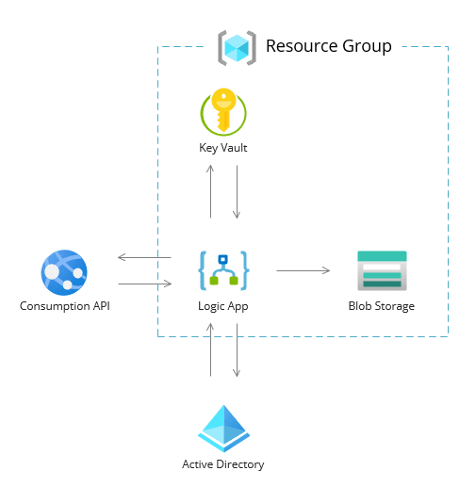

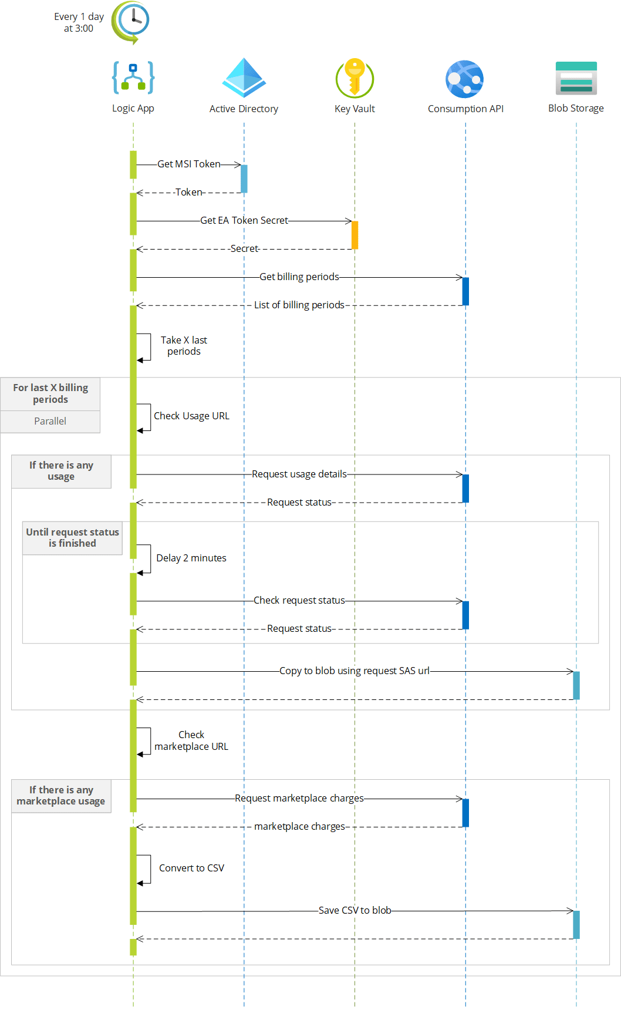

# 3. Architecture Summary

- The solution uses a **recurrence trigger** to fetch data via the **Azure EA Billing API** using a secure service principal.  
- Logic App parses the usage JSON and sends it via email (O365 or SendGrid), or stores it in Azure Blob Storage.  
- Minimal infrastructure is involved, ensuring ultra-low cost.  
- Supports custom filtering, tagging, and cost center allocation logic.

# 4. Security & Governance

- **Azure AD App Registration**: Secure, role-based access to EA API.  
- **Key Vault**: API keys and secrets managed securely.  
- **RBAC**: Applied to Blob Storage and other resources.  
- **Activity Logs**: All actions traceable through Logic App run history.  
- **Data Privacy**: GDPR-compliant design with no PII exposure.

# 5. Cost Estimation

- **Logic App Runs**: ~$0.03/month (assuming 1 execution per day)  
- **Blob Storage**: ~$0.01/month (for cost reports)  
- **Email Delivery**: Included with O365 or ~$5 with SendGrid  
- **Key Vault Access**: ~$0.03/month (basic usage)  
- **Total Cost**: **Less than $0.10/month**

# 6. Implementation Timeline

- Requirements & EA API setup: 1 Day  
- Logic App Design & Deployment: 1 Day  
- Security Hardening (Key Vault, Identity): 1 Day  
- Testing & Validation: 1 Day  
- Documentation & Handover: 1 Day  
- **Total Duration**: 5 Days

# 7. Business Benefits

- ✅ Near-zero operational cost for billing insight  
- ✅ Proactive alerts for budget thresholds  
- ✅ Enhanced governance and visibility into Azure consumption  
- ✅ Easily extensible to integrate with Power BI, SharePoint, or Excel  
- ✅ Proven, production-grade design used for multiple clients

For Developer:

And this is how “big” it is… or is it?

Only **14 actions** were required to complete this task.

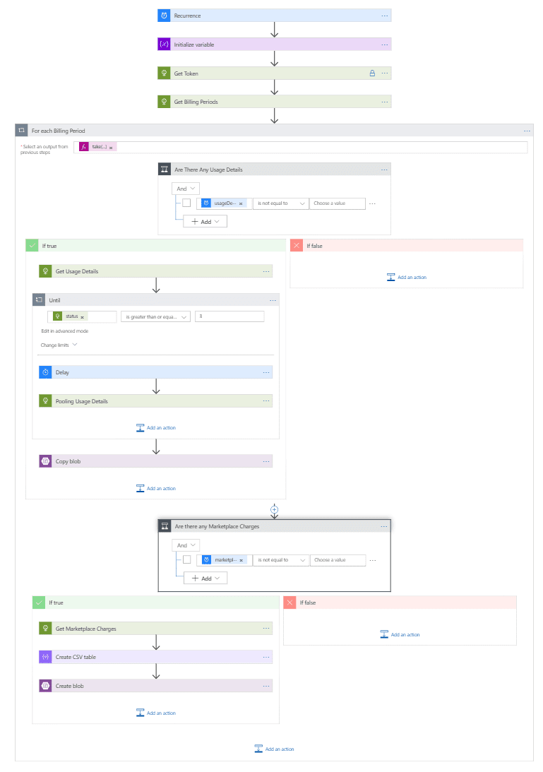

Provisioning

You can quickly deploy entire application using ARM or by yourself using Azure portal.

One Click deployment

If you want to deploy everything with a push of a button simply use deploy button below.

1. Click on the Deploy Button

2. Fill in the form

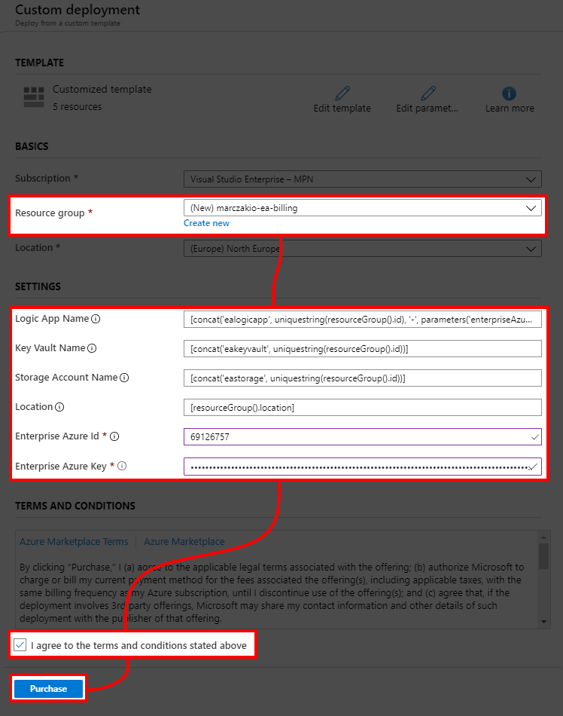

- **Resource group** - Resource Group to deploy solution to - **Location** - Region where your solution will be deployed to. If you plan to use this for Power BI reporting then deploy to closest data center of your Office region. - **Key Vault Name** - Name of Key Vault resource. Can be left as default. - **Storage Account Name** - Name of Storage Account resource. Can be left as default. - **Enterprise Azure Id** - Enterprise agreement ID from https://ea.azure.com portal - **Enterprise Azure Key** - Enterprise agreement Reporting Key from https://ea.azure.com portal > Reports > Download Usage > API Access Key > Expand Key > Copy

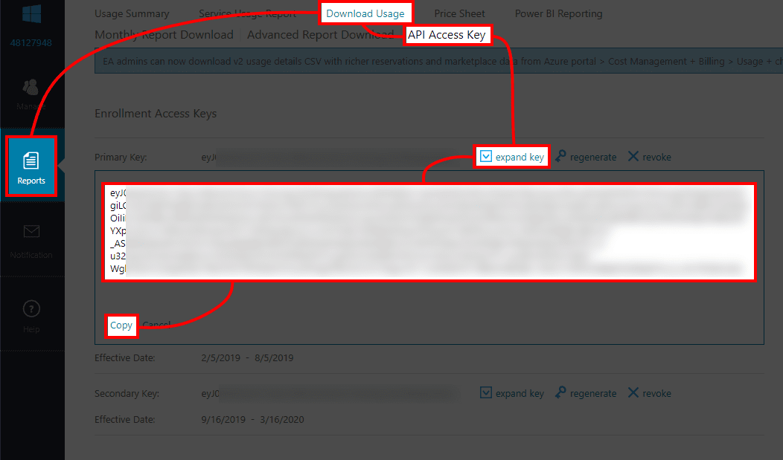

3. When deployment finishes go to the resource group to check resources

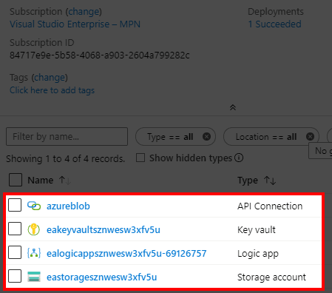

4. Go to the **Logic App** and hit **Enable**

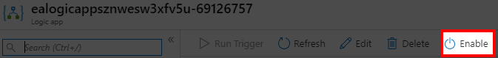

5. Confirm the app ran successfully

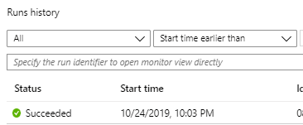

6. Verify the data is on the BLOB

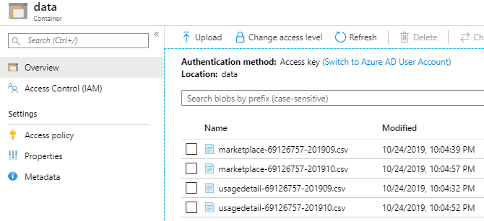

But Logic App refreshed only last 2 months?!

Logic App only refreshes last two month since older months do not need to be refreshed as the billing will never change. In case your company has EA already for longer than two month, then

1. Go to Logic App editor.

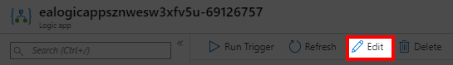

1. Find the value **2**, which can be found in in the **For each billing period** action as expression **take(…)** and simply change it to bigger number, and run it once.

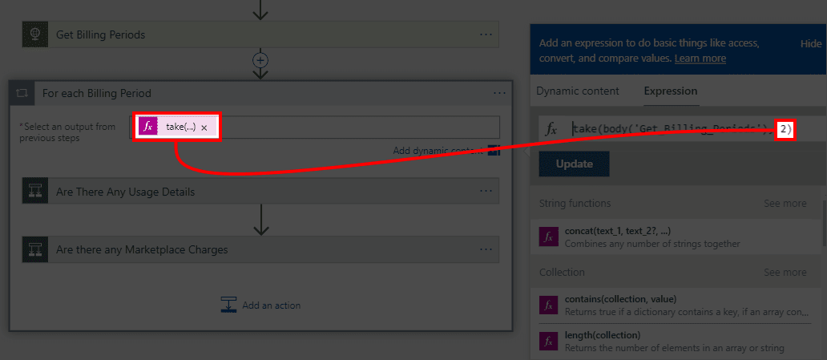

1. Remember to change it back to 2 afterwards.

And that’s it!

**Last 30 days** show consumption of **0.03 EUR per month**.

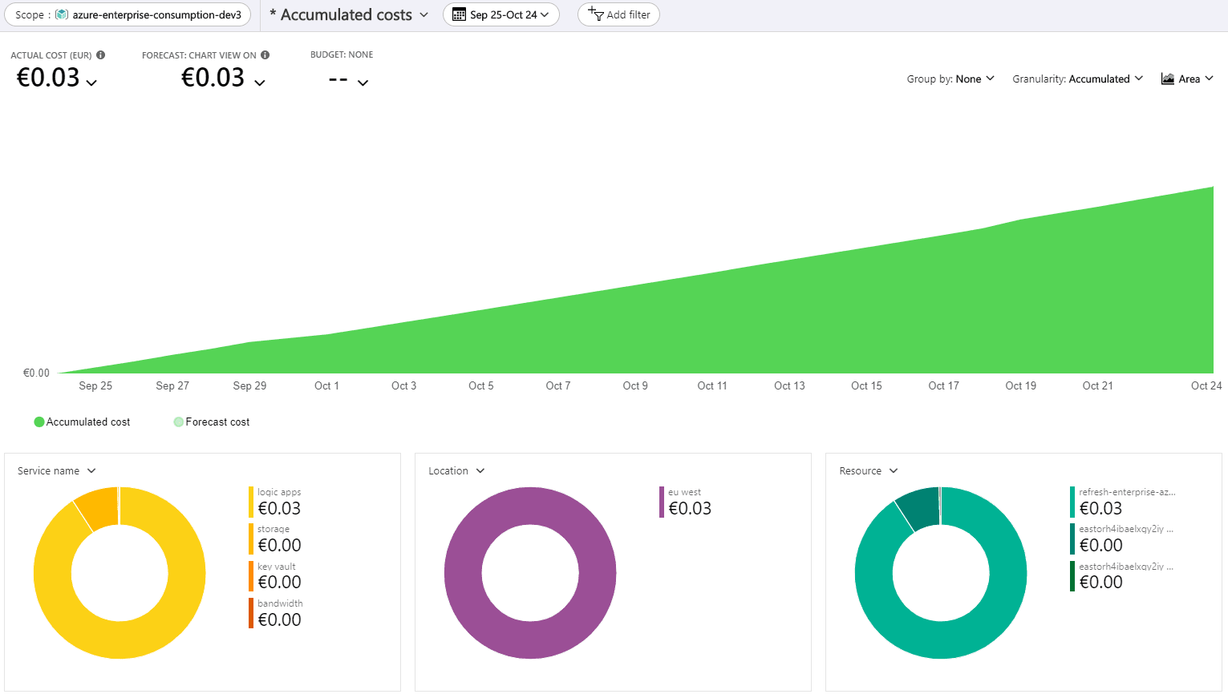

Conclusion

Logic Apps are not the cheapest service out there, but when used correctly they solve business challenges in no time and at ‘no cost’. Used as the right tool for the right challenge they fit perfectly here. I’m glad I did try them out because this is the perfect solution for our company.