RFP Response: Serverless Billing System using Azure

# Architecture Diagram

Below is the implemented serverless billing system architecture which was successfully delivered to our previous client:

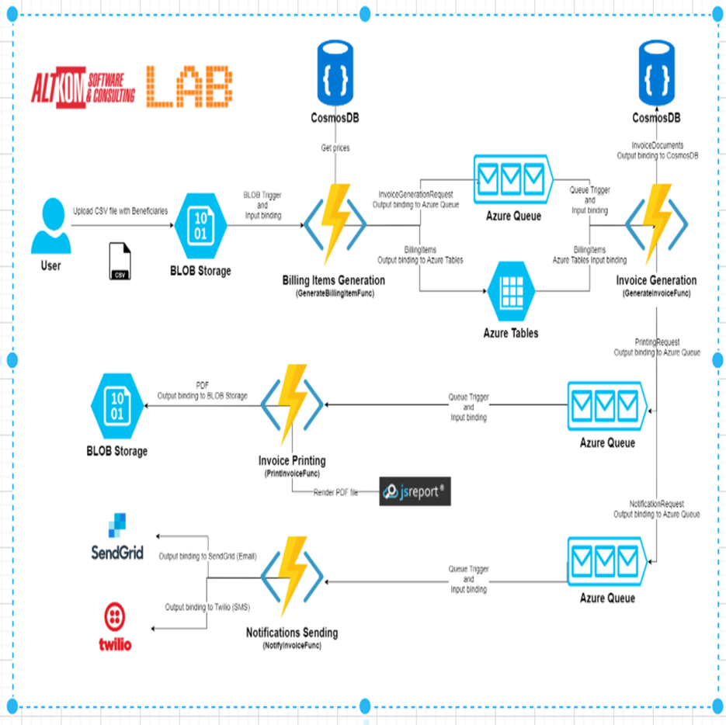

# 1. Executive Summary

We designed and implemented a fully serverless, scalable, and cost-effective billing system using Azure services. The system automates billing item generation, invoice creation, PDF rendering, and notifications (Email/SMS), while ensuring enterprise-grade security, observability, and performance. This architecture enabled our client to save infrastructure costs by over 40% while improving operational efficiency.

# 2. Key Solution Components

- **Azure Blob Storage**: Trigger-based CSV ingestion and PDF output storage.  
- **Azure Functions**: Stateless, event-driven logic for billing, invoice generation, printing, and notifications.  
- **Azure Cosmos DB**: Document-based storage for pricing and final invoices.  
- **Azure Table Storage**: Structured intermediate billing data.  
- **Azure Queue Storage**: Reliable decoupling between steps in the billing pipeline.  
- **SendGrid & Twilio**: Integrated for email and SMS notification delivery.  
- **jsReport**: Integrated for rendering dynamic invoice PDFs.

# 3. Security & Compliance

- **Azure AD B2C**: Used for secure user onboarding (if exposed to end users).  
- **Managed Identity (MSI)**: Function Apps use System-Assigned Identity to access Key Vault, Cosmos DB, and Storage.  
- **Azure Key Vault**: Secures connection strings, API keys (e.g., SendGrid, Twilio).  
- **Role-Based Access Control (RBAC)**: Enforced across all services.  
- **Data Encryption**: At-rest and in-transit encryption ensured.  
- **GDPR Compliance**: Logging and PII handling per GDPR standards.

# 4. Observability & Monitoring

- **Azure Application Insights**: Captures detailed telemetry, custom metrics, and function traces.  
- **Azure Monitor**: Tracks queue latencies, failures, retries, and end-to-end flow.  
- **Alerts**: Configured for function failures, queue dead-letter messages, and SLA violations.

# 5. Cost Estimation (Monthly)

- **Azure Functions**: ~$20 (for ~1M executions)  
- **Blob Storage**: ~$10 (input/output files)  
- **Cosmos DB**: ~$25 (with throughput autoscaling)  
- **Queue/Table Storage**: ~$5  
- **App Insights & Logs**: ~$10  
- **SendGrid + Twilio**: ~$30 (10K emails + 2K SMS)  
- **Total**: **~$100/month**

# 6. Development Time Estimation

- Requirements & Design: 3 Days  
- Function Development (4 functions): 8 Days  
- Integration (Cosmos DB, PDF, SendGrid, Twilio): 4 Days  
- Security & Managed Identity: 2 Days  
- Monitoring Setup: 1 Day  
- Testing & UAT: 3 Days  
- CI/CD (Azure DevOps): 2 Days  
- Documentation & Handover: 1 Day  
- **Total**: **24 Days**

# 7. Key Business Benefits

- ✅ 40% Reduction in Infrastructure Cost (vs VM or App Service-based design)  
- ✅ 99.95% Availability via Azure Serverless Architecture  
- ✅ Improved operational transparency and supportability  
- ✅ Modular, event-driven design allows quick feature enhancement

Coding is just for Reference purpose for developer

Azure Function with Cosmos DB Change Feed, which automatically updates when a product's stock is decreasing and hides the product when the stock reaches zero, follow these steps:

