DAYANANDA SAGAR UNIVERSITY
(Autonomous Private University)



Training Project Report On

Electricity Bill System
Using Core Java & JDBC

Submitted By:
Rajneet Kumar
Shrishti Singh
Sri Harsha
Sanjay

Electricity Bill System

INDEX
- Objective of the Project
- Scope of the Project
- Feasibility Study
- Existing System
- Proposed System
- System Design
- Entity-Relationship Diagram
- Database Design
- Database Design Screenshots
- Bill Calculation Logic
- Coding
- Output
- Conclusion
- Future Enhancement
- References

OBJECTIVE
The main objective of this project is to develop an efficient Electricity Bill Management System using Core Java and JDBC with MySQL as the backend. The system aims to:
• Store and manage consumer details in a structured database
• Calculate electricity bills using predefined slab rates
• Generate monthly bills and prevent duplicate billing
• Perform CRUD operations on consumer data
• Implement user authentication with role-based access (Admin/User)
• Allow users to view and pay bills, and track payment history
• Ensure data integrity using JDBC and database constraints.

SCOPE OF THE PROJECT
The Electricity Bill System is a console-based application developed using Core Java, JDBC, and MySQL to manage consumer data and generate electricity bills efficiently.
The scope of this project includes:
• Managing consumer details and performing CRUD operations
• Generating monthly electricity bills using predefined slab rates
• Preventing duplicate bill generation for the same billing period
• Storing and retrieving data using JDBC
• Providing a simple menu-driven interface
Enhanced features include:
• User registration and login system
• Role-based access control (Admin/User)
• Bill generation, payment, and status tracking
• User-specific access using consumer ID mapping
• Payment history tracking and first-login password change
The system focuses on database-driven operations and can be extended with GUI, online payments, and web/mobile deployment.

FEASIBILITY STUDY
The feasibility study evaluates whether the Electricity Bill System is practical, economical, and technically viable for implementation.
1. Technical Feasibility:
The system is developed using Core Java, JDBC, and MySQL, which are widely used and well-supported technologies. It can run on any standard computer with Java and MySQL installed. The system also supports features like role-based access, monthly billing, and payment tracking, making it technically reliable.
2. Economic Feasibility:
The project uses open-source technologies and does not require expensive hardware or software. Hence, the development and maintenance cost is minimal, making it economically feasible.
3. Operational Feasibility:
The system provides a simple menu-driven interface that is easy to use. It automates bill generation, payment tracking, and user management, reducing manual effort and improving accuracy and efficiency.
4. Schedule Feasibility:
The project is small in scale and can be completed within the given time frame. The development phases such as design, coding, testing, and documentation are manageable within the schedule.

EXISTING SYSTEM
In the existing system, electricity billing is often carried out manually or using basic tools like spreadsheets. Consumer data is recorded manually, and bills are calculated using fixed formulas.
This approach has several limitations:
• Manual calculations are time-consuming and prone to errors
• Managing large data manually leads to inconsistency and data loss
• Lack of secure authentication and role-based access control
• No proper tracking of bill payments and billing history
• Difficulty in managing monthly billing and preventing duplicate records
In some cases, semi-automated systems are used, but they often lack proper database integration, security, and payment management features.
Therefore, there is a need for an automated system that can efficiently manage consumer data, generate monthly bills, track payments, and provide secure role-based access.
PROPOSED SYSTEM
The proposed system is an automated Electricity Bill Management System developed using Core Java and JDBC with MySQL as the backend database. It overcomes the limitations of manual systems by providing an efficient, accurate, and secure way to manage consumer data and billing operations.
The system stores detailed consumer information in a structured database and allows adding new consumers, updating records, and retrieving data efficiently. Electricity bills are generated automatically based on predefined slab rates and are maintained monthly with proper tracking of billing month and year, preventing duplicate bill generation.
The system includes a secure login and registration module with role-based access control. Users are assigned roles such as ADMIN and USER. The Admin can manage consumers, generate monthly bills, and view all records, while Users can view their own bills, make payments, and track payment history.
The application provides a simple menu-driven interface and uses JDBC for seamless interaction between the Java application and the MySQL database.
Overall, the system improves efficiency, ensures data integrity, supports payment tracking, and simulates a real-world electricity billing system with secure and structured data management.
The system also includes enhanced administrative control where the admin can delete a consumer only if there are no unpaid bills associated with that consumer. This ensures data consistency and prevents loss of important billing records. Additionally, the user module has been improved to allow users to view their profile details and update their phone number. However, for security and data integrity reasons, users are restricted from modifying other personal details.

SYSTEM DESIGN
The Electricity Bill System is designed using a modular approach, dividing the application into different components to improve readability, maintainability, and efficiency.
1. Overall Design:
The system follows a three-layer architecture:
• User Interface Layer (MainApp.java)
• Business Logic Layer (DAO classes and billing logic)
• Database Layer (MySQL Database)
2. Module Description:
a) User Interface Module:
Provides a menu-driven interface for user interaction. It includes login and registration functionality and displays different menus based on user roles (Admin/User).
b) Business Logic Module:
Handles core functionalities such as authentication, bill calculation using slab rates, monthly bill generation, role-based access control, and payment processing.
c) Database Module:
Manages data storage using MySQL. JDBC is used to connect the Java application with the database and perform operations like INSERT, SELECT, UPDATE, and DELETE.
3. Data Flow:
• User registers or logs into the system
• Role-based menu (Admin/User) is displayed
• Admin manages consumers and generates monthly bills
• Users view bills, make payments, and track payment history
• JDBC connects to the database
• Data is stored, retrieved, and updated
• Output is displayed to the user

4. Database Design:
The system uses four tables:
• consumers – stores detailed consumer information
• users – stores login credentials, roles, and consumer mapping
• bills – stores monthly billing records (month, year, amount, status)
• payments – stores payment transactions and history
Relationships:
• Each user is optionally linked to one consumer (0..1 relationship)
• Each consumer can have multiple bills (1:N relationship)
• Each bill can have multiple payments (1:N relationship)

5. Design Advantages:
• Supports role-based access control (Admin/User)
• Secure authentication system with user-consumer mapping
• Monthly billing with duplicate prevention
• Payment tracking and history management
• Efficient data management using relational database
• Modular design improves maintainability and scalability

Login / Registration
(Authentication)
(MainApp.java)
USER

Role Management
(Admin / User)

User Module
- · View Profile Details
- · Update Phone Number (restricted update)
- View Bills
- Pay Bills
- View Payment History

Admin Module
- Manage Consumers (Add, View, Delete with validation)
- · Delete consumer only if no unpaid bills exist
- Generate Monthly Bills
- View All Records
- Monitor Payments

Business Logic
(Bill Calculation + Payment Processing + Authentication)

DAO Layer
(DB Operations)

JDBC Connection
(DBConnection)

MySQL Database
(consumers | users | bills | payments)

ENTITY–RELATIONSHIP DIAGRAM
The system consists of four main entities: USER, CONSUMER, BILL, and PAYMENT.
The USER entity stores login credentials such as username, password, role (ADMIN/USER), and is optionally linked to a consumer using consumer_id.
The CONSUMER entity stores detailed consumer information such as consumer_id, name, phone, and address details.
The BILL entity stores monthly billing records including bill_id, consumer_id, units consumed, bill amount, billing month, year, and payment status.
The PAYMENT entity stores transaction details such as payment_id, bill_id, amount, payment date, method, and status.
🔗 Relationships:
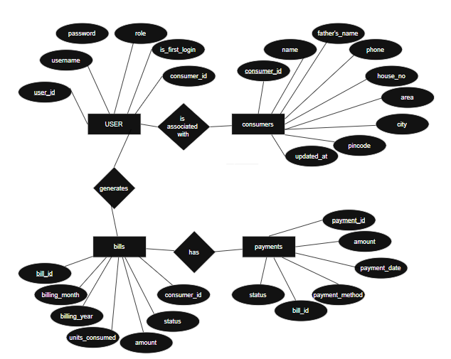
Database: electricity_db

• Each USER is optionally associated with one CONSUMER (0..1 relationship)
• Each CONSUMER can have multiple BILL records (1:N relationship)
• Each BILL can have multiple PAYMENT records (1:N relationship)
This design ensures secure authentication, role-based access control, efficient monthly billing, and proper tracking of payment transactions.

DATABASE DESIGN
The system uses a relational database to store and manage consumer information, user authentication, billing records, and payment transactions.
Database Name: electricity_db
Tables : 1. consumers
• consumer_id (Primary Key)
• name
• phone
• father_name
• house_no
• area
• city
• pincode
• updated_at

2. users
• user_id (Primary Key)
• username (Unique)
• password
• role (ADMIN/USER)
• consumer_id (Foreign Key)
• is_first_login
3. bills
• bill_id (Primary Key)
• consumer_id (Foreign Key)
• units_consumed
• amount
• billing_month
• billing_year
• status (PAID/UNPAID)
4. payments
• payment_id (Primary Key)
• bill_id (Foreign Key)
• amount
• payment_date
• payment_method
• status (SUCCESS/FAILED)
Table Structure:
- CONSUMERS TABLE
Field Name | Data Type | Description
consumer_id | INT | Primary Key, auto generated ID
name | VARCHAR | Name of the consumer
phone | varchar | Contact Number
father_name | VARCHAR | Father’s Name
house_no | VARCHAR | House Number
Area | VARCHAR | Area
City | Varchar | Area
Pincode | Varchar | Postal Code
Updated_at | TIMESTAMP | Last updated time

- USERS TABLE
Field Name | Data Type | Description
user_id | INT | Primary Key, auto-generated user ID
username | VARCHAR | Unique username for login
Password | VARCHAR | User password for authentication
role | ENUM | User role (ADMIN / USER)
Consumer_id | INT | Foreign Key linking to consumers table
is_first_login | BOOLEAN | Indicates first login status

Field Name | Data Type | Description
bill_id | INT | Primary Key, auto-generated bill ID
Consumer_id | INT | Foreign Key linking to consumers table
Units_consumed | INT | Units of electricity consumed
amount | Decimal(10,2) | Total bill amount
Billing_month | INT | Month of billing
Billing_year | INT | Year of billing
status | ENUM | Payment status (PAID / UNPAID)
- BILLS TABLE

- Payments table
Field Name | Data Type | Description
payment_id | INT | Primary Key, auto-generated payment ID
bill_id | INT | Foreign Key linking to bills table
amount | Decimal(10,2) | Amount Paid
Payment_date | DATETIME | Date and time of payment
Payment_method | VARCHAR | Payment method (Online, etc.)
status | ENUM | Payment status (SUCCESS / FAILED)

Database Design Screenshots
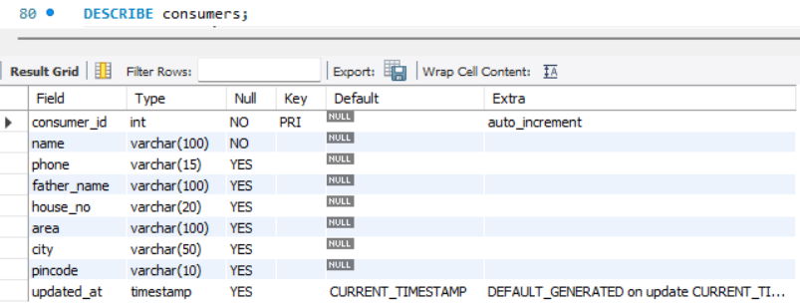
Figure 1: Structure of consumer table
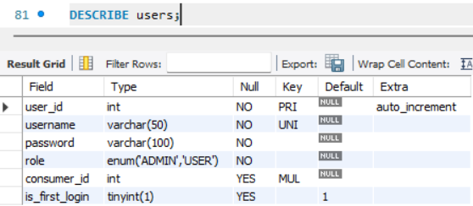
Figure 2: Structure of users table
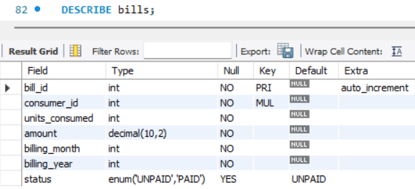
Figure 3: Structure of bills table
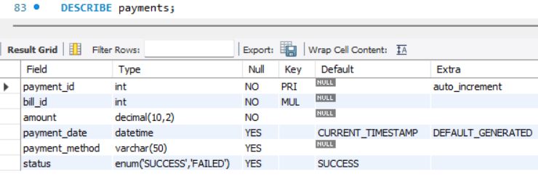
Figure 4: Structure of Payments table

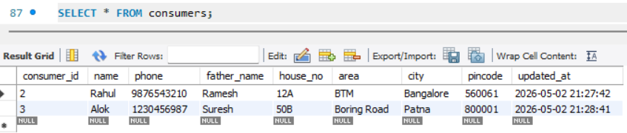
Figure 5: Consumers data stored in database

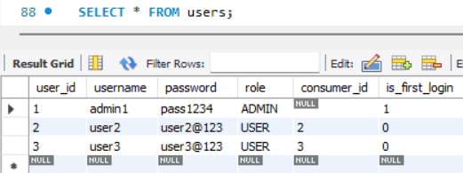
Figure 6: Users data stored in database

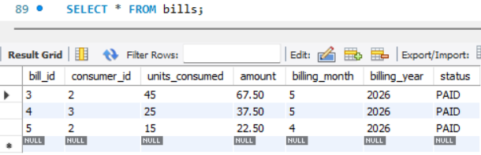
Figure 7: Bills stored in database
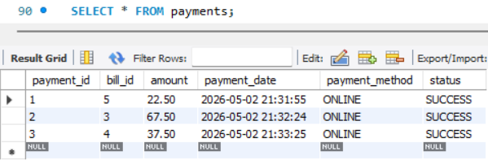
Figure 8: Payments stored in database

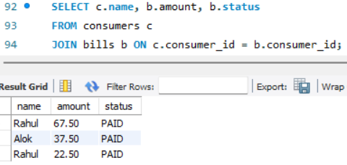
Figure 9: Join Query showing relationships between Consumers and bills

BILL CALCULATION LOGIC
The electricity bill is calculated based on a slab rate system, where different rates are applied to different ranges of units consumed. This ensures a progressive billing structure.
Slab Rates:
- 0 – 100 units: ₹1.5 per unit
- 101 – 300 units: ₹2.5 per unit
- Above 300 units: ₹4.0 per unit
Calculation Method:
- If the units consumed are less than or equal to 100, the bill is calculated as:
Bill = Units × 1.5
- If the units consumed are between 101 and 300, the bill is calculated as:
Bill = (100 × 1.5) + (Remaining Units × 2.5)
- If the units consumed are above 300, the bill is calculated as:
Bill = (100 × 1.5) + (200 × 2.5) + (Remaining Units × 4.0)
This slab-based calculation ensures that consumers are charged fairly based on their electricity usage, with higher consumption leading to higher per-unit costs.

CODING
The application is implemented using Core Java and JDBC with MySQL as the backend database. The project is developed in Eclipse IDE and follows a modular structure for better organization and maintainability.

The main classes of the system include:
• MainApp.java – Handles the user interface through a menu-driven console application, including login, registration, and role-based menu options for Admin and User.
• DBConnection.java – Establishes the connection between the Java application and the MySQL database using JDBC.
• ElectricityBillDAO.java – Contains database operations related to consumers and billing such as inserting consumer data, retrieving records, updating units consumed, generating bills, and managing payment status.
• UserDAO.java – Manages user authentication including registration, login verification, and role-based access control.
• Consumer.java – Represents the model class that stores consumer details such as consumer ID, name, and units consumed.
• User.java – Represents user information including username, password, role, and associated consumer ID.
• Bill (or Bills.java) – Represents billing data such as bill ID,
consumer ID, amount, and payment status.
The application uses PreparedStatement for executing SQL queries, ensuring secure and efficient database operations. The system also implements input validation and exception handling to maintain data integrity and prevent runtime errors.
The project demonstrates the use of object-oriented programming concepts, JDBC connectivity, role-based authentication, and real-time data processing using Java.

The system includes validation logic for safe deletion of consumers. Before deleting a consumer, the system checks whether any unpaid bills exist using database queries. If unpaid bills are found, deletion is restricted to maintain data integrity. Additionally, user functionality has been extended to include profile viewing and limited update capability, where users can update only their phone number. This ensures controlled data modification and enhances system reliability.
Full Source Code & SQL
-- ================= RESET DATABASE =================
DROP DATABASE IF EXISTS electricity_db;
CREATE DATABASE electricity_db;
USE electricity_db;
-- ================= CONSUMERS TABLE =================
CREATE TABLE consumers (
consumer_id INT AUTO_INCREMENT PRIMARY KEY,
name VARCHAR(100) NOT NULL,
phone VARCHAR(15),
father_name VARCHAR(100),
house_no VARCHAR(20),
area VARCHAR(100),
city VARCHAR(50),
pincode VARCHAR(10),
updated_at TIMESTAMP DEFAULT CURRENT_TIMESTAMP
ON UPDATE CURRENT_TIMESTAMP
);
-- ================= USERS TABLE =================
CREATE TABLE users (
user_id INT AUTO_INCREMENT PRIMARY KEY,
username VARCHAR(50) UNIQUE NOT NULL,
password VARCHAR(100) NOT NULL,
role ENUM('ADMIN','USER') NOT NULL,
consumer_id INT NULL,
is_first_login BOOLEAN DEFAULT TRUE,
FOREIGN KEY (consumer_id)
REFERENCES consumers(consumer_id)
ON DELETE SET NULL
);
-- ================= BILLS TABLE =================
CREATE TABLE bills (
bill_id INT AUTO_INCREMENT PRIMARY KEY,
consumer_id INT NOT NULL,
units_consumed INT NOT NULL CHECK (units_consumed >= 0),
amount DECIMAL(10,2) NOT NULL,
billing_month INT NOT NULL CHECK (billing_month BETWEEN 1 AND 12),
billing_year INT NOT NULL CHECK (billing_year >= 2020),
status ENUM('UNPAID','PAID') DEFAULT 'UNPAID',
FOREIGN KEY (consumer_id)
REFERENCES consumers(consumer_id)
ON DELETE CASCADE,
-- Prevent duplicate bill for same month
UNIQUE (consumer_id, billing_month, billing_year)
);
-- ================= PAYMENTS TABLE =================
CREATE TABLE payments (
payment_id INT AUTO_INCREMENT PRIMARY KEY,
bill_id INT NOT NULL,
amount DECIMAL(10,2) NOT NULL,
payment_date DATETIME DEFAULT CURRENT_TIMESTAMP,
payment_method VARCHAR(50),
status ENUM('SUCCESS','FAILED') DEFAULT 'SUCCESS',

FOREIGN KEY (bill_id)
REFERENCES bills(bill_id)
ON DELETE CASCADE
);
-- ================= INDEXES =================
CREATE INDEX idx_bill_consumer ON bills(consumer_id);
CREATE INDEX idx_payment_bill ON payments(bill_id);
-- ================= CHECK STRUCTURE =================
SHOW TABLES;
DESCRIBE consumers;
DESCRIBE users;
DESCRIBE bills;
DESCRIBE payments;
-- ================= SAMPLE QUERIES =================
-- View data
SELECT * FROM consumers;
SELECT * FROM users;
SELECT * FROM bills;
SELECT * FROM payments;

SELECT c.name, b.amount, b.status
FROM consumers c
JOIN bills b ON c.consumer_id = b.consumer_id;

-- ================= RESET DATA (SAFE ORDER) =================
SET FOREIGN_KEY_CHECKS = 0;
TRUNCATE payments;
TRUNCATE bills;
TRUNCATE users;
TRUNCATE consumers;
SET FOREIGN_KEY_CHECKS = 1;

DBConnection.java
import java.sql.*;
public class DBConnection {
private static final String URL = "jdbc:mysql://localhost:3306/electricity_db";
private static final String USER = "root";
private static final String PASSWORD = "0612";
public static Connection getConnection() {
try {
Class.forName("com.mysql.cj.jdbc.Driver");
return DriverManager.getConnection(URL, USER, PASSWORD);
} catch (Exception e) {
System.out.println("❌ DB Connection Error: " + e.getMessage());
}
return null;
}
}
Consumer.java
public class Consumer {
private String name;
private String phone;
private String fatherName;
private String houseNo;
private String area;
private String city;
private String pincode;
public Consumer(String name, String phone, String fatherName,
String houseNo, String area, String city, String pincode) {
this.name = name;
this.phone = phone;
this.fatherName = fatherName;
this.houseNo = houseNo;
this.area = area;
this.city = city;
this.pincode = pincode;
}
public String getName() { return name; }
public String getPhone() { return phone; }
public String getFatherName() { return fatherName; }
public String getHouseNo() { return houseNo; }
public String getArea() { return area; }
public String getCity() { return city; }
public String getPincode() { return pincode; }
}
ElectricityBillDAO.java
import java.sql.*;

public class ElectricityBillDAO {

// ➕ Add Consumer

public static int addConsumer(Consumer c) {

String query = "INSERT INTO consumers(name, phone, father_name, house_no, area, city, pincode) VALUES (?, ?, ?, ?, ?, ?, ?)";

try (Connection con = DBConnection.getConnection();
PreparedStatement ps = con.prepareStatement(query, Statement.RETURN_GENERATED_KEYS)) {

ps.setString(1, c.getName());
ps.setString(2, c.getPhone());
ps.setString(3, c.getFatherName());
ps.setString(4, c.getHouseNo());
ps.setString(5, c.getArea());
ps.setString(6, c.getCity());
ps.setString(7, c.getPincode());

ps.executeUpdate();

ResultSet rs = ps.getGeneratedKeys();
if (rs.next()) {
int id = rs.getInt(1);

System.out.println("✅ Consumer added. ID: " + id);

return id;
}

} catch (Exception e) {
e.printStackTrace();
}

return -1;
}
// 🔍 Get Consumer
public static Consumer getConsumer(int id) {

String query = "SELECT * FROM consumers WHERE consumer_id=?";

try (Connection con = DBConnection.getConnection();
PreparedStatement ps = con.prepareStatement(query)) {

ps.setInt(1, id);
ResultSet rs = ps.executeQuery();

if (rs.next()) {
return new Consumer(
rs.getString("name"),
rs.getString("phone"),
rs.getString("father_name"),
rs.getString("house_no"),
rs.getString("area"),
rs.getString("city"),
rs.getString("pincode")
);
}

} catch (Exception e) {
e.printStackTrace();
}

return null;
}

public static void showAllConsumers() {

String query = "SELECT consumer_id, name, city FROM consumers";

try (Connection con = DBConnection.getConnection();
PreparedStatement ps = con.prepareStatement(query);
ResultSet rs = ps.executeQuery()) {

System.out.println("\n====================================\n");
System.out.println("\n👥 CONSUMER LIST:");
System.out.println("\n====================================\n");

while (rs.next()) {
System.out.println(
"ID: " + rs.getInt("consumer_id") +
" | Name: " + rs.getString("name") +
" | City: " + rs.getString("city")
);
}

System.out.println("\n====================================\n");

} catch (Exception e) {
e.printStackTrace();
}
}

public static boolean hasAnyBill(int consumerId) {

String query = "SELECT 1 FROM bills WHERE consumer_id=?";

try (Connection con = DBConnection.getConnection();
PreparedStatement ps = con.prepareStatement(query)) {

ps.setInt(1, consumerId);
ResultSet rs = ps.executeQuery();

return rs.next();

} catch (Exception e) {
e.printStackTrace();
}

return false;
}

//Generate Bill
public static void generateBill(int consumerId, int units, int month, int year) {

String check = "SELECT 1 FROM bills WHERE consumer_id=? AND billing_month=? AND billing_year=?";

try (Connection con = DBConnection.getConnection();
PreparedStatement ps = con.prepareStatement(check)) {

ps.setInt(1, consumerId);
ps.setInt(2, month);
ps.setInt(3, year);

ResultSet rs = ps.executeQuery();

if (rs.next()) {
System.out.println("\n====================================\n");
System.out.println("\n❌ Bill already generated for this month!\n");
System.out.println("\n====================================\n");
return;
}

double amount = calculateBill(units);

String insert = "INSERT INTO bills(consumer_id, units_consumed, amount, billing_month, billing_year) VALUES (?, ?, ?, ?, ?)";

try (PreparedStatement ps2 = con.prepareStatement(insert)) {
ps2.setInt(1, consumerId);
ps2.setInt(2, units);
ps2.setDouble(3, amount);
ps2.setInt(4, month);
ps2.setInt(5, year);

ps2.executeUpdate();
System.out.println("\n====================================\n\n");
System.out.println("💰 Bill Generated Successfully!");
System.out.println("📅 Month: " + month + "/" + year);
System.out.println("⚡ Units: " + units);
System.out.println("💵 Amount: ₹" + amount);
System.out.println("\n\n====================================\n");
}

} catch (Exception e) {
e.printStackTrace();
}
}

public static void showAllUnpaidBills(int consumerId) {

String query = "SELECT bill_id, billing_month, billing_year, amount FROM bills WHERE consumer_id=? AND status='UNPAID'";

try (Connection con = DBConnection.getConnection();
PreparedStatement ps = con.prepareStatement(query)) {

ps.setInt(1, consumerId);
ResultSet rs = ps.executeQuery();

boolean found = false;

while (rs.next()) {
found = true;
System.out.println("\n====================================\n\n");
System.out.println(
"Bill ID: " + rs.getInt("bill_id") +
" | Month: " + rs.getInt("billing_month") + "/" + rs.getInt("billing_year") +
" | Amount: ₹" + rs.getDouble("amount")
);
System.out.println("\n\n====================================\n");
}

// if (!found) {
// System.out.println("\n====================================\n\n");
// System.out.println("❌ No unpaid bills!");
// System.out.println("\n\n====================================\n");
// }

} catch (Exception e) {
e.printStackTrace();
}
}

public static void viewBills() {

String query = "SELECT b.*, c.name FROM bills b " +
"JOIN consumers c ON b.consumer_id = c.consumer_id " +
"ORDER BY c.name, b.billing_year, b.billing_month";

try (Connection con = DBConnection.getConnection();
PreparedStatement ps = con.prepareStatement(query);
ResultSet rs = ps.executeQuery()) {

System.out.println("\n====================================\n");
System.out.println("📄 BILL RECORDS (USER-WISE):");
System.out.println("\n====================================\n");

if (!rs.isBeforeFirst()) {
System.out.println("❌ No bills available.");
return;
}

String currentUser = "";

while (rs.next()) {

String name = rs.getString("name");

// 🔹 Print header when user changes
if (!name.equals(currentUser)) {
currentUser = name;

System.out.println("\n👤 Consumer: " + name);
System.out.println("-------------------------------------------------------------");
System.out.printf("%-8s %-8s %-10s %-10s %-10s\n",
"BillID", "Units", "Month", "Amount", "Status");
System.out.println("-------------------------------------------------------------");
}

// 🔹 Print row
System.out.printf("%-8d %-8d %-10s %-10.2f %-10s\n",
rs.getInt("bill_id"),
rs.getInt("units_consumed"),
rs.getInt("billing_month") + "/" + rs.getInt("billing_year"),
rs.getDouble("amount"),
rs.getString("status"));
}

System.out.println("\n====================================\n");

} catch (SQLException e) {
System.out.println("❌ Error: " + e.getMessage());
}
}

// 👤 Show Full Consumer Profile
public static void showProfile(int consumerId) {

String query = "SELECT * FROM consumers WHERE consumer_id=?";

try (Connection con = DBConnection.getConnection();
PreparedStatement ps = con.prepareStatement(query)) {

ps.setInt(1, consumerId);
ResultSet rs = ps.executeQuery();

if (rs.next()) {

System.out.println("\n====================================");
System.out.println("👤 CONSUMER PROFILE");
System.out.println("====================================");

System.out.println("Name : " + rs.getString("name"));
System.out.println("Phone : " + rs.getString("phone"));
System.out.println("Father Name : " + rs.getString("father_name"));
System.out.println("House No : " + rs.getString("house_no"));
System.out.println("Area : " + rs.getString("area"));
System.out.println("City : " + rs.getString("city"));
System.out.println("Pincode : " + rs.getString("pincode"));

System.out.println("====================================\n");

} else {
System.out.println("❌ Profile not found!");
}

} catch (Exception e) {
e.printStackTrace();
}
}

// 🗑️ Delete Consumer
public static boolean deleteConsumer(int consumerId) {

String query = "DELETE FROM consumers WHERE consumer_id=?";

try (Connection con = DBConnection.getConnection();
PreparedStatement ps = con.prepareStatement(query)) {

ps.setInt(1, consumerId);

int rows = ps.executeUpdate();

return rows > 0;

} catch (Exception e) {
e.printStackTrace();
}

return false;
}

// 🗑️ Delete user linked to consumer
public static void deleteUserByConsumerId(int consumerId) {

String query = "DELETE FROM users WHERE consumer_id=?";

try (Connection con = DBConnection.getConnection();
PreparedStatement ps = con.prepareStatement(query)) {

ps.setInt(1, consumerId);
ps.executeUpdate();

} catch (Exception e) {
e.printStackTrace();
}
}

// 🚫 Check if consumer has unpaid bills
public static boolean hasUnpaidBillsForDelete(int consumerId) {

String query = "SELECT 1 FROM bills WHERE consumer_id=? AND status='UNPAID'";

try (Connection con = DBConnection.getConnection();
PreparedStatement ps = con.prepareStatement(query)) {

ps.setInt(1, consumerId);
ResultSet rs = ps.executeQuery();

return rs.next();

} catch (Exception e) {
e.printStackTrace();
}

return false;
}

// 📞 Get current phone number
public static String getPhone(int consumerId) {

String query = "SELECT phone FROM consumers WHERE consumer_id=?";

try (Connection con = DBConnection.getConnection();
PreparedStatement ps = con.prepareStatement(query)) {

ps.setInt(1, consumerId);
ResultSet rs = ps.executeQuery();

if (rs.next()) {
return rs.getString("phone");
}

} catch (Exception e) {
e.printStackTrace();
}

return null;
}

// 📱 Update Phone Number Only
public static boolean updatePhone(int consumerId, String phone) {

String query = "UPDATE consumers SET phone=? WHERE consumer_id=?";

try (Connection con = DBConnection.getConnection();
PreparedStatement ps = con.prepareStatement(query)) {

ps.setString(1, phone);
ps.setInt(2, consumerId);

return ps.executeUpdate() > 0;

} catch (Exception e) {
e.printStackTrace();
}

return false;
}

public static int getUnpaidBillId(int consumerId) {

String query = "SELECT bill_id FROM bills WHERE consumer_id=? AND status='UNPAID' LIMIT 1";

try (Connection con = DBConnection.getConnection();
PreparedStatement ps = con.prepareStatement(query)) {

ps.setInt(1, consumerId);
ResultSet rs = ps.executeQuery();

if (rs.next()) {
return rs.getInt("bill_id");
}

} catch (Exception e) {
e.printStackTrace();
}

return -1;
}

public static boolean hasUnpaidBill(int consumerId) {

String query = "SELECT 1 FROM bills WHERE consumer_id=? AND status='UNPAID'";

try (Connection con = DBConnection.getConnection();
PreparedStatement ps = con.prepareStatement(query)) {

ps.setInt(1, consumerId);
ResultSet rs = ps.executeQuery();

return rs.next();

} catch (Exception e) {
e.printStackTrace();
}

return false;
}

public static void showUnpaidBill(int consumerId) {

String query = "SELECT * FROM bills WHERE consumer_id=? AND status='UNPAID'";

try (Connection con = DBConnection.getConnection();
PreparedStatement ps = con.prepareStatement(query)) {

ps.setInt(1, consumerId);
ResultSet rs = ps.executeQuery();

if (rs.next()) {
System.out.println("\n====================================\n\n");
System.out.println("🧾 Bill ID: " + rs.getInt("bill_id"));
System.out.println("📅 Month: " + rs.getInt("billing_month") + "/" + rs.getInt("billing_year"));
System.out.println("⚡ Units: " + rs.getInt("units_consumed"));
System.out.println("💰 Amount: ₹" + rs.getDouble("amount"));

System.out.println("\n\n====================================\n");
}

} catch (Exception e) {
e.printStackTrace();
}
}

public static void payBill(int billId, int consumerId) {

String query = "SELECT amount FROM bills WHERE bill_id=? AND consumer_id=? AND status='UNPAID'";

try (Connection con = DBConnection.getConnection()) {

if (con == null) {
System.out.println("❌ Database connection failed!");
return;
}

try (PreparedStatement ps = con.prepareStatement(query)) {

ps.setInt(1, billId);
ps.setInt(2, consumerId);
ResultSet rs = ps.executeQuery();

if (!rs.next()) {

System.out.println("\n====================================\n\n");
System.out.println("❌ Invalid or already paid!");
System.out.println("\n\n====================================\n");
return;
}

double amount = rs.getDouble("amount");

// insert payment
String payment = "INSERT INTO payments(bill_id, amount, payment_method, status) VALUES (?, ?, 'ONLINE', 'SUCCESS')";

try (PreparedStatement ps2 = con.prepareStatement(payment)) {
ps2.setInt(1, billId);
ps2.setDouble(2, amount);
ps2.executeUpdate();
}

// update bill
String update = "UPDATE bills SET status='PAID' WHERE bill_id=?";

try (PreparedStatement ps3 = con.prepareStatement(update)) {
ps3.setInt(1, billId);
ps3.executeUpdate();
}
System.out.println("\n====================================\n");
System.out.println("\n✅ Payment Successful!");
System.out.println("\n====================================\n");
}
} catch (Exception e) {
e.printStackTrace();
}
}

// 💡 Bill Calculation Logic
public static double calculateBill(int units) {

double bill;

if (units <= 100) {
bill = units * 1.5;
} else if (units <= 300) {
bill = (100 * 1.5) + (units - 100) * 2.5;
} else {
bill = (100 * 1.5) + (200 * 2.5) + (units - 300) * 4;
}

return bill;
}

// 📊 Show Payment History
public static void showPaymentHistory(int consumerId) {

String query = "SELECT b.billing_month, b.billing_year, p.amount, p.payment_date " +
"FROM payments p JOIN bills b ON p.bill_id = b.bill_id " +
"WHERE b.consumer_id=? ORDER BY p.payment_date DESC";

try (Connection con = DBConnection.getConnection();
PreparedStatement ps = con.prepareStatement(query)) {

ps.setInt(1, consumerId);
ResultSet rs = ps.executeQuery();

boolean found = false;
System.out.println("\n====================================\n\n");

System.out.println("\n📊 PAYMENT HISTORY:");
System.out.println("\n\n====================================\n");

while (rs.next()) {
found = true;

System.out.println(
"📅 " + rs.getInt("billing_month") + "/" + rs.getInt("billing_year") +
" | 💰 ₹" + rs.getDouble("amount") +
" | 🕒 " + rs.getTimestamp("payment_date")
);
System.out.println("\n\n====================================\n\n");
}

if (!found) {
System.out.println("\n====================================\n\n");
System.out.println("❌ No payment history found.");
System.out.println("\n\n====================================\n");
}

} catch (Exception e) {
e.printStackTrace();
}
}
}

MainApp.java
import java.util.Scanner;

public class MainApp {

public static void main(String[] args) {

Scanner sc = new Scanner(System.in);
String role = null;
String username = "";

System.out.println("===== Welcome to Electricity Bill System =====");

// 🔁 LOGIN / REGISTER LOOP
while (true) {

System.out.println("\n1. Admin Register");
System.out.println("2. Login");
System.out.println("3. Exit");

System.out.println("\n====================================\n");
System.out.print("Enter option: ");

int option = sc.nextInt();
sc.nextLine(); // FIX

if (option == 1) {

// 🔹 REGISTER

System.out.print("Username: ");
String uname = sc.nextLine();

System.out.print("Password: ");
String pass = sc.nextLine();

if (uname.trim().isEmpty() || pass.trim().isEmpty()) {

System.out.println("\nxxxxxxxxxxxxxxxxxxxxxxxxxxxxxxxxxxxxx\n");
System.out.println("❌ Username/Password cannot be empty!");
System.out.println("\nxxxxxxxxxxxxxxxxxxxxxxxxxxxxxxxxxxxxx\n");
continue;
}

System.out.print("Role : ");
String r = sc.nextLine().toUpperCase();

if (!r.equals("ADMIN") && !r.equals("USER")) {
System.out.println("❌ Invalid role!");
continue;
}

int consumerId = 0;

// ✅ Only USER enters consumer ID
if (r.equals("USER")) {

System.out.println("\n--------------------------------------------\n");
System.out.print("Enter Consumer ID: ");
consumerId = sc.nextInt();
sc.nextLine();
}

User u = new User(uname, pass, r, consumerId);
boolean status = UserDAO.register(u);

if (status) {

System.out.println("\n--------------------------------------------\n");
System.out.println("✅ Registration successful!");
System.out.println("\n--------------------------------------------\n");
}
else
{
System.out.println("\n--------------------------------------------\n");
System.out.println("❌ Registration failed!");
System.out.println("\n--------------------------------------------\n");
}
}

else if (option == 2) {

// 🔹 LOGIN
System.out.println("\n--------------------------------------------\n");
System.out.print("Username: ");
username = sc.nextLine();

System.out.print("Password: ");

String password = sc.nextLine();
System.out.println("\n--------------------------------------------\n");

role = UserDAO.login(username, password);

if (role != null) {

System.out.println("\n--------------------------------------------\n");
System.out.println("✅ Login successful!");
System.out.println("\n--------------------------------------------\n");

// 🔐 FIRST LOGIN CHECK
if (role.equals("USER") && UserDAO.isFirstLogin(username)) {
System.out.println("\n\n--------------------------------------------\n\n");
System.out.println("⚠️ First Login - You must change your password!");
System.out.println("\n--------------------------------------------\n");

while (true) {

System.out.print("Enter New Password: ");
String newPass = sc.nextLine();

if (newPass.trim().isEmpty()) {
System.out.println("❌ Password cannot be empty!");
continue;
}

boolean updated = UserDAO.changePassword(username, newPass);

if (updated) {

System.out.println("\n--------------------------------------------\n");
System.out.println("✅ Password changed successfully!");

System.out.println("\n--------------------------------------------\n");
break;
} else {

System.out.println("\n--------------------------------------------\n");
System.out.println("❌ Failed to update password. Try again.");
System.out.println("\n--------------------------------------------\n");
}
}
}

break;
} else {
System.out.println("\nxxxxxxxxxxxxxxxxxxxxxxxxxxxxxxxxxxxxxx\n");
System.out.println("❌ Invalid credentials! Try again.");
System.out.println("\nxxxxxxxxxxxxxxxxxxxxxxxxxxxxxxxxxxxxxxx\n");

}
}

else if (option == 3) {

System.out.println("\n--------------------------------------------\n");
System.out.println("👋 Exiting...");
System.out.println("\n--------------------------------------------\n");
sc.close();
return;
}

else {
System.out.println("\n--------------------------------------------\n");
System.out.println("❌ Invalid option!");
System.out.println("\n--------------------------------------------\n");
}
}

// 🔐 ROLE BASED ACCESS
if (role.equals("ADMIN")) {
adminMenu(sc);
} else {
userMenu(sc, username);
}

sc.close();
}

// ================= ADMIN MENU =================
public static void adminMenu(Scanner sc) {

int choice;

do {
System.out.println("\n===== ADMIN MENU =====");
System.out.println("1. Add Consumer");
System.out.println("2. Generate Monthly Bill");
System.out.println("3. View Bill History");
System.out.println("4. Delete Consumer");
System.out.println("5. Exit");
System.out.println("\n--------------------------------------------\n");

System.out.print("Enter your choice: ");

choice = sc.nextInt();

switch (choice) {

case 1:
sc.nextLine(); // clear buffer
System.out.println("\n--------------------------------------------\n");
System.out.print("Enter Name: ");
String name = sc.nextLine();

if (name.trim().isEmpty()) {
System.out.println("❌ Name cannot be empty!");
break;
}

System.out.print("Phone: ");
String phone = sc.nextLine();

if (phone.trim().isEmpty()) {
System.out.println("❌ Phone cannot be empty!");
break;
}

System.out.print("Father Name: ");
String father = sc.nextLine();

System.out.print("House No: ");
String house = sc.nextLine();

System.out.print("Area: ");
String area = sc.nextLine();

System.out.print("City: ");
String city = sc.nextLine();

System.out.print("Pincode: ");
String pin = sc.nextLine();
System.out.println("\n--------------------------------------------\n");
Consumer c = new Consumer(name, phone, father, house, area, city, pin);

int generatedId = ElectricityBillDAO.addConsumer(c);

if (generatedId == -1) {
System.out.println("\n--------------------------------------------\n");
System.out.println("❌ Failed to create consumer!");
System.out.println("\n--------------------------------------------\n");
break;
}

// Generate username & password
String uname = "user" + generatedId;
String password = "User@" + generatedId;

// 🔥 Create user in database
User user = new User(uname, password, "USER", generatedId);
boolean created = UserDAO.register(user);

if (!created) {
System.out.println("\n--------------------------------------------\n");
System.out.println("❌ User creation failed! Please retry.");
System.out.println("\n--------------------------------------------\n");
break;
}

// Print credentials
if (created) {
System.out.println("\n--------------------------------------------\n");
System.out.println("🔐 Default Username: " + uname);
System.out.println("🔑 Default Password: " + password);
System.out.println("\n--------------------------------------------\n");
} else {
System.out.println("\n--------------------------------------------\n");
System.out.println("❌ Failed to create user account!");
System.out.println("\n--------------------------------------------\n");
}

System.out.println("\n--------------------------------------------\n");
System.out.println("✅ Consumer Created Successfully!\n");
System.out.println("👉 Generated Consumer ID: " + generatedId);

System.out.println("\n--------------------------------------------\n");

break;

case 2:

ElectricityBillDAO.showAllConsumers();
System.out.println("\n\n--------------------------------------------\n\n");
System.out.print("\nSelect Consumer ID: ");
int cid = sc.nextInt();

Consumer consumer = ElectricityBillDAO.getConsumer(cid);

if (consumer == null) {
System.out.println("\n❌ Consumer not found!");
break;
}

System.out.print("\n\nEnter Units Consumed (this month): ");
int units = sc.nextInt();

if (units < 0) {
System.out.println("\n\n❌ Units cannot be negative!");
break;
}

// 📅 Auto current month/year
java.time.LocalDate today = java.time.LocalDate.now();
int month = today.getMonthValue();
int year = today.getYear();

System.out.println("\n\n📅 Current Month: " + month + "/" + year);

// 🔥 Allow admin override (IMPORTANT FOR DEMO)
System.out.print("\n\nDo you want to override month? (yes/no): ");
String override = sc.next();

if (override.equalsIgnoreCase("yes")) {

System.out.print("\n\nEnter Month (1-12): ");
month = sc.nextInt();

if (month < 1 || month > 12) {
System.out.println("\n❌ Invalid month!");
break;
}

System.out.print("\nEnter Year: ");
year = sc.nextInt();

if (year < 2020) {
System.out.println("\n❌ Invalid year!");
break;
}
System.out.println("\n\n--------------------------------------------\n");
}

ElectricityBillDAO.generateBill(cid, units, month, year);
sc.nextLine();
break;

case 3:
ElectricityBillDAO.viewBills();
break;

case 4:

ElectricityBillDAO.showAllConsumers();

System.out.print("\nEnter Consumer ID to delete: ");
int delId = sc.nextInt();
sc.nextLine();

Consumer consumerToDelete = ElectricityBillDAO.getConsumer(delId);

if (consumerToDelete == null) {
System.out.println("❌ Consumer not found!");
break;
}

// 🚫 CHECK UNPAID BILL FIRST
if (ElectricityBillDAO.hasUnpaidBillsForDelete(delId)) {
System.out.println("\n====================================");
System.out.println("❌ Cannot delete consumer!");
System.out.println("⚠️ Unpaid bills exist for this consumer.");
System.out.println("👉 Please clear dues before deletion.");
System.out.println("====================================");
break;
}

// Confirm delete
System.out.print("Are you sure you want to delete this consumer? (yes/no): ");
String confirm = sc.nextLine();

if (!confirm.equalsIgnoreCase("yes")) {
System.out.println("❌ Deletion cancelled.");
break;
}

// Delete user
ElectricityBillDAO.deleteUserByConsumerId(delId);

// Delete consumer
boolean deleted = ElectricityBillDAO.deleteConsumer(delId);

if (deleted) {
System.out.println("✅ Consumer deleted successfully!");
} else {
System.out.println("❌ Deletion failed!");
}

break;

case 5:

System.out.println("\n--------------------------------------------\n\n");
System.out.println("👋 Exiting Admin Menu...");
System.out.println("\n\n--------------------------------------------\n");
break;

default:
System.out.println("❌ Invalid choice!");
}

} while (choice != 5);
}

// ================= USER MENU =================
public static void userMenu(Scanner sc, String username) {

int consumerId = UserDAO.getConsumerId(username);
if (consumerId == -1) {
System.out.println("\n❌ User not linked to any consumer!");
return;
}
int choice;

do {
System.out.println("\n===== USER MENU =====");
System.out.println("1. View Bill");
System.out.println("2. Pay Bill");
System.out.println("3. View Payment History");
System.out.println("4. Update Phone Number");
System.out.println("5. View Profile");
System.out.println("6. Exit\n");
System.out.println("\n--------------------------------------------\n");
System.out.print("Enter choice: ");

choice = sc.nextInt();
sc.nextLine();

switch (choice) {

case 1:

// Check unpaid bill first
if (ElectricityBillDAO.hasUnpaidBill(consumerId)) {

System.out.println("⚠️ Unpaid Bill Found:");
ElectricityBillDAO.showUnpaidBill(consumerId);

} else {

// Check if any bill exists (paid or not)
if (ElectricityBillDAO.hasAnyBill(consumerId)) {

System.out.println("\n=================================================");
System.out.println("✅ Previous bill already paid.\n");
System.out.println("ℹ️ New bill has not been generated yet.\n");
System.out.println("👉 Please wait for admin to generate the next bill.");
System.out.println("\n=================================================");

} else {

System.out.println("=================================================");
System.out.println("ℹ️ No bill found for your account.");
System.out.println("👉 Please contact admin.");

}
}

break;

case 2:

// Show all unpaid bills
ElectricityBillDAO.showAllUnpaidBills(consumerId);

if (!ElectricityBillDAO.hasUnpaidBill(consumerId)) {
System.out.println("❌ No unpaid bills!");
break;
}

System.out.print("\nEnter Bill ID to pay: ");
int billId = sc.nextInt();
sc.nextLine();

ElectricityBillDAO.payBill(billId, consumerId);

// if (billId == -1) {
// System.out.println("\n❌ No unpaid bills!");
// } else {
// ElectricityBillDAO.payBill(billId, consumerId);
// }

break;

case 3:
ElectricityBillDAO.showPaymentHistory(consumerId);
break;

case 4:

// 🔹 Show current phone
String currentPhone = ElectricityBillDAO.getPhone(consumerId);

System.out.println("\n--------------------------------------------");
System.out.println("📞 Current Phone: " + currentPhone);
System.out.println("--------------------------------------------");

System.out.print("Enter new phone number: ");
String phone = sc.nextLine();

// 🔹 Validation
if (!phone.matches("\\d{10}")) {
System.out.println("❌ Enter valid 10-digit phone number!");
break;
}

// 🔹 Confirm before update (extra polish)
System.out.print("Are you sure you want to update? (yes/no): ");
String confirm = sc.nextLine();

if (!confirm.equalsIgnoreCase("yes")) {
System.out.println("❌ Update cancelled.");
break;
}

boolean updated = ElectricityBillDAO.updatePhone(consumerId, phone);

if (updated) {
System.out.println("✅ Phone number updated successfully!");
} else {
System.out.println("❌ Update failed!");
}

break;

case 5:
ElectricityBillDAO.showProfile(consumerId);
break;

case 6:
System.out.println("\n👋 Exiting User Menu...");
break;

default:
System.out.println("\n❌ Invalid choice!");
}

} while (choice != 6);
}
}

User.java
public class User {
private String username;
private String password;
private String role;
private int consumerId;

public User(String username, String password, String role, int consumerId) {
this.username = username;
this.password = password;
this.role = role;
this.consumerId = consumerId;
}

public String getUsername() { return username; }
public String getPassword() { return password; }
public String getRole() { return role; }
public int getConsumerId() {
return consumerId;
}
}

UserDAO.java
import java.sql.*;

public class UserDAO {

// 🔹 REGISTER USER
public static boolean register(User user) {

String checkQuery = "SELECT * FROM users WHERE username=?";
String insertQuery = "INSERT INTO users (username, password, role, consumer_id) VALUES (?, ?, ?, ?)";

try (Connection con = DBConnection.getConnection();
PreparedStatement checkPs = con.prepareStatement(checkQuery)) {

// 🔍 1. Check duplicate username
checkPs.setString(1, user.getUsername());
ResultSet rs = checkPs.executeQuery();

if (rs.next()) {
System.out.println("❌ Username already exists!");
return false;
}

// 🔥 2. ADD THIS PART (consumer validation)
if (user.getRole().equals("USER")) {

String checkConsumer = "SELECT * FROM consumers WHERE consumer_id=?";

try (PreparedStatement ps = con.prepareStatement(checkConsumer)) {
ps.setInt(1, user.getConsumerId());
ResultSet crs = ps.executeQuery();

if (!crs.next()) {
System.out.println("❌ Consumer ID does not exist!");
return false;
}
}
}

// 🔥 3. Insert user
try (PreparedStatement insertPs = con.prepareStatement(insertQuery)) {

insertPs.setString(1, user.getUsername());
insertPs.setString(2, user.getPassword());
insertPs.setString(3, user.getRole());

if (user.getRole().equals("ADMIN")) {
insertPs.setNull(4, Types.INTEGER);
} else {
insertPs.setInt(4, user.getConsumerId());
}

insertPs.executeUpdate();
return true;
}

} catch (SQLException e) {
System.out.println("❌ DB Error: " + e.getMessage());
}

return false;
}

public static boolean isFirstLogin(String username) {

String query = "SELECT is_first_login FROM users WHERE username=?";

try (Connection con = DBConnection.getConnection();
PreparedStatement ps = con.prepareStatement(query)) {

ps.setString(1, username);
ResultSet rs = ps.executeQuery();

if (rs.next()) {
return rs.getBoolean("is_first_login");
}

} catch (Exception e) {
e.printStackTrace();
}

return false;
}

// 🔹 LOGIN USER
public static String login(String username, String password) {

String query = "SELECT role FROM users WHERE username=? AND password=?";

try (Connection con = DBConnection.getConnection();
PreparedStatement ps = con.prepareStatement(query)) {

ps.setString(1, username);
ps.setString(2, password);

ResultSet rs = ps.executeQuery();

if (rs.next()) {
return rs.getString("role");
}

} catch (SQLException e) {
System.out.println("❌ DB Error: " + e.getMessage());
}

return null;
}

// 🔹 GET CONSUMER ID (IMPORTANT)
public static int getConsumerId(String username) {

String query = "SELECT consumer_id FROM users WHERE username=?";

try (Connection con = DBConnection.getConnection();
PreparedStatement ps = con.prepareStatement(query)) {

ps.setString(1, username);
ResultSet rs = ps.executeQuery();

if (rs.next()) {
return rs.getInt("consumer_id");
}

} catch (SQLException e) {
System.out.println("❌ DB Error: " + e.getMessage());
}

return -1;
}
public static boolean changePassword(String username, String newPassword) {

String query = "UPDATE users SET password=?, is_first_login=FALSE WHERE username=?";

try (Connection con = DBConnection.getConnection();
PreparedStatement ps = con.prepareStatement(query)) {

ps.setString(1, newPassword);
ps.setString(2, username);

int rows = ps.executeUpdate();

return rows > 0;

} catch (Exception e) {
e.printStackTrace();
}

return false;
}

}

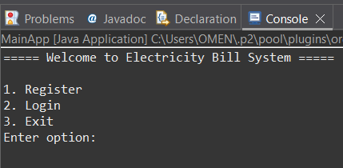
OUTPUT
Figure 1: User Login and Registration Interface

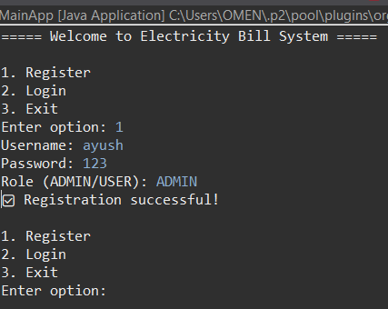

Figure 2: Registration Process
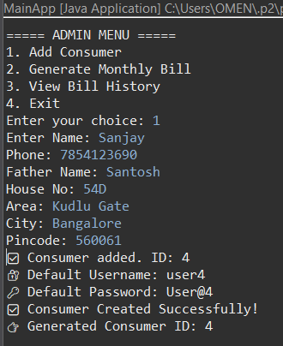
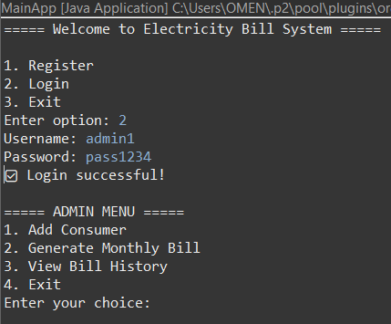
Figure 4: Adding new consumer details
Figure 3: Admin dashboard with available operations

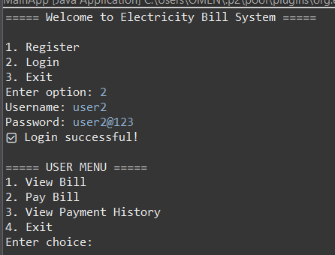
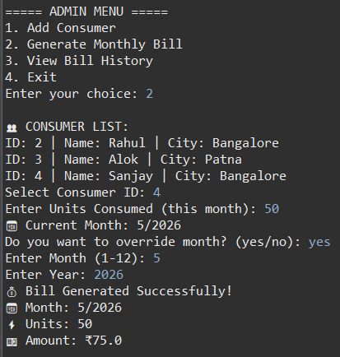
Figure 10: User dashboard
Figure 5: Electricity bill calculation output

CONCLUSION
The Electricity Bill System demonstrates the use of Core Java and JDBC for efficient database connectivity and data management using MySQL. The system successfully manages consumer details and generates accurate electricity bills based on predefined slab rates.
It supports real-time database operations, role-based access control, and features such as monthly billing, payment processing, and payment tracking. These functionalities make the system closer to a real-world application.
Overall, the project provides a strong foundation for developing database-driven systems and can be further enhanced with GUI, online payments, and scalable deployment.
The system also ensures data integrity by restricting deletion of consumers with pending dues and provides controlled user profile management.

FUTURE ENHANCEMENT
The Electricity Bill System can be further enhanced by adding a graphical user interface (GUI) using Java Swing to improve usability. Online payment gateway integration can be introduced for real-time bill payments.
Additional features such as email/SMS notifications for billing updates and advanced security mechanisms like password encryption can be implemented. The system can also be extended into a web or mobile-based application for better accessibility and scalability.

REFERENCES
• Oracle Corporation. (n.d.). Java Documentation. Retrieved from https://docs.oracle.com/javase/
• Oracle Corporation. (n.d.). MySQL Official Documentation. Retrieved from https://dev.mysql.com/doc/
• GeeksforGeeks. (n.d.). JDBC Tutorial. Retrieved from https://www.geeksforgeeks.org/jdbc/
• W3Schools. (n.d.). JDBC Tutorial. Retrieved from https://www.w3schools.com/java/java_jdbc.asp

