PROJECT DOCUMENTATION
Caesar Cipher Converter
A Simple Web Tool to Encrypt and Decrypt Text
Submitted by: Rajni
Kurukshetra University

Source Code (index.html)
The complete source code of the Caesar Cipher Converter is given below. The entire application — structure, styling, and logic — is written in a single HTML file (81 lines).
<html lang="en">
<head>
<meta charset="UTF-8" />
<meta name="viewport" content="width=device-width, initial-scale=1.0" />
<title>Caesar Cipher Converter</title>
<style>
* { box-sizing: border-box; font-family: Arial, sans-serif; }
body {
margin: 0; min-height: 100vh; display: flex; justify-content: center; align-items: center;
background: linear-gradient(135deg, #56CCF2, #2F80ED); color: white; padding: 20px;
}
.card {
width: 100%; max-width: 600px; background: rgba(255,255,255,0.12);
border: 1px solid rgba(255,255,255,0.2); border-radius: 18px; padding: 24px;
box-shadow: 0 10px 30px rgba(0,0,0,0.25); backdrop-filter: blur(12px);
}
h1, p { text-align: center; }
p { color: #eaf6ff; }
textarea, input {
width: 100%; padding: 12px; margin-top: 10px; border: none; outline: none;
border-radius: 10px; font-size: 16px;
}
textarea { min-height: 120px; resize: vertical; }
input { height: 48px; }
.btns { display: flex; gap: 12px; flex-wrap: wrap; margin-top: 14px; }
button {
flex: 1; min-width: 120px; padding: 12px 16px; border: none; border-radius: 10px;
font-size: 15px; font-weight: bold; cursor: pointer;
}
.enc { background: #22c55e; color: white; }
.dec { background: #ef4444; color: white; }
.clr { background: #f9a8d4; color: white; }
.result {
margin-top: 18px; padding: 14px; background: rgba(255,255,255,0.15);
border-left: 4px solid #ffffff; border-radius: 10px; min-height: 60px; word-break: break-word;
}
@media (max-width: 600px) { .btns button { width: 100%; } }
</style>
</head>
<body>
<div class="card">
<h1>Caesar Cipher</h1>
<p>Text ko shift karke encrypt aur decrypt karo</p>

<label>Enter text:</label>
<textarea id="textInput" placeholder="Type message here..."></textarea>

<label>Shift key (0-25):</label>
<input type="number" id="shiftInput" min="0" max="25" value="3">

<div class="btns">
<button class="enc" onclick="act(1)">Encrypt</button>
<button class="dec" onclick="act(-1)">Decrypt</button>
<button class="clr" onclick="clr()">Clear</button>
</div>

<div id="result" class="result">Result will appear here.</div>
</div>

<script>
const c = (t, s) => [...t].map(ch => {
let x = ch.charCodeAt(0);
if (x >= 65 && x <= 90) return String.fromCharCode((x - 65 + s + 26) % 26 + 65);
if (x >= 97 && x <= 122) return String.fromCharCode((x - 97 + s + 26) % 26 + 97);
return ch;
}).join('');

function act(k) {
let t = document.getElementById("textInput").value;
let s = parseInt(document.getElementById("shiftInput").value) || 0;
document.getElementById("result").innerText = (k == 1 ? "Encrypted: " : "Decrypted: ") + c(t, k * s);
}

function clr() {
document.getElementById("textInput").value = "";
document.getElementById("shiftInput").value = 3;
document.getElementById("result").innerText = "Result will appear here.";
}
</script>
</body>
</html>

Output
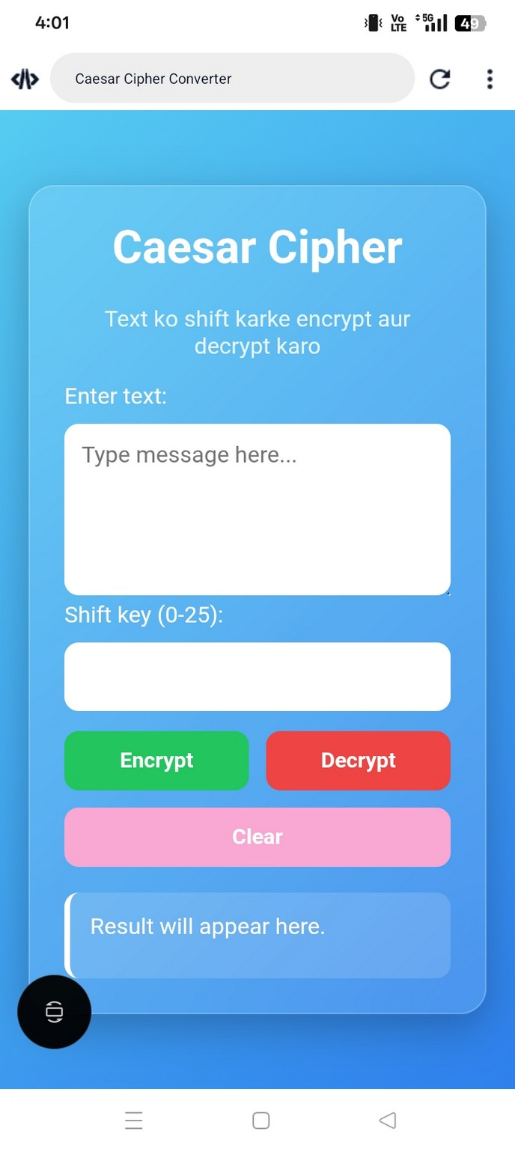
Screenshot 1: Home page with the text box, shift key box, and buttons.
When the page loads, the card-style interface appears with the title "Caesar Cipher" and a short instruction below it. The user sees an empty text box to type a message, a shift key box (pre-filled with a default value of 3), and three action buttons — Encrypt, Decrypt, and Clear. The result box below shows a placeholder message, "Result will appear here," until an action is performed.
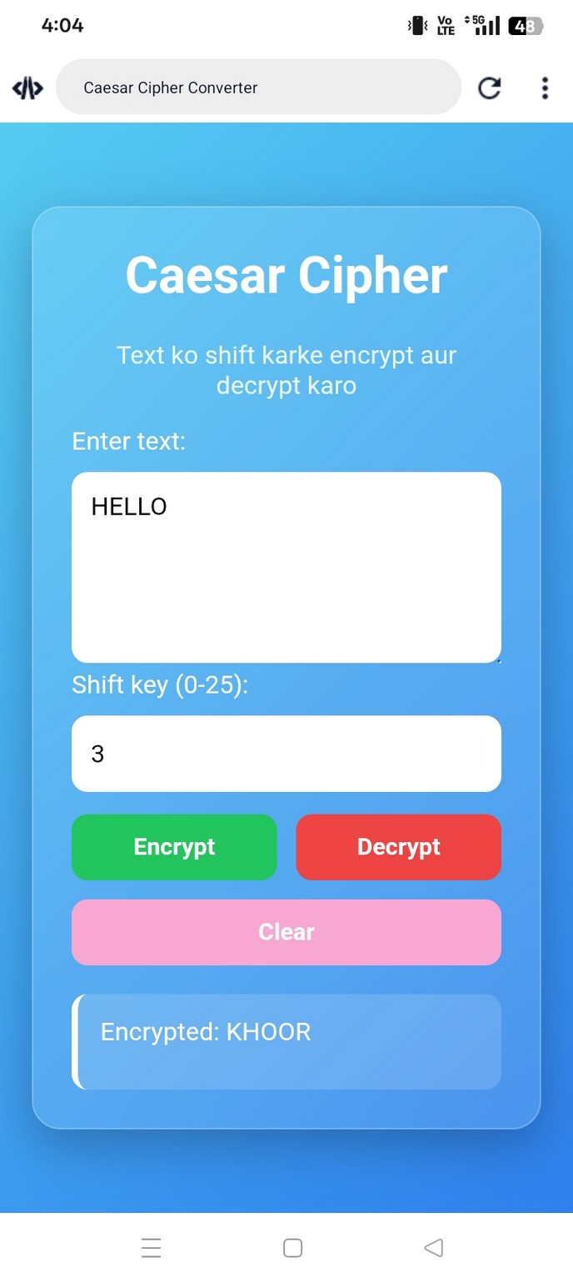
Screenshot 2: Encrypted result after typing "HELLO" with shift key 3 and clicking Encrypt.
Here the user has typed "HELLO" in the text box and kept the shift key as 3, then clicked the Encrypt button. The act(1) function runs the caesarCipher (c) logic with a positive shift, moving each letter forward by 3 places in the alphabet. As a result, "HELLO" is converted to "KHOOR", which is displayed in the result box as "Encrypted: KHOOR".
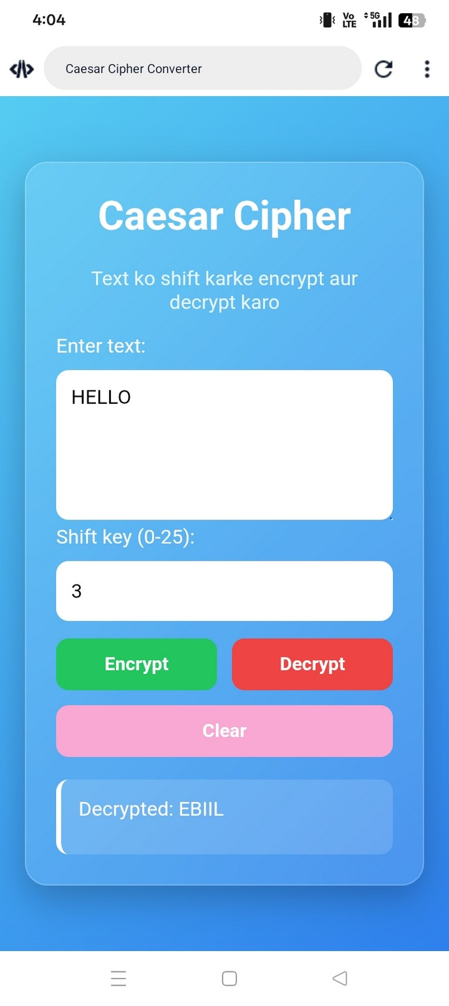
Screenshot 3: Decrypted result for the same text and shift key after clicking Decrypt.
With the same text "HELLO" and shift key 3 still in place, the user now clicks the Decrypt button. The act(-1) function runs the same cipher logic but with the shift made negative, moving each letter backward by 3 places instead of forward. This produces "EBIIL" from "HELLO", shown as "Decrypted: EBIIL" — confirming that the same function correctly shifts letters in either direction simply by changing the sign of the shift value.

1. Project Name
Caesar Cipher Converter — a simple web app that lets you encrypt and decrypt text messages using the old Caesar Cipher method.

2. Objective
The goal of this project is to make a simple and easy-to-use web tool that lets people encrypt and decrypt text using the Caesar Cipher method. The project shows how a basic idea from cryptography can be turned into a real, working tool with a nice-looking design.

3. Problem Statement
Most students only read about ciphers in books, which makes it hard to understand how encryption really works. There was a need for a simple tool where a user can type any text, pick a shift number, and see the encrypted or decrypted text right away. This project solves that problem by giving an easy, browser-based Caesar Cipher tool. It needs no installation and works on any device.

4. Research Findings
Before making the tool, these points were studied:
- The Caesar Cipher is one of the oldest encryption methods. Julius Caesar used it to send secret messages to his army.
- It works by shifting each letter a fixed number of steps in the alphabet.
- The same shift number is used to both encrypt and decrypt. Decrypting just shifts the letters back the other way.
- A mod 26 rule is used so that letters wrap around correctly, like going from 'Z' back to 'A'.
- The Caesar Cipher is easy to break and is not safe for real secrets, but it is a great way to learn how encryption works.
- HTML, CSS, and JavaScript are enough to build this tool. No server is needed.

5. Methodology
The project was made step by step using simple web development steps:
- Planning: Decided that the tool needs a text box, a shift number box, and buttons for encrypt, decrypt, and clear.
- Design: Made a clean, card-style layout using CSS with a color gradient and a frosted-glass look.
- Logic: Wrote one JavaScript function that shifts each letter, keeps upper/lower case correct, and leaves other symbols as they are.
- Buttons: Linked each button to its own JavaScript action, so clicking it runs encrypt, decrypt, or clear.
- Testing: Checked the tool with different shift numbers, capital and small letters, numbers, spaces, and symbols.
- Mobile Support: Added CSS rules so the page also looks good on small mobile screens.

6. Tools Used
Tool / Technology | Purpose
HTML5 | To build the page structure — text box, buttons, layout
CSS3 | To style the page — colors, card design, mobile-friendly layout
JavaScript | To run the Caesar Cipher logic and handle button clicks
Web Browser | To open and test the tool (Chrome, Edge, Firefox)
Code Editor | To write and edit the code

7. Implementation
The whole app is in one HTML file, with structure, style, and logic all together. Here are the main parts:
- Input Box: A text area to type the message, and a number box (0–25) for the shift key.
- Main Function — caesarCipher(text, shift): This goes through each letter one by one. If it is a capital or small letter, it shifts it using a simple formula. Spaces, numbers, and symbols are left as they are.
- Encrypt Button: Runs caesarCipher() with the shift number the user typed.
- Decrypt Button: Runs the same function but with the shift number turned negative, so it goes back to the original text.
- Clear Button: Empties the text box, resets the shift number, and clears the result.
Here is the main code:
function caesarCipher(text, shift) {
shift = shift % 26;
let result = "";
for (let i = 0; i < text.length; i++) {
let char = text[i];
if (char >= 'A' && char <= 'Z') {
result += String.fromCharCode(
((char.charCodeAt(0) - 65 + shift + 26) % 26) + 65);
} else if (char >= 'a' && char <= 'z') {
result += String.fromCharCode(
((char.charCodeAt(0) - 97 + shift + 26) % 26) + 97);
} else {
result += char;
}
}
return result;
}

9. Results
The tool was tested with different inputs and worked well every time. Some test cases:
Input Text | Shift | Encrypted Output | Decrypted Back
Hello World | 3 | Khoor Zruog | Correct
Rajni@2026 | 5 | Wfsul@2026 | Correct
XYZ abc | 2 | ZAB cde | Correct

All test cases gave the correct results. This shows the encrypt and decrypt logic works well, even for tricky cases like letters near the end of the alphabet ('X', 'Y', 'Z') and symbols.

10. Challenges
- Making letters wrap around correctly when the shift goes past 'Z' or before 'A' — fixed by using a mod 26 rule with +26 added.
- Keeping capital and small letters correct while shifting them the same way.
- Making sure numbers, spaces, and symbols stay the same and are not changed.
- Making a good-looking design using only CSS, with no extra libraries, that also works well on mobile.
- Handling empty or wrong shift key values so the tool does not break (it uses 0 as a safe default).

11. Future Scope
- Add more ciphers in the same tool, like Vigenère Cipher, Atbash Cipher, and ROT13.
- Add a 'try all shifts' feature that shows all 25 possible results at once.
- Add a copy and download option for the result.
- Let users encrypt/decrypt whole files, not just typed text.
- Add a dark/light mode switch and a Hindi/English language option.
- Use this project as a teaching tool for maths and computer classes to explain modular arithmetic.

12. Conclusion
The Caesar Cipher Converter shows how a classic encryption idea can be built into a real, working tool using HTML, CSS, and JavaScript. It gives an easy and fun way to learn about ciphers and shifting letters. The Caesar Cipher itself is too simple to protect real secrets, but this project does its job well — it makes a hard-to-picture idea simple, visual, and easy to try out. The code is also written in a way that makes it easy to add more ciphers later.

