Model Verification & Evaluation
Slope Stability AI — four failure-mode TabPFN models
Physics-based sensitivity verification · held-out performance · safe-deployment thresholds
12 September 2026

1 Overview & scope
This report verifies and evaluates the four mechanism-specific TabPFN models behind Slope Stability AI — planar, wedge and toppling (Factor-of-Safety regressors) and circular (a stable/unstable classifier). Three independent checks were run, none of which retrains the models:
• Physics-based sensitivity — does predicted FoS move in the physically correct direction, and non-linearly, as each input is swept?
• Held-out evaluation matrix — fit quality plus the safety-critical metrics (signed bias, false-negative rates at the failure and DGMS thresholds) on cross-validated out-of-fold predictions.
• Safe-deployment thresholds — the decision cutoff each model needs to catch every unsafe slope, and the false-alarm cost of that guarantee.
Method note. All metrics are computed on held-out data. Sensitivity sweeps fix every input at its training-set median and vary one input across its dataset range (50 steps). Evaluation and threshold metrics use 5-fold cross-validated out-of-fold predictions (seed 42): every row is scored by a model that never saw it. Models are fit locally on the same data the deployed app uses; nothing is retrained in the machine-learning sense.

2 Physics-based verification (one-at-a-time sensitivity)
Direction is judged by the sign of the Spearman correlation between the swept input and the response (FoS, or P(stable) for the circular classifier). Geometric/ambiguous inputs — unit weight and the wedge joint/azimuth orientations — were swept and reported but not given a pass/fail. Headline result: 24 of 26 physics-scored direction checks pass (92%).
Mechanism | Parameter | Expected | Observed | Verdict
Planar | Slope face ψf | ↓ | ↓ | PASS
Planar | Plane dip ψp | ↓ | ↓ | PASS
Planar | Upper slope ψs | ↓ | ↓ | PASS
Planar | Height H | ↓ | ↓ | PASS
Planar | Friction φ | ↑ | ↑ | PASS
Planar | Cohesion c | ↑ | ↑ | PASS
Planar | Seismic kh | ↓ | ↓ | PASS
Planar | Water level | ↓ | ↓ | PASS
Wedge | Slope-face dip | ↓ | ↓ | PASS
Wedge | Height H | ↓ | ↓ | PASS
Wedge | Cohesion c1 | ↑ | ↑ | PASS
Wedge | Friction φ1 | ↑ | ↑ | PASS
Wedge | Cohesion c2 | ↑ | ↑ | PASS
Wedge | Friction φ2 | ↑ | ↑ | PASS
Wedge | Water % | ↓ | ↓ | PASS
Toppling | Slope angle | ↓ | ↓ | PASS
Toppling | Bedding dip | ↑ | ↑ | PASS
Toppling | Joint spacing | ↑ | ↑ | PASS
Toppling | Height H | ↓ | ↓ | PASS
Toppling | Joint friction φj | ↑ | ↑ | PASS
Toppling | Water ratio | ↓ | ↓ | PASS
Circular* | Cohesion c | ↑ | ↑ | PASS
Circular* | Height H | ↓ | ↓ | PASS
Circular* | Pore ratio r_u | ↓ | ↓ | PASS
Circular* | Friction φ | ↑ | ↓ | FAIL
Circular* | Slope angle β | ↓ | ↑ | FAIL
* Circular is a classifier; its response is P(stable) = 1 − P(failure). Report-only inputs (11 total: unit weight in all modes; wedge upper-slope dip, both joint dips and all four dip-directions) are omitted from this table. The response is non-linear (cubic fit materially better than linear) in 31 of 37 sweeps.
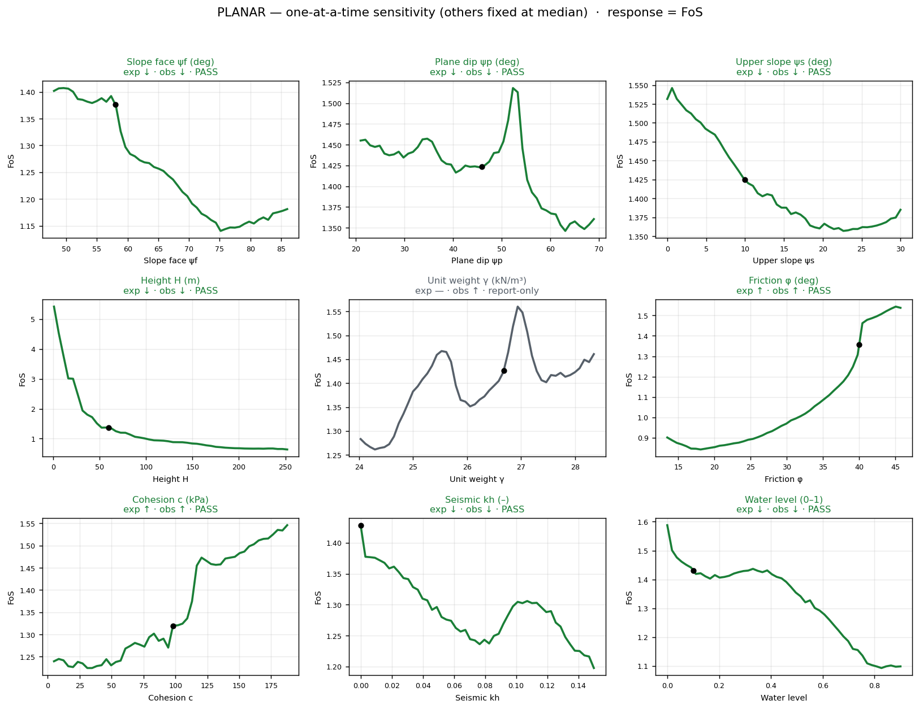
Figure 1. Planar — all 8 physics directions pass.
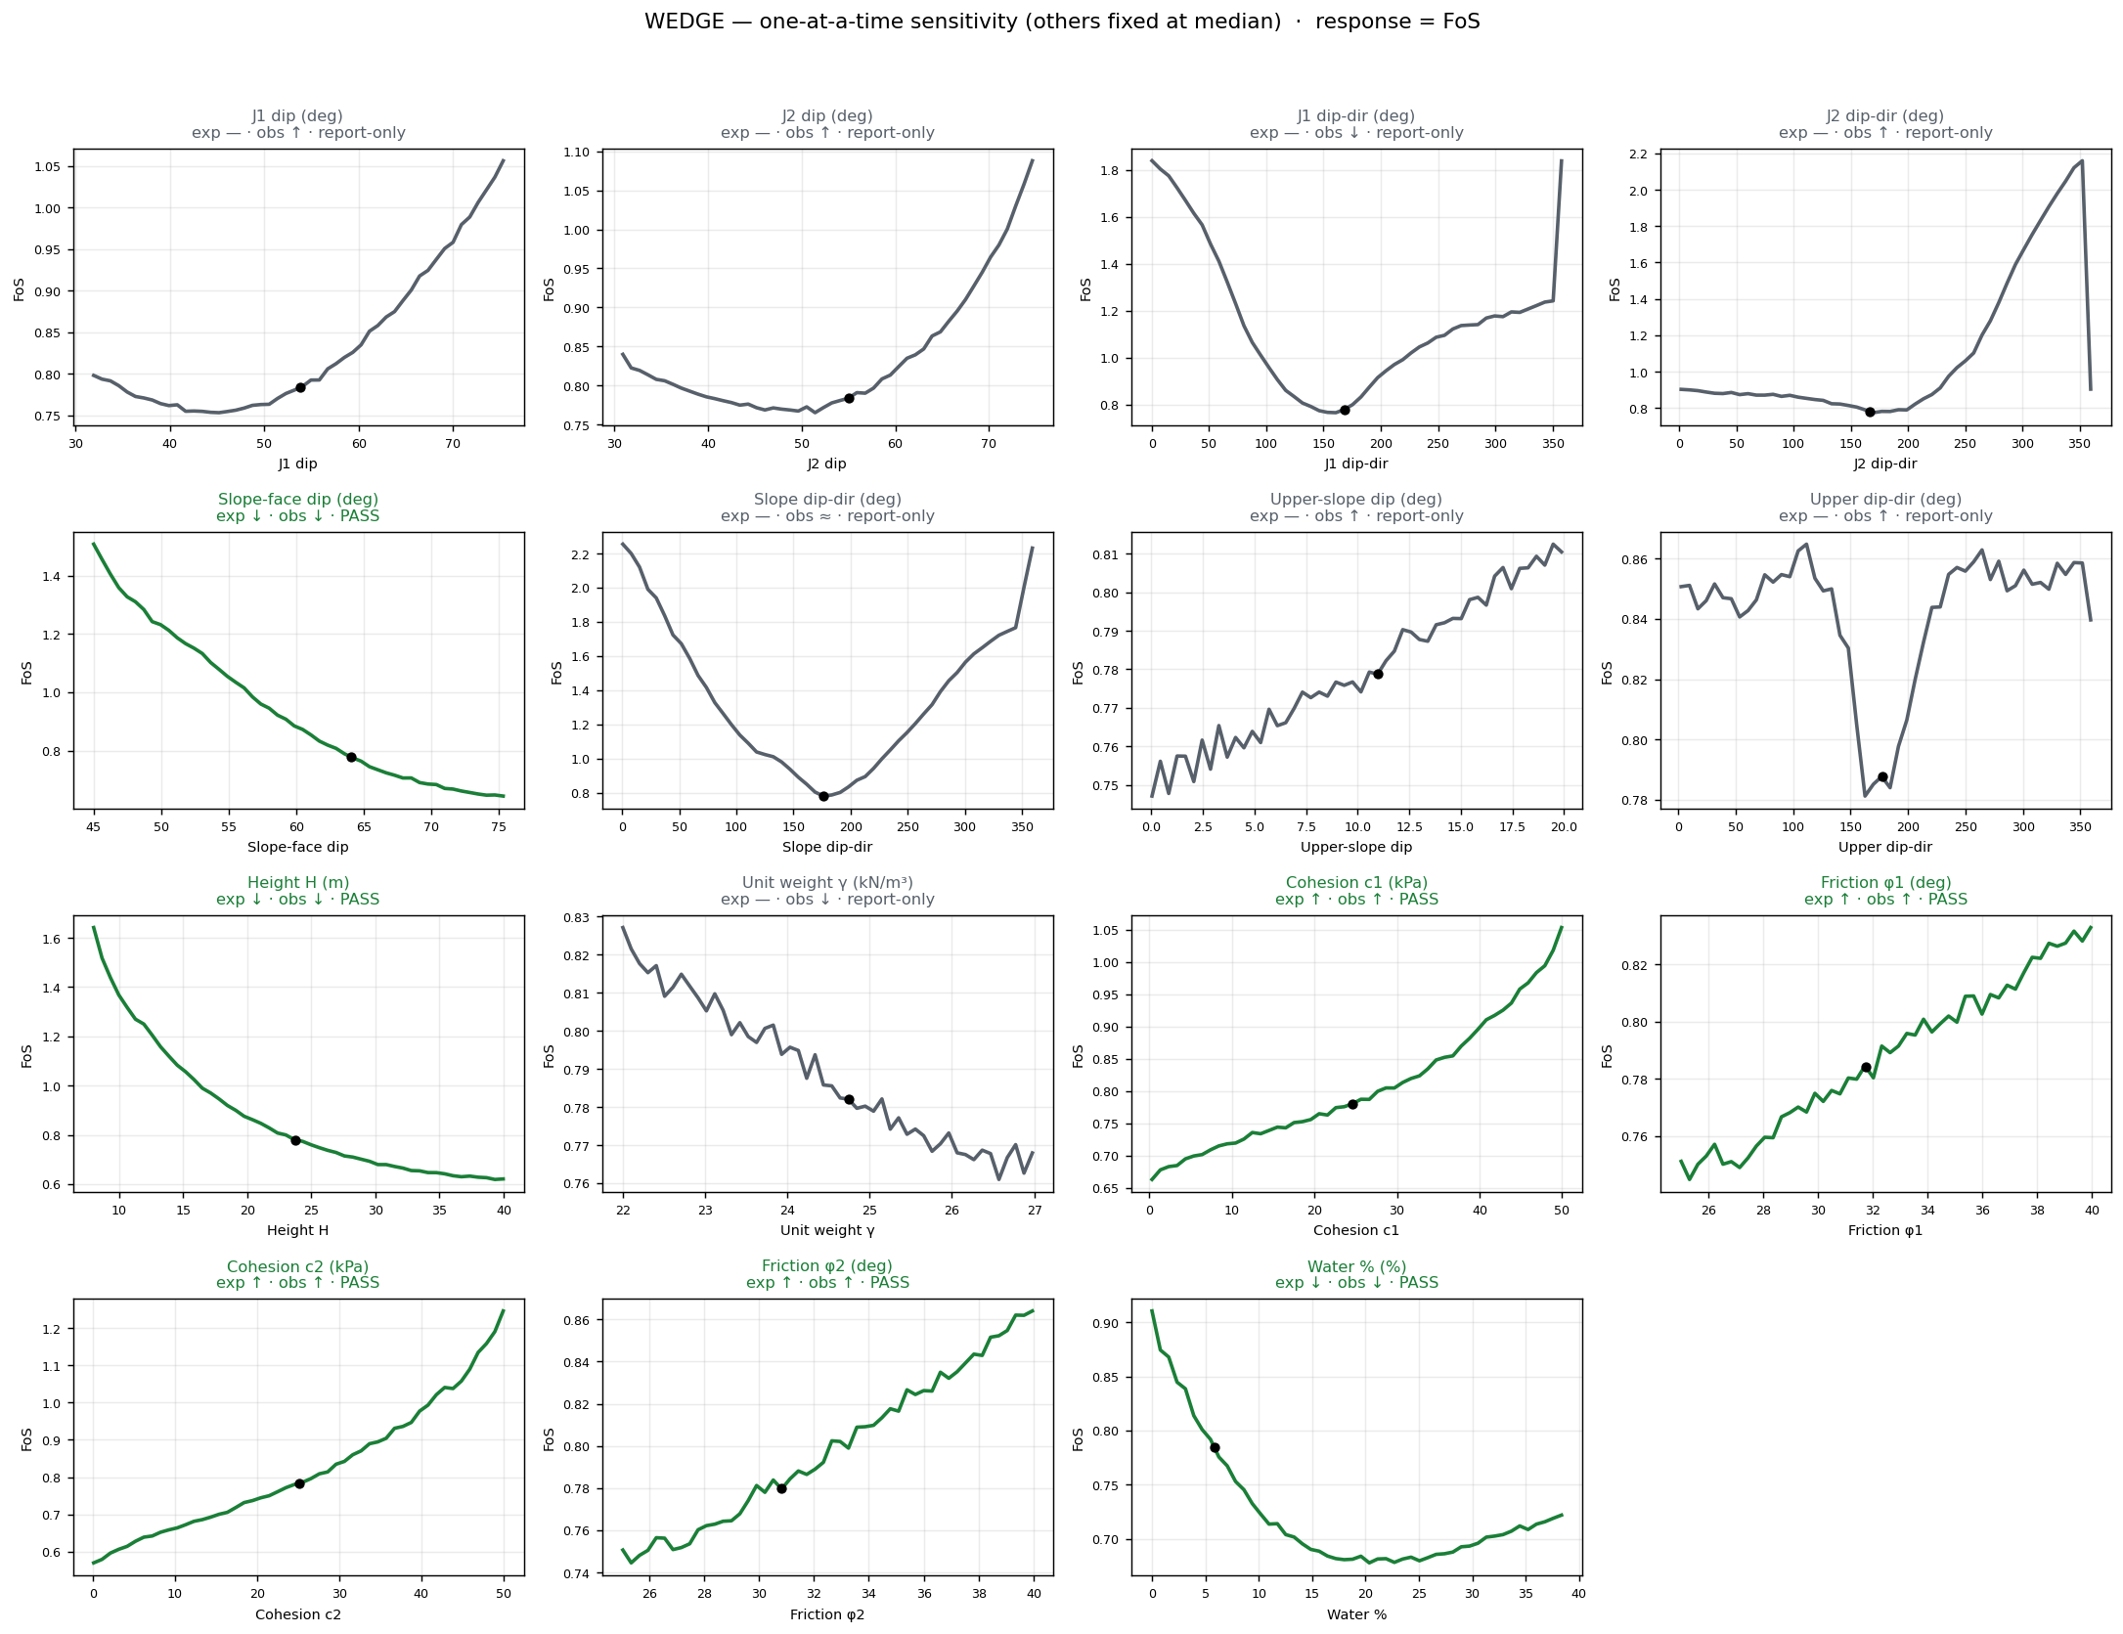
Figure 2. Wedge — 7/7 scored pass; the 8 orientation inputs are report-only (grey).
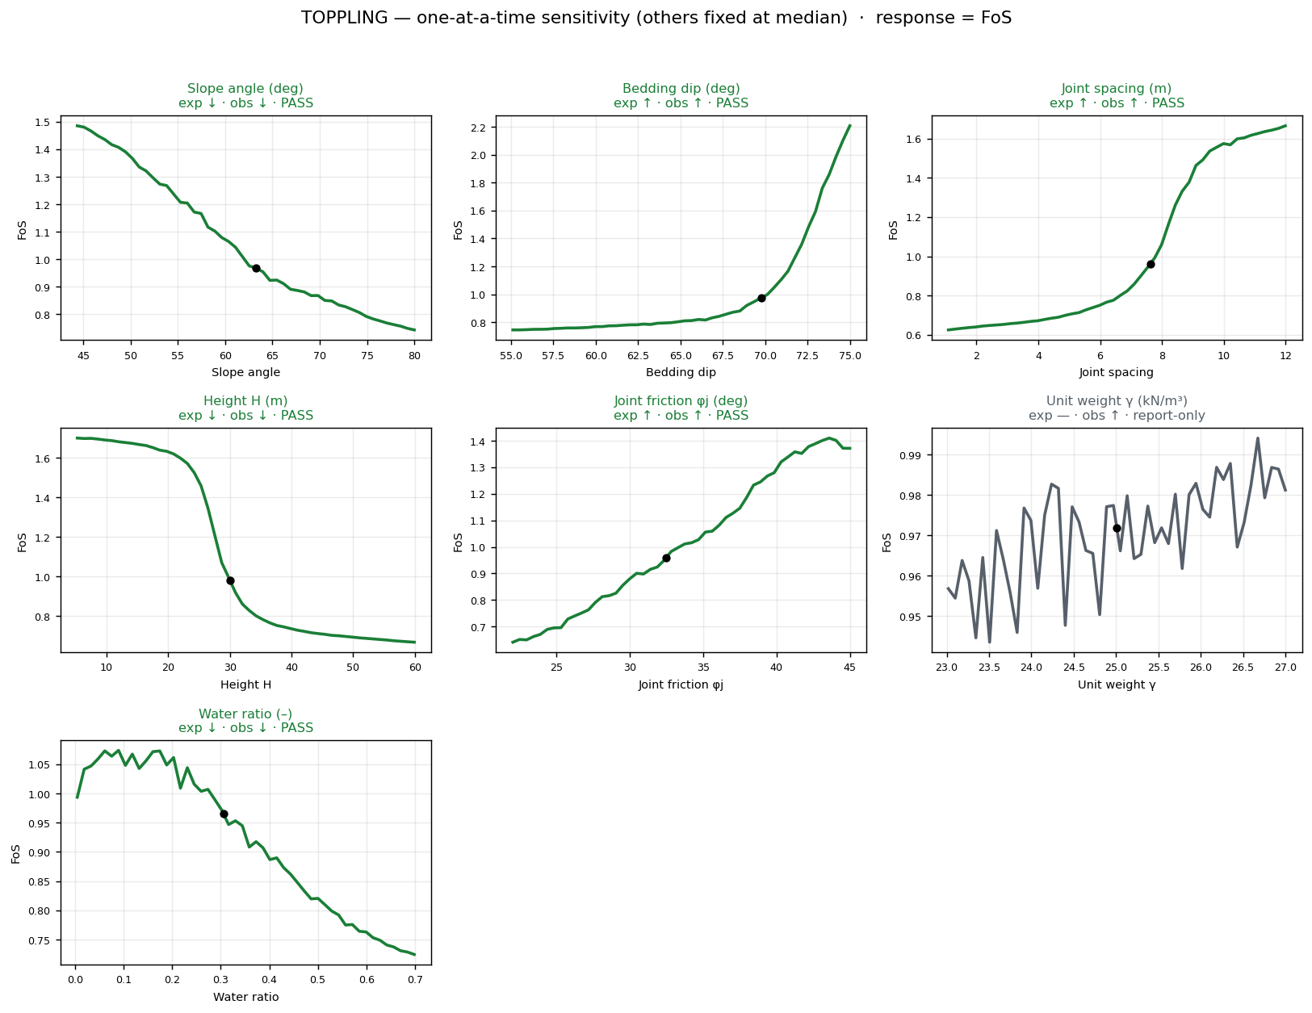
Figure 3. Toppling — 6/6 pass, including bedding dip (see §2.1).
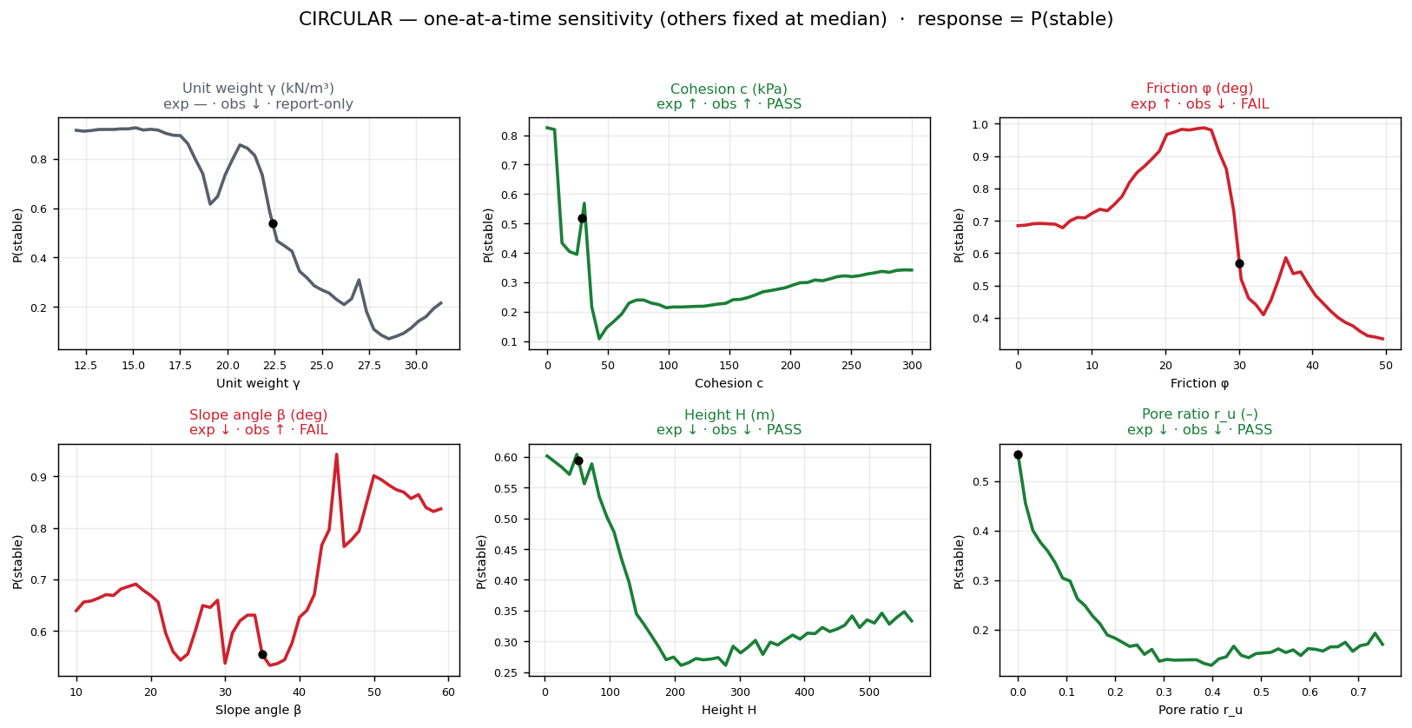
Figure 4. Circular — cohesion, height and pore ratio pass; friction φ and slope angle β are reversed at the median baseline.

2.1 The bedding-dip result (why it is a PASS, not a failure)
The initial expectation — steeper bedding dip should lower FoS — disagreed with the model. Checking the Goodman–Bray solver data directly showed the model was right and the expectation was the wrong intuition: controlling for the other six inputs, FoS genuinely rises with bedding dip (partial ρ = +0.58), and mean FoS climbs monotonically across the dip range:
Bedding dip band | Mean FoS | n cases
55–60° | 0.750 | 44
60–65° | 0.838 | 100
65–70° | 0.976 | 167
70–75° | 1.270 | 289
Physically, over this steep range the toppling moment is governed by column overhang: as layers steepen toward vertical the columns stand more upright, their centre of gravity moves back over the base, and FoS rises. The model faithfully reproduces the solver. Caveat: this confirms fidelity to the solver, not to field reality — the toppling dataset is synthetic (pretrain-only).

2.2 The two genuine failures (circular classifier)
Friction φ (expected ↑) and slope angle β (expected ↓) are reversed at the median baseline. Both response curves are strongly non-monotonic, so a single median baseline lands on a locally reversed segment. Root cause: circular is a classifier (a decision-surface probability, not a mechanistic FoS) trained on 184 real, correlated field cases. Cohesion, height and pore-pressure ratio still pass, so the model is not globally wrong — but its friction and slope-angle response is not monotonically physical and should not be presented as verified.

3 Held-out evaluation matrix
Every value is computed on 5-fold out-of-fold predictions. False-negative (FN) rate at threshold T = of the truly-unsafe slopes (actual FoS < T), the fraction the model calls safe (predicted ≥ T). DGMS statutory thresholds: 1.2 (rock), 1.3 (dump).
Metric | Planar | Wedge | Toppling | Circular
R² (CV) | 0.967 | 0.863 | 0.962 | n/a (clf)
MAE | 0.062 | 0.153 | 0.040 | n/a
RMSE | 0.162 | 0.238 | 0.080 | n/a
RMSE / MAE (tail) | 2.63 | 1.55 | 2.00 | —
MAPE | 7.3% | 11.6% | 3.4% | n/a
Signed bias (FoS) | −0.003 | −0.001 | −0.001 | n/a
Signed bias (%) | +2.3% | +2.7% | +0.3% | n/a
FN @ 1.0 | 4.2% (3/71) | 22.8% (18/79) | 3.0% (9/300) | 21.4% (21/98)
FN @ 1.2 (DGMS rock) | 1.1% (1/92) | 10.9% (14/129) | 3.3% (14/422) | n/a
FN @ 1.3 (DGMS dump) | 2.0% (2/99) | 10.8% (16/148) | 1.5% (7/453) | n/a
Worst unconservative miss | +0.79 (+96%) | +1.17 (+83%) | +0.59 (+54%) | —
Data provenance | real + textbook | synthetic | synthetic | real
Circular (classifier): accuracy 0.788, ROC-AUC 0.884, recall(unstable) 0.786, precision(unstable) 0.811. Its FN = truly-unstable slopes classified stable (native binary label ≈ FoS<1 boundary); it has no FoS output, so the 1.2/1.3 columns do not apply.

3.1 The honest read
Signed bias ≈ 0 is a trap. All three regressors are near-perfectly centred on average (|bias| < 0.003 FoS), but that aggregate hides the unconservative tail: the worst single miss is planar predicting +96% (true FoS 0.82 → predicted ~1.61, an unstable slope called very safe), wedge +83%, toppling +54%. The metric to watch is FN rate and worst miss, not mean bias.
RMSE ≫ MAE confirms the tail. Planar (2.63×) and toppling (2.0×) have RMSE well above MAE — a few large errors dominate, and that is where the unconservative misses live.
Two red flags for a regulator. Wedge FN@1.0 = 22.8% (nearly a quarter of failing wedges called stable; still 10.9% at DGMS 1.2) — though wedge data is 100% synthetic, so this measures solver-reproduction near the threshold, not field safety. Circular FN = 21.4% (21 of 98 truly-unstable real field slopes called stable) — the most field-meaningful FN number in the project, and not a synthetic artifact.
The good news. Toppling (FN 3.0%, MAPE 3.4%) and planar (FN@1.2 = 1.1%, only 3 misses at FoS=1.0) are well behaved; planar is the strongest real-data-informed regressor.

4 Safe-deployment operating thresholds
To guarantee zero false negatives, a regressor must flag for review any slope whose predicted FoS ≤ T*, where T* is the largest FoS the model predicted for any actual failure. One badly over-predicted failure forces a high cutoff — and a large false-alarm rate. For circular, the equivalent is lowering the P(unstable) trigger to p* (the smallest failure probability assigned to any truly-unstable slope).
Model | Boundary | Current FN | Zero-FN cutoff | False alarms | Workload
Planar | FoS < 1.0 | 4.2% | 1.607 | 76.9% (60/78) | 88%
Planar | FoS < 1.2 | 1.1% | 1.607 | 68.4% (39/57) | 88%
Wedge | FoS < 1.0 | 22.8% | 1.543 | 50.7% (102/201) | 65%
Wedge | FoS < 1.2 | 10.9% | 1.769 | 55.6% (84/151) | 76%
Toppling | FoS < 1.0 | 3.0% | 1.218 | 41.7% (125/300) | 71%
Toppling | FoS < 1.2 | 3.3% | 1.673 | 64.0% (114/178) | 89%
Circular | P(unstable) | 21.4% | p*=0.073 | 64.0% (55/86) | —
Reading it. Reaching FN = 0 is expensive everywhere (41–77% of safe slopes get flagged), driven by the unconservative tail. Toppling is the cheapest to make safe — a cutoff bump to 1.22 catches every failure at a 42% false-alarm cost. Planar's single +96% outlier forces T* = 1.61, which flags 88% of all slopes, making a strict zero-FN policy impractical without also fixing that outlier. No model reaches FN = 0 at its natural cutoff, so none is safe as a sole arbiter.

5 Limitations & recommendations
Synthetic training data. Wedge and toppling are trained entirely on limit-equilibrium solver output (flagged pretrain-only). Their strong sensitivity and evaluation results confirm fidelity to the solver, not to field behaviour; they must be fine-tuned on real cases before any field claim.
Circular real-data weakness. The only pure real-data model shows a non-physical friction/slope-angle response and a 21.4% false-negative rate. It should be treated as the least reliable of the four and is a priority for more data and a possible switch to an FoS regression target.
Single-baseline sensitivity. Directions were checked from one median baseline; a partial-dependence pass (averaging over all training rows) is the recommended next step to confirm whether the circular reversals are a baseline artifact or a true defect.
Deployment stance. Use the models as screening / decision-support, not as a sole stability arbiter. Flag any slope near or below its DGMS threshold for mandatory engineer review, and adopt a raised review cutoff (per §4) sized to the acceptable false-alarm burden.

