What is GPT?
GPT stands for Generative Pre-trained Transformer. It is OpenAI’s family of large language models, developed using the Transformer architecture and trained to generate and understand language and other token-based inputs. GPT models power products such as ChatGPT and are also available through the OpenAI API.
The three parts of the name describe the technology:
- Generative: The models generate outputs rather than simply classifying inputs.
- Pre-trained: A model first learns broad patterns from large datasets before being adapted for tasks such as instruction following, reasoning, coding and tool use.
- Transformer: The models use the Transformer neural-network architecture and attention mechanisms to model relationships between tokens.
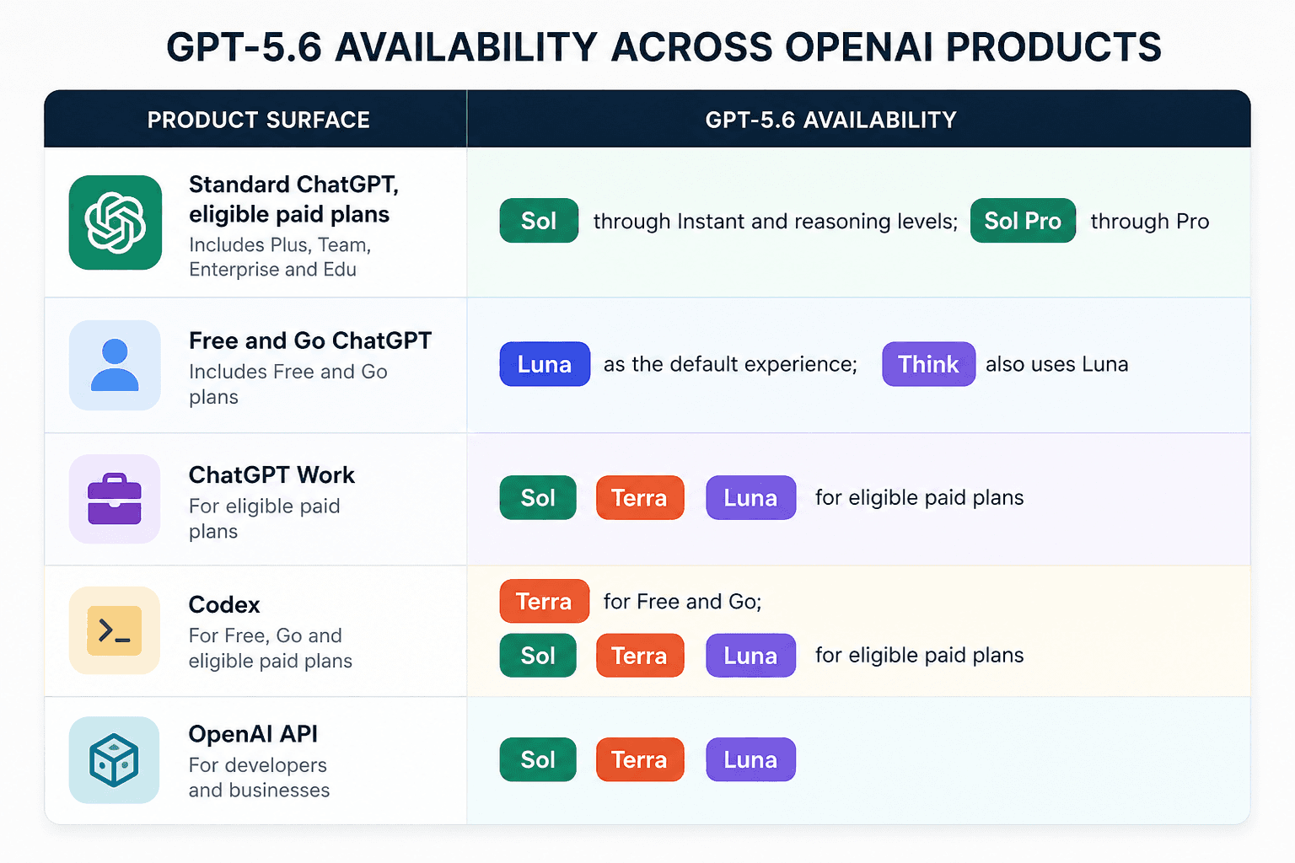
DALL-E is a technology introduced by Open AI and it is a neural network-based picture-generating system. DALL-E is a technology that helps users create new images with their imagination only by using graphics prompts. DALL-E can create the impression that may look entirely different as mentioned by the user’s prompt. DALL-E is the variation of a model GPT 3(Generative Pre-trained Transformer )
DALL-E has made a greater impact due to its remarkable ability to create images that are highly realistic and real images just from textual description. At its core, DALE-E utilizes a modified version of the GPT-3 architecture. GPT-3, which primarily focuses on natural language processing, relies on the Transformer architecture, a neural network design known for its efficacy in handling sequences, be it sentences or time series data. This foundation is also what empowers DALE-E to understand and process textual descriptions efficiently.
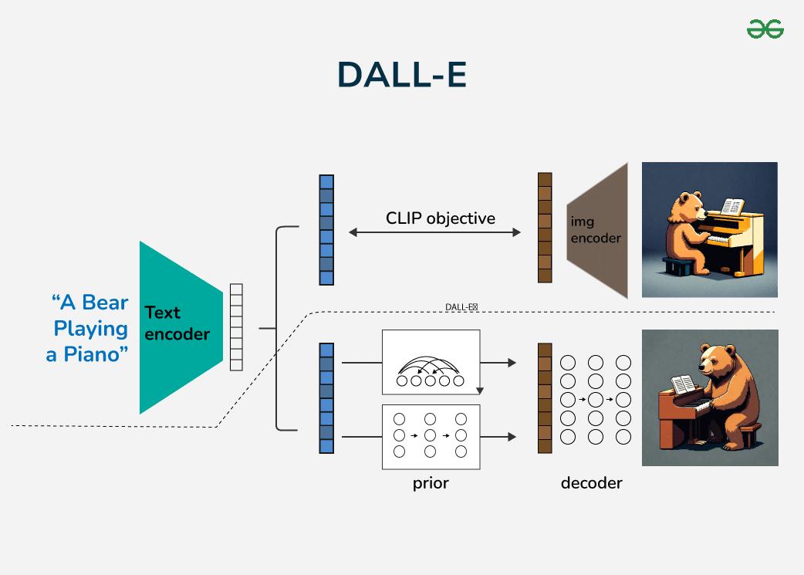

DALL-E is a neural network and works on a transformer model. This model works on handling input data and making highly flexible data to run the various task o generative. Some of the applications of transformers are DALL-E which transforms the text into an image as per the need of the user.
- Training Phase: DALL-E is trained using vast datasets containing text-image pairs. The model learned the relationships between textual descriptions and images corresponding to that text.
- Generating New Images: Once the model is trained with the data then DALL-E can take an input and predict the image that is corresponding to that. It does this by checking relationships it has learned and applying them to create a new input. The Main Mechanism behind DALL-E's Creativity is
  - Latent space Interpolation: DALL-E operates on "latent space", a representation of data it was trained on. navigating and interpolating within the space, DALL E can blend concepts and produce an image.
  - Attention Mechanism : The transformer architecture relies heavily on attention mechanisms, allowing the model to focus on specific parts of the input text when generating an image.
  - Vast Training Data: The sheer volume and diversity of the training data equip DALL-E with a rich palette of concepts, enabling it to produce varied and often unexpected result

What is OpenAI Codex?
Codex is OpenAI's AI agent for programming — an AI that doesn't just answer questions but does things on its own: reads through the code, works out what needs to change, writes the change, tests that it works and fixes its own mistakes. If you want to know more about the idea itself, we've written about AI agents and how they work.
Think of it as the difference between asking a knowledgeable friend for advice and hiring a tradesperson. Regular ChatGPT gives you a snippet of code that you have to paste in somewhere yourself. Codex does the job — and then shows you what it did.
The name isn't entirely new: back in 2021 OpenAI's first code model, the one that powered GitHub Copilot, was also called Codex. Today's Codex launched in April 2025, first as a tool for the terminal (the black text window programmers type commands into). A month later came a version that works in the cloud, and in February 2026 a dedicated app for Mac and Windows. In autumn 2026 Codex runs on OpenAI's newest AI, GPT-6 Astra, and the cheaper GPT-6.1 Sol and GPT-6 Luna.
What is a GAN?
A generative adversarial network, or GAN, is a machine learning model designed to generate realistic data by learning patterns from existing training datasets. It operates within an unsupervised learning framework by using deep learning techniques, where two neural networks work in opposition—one generates data, while the other evaluates whether the data is real or generated.
While deep learning has excelled in tasks such as image classification and speech recognition, generating new data, including realistic images or text, has been more challenging due to the complexity of computations in generative models.
GANs, introduced by Ian Goodfellow in his 2014 paper Generative Adversarial Nets, offer a groundbreaking solution to this challenge.1 This innovative framework has transformed generative modeling, making it easier to develop models and algorithms capable of creating high-quality, realistic data.
How do GANs work?
A GAN architecture consists of two deep neural networks: the generator network and the discriminator network. The GAN training process involves the generator starting with random input (noise) and creating synthetic data such as images, text or sound that mimics the real data from the given training set. The discriminator evaluates both the generated samples and the data from the training set and decides whether it’s real or fake. It assigns a score between 0 and 1: a score of 1 means that the data looks real, and a score of 0 means it’s fake. Backpropagation is then used to optimize both the networks. This means that the gradient of the loss function is calculated according to the network's parameters, and these parameters are adjusted to minimize the loss. The generator then uses feedback from the discriminator to improve, trying to create more realistic data.
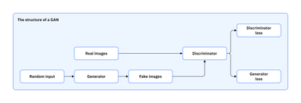
What are diffusion models?
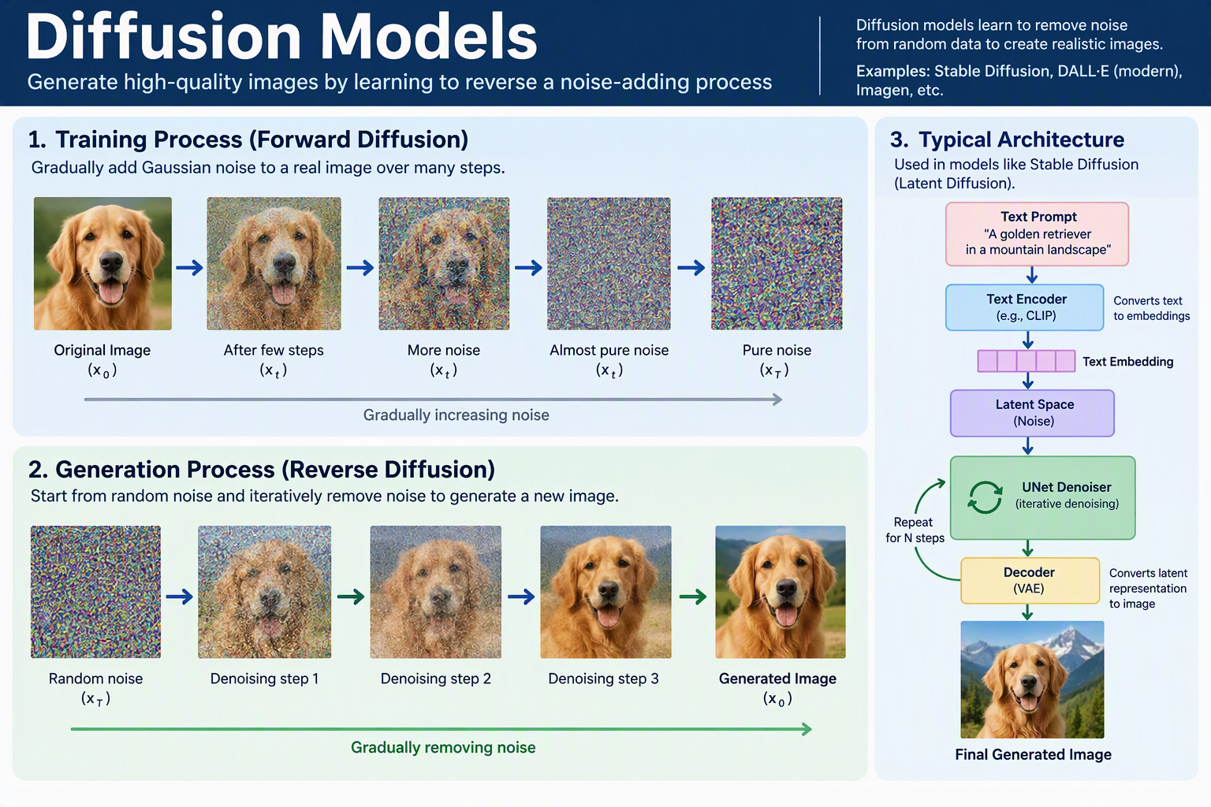
Diffusion models are generative models used primarily for image generation and other computer vision tasks. Diffusion-based neural networks are trained through deep learning to progressively “diffuse” samples with random noise, then reverse that diffusion process to generate high-quality images.
Diffusion models are among the neural network architectures at the forefront of generative AI, most notably represented by popular text-to-image models including Stability AI’s Stable Diffusion, OpenAI’s DALL-E (beginning with DALL-E-2), Midjourney and Google’s Imagen. They improve upon the performance and stability of other machine learning architectures used for image synthesis such as variational autoencoders (VAEs), generative adversarial networks (GANs) and autoregressive models such as PixelCNN.
The intuition behind diffusion models is inspired by physics, treating pixels like the molecules of a drop of ink spreading out in a glass of water over time. Much like how the random movement of the ink molecules will eventually lead to their even dispersal in the glass, the random introduction of noise into an image will eventually result in what looks like TV static. By modeling that diffusion process, then somehow learning to reverse it, an artificial intelligence model can generate new images by simply “denoising” samples of random noise.
Diffusion models are most prominently associated with image generation and other image processing tasks such as inpainting and super-resolution, but their applications extend to other domains including audio generation, drug design and molecule generation. For simplicity, this article will focus on image generation.

