What is a transformer model?
The transformer model is a type of neural network architecture that excels at processing sequential data, most prominently associated with large language models (LLMs). Transformer models have also achieved elite performance in other fields of artificial intelligence (AI), such as computer vision, speech recognition and time series forecasting.
The transformer architecture was first described in the seminal 2017 paper “Attention is All You Need” by Vaswani and others, which is now considered a watershed moment in deep learning.
Originally introduced as an evolution of the recurrent neural network (RNN)-based sequence-to-sequence models used for machine translation, transformer-based models have since attained cutting-edge advancements across nearly every machine learning (ML) discipline.
Despite their versatility, transformer models are still most commonly discussed in the context of natural language processing (NLP) use cases, such as chatbots, text generation, summarization, question answering and sentiment analysis.
BERT (or Bidirectional Encoder Representations from Transformers), an encoder-only model introduced by Google in 2019, was a major landmark in the establishment of transformers and remains the basis of most modern word embedding applications, from modern vector databases to Google search.

Why are transformer models important?
Before the introduction of transformer models, most NLP tasks relied on recurrent neural networks (RNNs). The way RNNs process sequential data is inherently serialized: they ingest the elements of an input sequence one at a time and in a specific order.
Attention mechanisms, conversely, can examine an entire sequence simultaneously and make decisions about how and when to focus on specific time steps of that sequence.
In addition to significantly improving the ability to understand long-range dependencies, this quality of transformers also allows for parallelization: the ability to perform many computational steps at once, rather than in a serialized manner.
Being well-suited to parallelism enables transformer models to take full advantage of the power and speed offered by GPUs during both training and inference. This possibility, in turn, unlocked the opportunity to train transformer models on unprecedentedly massive datasets through self-supervised learning.
Especially for visual data, transformers also offer some advantages over convolutional neural networks. CNNs are inherently local, using convolutions to process smaller subsets of input data one piece at a time.
Therefore, CNNs also struggle to discern long-range dependencies, such as correlations between words (in text) or pixels (in images) that aren’t neighboring one another. Attention mechanisms don’t have this limitation.

What is self-attention?
Understanding the mathematical concept of attention, and more specifically self-attention, is essential to understanding the success of transformer models in so many fields. Attention mechanisms are, in essence, algorithms designed to determine which parts of a data sequence an AI model should “pay attention to” at any particular moment.
Consider a language model interpreting the English text " on Friday, the judge issued a sentence. "
The preceding word “ the ” suggests that “ judge ” is acting as a noun—as in, a person presiding over a legal trial—rather than a verb meaning to appraise or form an opinion.
That context for the word “ judge ” suggests that “ sentence ” probably refers to a legal penalty, rather than a grammatical “sentence.”
The word “ issued ” further implies that “ sentence ” refers to the legal concept, not the grammatical concept.
Therefore, when interpreting the word “ sentence ,” the model should pay close attention to “ judge ” and “ issued. ” It should also pay some attention to the word “ the .” It can more or less ignore the other words.

How does self-attention work?
Broadly speaking, a transformer model’s attention layers assess and use the specific context of each part of a data sequence in 4 steps:

The model “reads” raw data sequences and converts them into vector embeddings, in which each element in the sequence is represented by its own feature vector(s) that numerically reflect qualities such as semantic meaning.

The model determines similarities, correlations and other dependencies (or lack thereof) between each vector and each other vector. In most transformer models, the relative importance of one vector to another is determined by computing the dot product between each vector. If the vectors are well aligned, multiplying them together will yield a large value. If they’re not aligned, their dot product will be small or negative.

These “alignment scores” are converted into attention weights. This is achieved by using alignment scores as inputs to a softmax activation function, which normalizes all values to a range between 0–1 such that they all add up to a total of 1. So for instance, assigning an attention weight of 0 between “Vector A” and “Vector B” means that Vector B should be ignored when making predictions about Vector A. Assigning Vector B an attention weight of 1 means that it should receive 100% of the model’s attention when making decisions about Vector A.

These attention weights are used to emphasize or deemphasize the influence of specific input elements at specific times. In other words, attention weights help transformer models focus on or ignore specific information at a specific moment.
Before training, a transformer model doesn’t yet “know” how to generate optimal vector embeddings and alignment scores. During training, the model makes predictions across millions of examples drawn from its training data, and a loss function quantifies the error of each prediction.

Through an iterative cycle of making predictions and then updating model weights through backpropagation and gradient descent, the model “learns” to generate vector embeddings, alignment scores and attention weights that lead to accurate outputs.

How do transformer models work?
Transformer models such as relational databases generate query, key and value vectors for each part of a data sequence, and use them to compute attention weights through a series of matrix multiplications.

Relational databases are designed to simplify the storage and retrieval of relevant data: they assign a unique identifier (“key”) to each piece of data, and each key is associated with a corresponding value. The “Attention is All You Need” paper applied that conceptual framework to processing the relationships between each token in a sequence of text.

The query vector represents the information a specific token is “seeking.” In other words, a token’s query vector is used to compute how other tokens might influence its meaning, conjugation or connotations in context.
The key vectors represent the information that each token contains. Alignment between query and key is used to compute attention weights that reflect how relevant they are in the context of that text sequence.
The value (or value vector) “returns” the information from each key vector, scaled by its respective attention weight. Contributions from keys that are strongly aligned with a query are weighted more heavily; contributions from keys that are not relevant to a query will be weighted closer to zero.
For an LLM, the model’s “database” is the vocabulary of tokens it has learned from the text samples in its training data. Its attention mechanism uses information from this “database” to understand the context of language.

Tokenization and input embeddings
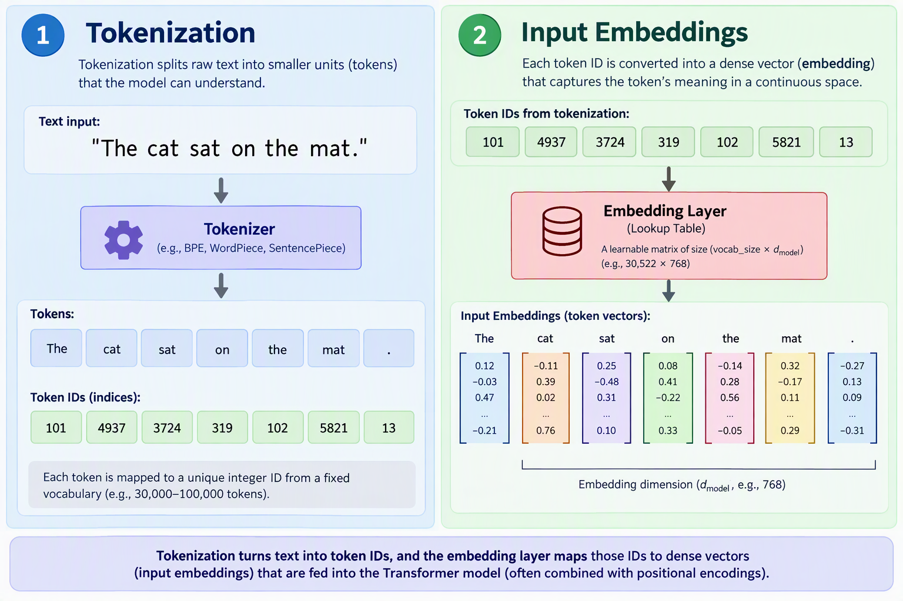
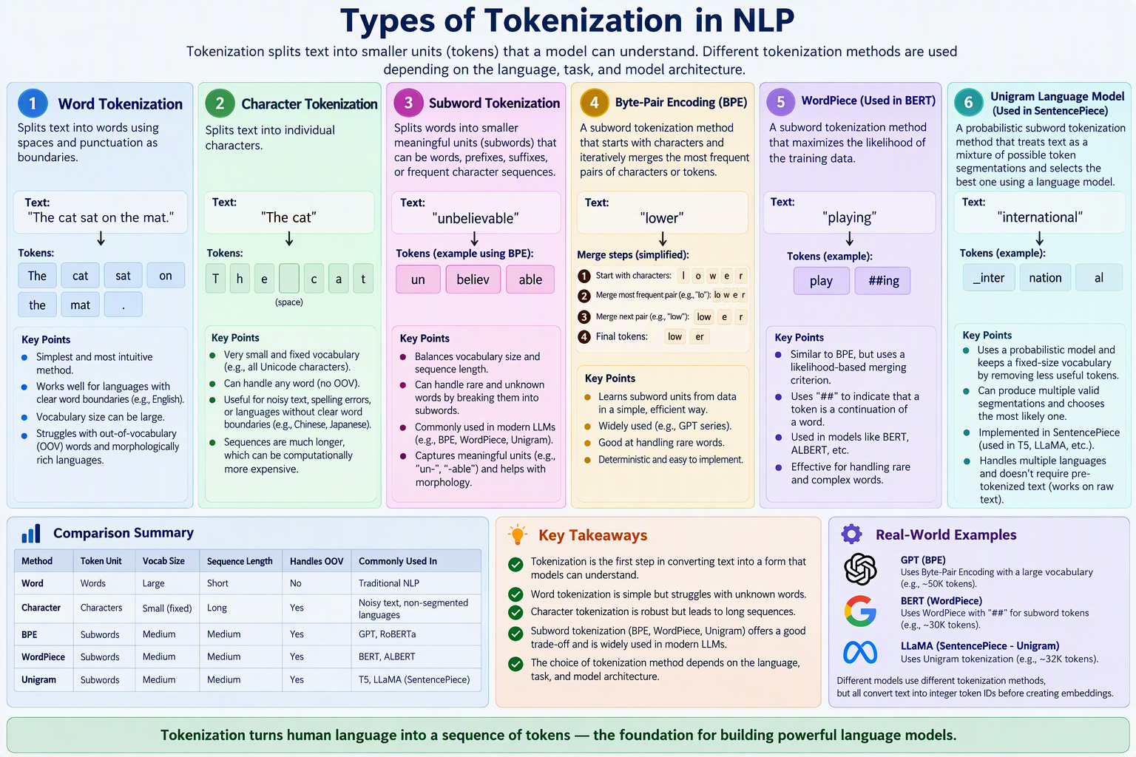

Positional encoding
The order and position of words can significantly impact their semantic meanings. Whereas the serialized nature of RNNs inherently preserves information about the position of each token, transformer models must explicitly add positional information for the attention mechanism to consider.
With positional encoding, the model adds a vector of values to each token’s embedding, derived from its relative position, before the input enters the attention mechanism. The nearer the 2 tokens are, the more similar their positional vectors will be and therefore, the more their alignment score will increase from adding positional information. The model thereby learns to pay greater attention to nearby tokens.
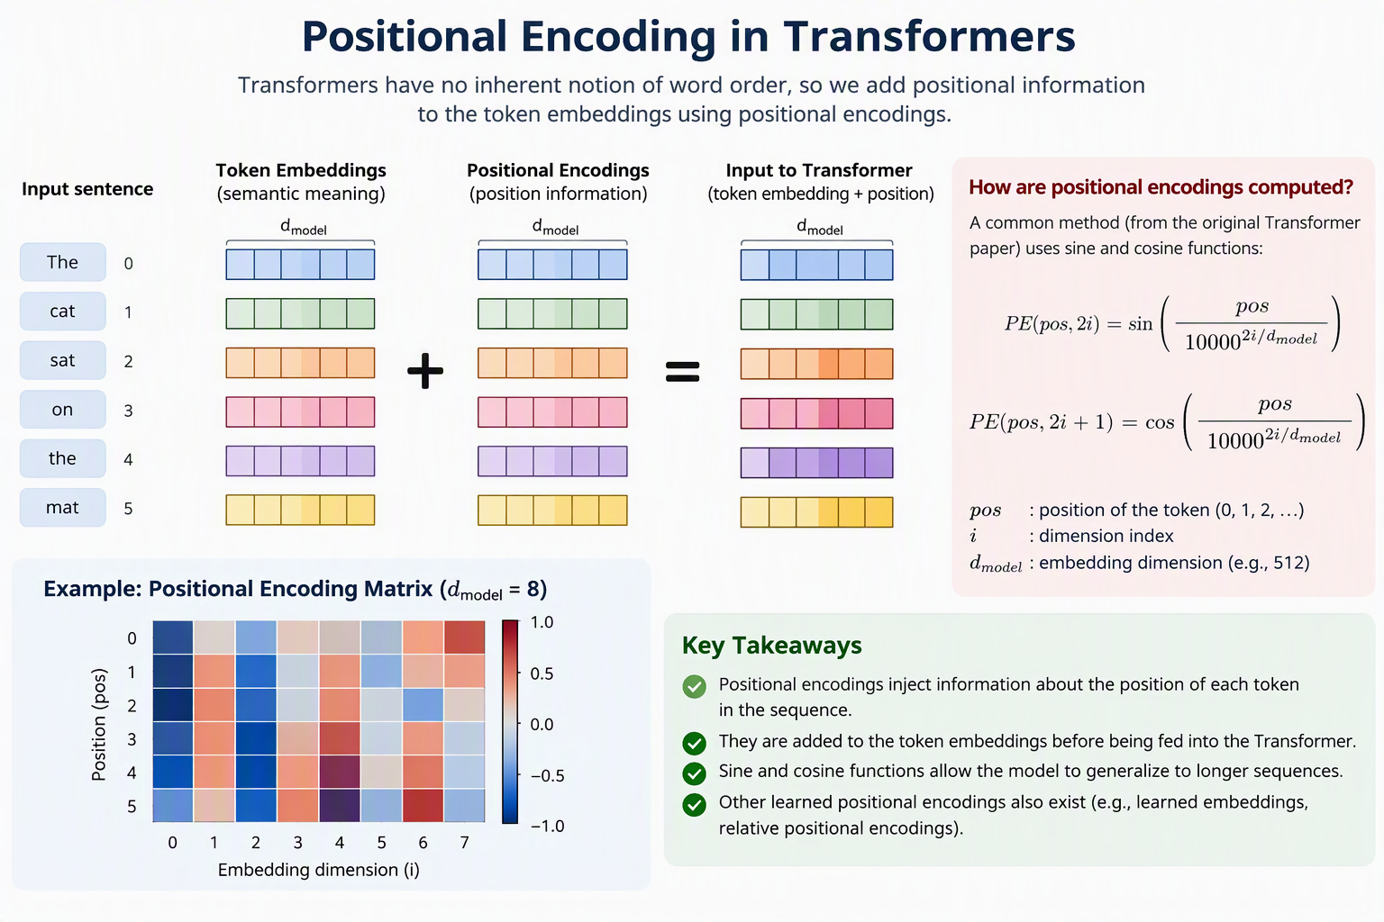
Generating query, key and value vectors
When positional information has been added, each updated token embedding is used to generate three new vectors. These query, key and value vectors are generated by passing the original token embeddings through each of three parallel feedforward neural network layers that precede the first attention layer. Each parallel subset of that linear layer has a unique matrix of weights, learned through self-supervised pretraining on a massive dataset of text.
- The embeddings are multiplied by the weight matrix W_{Q} to yield the query vectors (Q), which have d_{k} dimensions
- The embeddings are multiplied by the weight matrix W_{K} to yield the key vector (K), also with dimensions d_{k}
- The embeddings are multiplied by the weight matrix W_{V} to yield the value vectors (V), with dimensions d
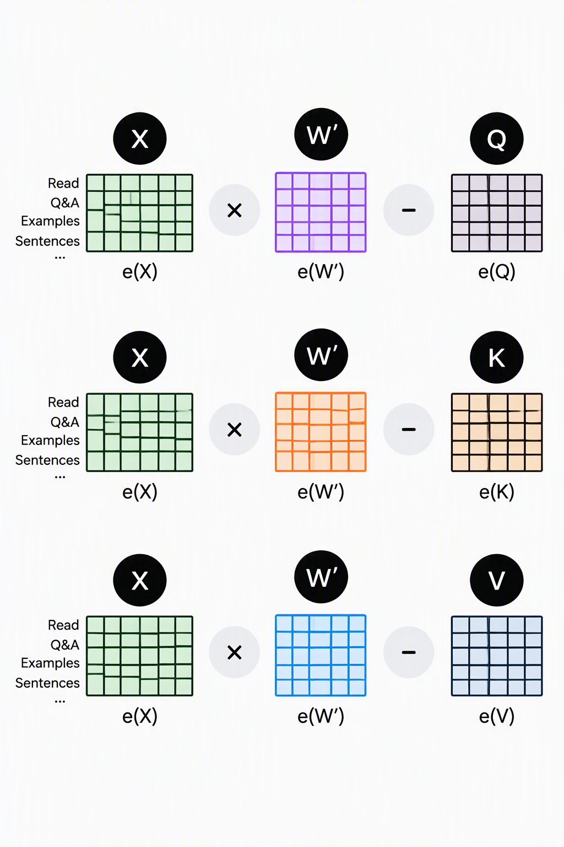
Computing self-attention
The transformer’s attention mechanism’s primary function is to assign accurate attention weights to the pairings of each token’s query vector with the key vectors of all the other tokens in the sequence. When achieved, you can think of each token X as now having a corresponding vector of attention weights, in which each element of that vector represents the extent to which some other token should influence it.
Each other token’s value vector is now multiplied by its respective attention weight.
These attention-weighted value vectors are all summed together. The resulting vector represents the aggregated contextual information being provided to token X by all of the other tokens in the sequence.
Finally, the resulting vector of attention-weighted changes from each token is added to the token x’s original, post-positional encoding vector embedding.
In essence, x's vector embedding has been updated to better reflect the context provided by the other tokens in the sequence.

Multi-head attention
To capture the many multifaceted ways tokens might relate to one another, transformer models implement multi-head attention across multiple attention blocks.
Before being fed into the first feedforward layer, each original input token embedding is split into h evenly sized subsets. Each piece of the embedding is fed into one of h parallel matrices of Q, K and V weights, each of which are called a query head, key head or value head. The vectors output by each of these parallel triplets of query, key and value heads are then fed into a corresponding subset of the next attention layer, called an attention head.
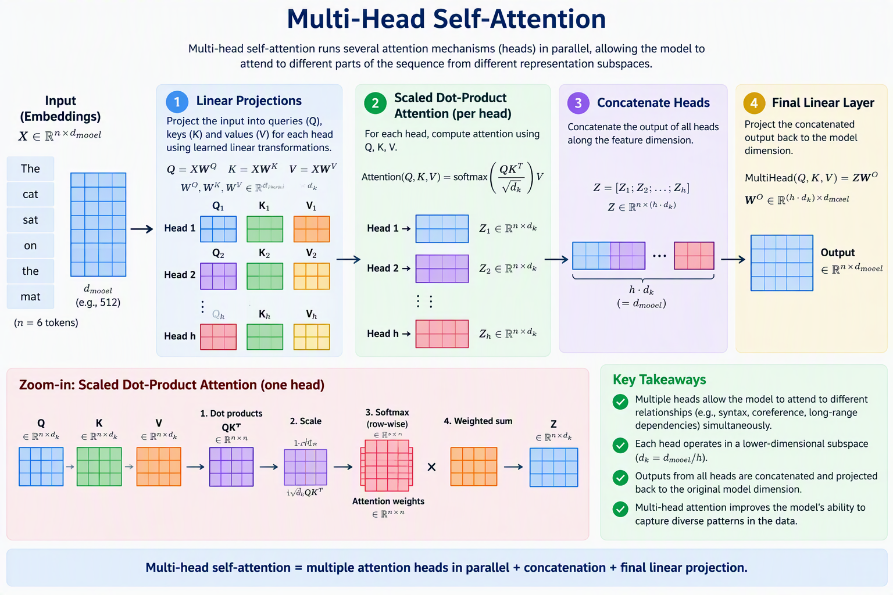

Fine tuning Vs Pre-training
To create domain-specific Language Models (LLMs), we have two main approaches:
- Training from Scratch: Building specialized LLMs entirely from domain-specific data.
- Continual Pre-training: Enhancing existing LLMs by further pre-training them with domain-specific data.
Fine-tuning
Fine-tuning employs labeled data to fine-tune the model’s parameters, tailoring it to the specific nuances of a task. This specialization significantly enhances the model’s effectiveness in that particular task compared to a general-purpose pre-trained model.
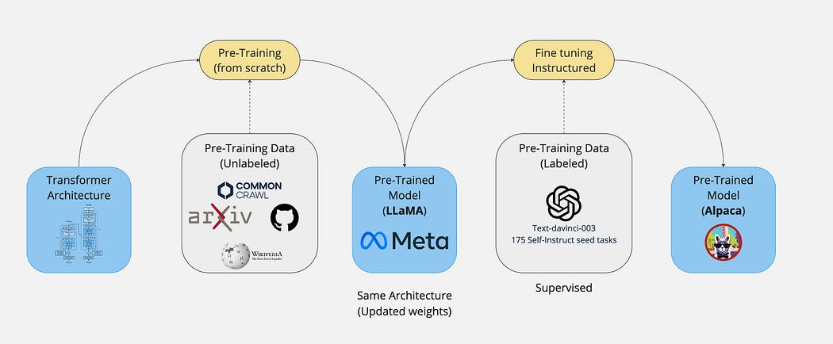
Pre-training
Pre-training usually would mean take the original model, initialise the weights randomly, and train the model from absolute scratch on some large corpora.
Further/Continuous pre-training means take some already pre-trained model, and basically apply transfer learning — use the already saved weights from the trained model (checkpoint) and train it on some new domain (i.e financial data).
