**OUTPUT:**

**User Interface**

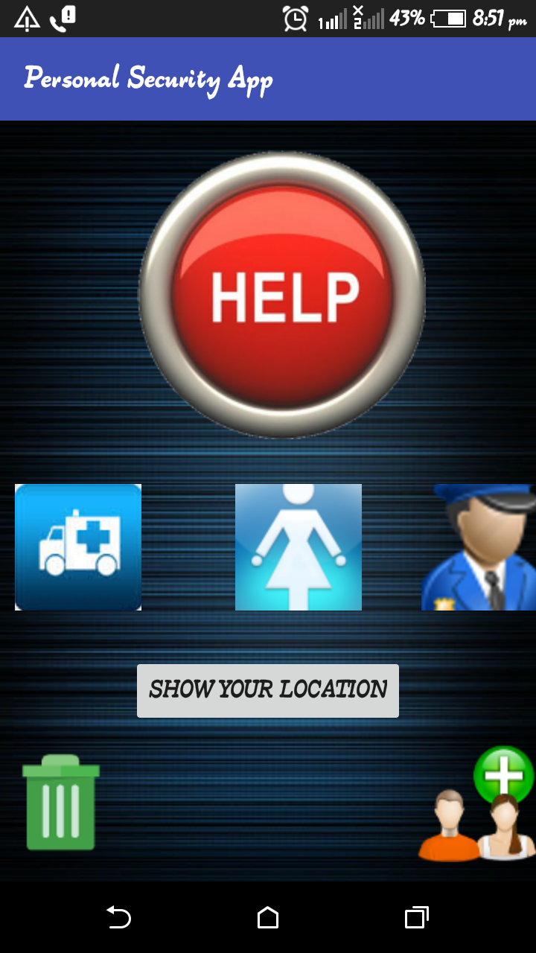

**Show location**

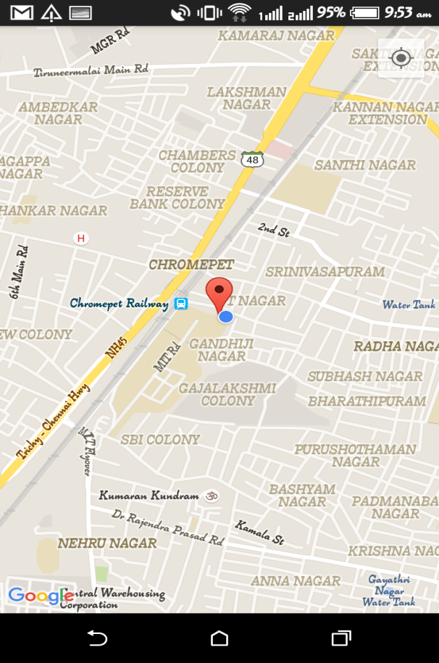

**Add User**

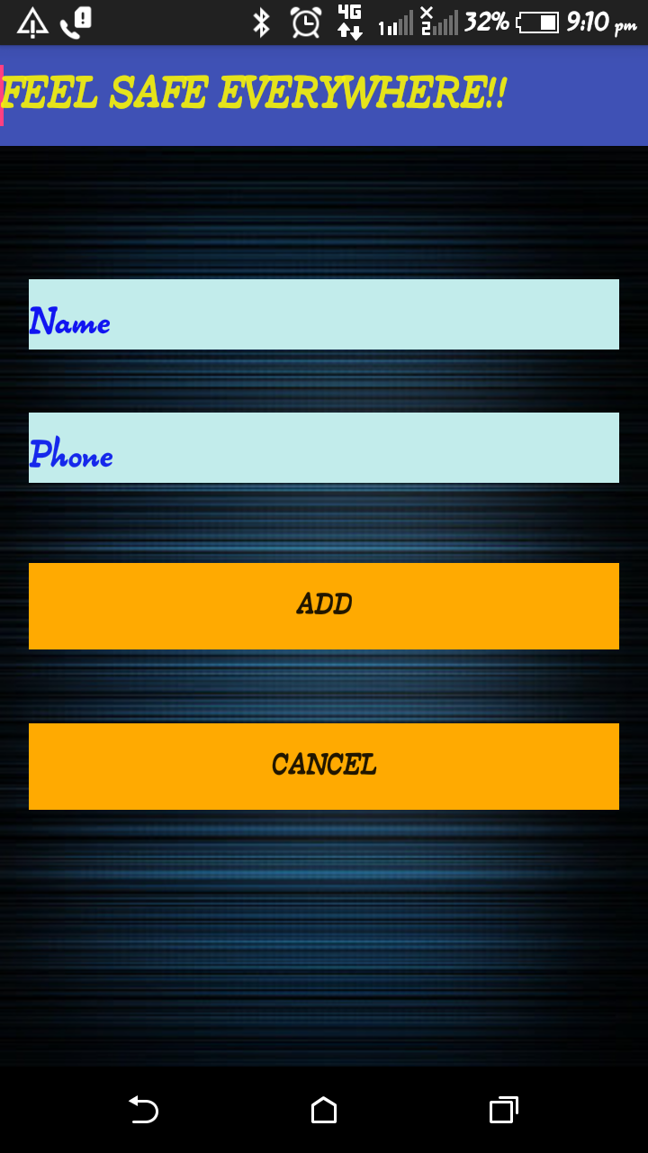

**Edit User details**

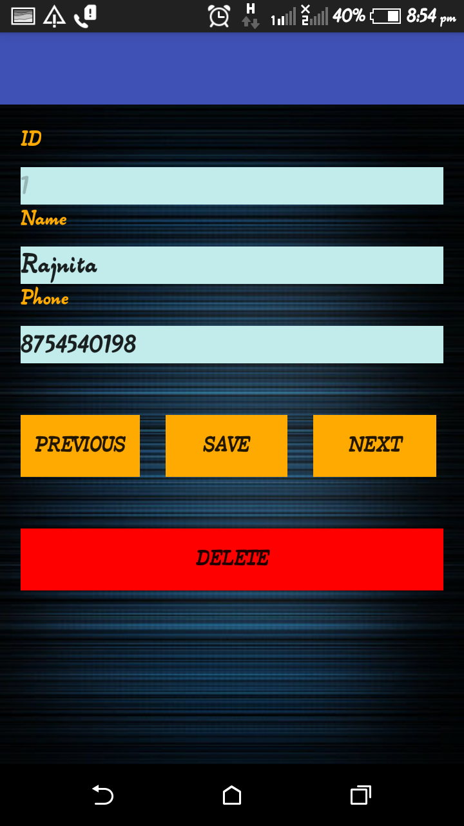

**Message Received On pressing emergency call button**

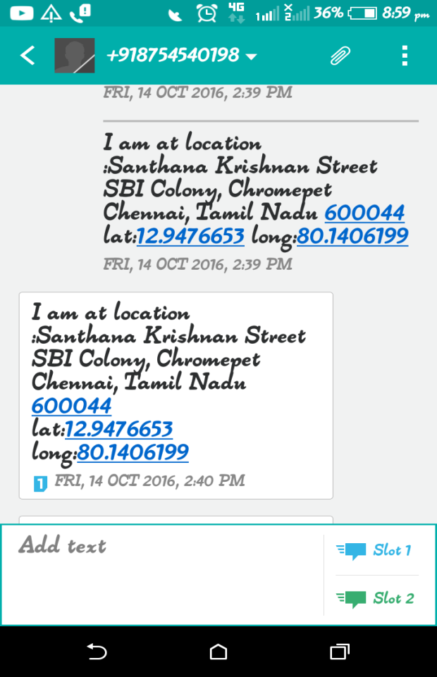 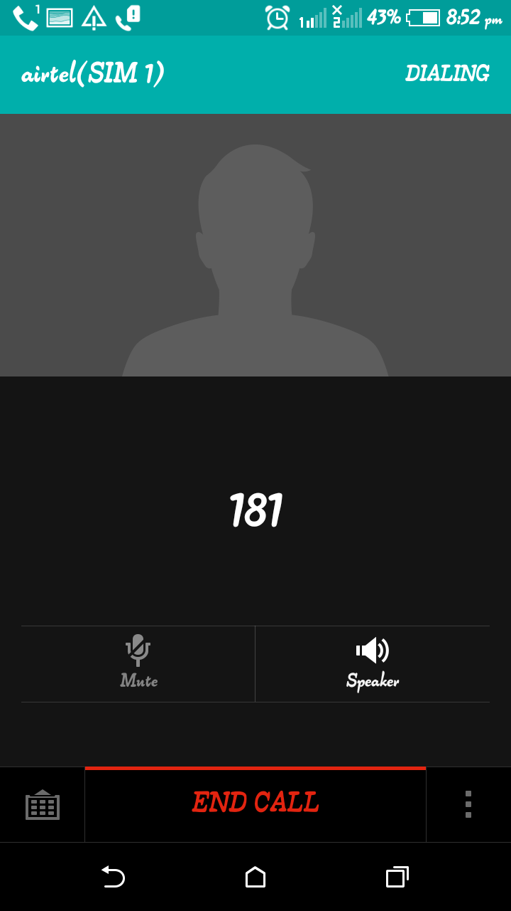

**CONCLUSION:**

This app will help in making cities a better place to live. It serves as a personal security app. It will be useful for people especially those who go for hiking in the forest, journalists, students and women.