Answer to the question no 5
(c)
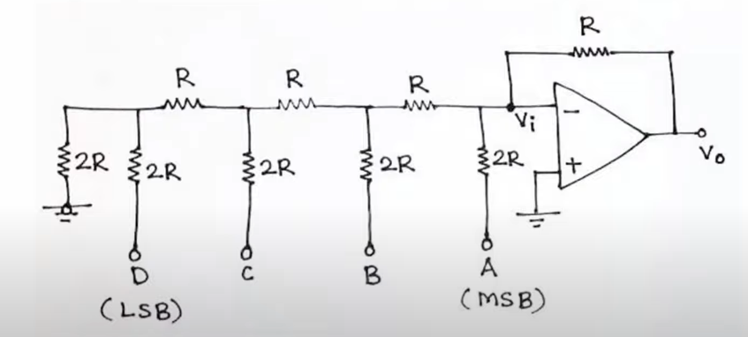
R-2R ladder DACs turn digital signals into analog by using a ladder of resistors.

Each digital bit matches a resistor, creating different voltage levels at the output. The output voltage is a mix of the reference voltage, based on the digital input. Accurate resistors are important for correct results. Sometimes, filtering is needed to reduce noise.

Overall, R-2R DACs offer an affordable way to change digital signals into analog for many uses, like audio systems and industrial controls.
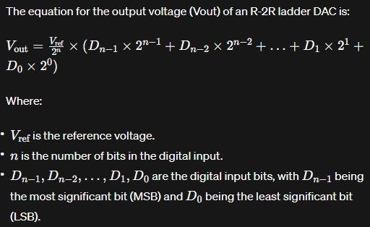

Answer to the question no 6
(a)
The ADC’s stands for Analog to digital converters. The specification of ADCs written bellow-

Resolution: Indicates how well the ADC can detect tiny changes in voltage.
Sampling Rate: Determines how fast the ADC converts real-world signals into digital numbers.
Accuracy: Reflects how closely the ADC's numbers match the actual signal being measured.
Input Voltage Range: Specifies the range of voltages the ADC can accurately handle.
Power Consumption: Describes how much energy the ADC uses, affecting battery life and efficiency.

(b)
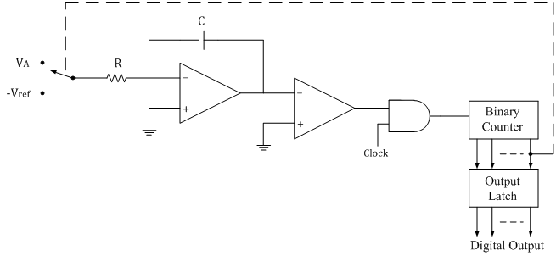.
The operation of a Dual Slope type Analog-to-Digital Converter (ADC) involves the following steps:

Integration Phase: Apply reference voltage and charge capacitor based on input signal's polarity for a specific duration.
Reference Switching: Disconnect capacitor from the signal and connect it to a reference voltage of opposite polarity for discharge.
Clock Pulse Counting: Measure the time taken for the capacitor to return to its original level or reach a set threshold by counting clock pulses.
Conversion Process: Translate the counted pulses into a digital output representing the input signal's voltage.
Accuracy and Linearity: Depend on the precision of the reference voltage and integration time. Linearity

(c)
Applications of ADCs (Analog-to-Digital Converters):

- Digital signal processing
- Data acquisition systems
- Instrumentation and measurement
- Audio recording and processing
- Image processing and digitization

Applications of DACs (Digital-to-Analog Converters):

- Audio playback and reproduction
- Video signal generation
- Motor control in robotics
- Telecommunications and networking
- Industrial automation and control

Answer to the question no 7
(a)
Latches and flip-flops are both sequential logic circuits, but they differ in their behavior and operation:
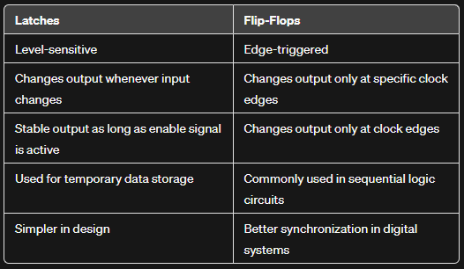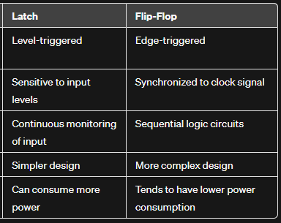

(b)
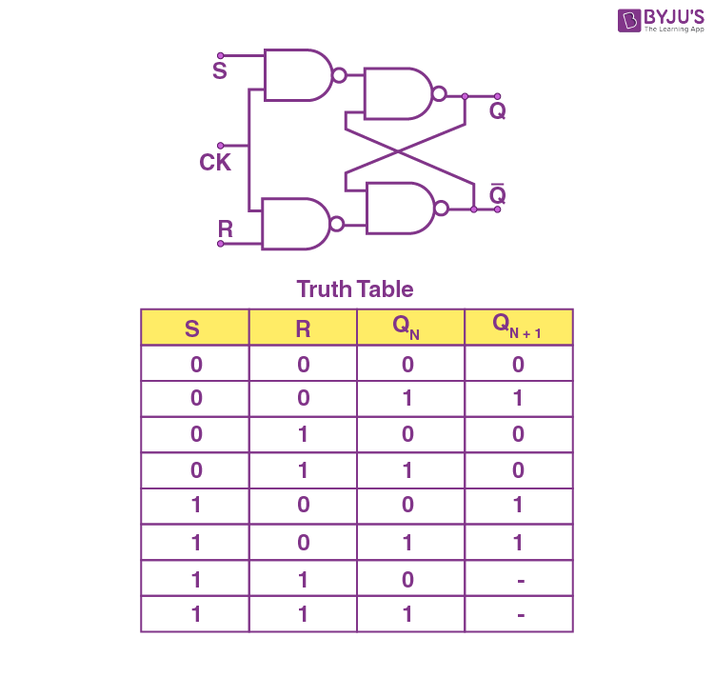
The type flip-flop which has two inputs namely S (Set) and R (Reset) is termed as an SR flipflop. If the S and R inputs of the flip-flop control its outputs when a clock pulse is present (i.e. goes from either low to high or high to low), then it called a clocked SR flip-flop. Since, the clock signal synchronizes the operation of the SR flip-flop, hence the clocked SR flip-flop is also known as synchronous SR flip-flop.

Applications:
- Digital counters
- Storage and shift registers
- Data storage elements
- Data transfer systems
- Frequency divider circuits, etc.

(c)

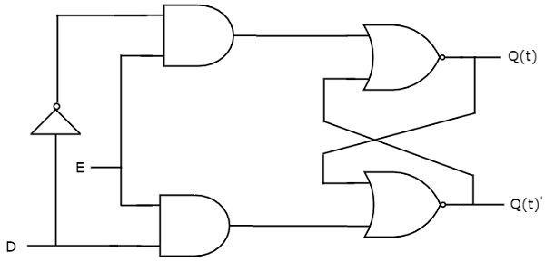
Input & Activation: D latch has data (D) and control inputs. When the control input is active (usually high), the latch takes the data input value.
Storage: The value from the data input is stored in the latch's output as long as the control input remains active.
Hold State: When the control input is inactive (usually low), the latch maintains its current output state regardless of any changes in the data input.
Change of State: When control is active, input change updates output instantly. Inactive control retains last output until new change with active control.

Answer to the question no 8
(a)
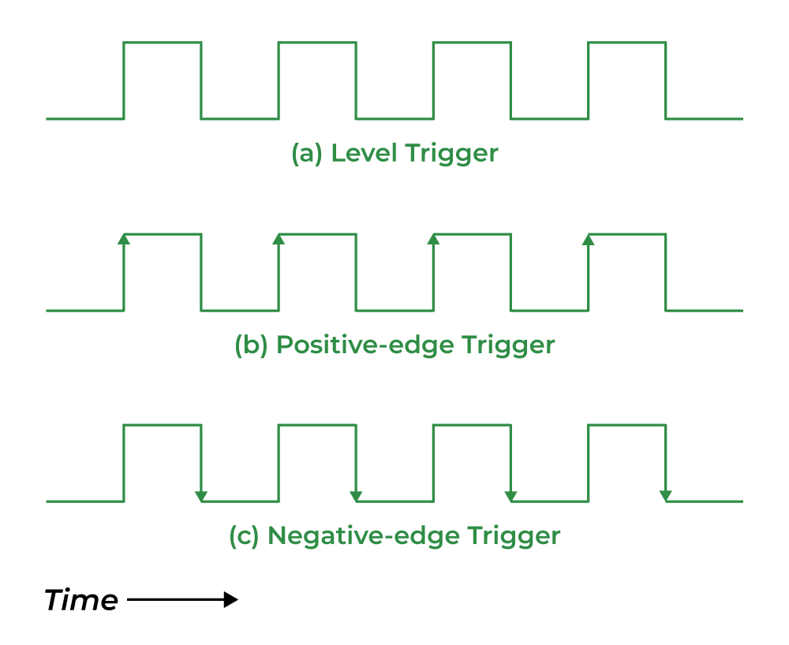
Edge triggering is a method used in digital circuits, like flip-flops and counters, to recognize changes in the input signal's level from low to high or high to low.
Edge triggering detects sharp changes in the input signal's level, triggered by the circuit's clock signal. This method is crucial for precise timing in synchronous circuits like flip-flops and counters, ensuring accurate event sequencing.

(b)
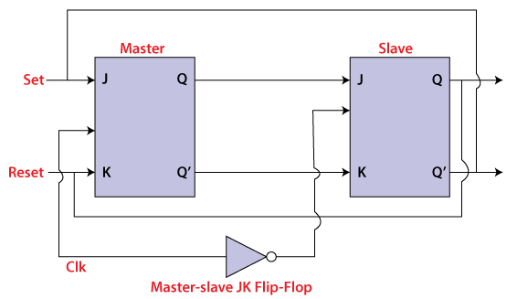
The master-slave flip flop is constructed by combining two JK flip flops. These flip flops are connected in a series configuration. In these two flip flops, the 1st flip flop work as "master", called the master flip flop, and the 2nd work as a "slave", called slave flip flop. The master-slave flip flop is designed in such a way that the output of the "master" flip flop is passed to both the inputs of the "slave" flip flop. The output of the "slave" flip flop is passed to inputs of the master flip flop.
In "master-slave flip flop", apart from these two flip flops, an inverter or NOT gate is also used. For passing the inverted clock pulse to the "slave" flip flop, the inverter is connected to the clock's pulse. In simple words, when CP set to false for "master", then CP is set to true for "slave", and when CP set to true for "master", then CP is set to false for "slave".
