ML COMPONENT - TRAINING REPORT
Claim-Veracity Classification for TruthLens AI
A supervised machine learning component trained on a public benchmark dataset, evaluated against a held-out test set, and integrated into the live application as an independent second signal alongside the RAG + LLM verdict.

1. Purpose
TruthLens AI's primary verdict comes from a retrieval-augmented pipeline: search a knowledge base, then have a language model reason over what was retrieved. That pipeline involves no training on our end - the language model is pre-trained by a third party, and the retrieval step (BM25) is a fixed statistical formula rather than a learned model. This component adds the piece that was missing: an actual supervised model, trained by us, on a real labeled dataset, evaluated with standard classification metrics on data it never saw during training.

2. Dataset
We use the LIAR dataset (Wang, 2017 - “Liar, Liar Pants on Fire”: A New Benchmark Dataset for Fake News Detection, ACL 2017), the standard academic benchmark for short-statement veracity classification. It consists of 12,836 political statements, each collected from PolitiFact.com and hand-labeled by professional fact-checkers on a six-point truthfulness scale.
- Training set: 10,240 statements
- Validation set: 1,284 statements
- Test set: 1,267 statements (held out - used only for final evaluation, never for training or model selection)
- Original labels: pants-fire, false, barely-true, half-true, mostly-true, true
Because LIAR's six-point scale is finer-grained than TruthLens's own four-verdict scheme, we additionally map the labels onto True / False / Misleading (true+mostly-true → True; false+pants-fire → False; half-true+barely-true → Misleading) for the model that is actually deployed in the app. LIAR has no “Unverified” category, since every statement in it was fact-checked - that verdict remains reserved for claims TruthLens's own knowledge base genuinely has no evidence for.

3. Methodology
Text features: TF-IDF vectorization of the statement text (unigrams and bigrams, top 20,000 features by frequency, English stop-words removed). Four models were trained and compared, using an identical train/validation/test split for all of them:
- Multinomial Naive Bayes - probabilistic baseline
- Logistic Regression - linear, class-balanced
- Linear SVM - margin-based, class-balanced
- A neural network (multi-layer perceptron, 2 hidden layers of 256 and 64 units, ReLU activations, Adam optimizer) - trained for 40 epochs with training loss and validation accuracy logged after every epoch
Each model was trained twice: once on the original six-way task (for direct comparison against the published LIAR benchmark), and once on TruthLens's own three-way verdict scheme (for deployment). All metrics below are computed on the held-out test set only.

4. Results — Six-Way Task (matches the published benchmark)
Model | Accuracy | Macro P | Macro R | Macro F1
Naive Bayes | 24.2% | 20.5% | 20.8% | 18.9%
Logistic Regression | 24.0% | 23.6% | 24.1% | 23.6%
Linear SVM | 23.8% | 23.4% | 23.8% | 23.5%
Neural Net (MLP) | 23.0% | 22.6% | 22.2% | 22.3%

For context: the original LIAR paper reports its strongest text-only baseline at roughly 27% accuracy on this exact six-way task, and even later transformer-based approaches in follow-up research typically land in the 30-37% range. Six-way accuracy in the low-to-mid twenties, as seen above, is therefore consistent with the literature, not a sign of a broken pipeline - this is a genuinely difficult task, since human fact-checkers themselves draw fine, often subjective distinctions between adjacent categories like “half-true” and “mostly-true.”

5. Results — Three-Way Task (True / False / Misleading, used in the app)
Model | Accuracy | Macro P | Macro R | Macro F1
Naive Bayes | 42.0% | 42.1% | 39.5% | 37.9%
Logistic Regression | 42.3% | 42.1% | 42.4% | 42.1%
Linear SVM | 41.8% | 41.5% | 41.7% | 41.6%
Neural Net (MLP) | 40.6% | 40.1% | 39.9% | 40.0%
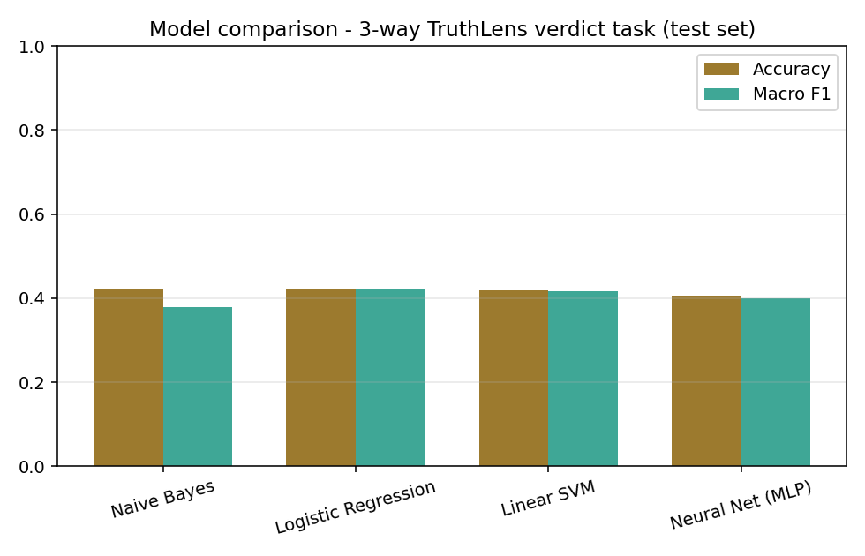
Figure 1. Accuracy and macro-F1 across all four models, three-way task, test set.
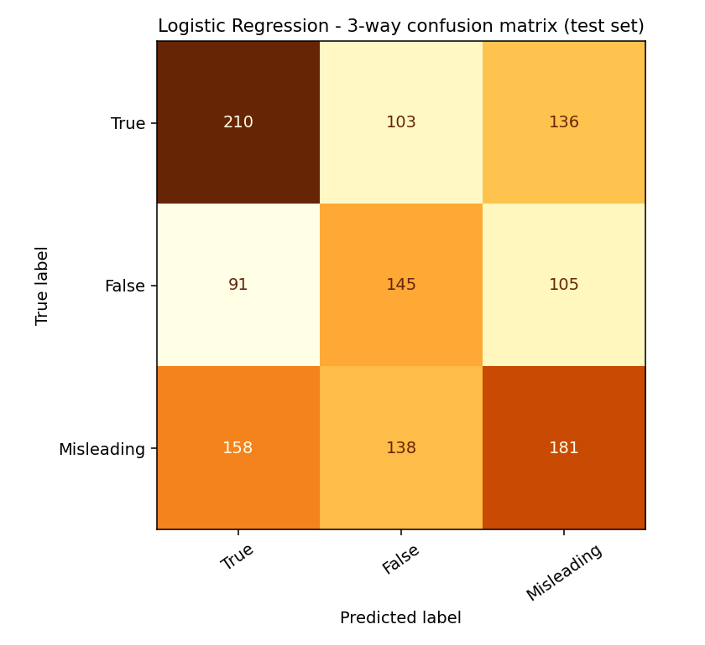
Figure 2. Confusion matrix for the best-performing model (Logistic Regression), test set.

6. Neural Network Training Curves — and an Honest Finding
The MLP was trained with real per-epoch tracking rather than a single train/test call, so its learning behaviour over time is directly visible:
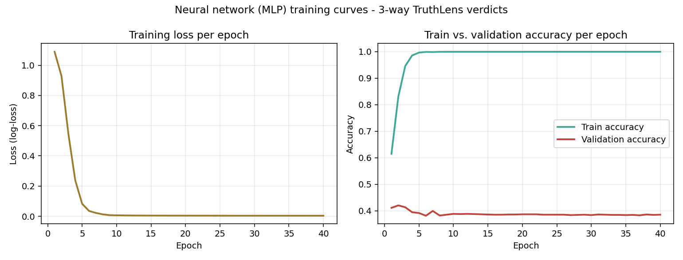
Figure 3. MLP training loss and train/validation accuracy across 40 epochs, three-way task.
The curves show clear overfitting: training accuracy reaches ~99.9% by epoch 6, while validation accuracy plateaus around 38-39% - close to where the classical models land, and no better. This is an expected and instructive result rather than a failure: TF-IDF features are extremely high-dimensional and sparse (20,000 dimensions) relative to the size of the training set (~10,000 examples), which is exactly the regime where a large neural network can memorise the training data instead of generalising from it, while a simpler linear model (Logistic Regression / SVM) stays better-regularised and generalises at least as well. It is a textbook illustration of the bias-variance trade-off, and the reason classical ML is still a legitimate, competitive choice on small or sparse text datasets rather than something deep learning automatically outperforms.

7. Integration into TruthLens
The best three-way model (Logistic Regression, macro-F1 42.1%) and its TF-IDF vectorizer were saved and wired into the live backend (backend/ml_classifier.py). On every /api/verify request, this trained model runs independently of the RAG + LLM pipeline and its prediction is returned alongside the main verdict as a clearly labelled “second opinion” - shown in the UI with its own confidence and full class-probability breakdown. The two signals are deliberately kept separate rather than merged, so each can be evaluated on its own terms: one is evidence-grounded generative reasoning, the other is a fixed, statistically trained classifier.
The saved model files total under 1MB (TF-IDF vocabulary + Logistic Regression weights), so this adds a genuine trained-ML component without materially affecting deploy size, cold-start time, or hosting cost on the free-tier infrastructure the rest of the project targets.

8. Summary
This component contributes what the RAG pipeline alone cannot: a model we trained ourselves, on a real public benchmark, with a proper train/validation/test split, standard classification metrics, visible training curves, and a considered comparison across four different algorithms - integrated into, not separate from, the working application.

