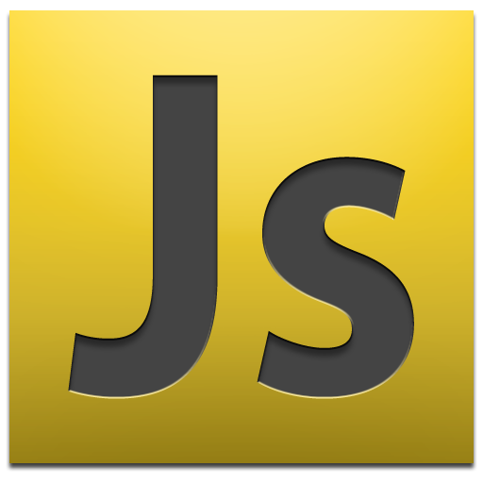

Java, Javascript, C, C++, which is the best for me? In my opinion, all programming is the same; it’s hard. All languages have their ups and downs and different conventions but personally, I don’t have a preference. If I had to choose, it would probably be Java since I’ve spent the most time using it. I’m a beginner at Javascript so I probably don’t know the full ins and outs, but overall, it seems just as complex as Java. Knowing how to program in Java definitely helps with getting to understand Javascript. I have no clue if Javascript is good from a software engineering perspective. Being at the basics, I cannot determine the capabilities Javascript has over the other programming languages. Some parts to Javascript are in fact easier and more programming friendly, so it could be advantageous to use it in software development.

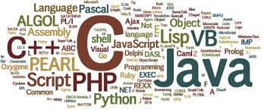

The whole idea behind athletic software engineering is to implement high quality solutions to short problems. I never once thought of software engineering as a speed related topic. Training myself to program short and efficient programs is definitely a tough challenge. The idea of high intensity problems is a unique and beneficial way of learning. I can already see that my style of programming is trying to adapt from finding the best solution to finding the most efficient answer in the given time frame. It is very stressful having to program fast, but it is such of valuable skill to have.Practicing the WODs will definitely get me to the level of high speed programming that I want to be at.