

LINKS

<https://onecompiler.com/sqlserver/> - one compiler (Online)

<https://dev.mysql.com/downloads/mysql/> - MySQL Server (Community Edition)

<https://www.mysql.com/products/workbench/> - MySQL Workbench

Domain Driven Design

Educational Application

           Student, Teacher, Course, Department, Subject

Banking Application

           Account, Customer, Fund Transfer …

Retail Application

           Product, Order, Cart, Payment

MySQL,

* MySQL is an open-source relational database management system (RDBMS).
* It uses Structured Query Language (SQL) for accessing and managing data.

Data Storage

* Stores data in tables, rows, and columns.
* Uses a fixed schema (predefined structure).

Advantages

* Free and open-source (with enterprise options).
* Fast read operations and reliable performance.
* Well-documented and has a large community.

Limitations

* Not ideal for unstructured or semi-structured data.
* Vertical scaling is often required for large loads.
* Less flexible than NoSQL systems when schema changes are frequent.

TABLE CREATION

create table students(

student_id int primary key,

name varchar(100),

dept varchar(100),

join_date Date

);

insert into students(student_id,name,dept,join_date) VALUES

(1, 'Amit Sharma', 'Data Engineering', '2025-09-15'),

(2, 'Neha Verma','Data Science','2025-09-17'),

(3,'Rohit Iyer','Data Engineering','2025-09-20');

VARIATIONS

select * from students;

select name, dept from students;

select * from students where dept = 'Data Engineering';

select * from students where join_Date > '2025-09-15';

select * from students

where dept='Data Engineering' and join_Date > '2025-09-15';

-- students in either Data Science or AI

select * from students

where dept in('Data Science', 'AI');

-- students who joined between sept 15 and sept 20

select * from students

where join_Date between '2025-09-15' and '2025-09-20';

LIKE

select * from students where name like 'A%';

select * from students where name like '%a';

select * from students where name like '%it%';

UPDATE

update students

set dept='Advanced Data Engineering'

where student_id=1;

update students

set join_Date='2025-09-18'

where name = 'Neha Verma';

select * from students;

update students

set join_Date=DATE_ADD('2025-09-18',interval 1 day);

DELETE

delete from students

where student_id=2;

delete from students

where join_date < '2025-09-16';

select * from students;

CRUD operations - create, read, update, delete

EXERCISES

create database retail_store;

use retail_store;

create table products(

products_id int primary key,

product_name varchar(50),

category varchar(50),

price decimal(10,2),

stock_quantity int,

added_Date date

);

insert into products(products_id,product_name,category,price,stock_quantity,added_Date)

values

(1,'Headphones','Electronics',300.00,80,'2023-01-01'),

(2,'Mouse','Electronics',500.50,15,'2023-02-01'),

(3,'Laptop','Electronics',45500.00,8,'2023-03-01'),

(4,'Sofas','Furniture',85599.00,52,'2023-04-01'),

(5,'Chairs','Furniture',599.50,66,'2023-05-01');

select * from products;

CREATE DATABASE analytics_practice;

USE analytics_practice;

CREATE TABLE sales_data (

sale_id INT PRIMARY KEY,

employee_name VARCHAR(100),

region VARCHAR(50),

sale_amount DECIMAL(10,2),

sale_date DATE

);

INSERT INTO sales_data VALUES

(1, 'Amit Sharma', 'North', 12000.50, '2024-01-15'),

(2, 'Neha Reddy', 'East', 8500.00, '2024-01-16'),

(3, 'Faizan Ali', 'North', 10000.00, '2024-01-20'),

(4, 'Divya Iyer', 'South', 13000.00, '2024-01-21'),

(5, 'Kiran Mehta', 'East', 9000.00, '2024-01-22'),

(6, 'Amit Sharma', 'North', 15000.00, '2024-02-05'),

(7, 'Neha Reddy', 'East', 8000.00, '2024-02-10'),

(8, 'Faizan Ali', 'North', 7000.00, '2024-02-15'),

(9, 'Divya Iyer', 'South', 14000.00, '2024-02-18'),

(10, 'Kiran Mehta', 'East', 6500.00, '2024-02-20');

-- show employees whose total sales > average sales of all employees

select employee_name

from sales_data

group by employee_name

having sum(sale_amount)>

(select avg(sale_amount) from sales_data);

CREATE DATABASE simple_sql;

USE simple_sql;

CREATE TABLE employees (

emp_id INT PRIMARY KEY,

emp_name VARCHAR(100),

department VARCHAR(50),

salary INT,

age INT

);

INSERT INTO employees VALUES

(1, 'Amit', 'HR', 30000, 25),

(2, 'Neha', 'IT', 45000, 28),

(3, 'Rahul', 'IT', 50000, 30),

(4, 'Divya', 'Sales', 40000, 26),

(5, 'Kiran', 'Sales', 35000, 24),

(6, 'Meena', 'HR', 32000, 29);

-- show employees who earn more than the average salary

select * from employees

where salary > (select avg(salary) from employees); -- subquery

-- show department-wise average salary using a derived table

-- when we write the subquery in from that is called as inline subquery

select dept_avg.department, dept_avg.avg_salary

from(

select department, avg(salary) as avg_salary

from employees

group by department

)as dept_avg;

-- show employees with their rank based on salary (highest first)

-- rank() over(order by) is an analytic function

select emp_name, department, salary,

rank() over(order by salary desc) as salary_rank

from employees;

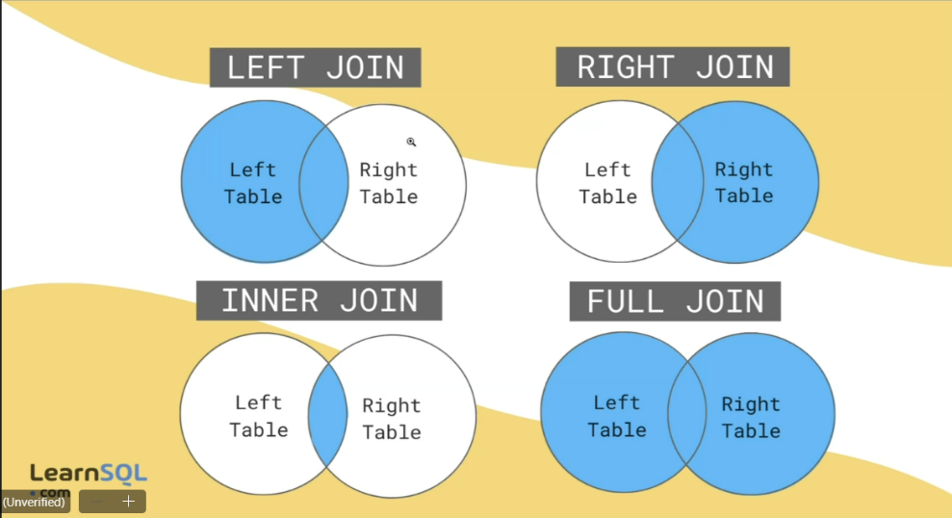JOINS

use analytics_practice;

CREATE TABLE customers (

customer_id INT PRIMARY KEY,

customer_name VARCHAR(100),

city VARCHAR(50)

);

INSERT INTO customers VALUES

(1, 'Amit Sharma', 'Delhi'),

(2, 'Neha Reddy', 'Hyderabad'),

(3, 'Rahul Iyer', 'Mumbai'),

(4, 'Divya Mehta', 'Chennai');

CREATE TABLE orders (

order_id INT PRIMARY KEY,

customer_id INT,

product_name VARCHAR(100),

order_amount INT,

FOREIGN KEY (customer_id) REFERENCES customers(customer_id)

);

INSERT INTO orders VALUES

(101, 1, 'Laptop', 55000),

(102, 2, 'Mouse', 500),

(103, 1, 'Keyboard', 1500),

(104, 3, 'Monitor', 7000),

(105, 2, 'Printer', 8500);

-- inner join

select customers.customer_name,orders.product_name,orders.order_amount

from customers

inner join orders

on customers.customer_id = orders.customer_id;

-- left join

select customers.customer_name,orders.product_name,orders.order_amount

from customers

left join orders

on customers.customer_id = orders.customer_id;

-- right join

select customers.customer_name,orders.product_name,orders.order_amount

from customers

right join orders

on customers.customer_id = orders.customer_id;

-- full join is not supported in this compiler

-- join 2 tables where order_amount is greater than 5000

select customers.customer_name,orders.product_name, orders.order_amount

from customers

join orders

on customers.customer_id=orders.customer_id

where orders.order_amount>5000;

-- providing alias

select o.order_id,c.customer_name,c.city, o.product_name,o.order_amount

from orders o

join customers c

using(customer_id);

-- more than 1 orders

select c.customer_name,count(o.order_id) as total_orders

from customers c

join orders o using(customer_id)

group by c.customer_name

having total_orders>1;

-- total amount spent by each customer

select c.customer_name,sum(o.order_amount)

as total_spent

from customers c join orders o

using(customer_id)

group by c.customer_name;

-- the customers who have not placed any orders

select c.customer_name

from customers c

left join orders o using(customer_id)

where o.order_id is null;

-- get which city is placing how many orders

select c.city,count(o.order_id)

from customers c join orders o

using(customer_id)

group by c.city;

create database hex;

use hex;

create table departments (

dept_id int primary key,

dept_name varchar(100)

);

insert into departments values

(1,'Human Resources'),

(2, 'Engineering'),

(3,'Marketing');

create table employees(

emp_id int primary key,

emp_name varchar(100),

dept_id int,

salary int

);

insert into employees values

(101,'Amit Sharma',1,30000),

(102,'Neha Reddy',2,45000),

(103,'Faizan Ali',2,48000),

(104,'Divya Mehta',3,35000),

(105,'Ravi Verma',NULL,28000);

-- JOIN-BASED Questions

-- 1. Show all employees with their department names.

select e.emp_id,e.emp_name,d.dept_name from departments d

join employees e using(dept_id);

-- 2. List employees who do not belong to any department.

select e.emp_id,e.emp_name from departments d

right join employees e using(dept_id)

where d.dept_id is null;

-- 3. Display the total number of employees in each department.

select d.dept_name,count(e.emp_id) as total_employees from departments d

left join employees e using(dept_id)

group by dept_name;

-- 4. Show departments with no employees.

select d.dept_name from departments d

left join employees e using(dept_id)

where e.emp_id is null;

-- 5. List employee names and department names for those who earn more than 40,000.

select e.emp_name, d.dept_name from departments d

join employees e using(dept_id)

where e.salary > 40000;

ASSIGNMENT -1

-- Task 1: Create a Table

create table products(

products_id int primary key,

product_name varchar(50),

category varchar(50),

price decimal(10,2),

stock_quantity int,

added_Date date

);

-- Task 2: Insert Records

insert into products(products_id, product_name, category, price, stock_quantity, added_Date)

values

(1,'Headphones','Electronics',300.00,80,'2023-01-01'),

(2,'Mouse','Electronics',500.50,15,'2023-02-01'),

(3,'Laptop','Electronics',45500.00,8,'2023-03-01'),

(4,'Sofas','Furniture',85599.00,52,'2023-04-01'),

(5,'Chairs','Furniture',599.50,66,'2023-05-01');

-- Task 3: Write Queries

-- 1. List all products.

select * from products;

-- 2. Display only product_name and price.

select product_name,price from products;

-- 3. Find products with stock_quantity less than 10.

select * from products where stock_quantity < 10;

-- 4. Find products with price between 500 and 2000.

select * from products where price between 500 and 2000;

-- 5. Show products added after 2023-01-01 .

select * from products where added_Date > '2023-01-01';

-- 6. List all products whose names start with ‘S’.

select * from products where product_name like 'S%';

-- 7. Show all products that belong to either Electronics or Furniture.

select * from products where category in ('Electronics','Furniture');

-- Task 4: Update & Delete

-- 1. Update the price of one product.

update products

set price = 399.50 where products_id=1;

-- 2. Increase stock of all products in a specific category by 5.

update products

set stock_quantity=stock_quantity+5 where category='Electronics';

-- 3. Delete one product based on its product_id .

delete from products where products_id=5;

-- 4. Delete all products with stock_quantity = 0.

delete from products where stock_quantity=0;

select * from products;