**1.Introduction**

Just about everything today in the technology area is a candidate for having the prefix smart added to it. The term smart sensor was coined in the mid-1980s, and since then several devices have been called smart sensors. The intelligence required by such devices is available from microcontroller unit (MCU), digital signal processor (DSP), and application-specific integrated circuit (ASIC) technologies developed by several semiconductor manufacturers. Some of those same semiconductor manufacturers are actively working on smarter silicon devices for the input and output sides of the control system as well. The term microelectromechanical system (MEMS) is used to describe a structure created with semiconductor manufacturing processes for sensors and actuators. To understand what is occurring today when advanced microelectronic technology is applied to sensors, a brief review of the transitions that have occurred is in order.

Before the availability of microelectronics, the sensors or transducers used to measure physical quantities, such as temperature, pressure, and flow, usually were coupled directly to a readout device, typically a meter that was read by an observer. The transducer converted the physical quantity being measured to a displacement. The observer initiated system corrections to change the reading closer to a desired value.

Many home thermostats, tire pressure gauges, and factory flow meters still operate in the same manner. However, the advent of microprocessor technology initiated the requirement for sensors to have an electrical output that could be more readily interfaced to provide unattended measurement and control. That also required the analog signal level to be amplified and converted to digital format prior to being supplied to the process controller. Todays MCUs and analog-to-digital (A/D) converters typically have a 5V power supply, which has dictated the supply voltage for many amplified and signal conditioned sensors. However, the reduction in the supply voltage from 5V to 3.3V and even lower voltages and the presence of more than one voltage in a system pose challenges not typically associated with even the smartest sensors. Separate integrated circuits (ICs) are available to handle the variety of voltages and resolve the problem, but they add to system and sensor complexity.

Commonly used definitions for the terms sensor and transducer must be the first in the list of many terms that will be defined. A transducer is a device that converts energy from one domain into another, calibrated to minimize the errors in the conversion process [2]. A sensor is a device that provides a useful output to a specified measurand. The sensor is a basic element of a transducer, but it also may refer to a detection of voltage or current in the electrical regime that does not require conversion. Throughout this book, the terms are used synonymously, because energy conversion is part of every device that is discussed.

The definition of smart sensor (intelligent transducer) has not been as widely accepted and is subject to misuse. However, an Institute of Electrical and Electronics Engineers (IEEE) committee has been actively consolidating terminology that applies to microelectronic sensors. The recently approved IEEE 1451.2 specification defines a smart sensor as a sensor that provides functions beyond those necessary for generating a correct representation of a sensed or controlled quantity. This function typically simplifies the integration of the transducer into applications in a networked environment [2]. That definition provides a starting point for the minimum content of a smart sensor. Future smart sensors will be capable of much more, and additional classifications (e.g., smart sensor type 1) may be required to differentiate the products. smart sensors and accelerate development and commercialization of smart sensors.

The advent of integrated circuits, which became possible because of the tremendous progress in semiconductor technology, resulted in the low cost microprocessor.Thus if it is possible to design a low cost sensor which is silicon based then the overall cost of the control system can be reduced .We can have integrated sensors which has electronics and the transduction element together on one silicon chip. This complete system can be called as system-on-chip .The main aim of integrating the electronics and the sensor is to make an intelligent sensor, which can be called as smart sensor. Smart sensors then have the ability to make some decision. Physically a smart sensor consists of transduction element, signal conditioning electronic and controller/processor that support some intelligence in a single package [1]. In this report the usefulness of silicon technology as a smart sensor, physical phenomena of conversion to electrical output using silicon sensors, characteristics of smart sensors. A general architecture of smart sensor is presented.

1. **Definition [1]**

* Smart sensors are sensors with integrated electronics that can perform one or more of the following function:
* Logic functions,
* Two-way communication,
* make decisions.

1. **Nature of Sensors**

The output from most sensing elements is low level and subject to several signal interference sources, a generalized model of a transducer [3]. Self-generating transducers such as piezoelectric devices do not require a secondary input to produce an output signal. However, transducers based on resistive, capacitive, and inductive sensing elements require excitation to provide an output. In addition to the desired input (e.g., pressure and undesired environmental effects, such as temperature, humidity, and vibration) are factors that affect the performance and accuracy of the transducer, factors that must be taken into account during the design of the transducer. Compensation for those secondary parameters historically has been performed by additional circuitry, but with smart sensing technology the compensation can be integrated on the sensor or accomplished in the microcontroller.

The output of a micromachined piezoresistive silicon pressure sensor and the effect of temperature on both the span and the offset . Although the output is quite linear, in this case within 0.1% full scale (F.S.), the output varies due to the effect of temperature on the span of the sensor by about 0.12 mV/°C. Because that signal level is insufficient to directly interface to a control IC, additional amplification and calibration typically are performed in the next stage of a transducer.

In a simple control system, the sensor is only one of three items required to implement a control strategy. The sensor provides an input to a controller with the desired strategy in its memory, and the controller drives an output stage to modify or maintain the status of a load, such as a light, a motor, a solenoid, or a display. As shown in Figure 1.4, a signal conditioning interface typically exists between the sensor(s) and the controller and between the controller and the output device. Smart sensing includes a portion of the controllerfunctions in the sensor portion of the system. That means software will play an increasingly important role in smart sensors. The power supply requirements for the electronics and the sensor represent an additional consideration that is becoming more important as MCU voltages are decreased and more sensors are used in battery power or portable applications. The number of supplies may not be required for a particular application, but they serve as a reminder for considering the available voltage for the sensor and the interface versus the rest of the system.

The smart sensor models developed by several sources [57] have as many as six distinct elements for analog sensors. In addition to the sensing element and its associated amplification and signal conditioning, an A/D converter, memory of some type, and logic (control) capability are included in the smart sensor. Once the signal is in digital format, it can be communicated by several communication protocols. The regulated power supply also required for the system and its effect on system accuracy must be taken into account. That is becoming more of an issue as power management issues are addressed in system design and different supply voltages proliferate.

1. **Usefulness of Silicon Technology in Smart Sensor**

There are very convincing advantages of using silicon technology in the construction of smart sensor. All integrated circuits employ silicon technology. A smart sensor is made with the same technology as integrated circuits. A smart sensor utilizes the transduction properties of one class of materials and electronic properties of silicon (GaAs). A transduction element either includes thin metal films, zinc oxide and polymeric films. Integrating electronics circuits on the sensor chip makes it possible to have single chip solution. Integrated sensors provide significant advantages in terms of overall size and the ability to use small signals from the transduction element [1]. The IC industry will get involved in smart sensor if a very large market can be captured and the production of smart sensor does not require non-standard processing steps.

**Signal conversion effects**

We know that silicon shows a suitable physical signal conversion effect. Many of the physical effects of silicon can be used in making sensors. Based on these effects, different types of sensors can be constructed which can be used for measuring different physical and chemical measurand.

Table1 below shows how different non electrical signal in which we can classify different measurand and

Table 2 shows the physical effects for sensors in silicon [2].

**Signal conversion effects**

We know that silicon shows a suitable physical signal conversion effect. Many of the physical effects of silicon can be used in making sensors. Based on these effects, different types of sensors can be constructed which can be used for measuring different physical and chemical measurand.

Table1 below shows how different non electrical signal in which we can classify different measurand and

Table 2 shows the physical effects for sensors in silicon [2].

One problem with silicon is that its sensitivities to strain, light and magnetic field show a large crosssensitivity to temperature. When it is not possible to have silicon with proper effect, it is possible to deposit layers of materials with desired sensitivity on the top of a silicon substrate. Thus we can have a magnetic field sensor by depositing Ni-Fe layer on the top of a silicon substrate.

1. **Different Silicon Sensors Employing Above Effects**

**Radiant Signal Domain**

Silicon can be used to construct a sensor for sensing wide range of radiant signal from gamma rays to infrared. Silicon can be used for the fabrication of photoconductors, photodiode, and phototransistor or to detect nuclear radiation [2].

**Mechanical Signal Domain**

Silicon can be used for measuring force and pressure because of the piezo-resistance effect. This effect is large because the average mobility of electrons and holes in silicon is strongly affected by the application of strain. Silicon can also be used for the measurement of air or gas velocities. If we slightly heat a silicon structure having two temperature measuring devices, and is brought into airflow then the resulting a temperature difference is proportional to the square root of the flow velocity. Combining a piezoresistor, diffused in a cantilevered beam or a piezoelectric layer with silicon can make a miniature accelerometer [2]. By photoelectric principle one can find angular position by employing two photodiodes (i.e. one for X co-ordinate and other for Y) [2].

**Thermal Signal Domain**

We know that all electron devices in silicon show temperature dependence, this property of silicon can be used for the measurement of temperature. This can be achieved by using two bipolar transistors with a constant ratio of emitter current. Another way of measuring temperature is to integrate thermocouples consisting of evaporated aluminium films and diffused p-type and n-type layers. This is possible because Seebeck in silicon is very large [2].

**Magnetic Signal Domain**

Silicon is a non –magnetic material but it can be used for the construction of Hall plates and transistor structures that are sensitive to magnetic fields. These sensors are constructed by depositing a thin magnetic Ni-Fe film on top of silicon chip that also contains electronic circuits.

**Chemical Signal Domain**

The demand for the better process control for bio-medical, automotive and environmental applications has encouraged many laboratories to undertake silicon chemical sensor. The ion-sensitive FET (ISFET) is best suitable for such application. When an ISFET with properly chosen ion-sensitive gate insulators is immersed in an electrolyte,the change of the drain current is a measure of the concentration of the ions or the pH.Chemical sensors can be used as humidity sensor or gas sensor[2].

**Chemical Signal Domain**

The demand for the better process control for bio-medical, automotive and environmental applications has encouraged many laboratories to undertake silicon chemical sensor. The ion-sensitive FET (ISFET) is best suitable for such application. When an ISFET with properly chosen ion-sensitive gate insulators is immersed in an electrolyte,the change of the drain current is a measure of the concentration of the ions or the pH.Chemical sensors can be used as humidity sensor or gas sensor[2].

**Suitable Silicon Processing Circuit Using Silicon**

The silicon sensor can produce output as voltage, current, resistance or capacitance, output format can be analog or digital. Suitable signal conditioning circuits along with processor can easily designed using silicon technology.

**Importance and Adoption of Smart Sensor**

The presence of controller/processor in smart sensor has led to corrections for different undesirable sensor characteristics which include input offset and span variation, non-linearity and cross-sensitivity. As these are carried in software, no additional hardware is required and thus calibration becomes an electronic process. Thus it is possible to calibrate the batches of sensor during production without the need to remove the sensor from its current environment or test fixture [5].

**Cost improvement**

In case of smart sensor inside hardware is more complex in the sensor on the other hand it is simpler outside the sensor. Thus the cost of the sensor is in its setup, which can be reduced by reducing the effort of setup, and by removing repetitive testing.

**Reduced cost of bulk cables and connectors**

Use of smart sensor has significantly reduced the cost of bulk cables and connectors needed to connect different blocks (i.e. electronic circuits).

**Remote Diagnostics [5]**

Due to the existence of the processor with in the package, it is possible to have digital communication via a standard bus and a built in self-test (BIST). This is very helpful in production test of integrated circuits. This diagnostic can be a set of rules based program running in the sensor.

**Enhancement of application [1]**

Smart sensor also enhances the following applications:

Self calibration

Computation

Communication

Multisensing

***Self calibration:***

Self-calibration means adjusting some parameter of sensor during fabrication, this can be either gain or offset or both. Self-calibration is to adjust the deviation of the output of sensor from the desired value when the input is at minimum or it can be an initial adjustment of gain. Calibration is needed because their adjustments usually change with time that needs the device to be removed and recalibrated. If it is difficult to recalibrate the units once they are in service, the manufacturer over-designs, which ensure that device, will operate within specification during its service life. These problems are solved by smart sensor as it has built in microprocessor that has the correction functions in its memory.

***Computation:***

Computation also allows one to obtain the average, variance and standard deviation for the set of

measurements. This can easily be done using smart sensor. Computational ability allows to compensate for the environmental changes such as temperature and also to correct for changes in offset and gain

***Communication:***

Communication is the means of exchanging or conveying information, which can be easily accomplished by smart sensor. This is very helpful as sensor can broadcast information about its own status and measurement uncertainty.

***Multisensing:***

Some smart sensor also has ability to measure more than one physical or chemical variable simultaneously. A single smart sensor can measure pressure, temperature, humidity gas flow, and infrared, chemical reaction surface acoustic vapor etc [1].

**System Reliability [1]**

System reliability is significantly improved due to the utilization of smart sensors. One is due to the reduction in system wiring and second is the ability of the sensor to diagnose its own faults and their effect.

**Better Signal to Noise Ratio**

The electrical output of most of the sensors is very weak and if this transmitted through long wires at lot of noise may get coupled. But by employing smart sensor this problem can be avoided.

1. **Improvement in characteristics [2]**

***Non-linearity:***Many of the sensors show some non-linearity, by using on-chip feedback systems or look up tables we can improve linearity.

***Cross-sensitivity****:* Most of the sensors show an undesirable sensitivity to strain and temperature.

Incorporating relevant sensing elements and circuits on the same chip can reduce the cross-sensitivity.

***Offset****:* Offset adjustment requires expensive trimming procedures and even this offsets tend to drift. This is very well reduced by sensitivity reduction method.

***Parameter drift and component values****:* These are functions of time. This can be solved by automatic calibration.

1. **General Architecture of smart sensor:**

One can easily propose a general architecture of smart sensor from its definition, functions. From the definition of smart sensor it seems that it is similar to a data acquisition system, the only difference being the presence of complete system on a single silicon chip. In addition to this it has on–chip offset and temperature compensation. A general architecture of smart sensor consists of following important

components:

Sensing element/transduction element,

Amplifier,

Sample and hold,

Analog multiplexer,

Analog to digital converter (ADC),

Offset and temperature compensation,

Digital to analog converter (DAC),

Memory,

Serial communication and

Processor

The generalized architecture of smart sensor is shown below:

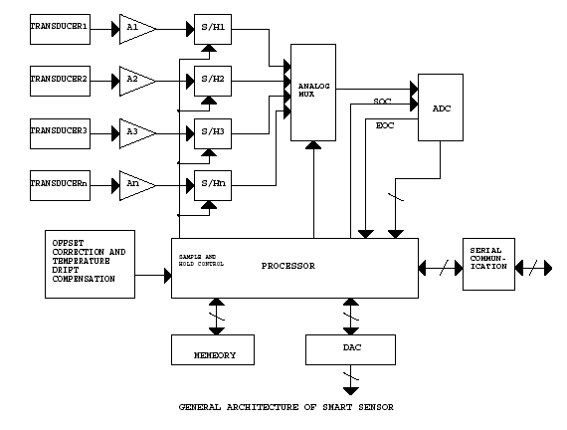

**Description of Smart Sensor Architecture**

Architecture of smart sensor is shown. In the architecture shown A1, A2…An and S/H1, S/H2…S/Hn are the amplifiers and sample and hold circuit corresponding to different sensing element respectively. So as to get a digital form of an analog signal the analog signal is periodically sampled (its instantaneous value is acquired by circuit), and that constant value is held and is converted into a digital words. Any type of ADC must contain or proceeded by, a circuit that holds the voltage at the input to the ADC converter constant during the entire conversion time. Conversion times vary widely, from nanoseconds (for flash ADCs) to

microseconds (successive approximation ADC) to hundreds of microseconds (for dual slope integrator ADCs). ADC starts conversion when it receives start of conversion signal (SOC) from the processor and after conversion is over it gives end of conversion signal to the processor. Outputs of all the sample and hold circuits are multiplexed together so that we can use a single ADC, which will reduce the cost of the chip. Offset compensation and correction comprises of an ADC for measuring a reference voltage and other for the zero. Dedicating two channels of the multiplexer and using only one ADC for whole system can avoid the addition of ADC for this. This is helpful in offset correction and zero compensation of gain due to temperature drifts of acquisition chain. In addition to this smart sensor also include internal memory so that

we can store the data and program required.

**Block Level Design Considerations for Smart Sensor [3]**

Design choice of smart sensor depends on the specific application for which the sensor is required and also related to specific industry. Normally a smart sensor will utilize inputs form one or more sensor elements either to generate an output signal or to generate a correction signals which are applied to the primary output. This includes design of circuitry to take output of raw sensor elements and generate compensated and linearized sensor output.

**7.1 Functions within electronics:**

The smart sensor contains some or all of the following functions

***Sensor Excitation:***

Many a times it is required to alter the sensor excitation over the operating range of a sensor. An example of this is a silicon wheatstone bridge, where the drive voltage is increased with increasing temperature. This is done to compensate for the reduction in sensitivity of the piezoresistors with increase in temperature. A drive stage with temperature dependence can be used which is control by a microprocessor. This will also reduce the calibration time.

***Analogue Input:***

Multiplexing of inputs can be done to avoid duplication of circuit. In multiplexing inputs of same type and range are switched to a common front end. The outputs of sensors are normalized before they are switched and a variable gain stage is included after the multiplexer. This allows the sensitivity variations between the different sensors to be accounted for by a common front-end .In addition to this an offset adjustment is also included in the common front end. The variable gain stage also offers an additional advantage where the input signals are to be sampled by

analog to digital converter (ADC) with fixed reference points. Under such situation gain can be increased at the lower end to increase the sensitivity.

***Data Conversion:***

In case of smart sensor most of the signal processing is done in digital form. This is possible only when we have an ADC along with an anti-aliasing filter. This is because most of the sensor output is in the analog form. Choice of ADC depends on the resolution, bandwidth and complexity of anti-aliasing filter.

***Digital data bus interface:***

The controller embedded in the smart sensor supports communications by digital data bus. The advantages of this are:

Wiring is reduced considerably

Automatic calibration at production can be simplified.

***Monitoring and diagnostic functions:***

In many applications self-test is required. This self-test includes connectivity checking and long-term offset correction.

***Control processor:***

To provide greater flexibility and reduced complexity, a control processor can be used. Control processor can do digital filtering. Another important point is software development. Processor must allow writing codes in higher language as it reduces the development time.

**7.2 Level of integration:**

Though it is possible to integrate smart sensor on a single piece of silicon it is unattractive due to cost and performance. Analog processing, digital logic and non-volatile memory (NVRAM), can all be done on same piece of silicon. But compromise must be made that limit the performance of at least one of these functions.

**Summary of different smart sensors:**

Some of the smart sensors developed at different research institutes are as follow:

***Optical sensor:***Optical sensor is one of the examples of smart sensor, which are used for measuring exposure in cameras, optical angle encoders and optical arrays. Similar examples are load cells silicon based pressure sensors [1].

***Infrared detector array****:* Integrated sensor is the infrared detector array developed at the solid laboratory of the University of Michigan. The Infrared-sensing element was developed using polysilicon –Au thermocouples and thin film dielectric diaphragm to support the thermocouples. On-chip multiplexer was fabricated by using silicon gate MOS processing. This detector operates over a temperature range of 0 to 100 degree centigrade with a 10msec response time. It has a responsiveness of 12V/W.It is a 16\*2 element staggered linear array with one lead of each detector connected to a common ground line and other connected to one of the input of 16\*1 analog multiplexer. This chip also contains a separate calibration thermopile, polysilicon resistors, and diodes and MOS transistors to allow direct measurements of the cold junction temperature both and the thermoelectric power of the polysilicon lines [1].

***Accelerometer:***Accelerometer fabricated at the IBM Research laboratory at San Jose California, which consists of the sensing element and electronics on silicon. The accelerometer itself is a metal-coated SiO2 cantilever beam that is fabricated on silicon chip where the capacitance between the beam and the substrate provides the output signal [1].

***Integrated multisensor:***Integrated multisensor chip developed at the electronics research Laboratory University of California. This chip contains MOS devices for signal conditioning with on chip sensor, a gas flow sensor, an infrared sensing array, a chemical reaction sensor, a cantilever beam, accelerometer, surface acoustic wave vapor sensor, a tactile sensor array and an infrared charge coupled device imager. This chip was fabricated using conventional silicon planer processing, silicon micromachining and thin deposition techniques [1].

8.Anodic bonding

Anodic bonding is a [wafer bonding](https://en.wikipedia.org/wiki/Wafer_bonding) process to seal glass to either silicon or metal without introducing an intermediate layer; it is commonly used to seal glass to silicon [wafers](https://en.wikipedia.org/wiki/Wafer_(electronics)) in electronics and microfluidics. This bonding technique, also known as field assisted bonding or electrostatic sealing,[[1]](https://en.wikipedia.org/wiki/Anodic_bonding#cite_note-WP1969-1) is mostly used for connecting [silicon](https://en.wikipedia.org/wiki/Silicon)/[glass](https://en.wikipedia.org/wiki/Glass) and [metal](https://en.wikipedia.org/wiki/Metal)/[glass](https://en.wikipedia.org/wiki/Glass) through [electric fields](https://en.wikipedia.org/wiki/Electric_field). The requirements for anodic bonding are clean and even wafer surfaces and atomic contact between the bonding substrates through a sufficiently powerful electrostatic field. Also necessary is the use of borosilicate glass containing a high concentration of alkali ions. The [coefficient of thermal expansion](https://en.wikipedia.org/wiki/Coefficient_of_thermal_expansion) (CTE) of the processed glass needs to be similar to those of the bonding partner.[[2]](https://en.wikipedia.org/wiki/Anodic_bonding#cite_note-WFG2003-2)

Anodic bonding can be applied with glass wafers at temperatures of 250 to 400 °C or with sputtered glass at 400 °C.[[3]](https://en.wikipedia.org/wiki/Anodic_bonding#cite_note-GMS+1999-3) Structured borosilicate glass layers may also be deposited by plasma-assisted e-beam evaporation.[[4]](https://en.wikipedia.org/wiki/Anodic_bonding#cite_note-LHM+2010-4)

This procedure is mostly used for hermetic encapsulation of micro-mechanical silicon elements. The glass substrate encapsulation protects from environmental influences, e.g. humidity or contamination.[[2]](https://en.wikipedia.org/wiki/Anodic_bonding#cite_note-WFG2003-2) Further, other materials are used for anodic bonding with silicon, i.e. low-temperature cofired ceramics (LTCC).[[5]](https://en.wikipedia.org/wiki/Anodic_bonding#cite_note-KGH+2010-5)

Overview[[edit](https://en.wikipedia.org/w/index.php?title=Anodic_bonding&action=edit&section=1)]

Anodic bonding on silicon substrates is divided into bonding using a thin sheet of glass (a wafer) or a glass layer that is deposited onto the silicon using a technique such as sputtering. The glass wafer is often sodium-containing Borofloat or Pyrex glasses. With an intermediate glass layer, it is also possible to connect two silicon wafers.[[6]](https://en.wikipedia.org/wiki/Anodic_bonding#cite_note-QDW1996-6) The glass layers are deposited by sputtering, spin-on of a glass solution or vapor deposition upon the processed silicon wafer.[[3]](https://en.wikipedia.org/wiki/Anodic_bonding#cite_note-GMS+1999-3) The thickness of these layers range from one to a few micrometers with spin-on glass layers needing 1 µm or less.[[6]](https://en.wikipedia.org/wiki/Anodic_bonding#cite_note-QDW1996-6) Hermetic seals of silicon to glass using an aluminum layer with thickness of 50 to 100 nm can reach strengths of 18.0 MPa. This method enables burying electrically isolated conductors in the interface.[[7]](https://en.wikipedia.org/wiki/Anodic_bonding#cite_note-SPM+2006-7) Bonding of thermally oxidized wafers without a glass layer is also possible.

The procedural steps of anodic bonding are divided into the following:[[2]](https://en.wikipedia.org/wiki/Anodic_bonding#cite_note-WFG2003-2)

1. Contact substrates
2. Heating up substrates
3. Bonding by the application of an electrostatic field
4. Cooling down the wafer stack

with a process characterized by the following variables:[[8]](https://en.wikipedia.org/wiki/Anodic_bonding#cite_note-Mac1997-8)

* bond voltage UB
* bond temperature TB
* current limitation IB

The typical bond strength is between 10 and 20 MPa according to pull tests, higher than the fracture strength of glass.

Differing coefficients of thermal expansion pose challenges for anodic bonding. Excessive mismatch can harm the bond through intrinsic material tensions and cause disruptions in the bonding materials. The use of sodium-containing glasses, e.g. Borofloat or Pyrex, serve to reduce the mismatch. These glasses have a similar CTE to silicon in the range of applied temperature, commonly up to 400 °C.[[9]](https://en.wikipedia.org/wiki/Anodic_bonding#cite_note-GOWF2005-9)

**9.Temperature Sensor**

**Silicon sensors** are available in a wide variety of designs, outputs, and costs. Temperature ranges are available from the cryogenic (1.4K) to 200°C. With high sensitivity and a nearly linear resistance curve, they are ideal for many applications.

IC versions are available with on-chip signal conditioning for direct voltage or current output to controllers or meters. Because they have memory, IC-types can be very accurately calibrated. They work effectively in multi-sensor environments such as communications networks.

The output value of most IC sensors is proportional with temperature over a specific range. Standard accuracy is usually assigned, but can often be calibrated at a specific temperature. Along with basic temperature control and indication, various temperature compensation functions are often directly incorporated in printed circuits.

Depending on the application, silicon sensors can be designed as an element into probe assemblies or incorporated directly onto [printed circuit](https://www.sciencedirect.com/topics/engineering/printed-circuits) boards in a surface-mount configuration. Care must be taken in the design of circuits employing silicon-based technology as excess current can cause self-heating of the sensing element. This can significantly reduce system accuracy.

Some manufacturers have developed IC designs that can be used in place of thermostats in some applications. They feature factory programmed or user programmable setpoints or [hysteresis](https://www.sciencedirect.com/topics/engineering/hysteresis). They are available in standard Joint Electron Device Engineering Council (JEDEC) configurations.

The operating parameters of the user programmable types are set either through the use of external resistors or are digitally programmed through a two-wire interface with a processor.

## 10.[POROUS SILICON – SENSORS AND FUTURE APPLICATIONS](https://www.sciencedirect.com/science/article/pii/B9780080445281500051)

[View chapter](https://www.sciencedirect.com/science/article/pii/B9780750677295500604)

### PS Chemical Sensors

[PS](https://www.sciencedirect.com/topics/engineering/porous-silicon) sensors for chemical detection can utilize the optical or photoluminescent properties of PS for transduction [61] or, more simply, they can use the PS layer as the framework and electrode for detection. For example, the PS layer could have a reactive or selective layer deposited on it, and then the entire framework would be used as the counter electrode in an [electrochemical cell](https://www.sciencedirect.com/topics/engineering/electrochemical-cell). Bio-chemical sensors cover sensors produced to allow the detection of urea [62], glucose [63], and other biological molecules [64]. Chemical sensors which detect concentrations of either ionic solutions, or non-biological solutions constitute a second distinct group.

Exemplified below is the PS chemical ion sensor, developed by Ben Ali et al. [65]. Here, PS is used as a working electrode in an electrochemical cell. P-type silicon was etched with an HF-ethanol solution, which was subsequently oxidized to form a porous Si–OX structure. This PS surface was used as a framework for the deposition of calix(4)arene, a sensitive material for sodium ion detection. A sensitivity of 240 mV/decade to the concentration of sodium ions is demonstrated with this device. Analysis of wafer resistivity and of the depth of the PS film was used to demonstrate the effect each has on the sensitivity of the device. Further analysis of this sensor explains the Nernstian mechanism of the response in detail [66,67].

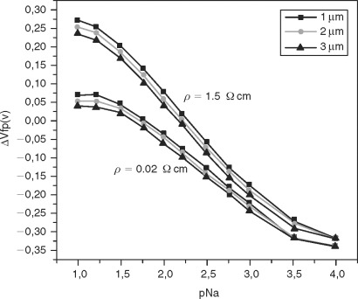

### Sensor Element

The silicon sensor element . A seismic mass and four [flexures](https://www.sciencedirect.com/topics/engineering/flexure) are formed using bulk [micromachining](https://www.sciencedirect.com/topics/engineering/micro-machining) processes. Each of the four beams contains two implanted resistors that are interconnected to form a Whetstone bridge. When the device undergoes acceleration, the mass moves up or down, causing four of the resistors to increase and the other four to decrease in value. This results in an output voltage change proportional to the applied acceleration. The eight resistors are interconnected such that the effect of any off-axis acceleration is canceled.

Silicon top and bottom caps are attached to the section containing the seismic mass and the beams. The silicon caps serve several purposes. Precision gaps are etched into the caps to provide air damping to suppress the resonant peak of the structure. Because the part is critically damped, the frequency response is flat up to several kilohertz with little dependence on temperature. Small elevated stops on the top and bottom caps limit the motion of the mass to a fraction of the deflection at which fracture occurs. The caps also form a chamber around the seismic mass to provide protection during the later stages of manufacturing and its operating lifetime.

Last, the top cap allows testing the accelerometer in the absence of acceleration. When a voltage is applied to a metal electrode on the top cap, an electrostatic force moves the mass toward the top cap. This results in a change in output voltage proportional to the sensitivity and to the square of the applied voltage. It thus is possible to generate an “acceleration” using an external voltage and check the functionality of the mechanical structure as well as the electronics.

## 11.[Porous silicon biosensors for DNA sensing](https://www.sciencedirect.com/science/article/pii/B9780128216774000021)

### Kinetics for real-time sensing

The integration of [microfluidic](https://www.sciencedirect.com/topics/engineering/microfluidics) cells with PSi sensors not only enables studies on diffusion and reaction kinetics of molecules in [nanoscale](https://www.sciencedirect.com/topics/engineering/nanoscale) pores but is also a key step towards the realization of compact PSi lab-on-chip microanalysis systems operating with low analyte volume requirements. Several studies have investigated the performance of PSi DNA sensors utilizing fluidic cells for analyte delivery. For example, De Stefano et al. demonstrated a PSi Bragg reflector microarray integrated with a polydimethylsiloxane (PDMS) microfluidic cell (Rea et al., 2011), and Weiss et al. demonstrated a grating-coupled PSi [waveguide](https://www.sciencedirect.com/topics/engineering/waveguides) with PDMS flow cell (Wei et al., 2012).

In the case of the PSi Bragg reflector array, the PSi array was bonded to the PDMS cell after APTES functionalization and treatment of both the PSi microarray and PDMS surfaces with oxygen plasma. An image of the PDMS integrated microarray with inlet and outlet tube holes is depicted in Fig. 9.21.

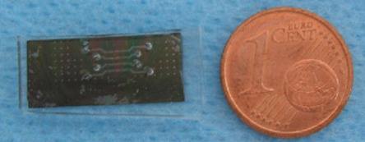

The PDMS cell consisted of four channels 250 μm wide × 10 μm tall × 3 mm long that each addressed a row of four Bragg reflectors in series. It was found that the addition of the flow cell introduced a minor reduction in the reflectance intensity, but did not otherwise significantly affect the key signatures of the measured reflectance spectrum of the PSi array elements. The PSi elements were further functionalized with GA in the flow cell before introducing 24-base probe DNA in a HEPES buffer and then complementary DNA in HEPES using a [peristaltic pump](https://www.sciencedirect.com/topics/engineering/peristaltic-pump). Flushing of excess molecules between molecular attachments is very important for accurate detection in fluidic systems; unbound species in the pores or changing concentrations of molecules in the flow cell lead to erroneous measurements. While there was some variability in the magnitude of the reflectance shift in each element of the array due to non-uniform molecular concentrations as a function of propagation distance in the flow cell, detection of 200 μM complementary DNA was demonstrated; the predicted detection limit is below 1 μm. Calculations were performed using the Navier-Stokes equations and diffusion equations to model fluid motion and mass transport in the pores. It was found that the association rate constant increased with bound probe concentration; when all binding sites are saturated, the association rate is estimated to be near 103 M− 1 s− 1 (Rea et al., 2011).

The grating-coupled PSi waveguide with PDMS flow cell is shown in Fig. 9.22. Here, a single flow channel is utilized. APTES, Sulfo-SMCC, and 16-base probe and target DNA molecules are injected into the microfluidic chamber; constant inlet velocity of the solutions is not maintained since a constant injection pump was not used in these experiments.

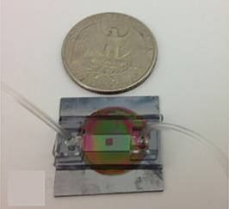

The binding of the molecules to the PSi waveguide is monitored via consecutive angular reflectance measurements. The waveguide resonance angles were plotted over time and are shown in Fig. 9.23.

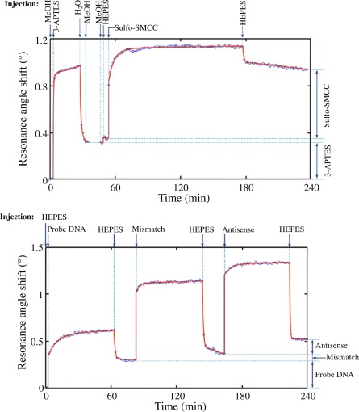

The molecular diffusion and attachment within the pores were tracked by monitoring the resonance angle shift after molecule injection and rinsing steps, respectively. Diffusion, adsorption, and desorption parameters were calculated by mass transport equations with appropriate boundary conditions using the finite element method. The kinetic parameters for each molecule are described in Table 9.2. For 100 μM 16-base pair oligos, a 10-fold decrease of the [diffusion coefficient](https://www.sciencedirect.com/topics/engineering/diffusion-coefficient) and at least a 100-fold smaller adsorption rate constant were observed compared to the attachment on flat surfaces. The slower kinetics were attributed to the steric and electrostatic interactions of the molecules within the pores (Wei et al., 2012).

| **Kinetic parameters** | **3-APTES** | **Sulfo-SMCC** | **Probe DNA** | **Antisense PNA** |
| --- | --- | --- | --- | --- |
| **D (m2·s− 1)** | 5.41 × 10− 9 | 2.442 × 10− 9 | 9.542 × 10− 11 | 9.57 × 10− 11 |
| **Kad (M− 1·s− 1)** | 0.02958 | 0.1274 | 5.641 | 4.442 |
| **Kdes (s− 1)** | 7.652 × 10− 5 | 1.748 × 10− 5 | 7.4 × 10− 6 | 1.422 × 10− 5 |

The investigation of mass transport and real-time measurements in these initial PSi-microfluidic integration experiments is an important step towards understanding the advantages and limitations of future PSi DNA lab-on-chip sensors (Rea et al., 2011; Wei et al., 2012). Recent work has modeled diffusion and binding kinetics in PSi sensors (Arshavsky-Graham, Boyko, et al., 2020; Zhao et al., 2016). For most optical measurement configurations, detection of molecules in a fluidic environment decreases the change in [refractive index](https://www.sciencedirect.com/topics/engineering/refractive-index) upon molecular binding in the pores (i.e., the refractive index of typical molecules is closer to that of a fluidic environment rather than air ambient in the pores) and therefore reduces the detection sensitivity. Moreover, in multi-layered PSi structures, the resulting decrease in refractive index contrast between adjacent PSi layers due to a fluidic environment reduces the electric field confinement and sharpness of measured optical features, which can therefore further compromise the measured molecular detection limit. However, higher concentrations of molecules, which can be more easily achieved in the low analyte volumes needed in microfluidic channels, can more rapidly diffuse into nanoscale pores and lead to faster sensor response times for PSi-microfluidic sensor systems.

## 12.[Biometric Market Forecasts](https://www.sciencedirect.com/science/article/pii/B9781856173940500086)

**Market Developments**

This flexible technology allows fingerprint suppliers to be active in most of the horizontal markets, except for surveillance. They have also found success in all the vertical markets.

In particular, the vast majority of IT security installations over the last year were based on fingerprint recognition technology – and there have been numerous health sector installations using fingerprint [biometrics](https://www.sciencedirect.com/topics/engineering/biometric) in the run up to the USA’s HIPAA regulations which come into force in 2003.

Meanwhile some computer manufacturers have introduced PCs or laptops with fingerprint technology, such as Authentec’s link up with Acer America and STMicroelectronic’s connections with Samsung.

Many nationwide ID systems are based on AFIS (automated fingerprint identification system) installations. AFIS installations fall beyond the scope of this report, as they are generally massive systems where the [biometric](https://www.sciencedirect.com/topics/engineering/biometric) matching engine is only a small part of the overall infrastructure. (AFIS checks are also not performed in real-time, so do not fall under the true definition of a biometric system.)

Many of the large government schemes using biometrics around the world do use fingerprint technology in a true biometric sense, however. This is particularly notable with voting-applications, where a common scenario is for ID cards to be issued with a person’s biometric identifier embedded within, which is subsequently checked on polling day.

New legislation will likely provide a lot of potentially lucrative contracts for fingerprint vendors. For example, the Driver’s License Modernisation Act in the USA calls for the use of fingerprint templates to be used. One reason for the selection of fingerprint technology was said to be the low cost of the readers, which would have to be deployed in high numbers if the legislation was passed. Asylum seeker legislation across the globe is also backing fingerprint biometrics to facilitate their efficient processing at ports of entry and beyond.

#### Pricing

The price of fingerprint sensors has dropped significantly over the last two years – in particular the silicon sensors. Pricing is not an easy issue, however, as the devices fluctuate in price depending on the number ordered.

Silicon sensors are, for example, available at around US$10 for orders of 500,000 or more, some manufacturers claim. These fantastic quantities are not being realised in the industry yet, however. A more likely order size is 1000–10,000 sensors and at this level a price tag of closer to US$20-50 is more realistic.

Importantly, the price of the sensors has now come down to much more acceptable levels by manufacturers of mass consumer products, so removing one more obstacle from this technology becoming commonplace. (Mobile phone manufacturers’ reluctance to include biometrics until banking applications become more widespread is a remaining obstacle.)

Although silicon technology is becoming ever more competitive in terms of price and size, optical sensors will remain competitive for some time yet. This is especially true in the larger optical reader range, which is necessary for forensic quality readings in applications, such as civilian ID. Optical sensors still perform reasonably well on price too, at well under US$100 for a typical sensor. Optical sensor robustness is also another major advantage.

#### Other factors

There have been a number of other developments within the fingerprint sector that could have a bearing on the industry as it develops over the next few years. One of the most significant is the announcement made in 2002 by Identix, one of the [optical sensor](https://www.sciencedirect.com/topics/engineering/optical-sensors) market leaders.

Identix has pulled out of the low-cost optical sensor market and instead will adapt its verification software to also work with silicon sensors. It said that the falling price of silicon sensors, combined with their increasing stability and smaller sizes, makes them viable alternatives. This market exit for strategic reasons is a blow for optical sensor proponents.

Whether this strategic change will signal more optical sensor defections is yet to be seen. There has certainly been no obvious let up in demand for optical sensors according to manufacturers.

## 13.[DETECTION | Smart Pixel Arrays](https://www.sciencedirect.com/science/article/pii/B0123693950008083)

### Extension of the Spectral Sensitivity Range

The spectral sensitivity of silicon is essentially restricted to the spectral wavelength range between 0.1 and 1,100 nm. With a suitable choice of materials that cover the silicon sensor's surface, this sensitive wavelength range can be extended. For high-energy radiation, scintillator materials are employed, capable of converting incident high-energy photons into a proportional number of visible photons. Scintillators render smart image sensors particularly sensitive in the UV (300–400 nm), deep UV (below 300 nm), X-ray (0.002–1 nm), and gamma ray (below 0.002 nm) spectral region. Typically, the scintillator materials are fabricated as platelets that are glued on the surface of the produced CMOS/CCD image sensor.

The extension of the sensitive [spectral range](https://www.sciencedirect.com/topics/engineering/spectral-range) to the infrared can be achieved with semiconductor materials with smaller energy bandgaps than silicon. Examples include Ge, SiGe, SiC, PtSi, IrSi, InAs, InGaAs, or InGaAsP. Typically, these materials are deposited on the produced CMOS/CCD image sensor in an ultra-high vacuum environment. An alternative is the use of bump-bonding, with which the CMOS/CCD image sensor can be connected to a small-bandgap material chip at each pixel site. With these technologies, silicon-based smart pixel arrays become sensitive to wavelengths of several microns.

## 14.[Introduction to MEMS Devices](https://www.sciencedirect.com/science/article/pii/B9780444516169500023)

Before the sensor chips can be put into practical applications, they must be encapsulated. An example of the encapsulated pressure [transducer](https://www.sciencedirect.com/topics/engineering/transducers) is shown in Fig. The silicon sensor chip is first electrostatically bonded to a glass plate with a hole at center. The chip-glass combination is then mounted onto the base of a package (also with a hole at center). Then, pads on the chip are electrically connected to the leads of the package by wire-bonding. A cap with an input port is then hermetically sealed to the base of the package so that the pressure to be measured can be applied through the input port of the cap.

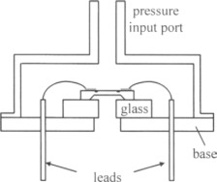

To meet different application needs, [pressure transducers](https://www.sciencedirect.com/topics/engineering/pressure-probe) can be packaged to form three types of devices. They are gauge pressure transducers (GP), absolute pressure transducers (AP) and [differential pressure transducers](https://www.sciencedirect.com/topics/engineering/differential-pressure-transducer) (DP). The [pressure transducer](https://www.sciencedirect.com/topics/engineering/pressure-probe) shown in Fig is a gauge pressure transducer. This kind of pressure transducer measures a pressure [measurand](https://www.sciencedirect.com/topics/engineering/measurand) with reference to the environmental pressure around the device.

An [absolute pressure transducer](https://www.sciencedirect.com/topics/engineering/absolute-pressure-transducer) measures a pressure measurand with reference to an absolute reference pressure. The reference pressure is usually a vacuum so that it is not temperature dependent.

A differential pressure transducer measures the difference between two pressure measurands. Therefore, a differential pressure transducer has two input ports for the two pressures. Generally, the sensor chips for the three types of pressure [transducers](https://www.sciencedirect.com/topics/engineering/transducers) are similar, but the packaging techniques are different.

According to the brief description given above, the analysis and design of a piezoresistive pressure transducer are based on much theory, including the stress distribution in a [diaphragm](https://www.sciencedirect.com/topics/engineering/diaphragms) caused by pressure and the piezoresistive effect of silicon.

## 15.[Security, Privacy and Risk Management](https://www.sciencedirect.com/science/article/pii/B978185617417650008X)

Creating a [biometric](https://www.sciencedirect.com/topics/engineering/biometric) template on a smart card requires the capture of a biometric during enrolment and the creation of a template . This can be achieved via an optical or silicon sensor for fingerprints, microphone for speaker verification or camera for face recognition. The integrity of this process is important to ensure the authenticity of the acquired biometric. Creation of the biometric template requires an [encryption](https://www.sciencedirect.com/topics/engineering/cryptography) component and a signature component. Encryption ensures that nobody has unauthorized access to the template data stored on the card. Signing the template ensures that no unauthorized tampering of the [biometric data](https://www.sciencedirect.com/topics/engineering/biometric-data) on the card can take place. This involves creating a unique code that is stored along with the data. This code will change if the data has been tampered with. Once the biometric has been acquired, the smart card provides a way of storing the biometric template so that it cannot be tampered with or viewed without authorization, by securely storing and generating cryptographic keys. Smart cards with a cryptographic capability allow the generation of the keys on the card, meaning that the key integrity cannot be compromised without breaking the cards security. Storage of the template is usually in a standard format such as International [Civil Aviation](https://www.sciencedirect.com/topics/engineering/civil-aviation) Organization (ICAO) doc 9303 or AMVMA.

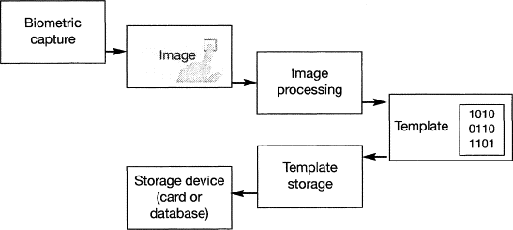

## 16.[Sensor Materials, Technologies and Applications](https://www.sciencedirect.com/science/article/pii/B9780080965321013091)

Schabmueller et al. developed and tested miniaturized sensor for continuous lactate measurement in saliva (168). The sensor was fabricated using silicon [microfabrication](https://www.sciencedirect.com/topics/engineering/microfabrication) technologies. Capillary blood and saliva samples were obtained during standardized ergometer experiments for testing the silicon sensor. Next, the salivary lactate concentrations were detected using the sensor and compared to photometrically obtained data from a lab-automate. Furthermore, a comparison was made between the saliva data and standard capillary blood lactate concentrations measured through a pocket photometer. Lactate concentration versus load graphs were plotted and compared in a visual manner. The results demonstrated very similar progress. This new technique allows a location-independent permanent real-time measuring of the lactate concentration during exercise.

**17.Static Characteristics of Sensors**

The static characteristic of the sensor refers to the relationship between the output and the input of the sensor for the static input signal. Because both input and output are independent of time at this time, the relationship between them is that the static characteristics of the sensor can be described by an algebraic equation without time variables, or by using input as abscissa and output as longitudinal coordinates. The main parameters that characterize the static characteristics of the sensor are linearity, sensitivity, hysteresis, repeatability, drift and so on.

(1) Linearity: refers to the degree to which the actual relationship curve between sensor output and input deviates from the fitting line. It is defined as the ratio of the maximum deviation between the actual characteristic curve and the fitting straight line in the full range to the output value of the full range.

(2) Sensitivity: Sensitivity is an important indicator of static characteristics of sensors. It is defined as the ratio of the increment of output to the corresponding increment of input that causes the increment. Sensitivity is expressed by S.

(3) Hysteresis: The phenomenon that the input-output characteristic curve does not coincide with the output characteristic curve becomes hysteresis when the input of the sensor changes from small to large (positive stroke) and from large to small (reverse stroke). For the input signal of the same size, the positive and negative stroke output signals of the sensor are different in size. This difference is called hysteresis difference.

(4) Repeatability: Repeatability refers to the degree of inconsistency in the characteristic curve of the sensor when the input varies continuously and repeatedly over the whole range in the same direction.

(5) Drift: Sensor drift refers to the change of sensor output over time when the input is constant. This phenomenon is called drift. There are two reasons for the drift: one is the sensor’s own structural parameters; the other is the surrounding environment (such as temperature, humidity, etc.).

**18.Dynamic characteristics of sensors**

The so-called dynamic characteristics refer to the output characteristics of the sensor when the input changes. In practical work, the dynamic characteristics of the sensor are often expressed by its response to some standard input signals. This is because the response of the sensor to the standard input signal can be easily obtained by experimental method, and there is a certain relationship between the response of the sensor to the standard input signal and its response to any input signal. The latter can be inferred by knowing the former. The most commonly used standard input signals are step signal and sinusoidal signal, so the dynamic characteristics of the sensor are often expressed by step response and frequency response.

Sensor linearity

Usually, the actual static characteristic output of the sensor is a curve rather than a straight line. In practice, in order to make the instrument have uniform calibration reading, a fitting straight line is often used to approximate the actual characteristic curve. Linearity (non-linear error) is a performance index of this approximation degree.

There are many ways to select the fitting line. If the theoretical straight line connected with zero input and full range output points is used as the fitting line, or the theoretical straight line with the least square deviation of each point on the characteristic curve is used as the fitting line, the fitting line is called the least square fitting line.

Sensitivity of Sensors

Sensitivity refers to the ratio of output change (y) to input change (x) of the sensor under steady-state operation.

It is the slope of the output-input characteristic curve. If there is a linear relationship between the output and input of the sensor, the sensitivity S is a constant. Otherwise, it will vary with the input.

The dimension of sensitivity is the dimension ratio of output to input. For example, if the output voltage of a displacement sensor changes to 200 mV when the displacement changes 1 mm, its sensitivity should be expressed as 200 mV/mm.

When the output and input dimensions of the sensor are the same, the sensitivity can be understood as an amplification factor.

Higher measurement accuracy can be obtained by improving sensitivity. However, the higher the sensitivity, the narrower the measurement range and the worse the stability.

Resolution of sensor

Resolution refers to the ability of the sensor to sense the smallest change in the measured value. That is, if the input changes slowly from a non-zero value. When the input change value does not exceed a certain value, the output of the sensor will not change, that is, the sensor can not distinguish the change of the input. Only when the change of input exceeds the resolution will the output change.

Generally, the resolution of the sensor varies from point to point in the full range, so the maximum change value of the input which can make the output step change in the full range is often used as the index to measure the resolution. If the above indicators are expressed as percentage of full range, they are called resolution. The resolution is negatively correlated with the stability of the sensor.

## 19.Digital Sensors

Digital sensors are the kind of electrochemical or [electrical](https://www.watelectrical.com/what-is-electrical-conductivity-working-principle-formula-applications/) sensors where the information is converted to digital form and then transmitted. The output of a digital sensor is the distinct digital signal of the quantity which is being measured. And the measured quantities might be of conductivity, pH value, redox potentials, and many others. The output is in the form of 1’s and 0’s where ‘1’ represents ON condition and ‘0’ represents OFF condition. This corresponds that a digital signal generates distinct (non-continuous) values and the output is considered either as a single “bit”, (serial transmission) or the combination of multiple bits called “byte” and is called (parallel transmission).

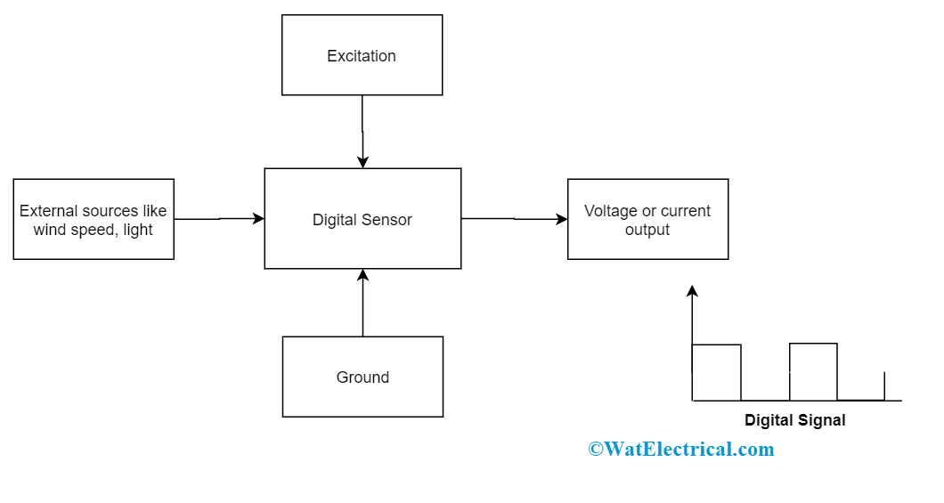

**Basic Digital Sensor**

The below example explains the output produced by a light sensor in digital form:

In the diagram, the rotating shaft speed is known with the help of a digital LED light sensor. Here, the place of the disk is positioned to the revolving shaft which has transparent slots internal to the disk design. As both the shaft and disc rotational speed are the same, every slot in the disk passes through the sensor thus generating output pulses in the form of logic ‘1’ and logic ‘0’ (the digital signal).

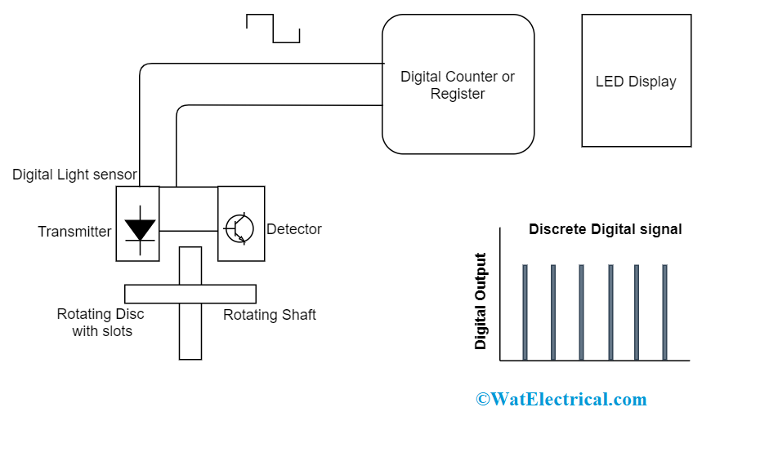

**Digital Sensor Output**

The generated pulses are then transmitted to the register in the counter and then to the output which displays the number of shaft revolutions. The number of output pulses for every rotation can be increased by augmenting the number of disk slots. The benefit of this increment is that higher accurateness and resolution can be obtained and minimal revolutions can also be observed easily. So, this kind of sensor construction is mainly utilized for controlling positions of the slots in the disk where this acts as a reference position.

So, in comparison to analog signals, discrete signals are with extensive accurateness and they can be calculated even at increased clock speeds. The exactness of the digital pulse is linear to the bits that are utilized for quantity measurement.

For instance, a processor of 8 bits, will generate an accuracy of nearly 0.390 percent, whereas with a 16-bit processor and accuracy of almost 0.0015 percent can be achieved. So, this accurateness can be asserted as digital quantities and these are many times quicker than that of analog signals.

### Types of Digital Sensors

Digital sensors are also classified as many types and few of those to be described as follows:

* Digital accelerometers
* Digital [temperature](https://www.watelectrical.com/types-of-thermocouples-with-temperature-ranges-color-codes/) sensor

#### Digital Accelerometer

Digital accelerometers generally make use of PWM (pulse width modulation) to generate output pulses. It corresponds that the output is a square wave of corresponding frequency and the time for which the voltage is high is linear to the amount of time taken for acceleration.

When a BASIC stamp or any kind of microcontroller is used as digital inputs, then the digital accelerometer is the preferred one to generate output.

**Features of Digital Accelerometers**

* The data rates can be selected by users
* Operates using FIFO/FILO memory buffers
* One can achieve digital high-pass filter outputs
* Minimal [power](https://www.watelectrical.com/powerfactor-importance-methods-to-improve-examples/" \t "_blank) consumption
* Solderability can be done without using lead
* Exceptional temperature performance
* Extensive shock survivability
* Factory programmable offset and compassion

**Applications**

* Implemented in mobile phones and other internet equipment’s
* Used in-game controllers and computer components
* Used in the health care industry
* Also implemented in personal navigation equipment

#### Digital Temperature Sensors

These are silicon dependent temperature sensors where the output is the accurate digital representation of the measured temperatures. These devices are designed to read the temperature ranges from 00C to that of 700C and with this, an output of nearly ±0.50C accurateness can be achieved. Whereas, packaged components are designed for extensive ranges which means for -550C to 1750C, the accuracy is ±10C and for -1300C to 1500C, the accuracy is ±1.50C.

**The flexibility of Digital Temperature Sensors**

In general, registers are programmed with the temperature levels of high, low, and medium. The calculated value is related to that of these temperature limits and either increased or decreased values apart from these limits prompts corresponding pins on the package. So, through the serial bus, the calculated temperature value is transmitted to the system controller which is even utilized for configuration.

On the other hand, these digital temperature sensors operate basically as thermostats.

**Example:**

DS18B20 is a kind of single wired digital temperature sensor. Each of these sensors is wit a 64-bit serial number engraved into it which permits for an extensive number of sensors to be utilized on a single data bus. The features of this sensor are as follows:

* This singled wired sensor needs only one port for communication purposes.
* The feature called multidrop ability streamlines distributed temperature sensing functionalities.
* No additional components are required
* It can be powered up through data lines
* The operating power supply ranges from 3.0V to 5.5V
* It can measure temperatures ranging between -550C to +1250C providing an accuracy of -100C to +850
* The resolution of a thermometer is customizable selecting from 9 -12 bits.
* Through alarm search command detects and addresses the devices where the temperature range is external to that of programmed limits.

With the one can measure the temperature ranges of air, water, and even the ground temperature.

### ****Use of digital sensors****

* Measuring signals are simply converted to digital signal internal to the sensor
* Digital sensors have no complication for humidity and corrosion
* These can be calibrated separately from the system
  1. Conclusions

In conclusion, silicon is very suitable material for fabrication of smart sensors. But still a lot of research is required to get benefits of the smart sensor, but from the experience of already existing devices, we can expect that in the coming decade a large number of successful smart sensors will emerge.

21.References

J. M. Giachino, “Smart sensors,” Sensors and actuators, 10(1986) 239-248.

S. Middelhoer and A.C. Hoogerwerf, “Smart sensors when and where,” Sensors and Actuators, 8(1985) 39-48.

M. Bowen, G. Smith, “Considerations for the design of smart sensors,” Sensors and Actuators, A 46- 47(1995) 516-520.

J.M. Riviere, D. Luttenbacher, M. Robert, J.P. Jouanet, “Design of smart sensors: towards an integration of design tools,” Sensors and Actuators A46-47 (1995) 509-515.

G. Smith, M. Bowen, “Considerations for the utilization of smart sensors,” Sensors and Actuators A 46-47(1995) 521-524.

J.G.Rocha, C. Couto, J.H. Corria, “Smart load cells: an industrial application,” Sensors and Actuators, 85 (2000) 262 –266.

G.D. Graaf, R.F. Wolffanbuttel, “Smart optical sensor systems in CMOS for measuring light intensity and color,” Sensors and Actuators, A67 (1998) 115-119.

Wai-chi Fang , “A low power high speed smart sensor design for space exploration missions,” Sensors and Actuators(small satellite for space exploration missions),Vol. 46,pp 241-250(2000)

D. Martinez, D. Esteve, “Adaptive quantization and fault detection in smart sensors,” Sensors and Actuators, 46-47(1995)530-533.