A

PROJECT REPORT

ON

“SMART SENSOR”

As a Partial Requirement for the Degree of

BACHELOR OF COMPUTER APPLICATION

[B. C. A]

Submitted to



C.B PATEL COMPUTER COLLEGE & J. N. M. PATEL SCIENCE COLLEGE,

BHARTHANA,VESU,SURAT

Affiliated to

VEER NARMAD SOUTH GUJARAT UNIVERSITY, SURAT.

ACADEMIC YEAR: 2021 – 2022

Guided by: Submitted by:

ASST. PROF JENISH BHAVSAR RAJPUT ANKITSINGH(EXAMNO.XXX)

-

**ACKNOWLEDGEMENT**

Success in such a comprehensive project cannot be achieved single-handled. It is team effort that sails the ship to the coast. So we would like to express our sincere thanks to all the dignitaries who were involved in making this project a great joy and turning it into successful piece of work.

We would like to take opportunity to thank our college **C.B. Patel Computer College**, Surat for giving us this tremendous opportunity to work in the real-time project.

**Mrs. Jenish Bhavsar**,our professor and project co-ordinator, has been very prudent to us throughout our college studies. She is the person who has been giving direction to our work and the shape to our imagination. We express our regards to her from the core of our heart.

We would also like to thank all our professors who are always ready to give best guidance. They are the individuals who give solutions whenever required.

We would also like to acknowledge all **our friends** and colleagues, team members for their help and encouragement from time to time. The constant support and encouragement of our friends deeply appreciates. The project indeed gave challenging and exhilarating experience in designing and developing the required system.

Finally we would like to thank **our Parents** for their support throughout the project. We owe a special debt to our family & friends for their supports blessing and encouragement for me.

THANKS ALL**………**

**INDEX**

|  |  |  |
| --- | --- | --- |
| Sr No. | Topic | Page No. |
| 1. | **Introduction** |  |
| 2. | **Objective of Project** |  |
| 3. | **Project Category** |  |
| 4. | **Tools/Environment Used** |  |
| 5. | **Analysis Report** |  |
|  | 5.1 Current System |  |
|  | 5.2 Drawback/Limitation Of Current System |  |
|  | 5.3 NeedsForNewSystem |  |
|  | 5.4 Requirement Specification |  |
|  | 5.5 Proposed System |  |
|  | 5.6 Advantages of proposed system |  |
|  | 5.7 Data Flow Diagram |  |
|  | 5.8 Process Specification |  |
|  | 5.9 Data Dictionary |  |
|  | 5.10 Table Structure |  |
| 6. | **Testing Report** |  |
|  | 6.1 Testing Issues |  |
|  | 6.2 Test Case Design |  |
| 7. | **Limitation Of System** |  |
| 8. | **Future Enhancement Of The Project** |  |
| 9. | **Appendix** |  |
| 10. | **References** |  |
|  |  |  |
|  |  |  |
|  |  |  |
|  |  |  |
|  |  |  |
|  |  |  |
|  |  |  |

## 

## CHAPTER 1

## INTRODUCTION

1. INTRODUCTION

* Today the internet and its boom have created a new economic scenario that not. Only stresses on the classical concept of the “product” but also on the modern Concept of “service”.
* It is this level of service that dicates whether a commercial venture will succeed Or not in the market.
* To provide a high accessibility of service we will design the online clothes shopping Website,so that potential customers need not to go a physical shop or mall to buy Products or service.
* They just need to online to complete their purchase. Unlike the prevailing “brick and mortar” shops which have physical existence,we will operate solely from cyberspace.
* Most current system have a physical foundation that is the root cause to quite a number of problems. By maintaining multiple store fronts , itself being an expensive

Proposition,store prices are forced to rise.

* Thus, by using our product , our clients ‘ competitors are at a disadvantage because

Their costs are significantly higher than our costs , allowing our clients to sell the same goods at a lower price.

* As people become more accustomed to using the internet , they view ordering

Products and services online as a time-saving and cost-saving experience , which

Is the very essence of our online clothes shopping system.

* Maintaining the deliverable goods as well as services through single or multiple

Windows is also on the agenda.

# PROJECT PROFILE

|  |  |
| --- | --- |
| **Project Title** | **Online clothes shopping** |
| **Project Definition** | The online clothes shopping is the shopping website. In this customers can purchase products from the mall using any electronic device. |
| **Operating System** | Windows 10 |
| **Front End** | PHP |
| **Back End** | MySql |
| **Project Duration** | 3 Months |
| **Guide** | Prof : JENISH BHAVSAR |
| **Submitted By** | Rajput AnkitSingh |

## CHAPTER 2

# OBJECTIVE OF PROJECT

1. OBJECTIVES OF PROJECT

* The main objective of online clothes shopping system is to provide the product at the door step of the customers.
* This project is aimed at developing an online clothes shopping system .
* We are designing online shopping website of particular mall,so that customers need
* not to go to a physical shop or mall individually for different types of product or services. They can easily do online shopping from this website and get their purchase done.
* Shopping has long been considered a recreational activity by many shopping online Is no exception.
* The goal of this application is to develop a web based interface for online retailers.
* The system would be easy to use and hence make the shopping experience pleasant for the user.
* The objective of this application is to develop an easy to use web based interface Where users can search for products,view a complete description of the products and order the products.
* A search engine that provides an easy and convenient way to search for Products specific to their needs.
* The search engine would list a set of products based on the search term and the user can further filter the list based on various parameters.
* Using the website user can search the products and view the details and image of products.
* user can create a wishlist.

## CHAPTER 3

# PROJECT CATEGORY

# 3.PROJECT CATEGORY

* Online clothes shopping system is a web based application.
* The Main module of the online clothes shopping system is the admin panel and user
* Panel.
* The admin panel and user panel is made in php core . while in user panel ,the javascript and ajax is used for better management of the website.
* Ajax is also used in searching the product according to the category.

## CHAPTER 4

# TOOLS/ENVIORNMENT USED

# 4 .TOOLS/ENVIRONMENT USED

* Mysql is a relational database system that is used to store information.Mysql can store

types of data from something as tiny as a single character to as large as complete files

or graphics.

* Although it can be accessed by most programming languages, it is often coupled with

PHP because they work together with ease.

* Information stored in a Mysql database hosted on a web server ca be accessed from

Anywhere in the world with a computer.

* This make it a good way to store information that needs the ability to change over time

,but also needs to be accessed over the net. Some examples that can utilize Mysql are

a web message board or a customer’s shipping status.

* A website that uses Mysql may include web pages that access information from a database . These pages are often reffered to as “dynamic,” meaning the content of each

page is generated from database as the page loads. Website that use dynamic web page

are often referred to as database-driven websites.

* Many database-driven website that use Mysql also use a web scripting language like php

to accesss information from the database.

* PHP and Mysql complement each other to do with neither can do alone.PHP can collect

data , and Mysql can in turn store the information.

* PHP can create dynamic calculations, and Mysql can provide it with the variables it uses .

PHP can create a shopping cart for you web store,but Mysql can then keep the data in a

Format PHP can use to create receipts on demand , show current order status , or even

Suggest other related products.

* The beauty of php as a language is that it is designed to be used along with HTML.You

Can use PHP right inside your already existing HTML content , or put HTML tags right

Inside your PHP coding . when learning PHP you are not Making your existing HTML

Knowledge obsolete , you are instead adding to it to give it more functions and abilities.

* Although PHP and Mysql can each be used independently ,when you put them together it opens up countless possibilities for your site.

# PHP

* PHP is a server side scripting language designed for web development but also used as

a general-purpose programming language.

* Originally created by Rasmus Lerdorf in 1995, the reference implementation of PHP is now

produced by the php group.

* While PHP originally stood for personal Home page , it is now said to stand for PHP : Hypertext Pre-processor , a recursive acronym.
* PHP code is interpreted by a web server with a PHP processor module with generates

the resulting web page: PHP commands can be embedded directly into an HTML source

document rather than calling an external file to process data .

* PHP can be deployed on most web server and also as a standalone shell on almost every operating system and platform , free of charge.
* PHP/F1 2-A rewrite came with PHP/F1 2 in 1997,but at that time the development Was almost solely handled by Rasmus.
* PHP 3 – Zeev and Andi decided to completely rewrite the scripting language. They then teamed up with Rasums to release PHP 3, and along also came a new name: PHP : Hypertext Pre-processor, to emphasize that PHP was a different product and not only suitable for personal use.
* PHP 4 - In late 1998, Zeev and Andi looked back at their work in PHP 3 and felt could Have written the scripting language even better , so they started yet another rewrite . while PHP 3 still continously parsed the scripts while executing them. PHP 4 came with a new paradigm of “compile first , execute later.” The compilation step does not compile PHP script into machine code ; it instead compiles them into byte code the new heart of PHP 4.
* PHP 5 –soon after ,the demand for more common object-oriented features increased immensely , and Andi came up with the idea of rewriting the object-oriented part of the zend Engine . Zeev and Andi wrote the “Zend Engine ||: Feature overview and Design “ document and jumpstarted heated discussion about PHP’s future.

# ENIVORNMENT DESCRIPTION

The Hardware and Software required for developing a website are described Below:

**HARDWARE REQUIRRMENT**

|  |  |
| --- | --- |
| PROCESSOR | Intel(R) Core(TM) i5-8250U CPU @ 1.60GHz 1.80 GHz |
| RAM | 8.00 GB (7.90 GB usable) |
| HARD DISK | 2 TB |

**SOFTWARE REQUIRRMENT**

|  |  |
| --- | --- |
| OPERATING SYSTEM | Windows 10 |
| WEB BROWSER | Chrome,Microsoft Edge |
| SOFTWARE | Microsoft VS Code |

## CHAPTER 5

# ANALYSIS REPORT

# .ANALYSIS REPORT

**5.1 CURRENT SYSTEM**

* There is no current Online clothes shopping system such that to buy a products sitting in home or anywhere.
* According to the current system,user have to physically go to the mall to purchase the product the products from the shop.

**5.2 LIMITATION OF CURRENT SYSTEM**

* The main limitation of current system is ,as people have to go physically to buy the products its very time consuming process.
* The cost of travelling to the mall to buy products will be costly.
* If online shopping is possible then the user can view all the products and the shops of the mall and purchase from any shop but in the current system

Users can’t view all the products of the shop and it’s a time consuming process to view the products physically.

* 1. **NEEDS FOR NEW SYSTEM**
* As the current system is time consuming and costly to go there and purchase the products people will refer this less.
* As compared if there is an online website to purchase the products,people will refer more to this system.
* The Online clothes shopping which saves the time and money.
* We will include following functionality in this websites.
* Floor-wise shops of the mall.
* Add to cart option.
* Payment via Paypal method.
* Shopping via shop-wise and category-wise.

# 5.4 REQUIREMENT SPECIFICATION

* Our goal is to make a website that allow the customers to shop virtually using the internet and allow the customer to buy the product and items .
* If a user is viewing a website who is not registered then he can register to site by filling a Registration form.
* Unregistered user can search the category wise products.
* Unregistered user can view the detail of products.
* If a user is registered to the site then he/she can search product by keyword,description, and category or product name.
* Admin can add new products.
* Only admin can add new category of product.
* Register user/Administrator can view his /her profile and edit his/her personal details and profile picture.
* Admin can edit his /her uploaded product .
* Customer can Add/Edit his /her own wishlist.
* Admin can manage product list,category list, dashboard and can view wishlist and order list of user.

# 5.5 PROPOSED SYSTEM

* The proposed system is a web based application which can be accessed by customer from anywhere around the world.
* This system offers customers to purchase the products sitting anywhere.
* The shops in the mall with the details of particular shop and particular products can be seen by the customers.
* The main objective of this project is to sell the products online and even customers can purchse it online using any electronic equipment .
* The system contains many featurs .
* It also includes features of showing the top 10 products that are added by the Admin.
* Customer can make review and rating on the products.
* Customer’s orders are send to Admin then it’s in the hand of Admin to make it confirm,reject or pending.

# ADVANTAGES OF PROPOSED SYSTEM

* The main advantage of this system is as the customers don’t want to go to particular mall to buy the products. Thus it is time saving process.
* The customers can view the products if the customers are once registered.
* Customer can get the details of product as required and even customers can buy the products of particular colour according to the colour he likes.
* It is ease in use for anyone . customers once registered can view all the details.
* It is save the lot of time , money and labour.
* This system is online so it is available all the time(24*7)for customer for book .
* Maintenance is easy and performance is good.

# 5.7 DFD

# CONTEXT LEVEL DFD FOR ONLINE CLOTHES SHOPPING

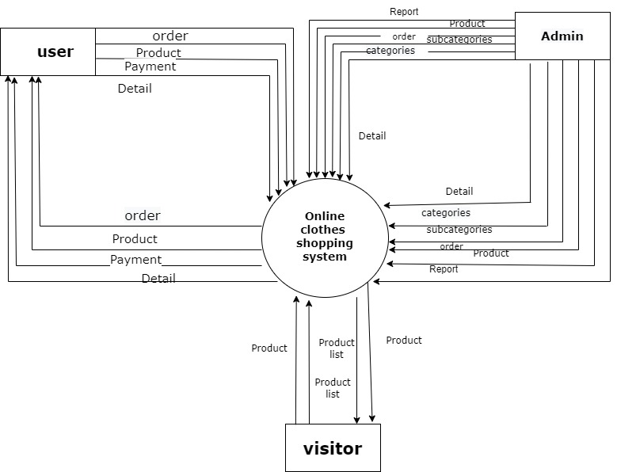

# 1ST LEVEL DFD FOR ADMIN

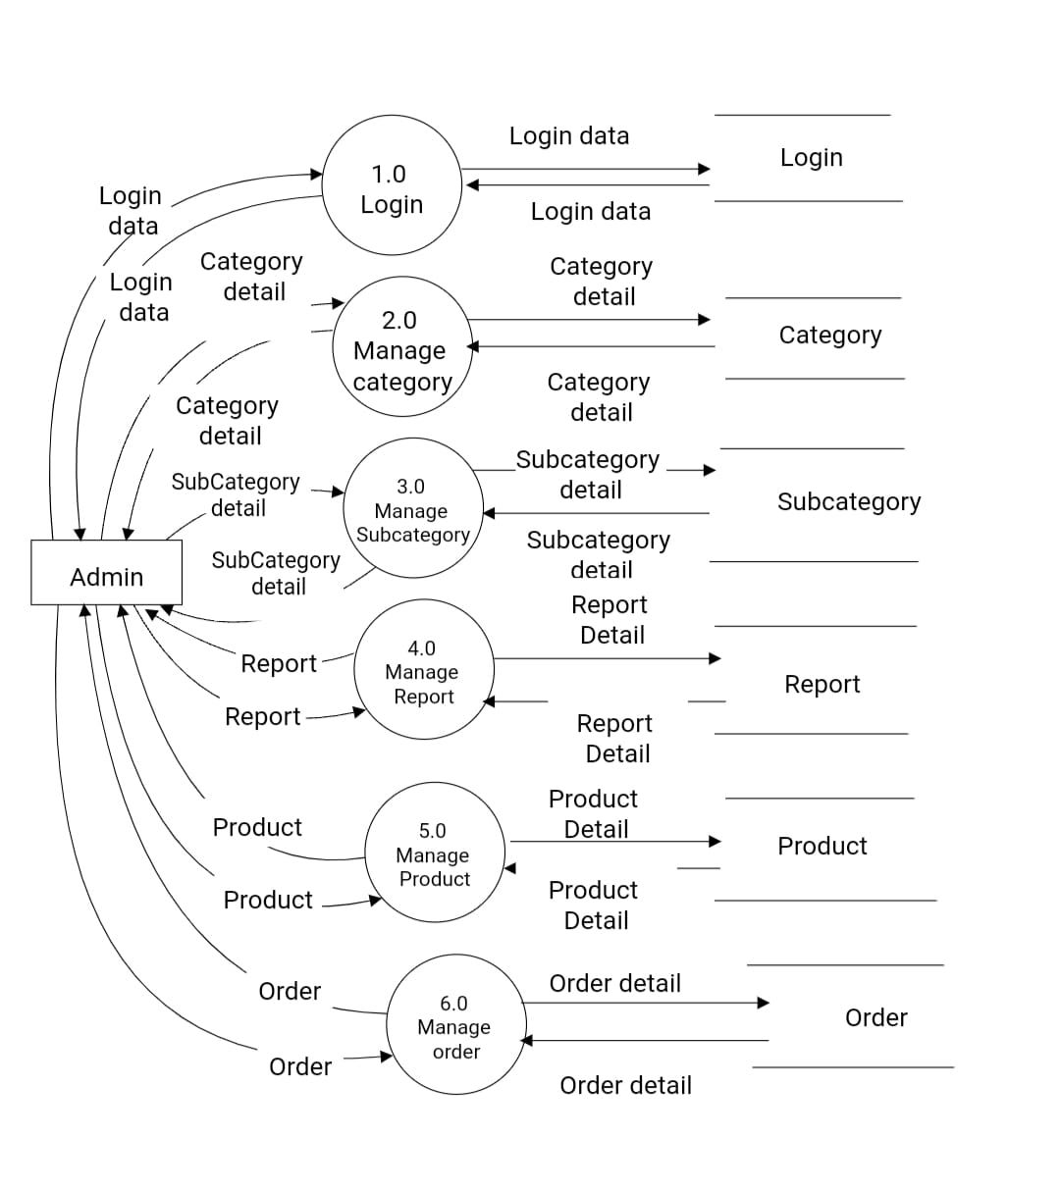

# 1ST LEVEL DFD FOR USERC:\Users\DELL\Pictures\DocumentDfd\Image 2022-03-09 at 00.02.05.jpeg

# 1ST LEVEL DFD FOR VISITOR

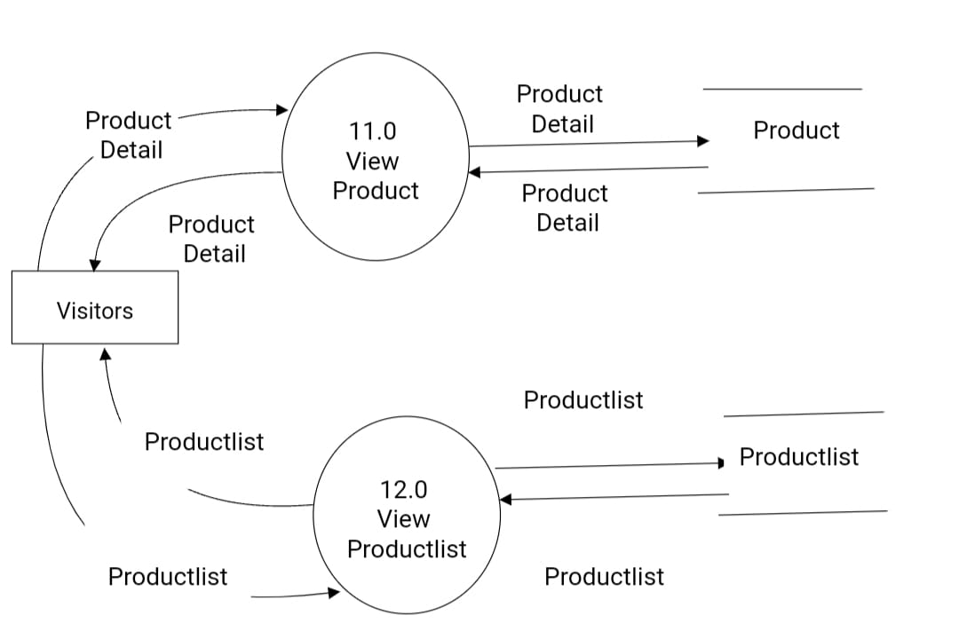

# 2ND LEVEL DFD FOR MANAGE ORDER

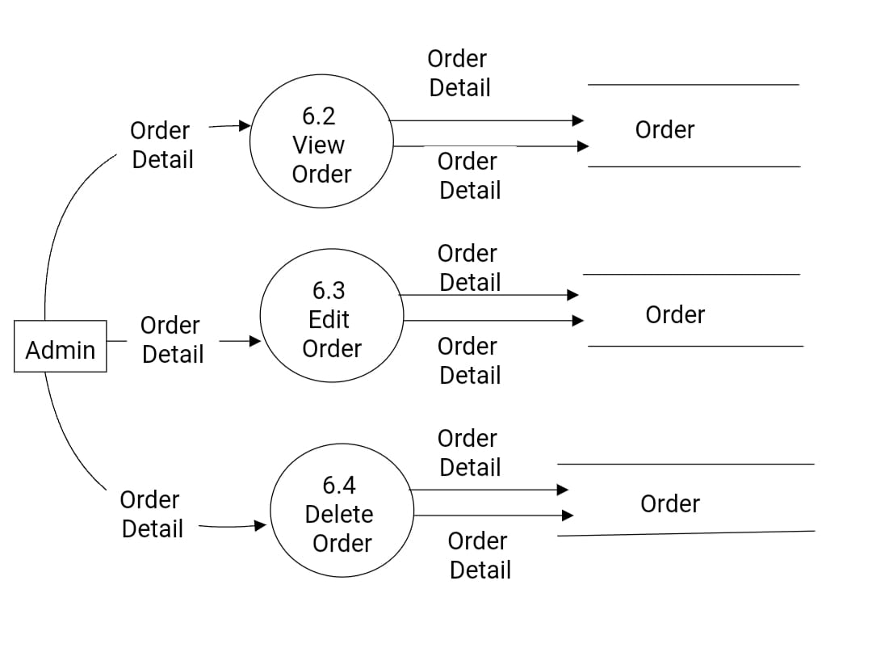

# 2ND LEVEL DFD FOR MANAGE CATEGORY

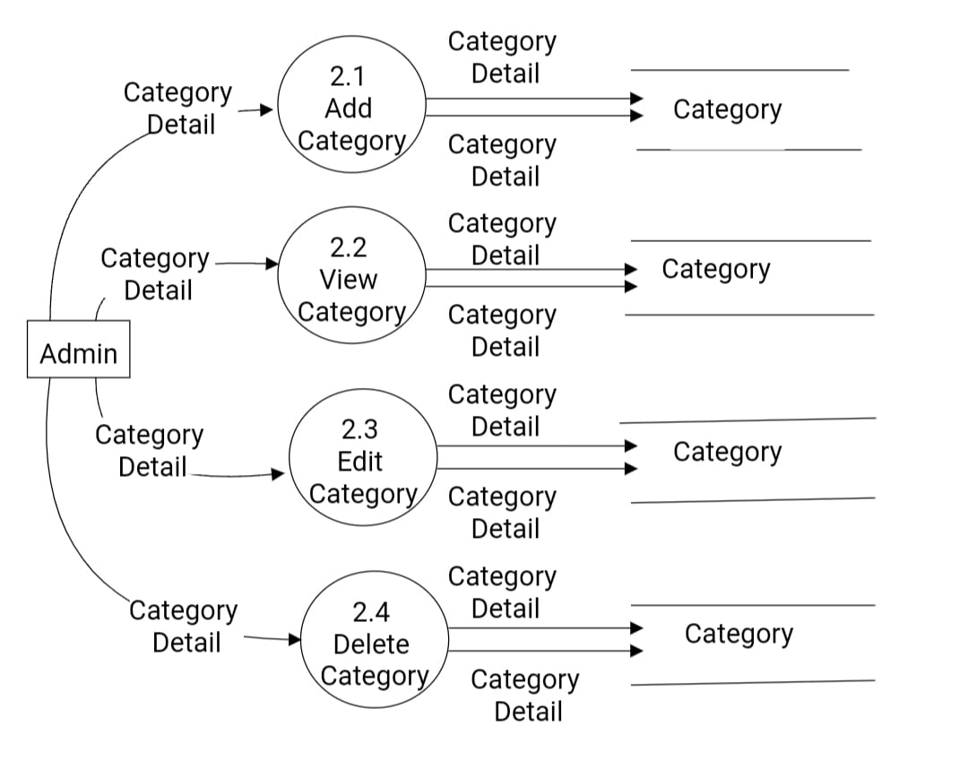

# 2ND LEVEL DFD FOR MANAGE SUBCATEGORY

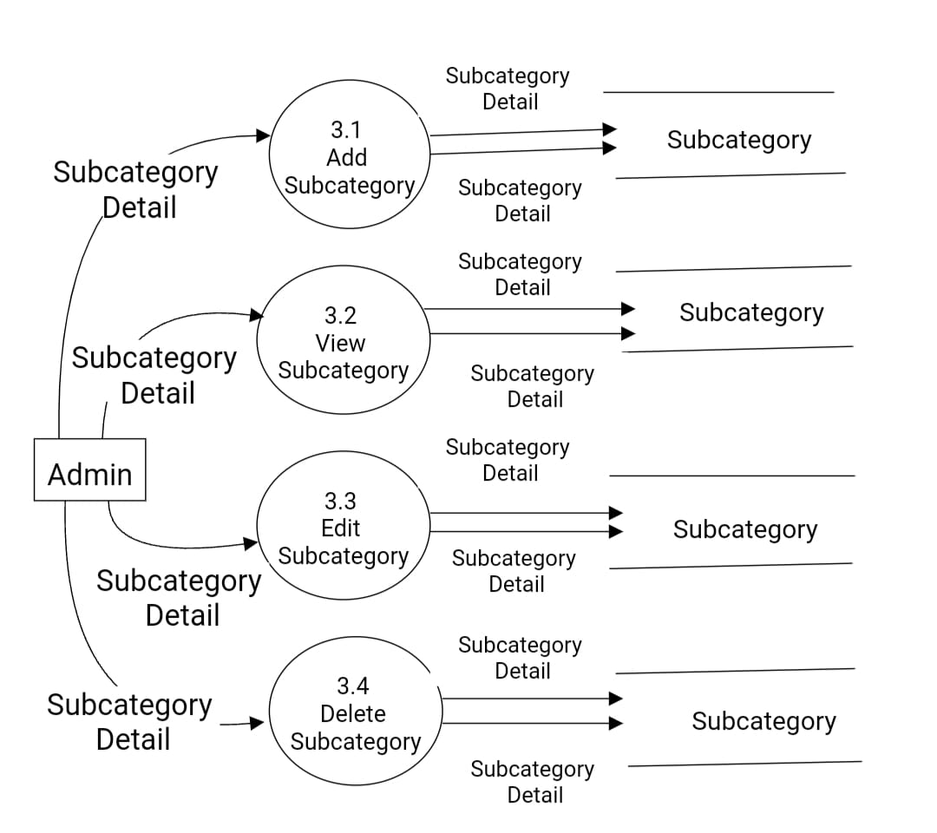

# 2ND LEVEL DFD FOR MANAGE PRODUCT

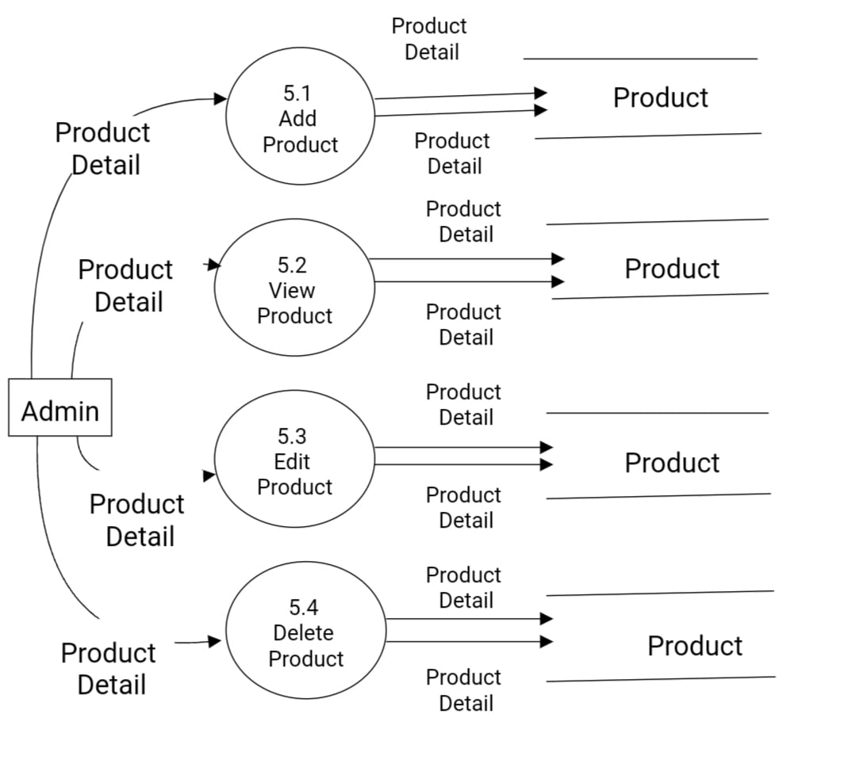

# 2ND LEVEL DFD FOR MANAGE ORDER

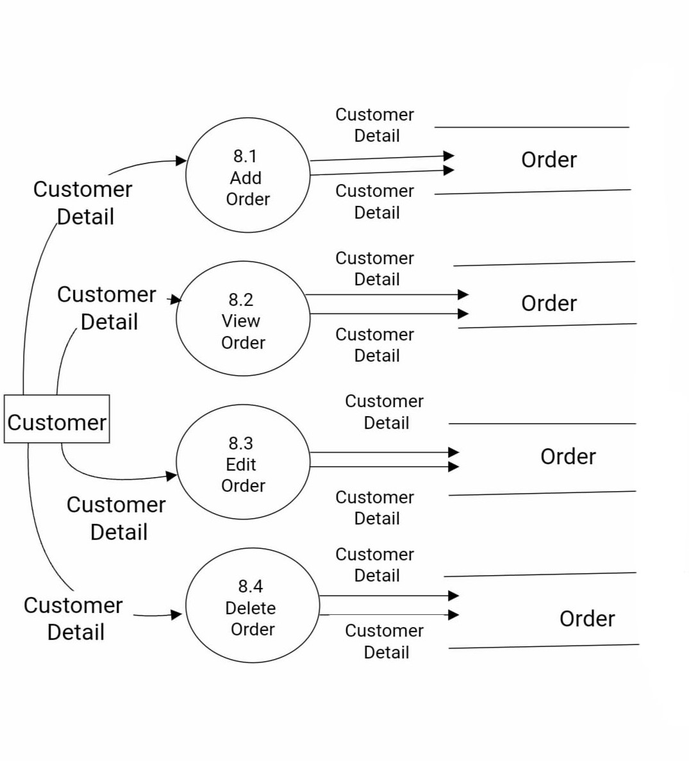

# 5.8 PROCESS SPECIFICATION

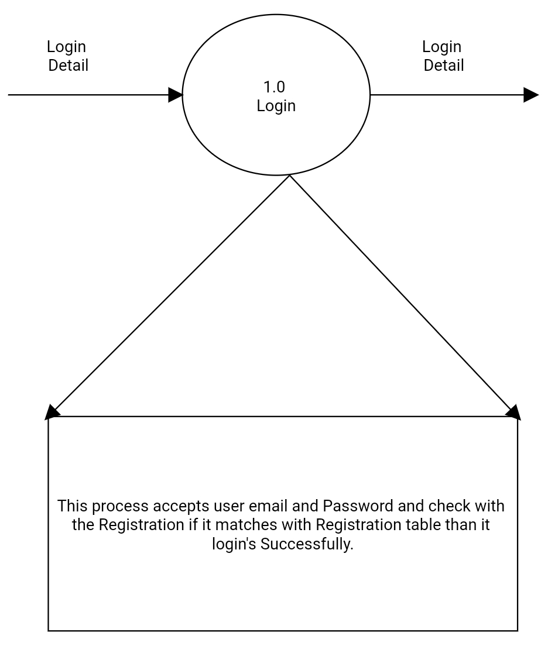

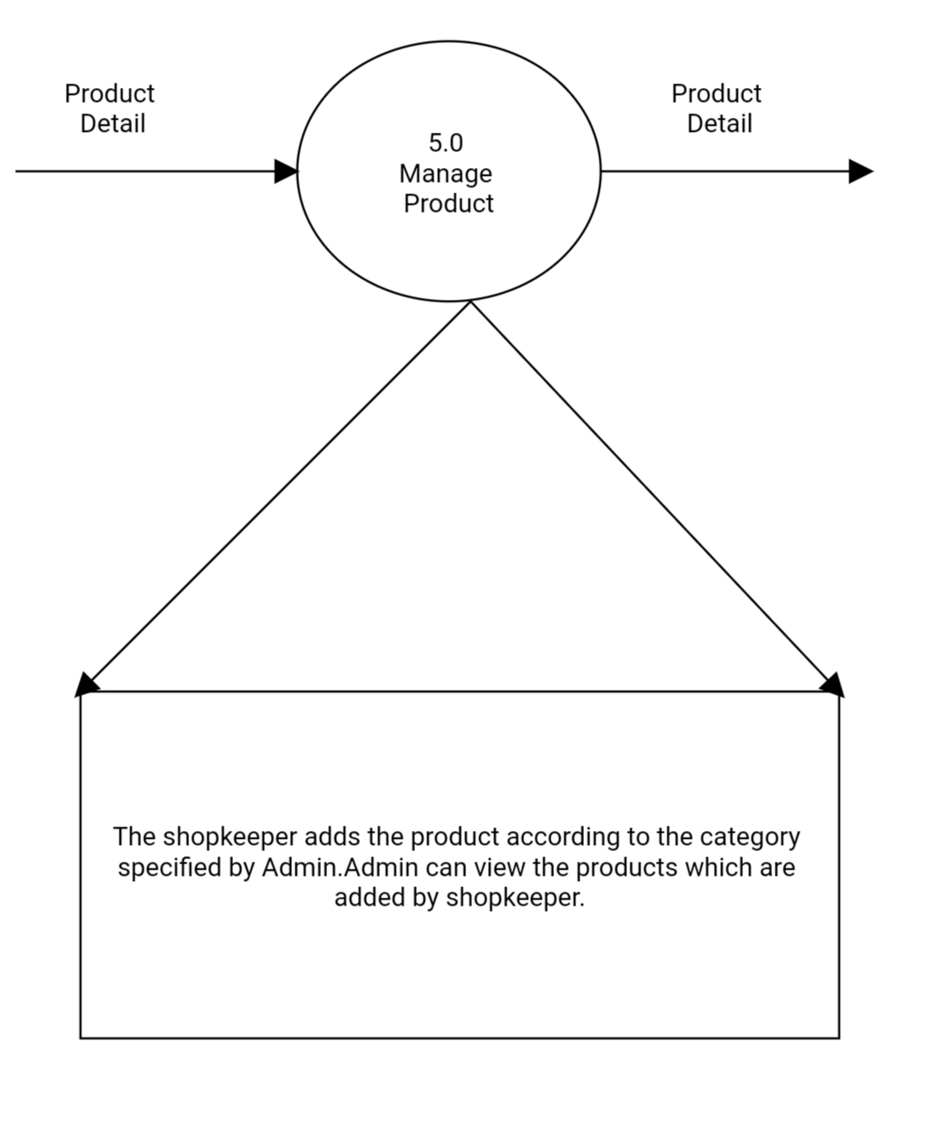

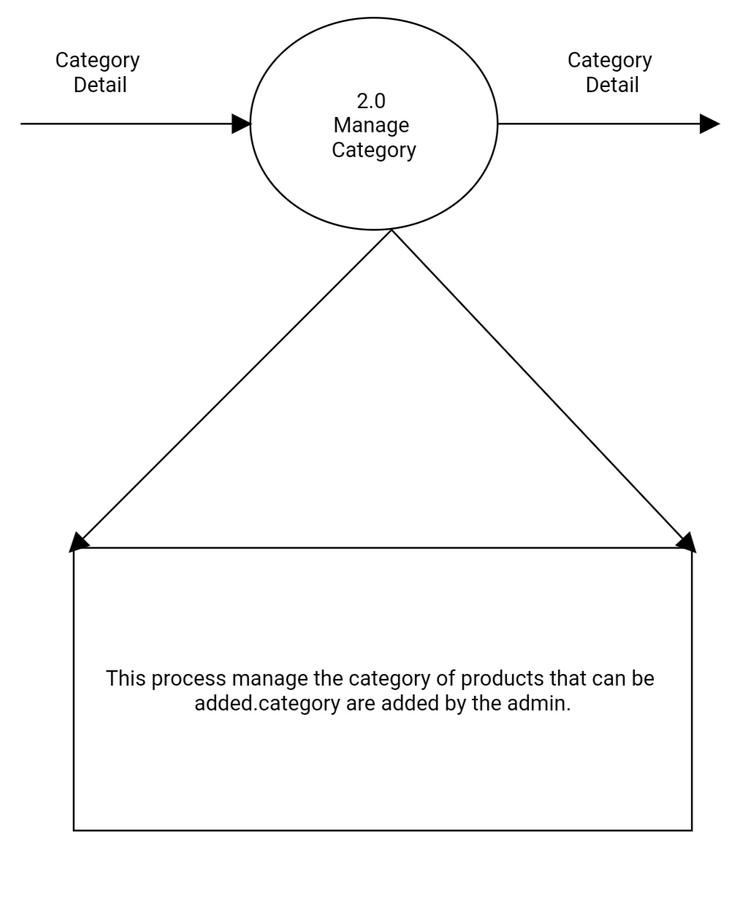

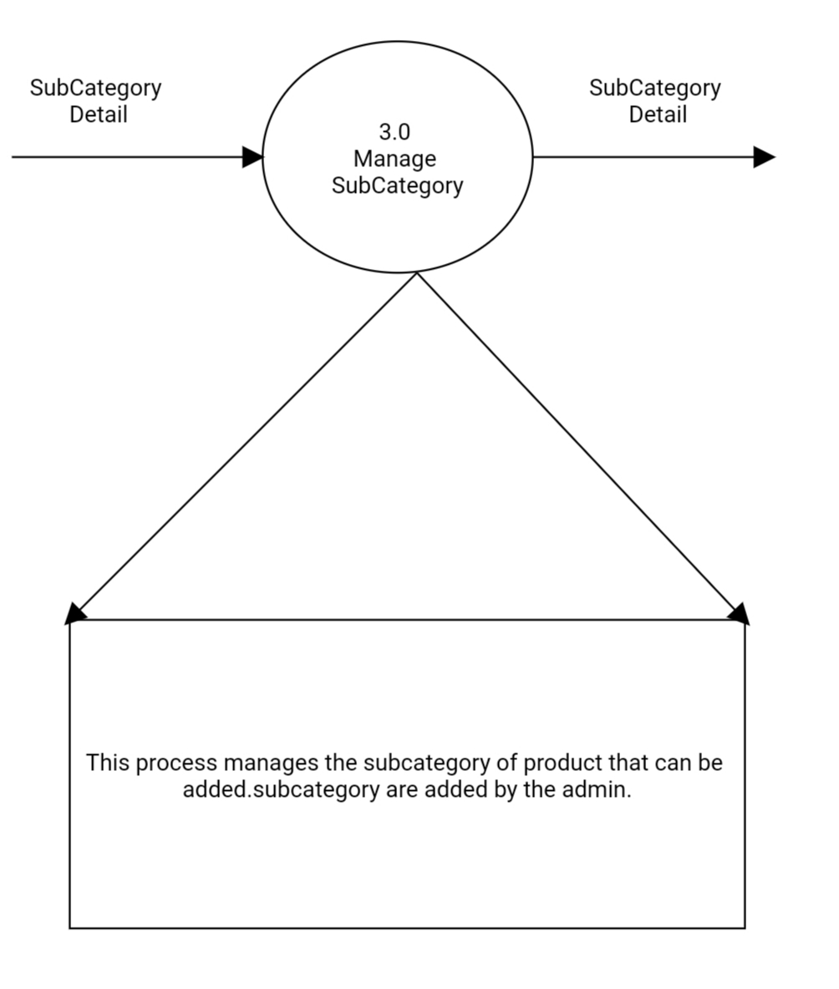

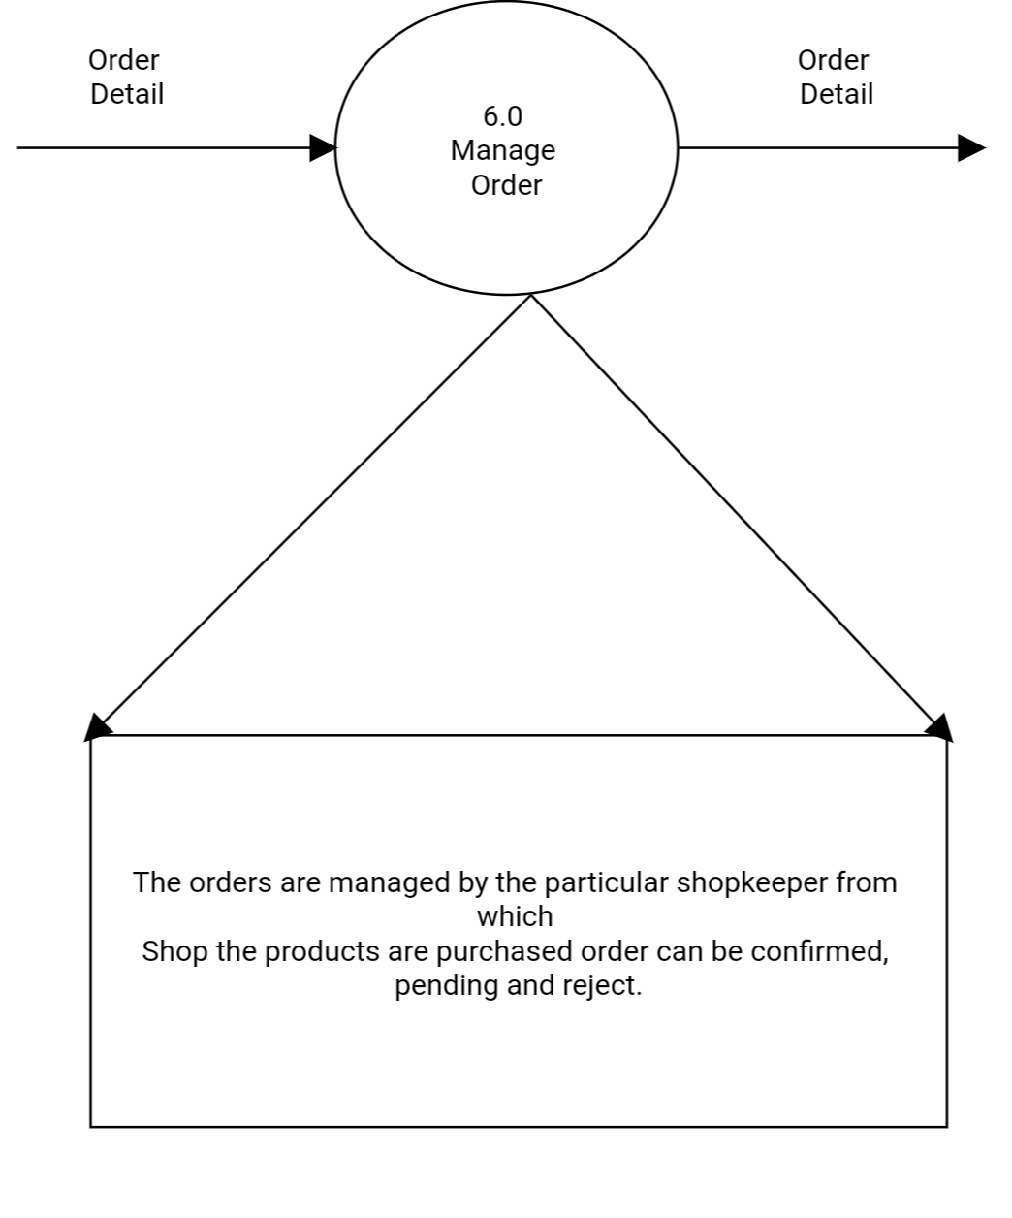

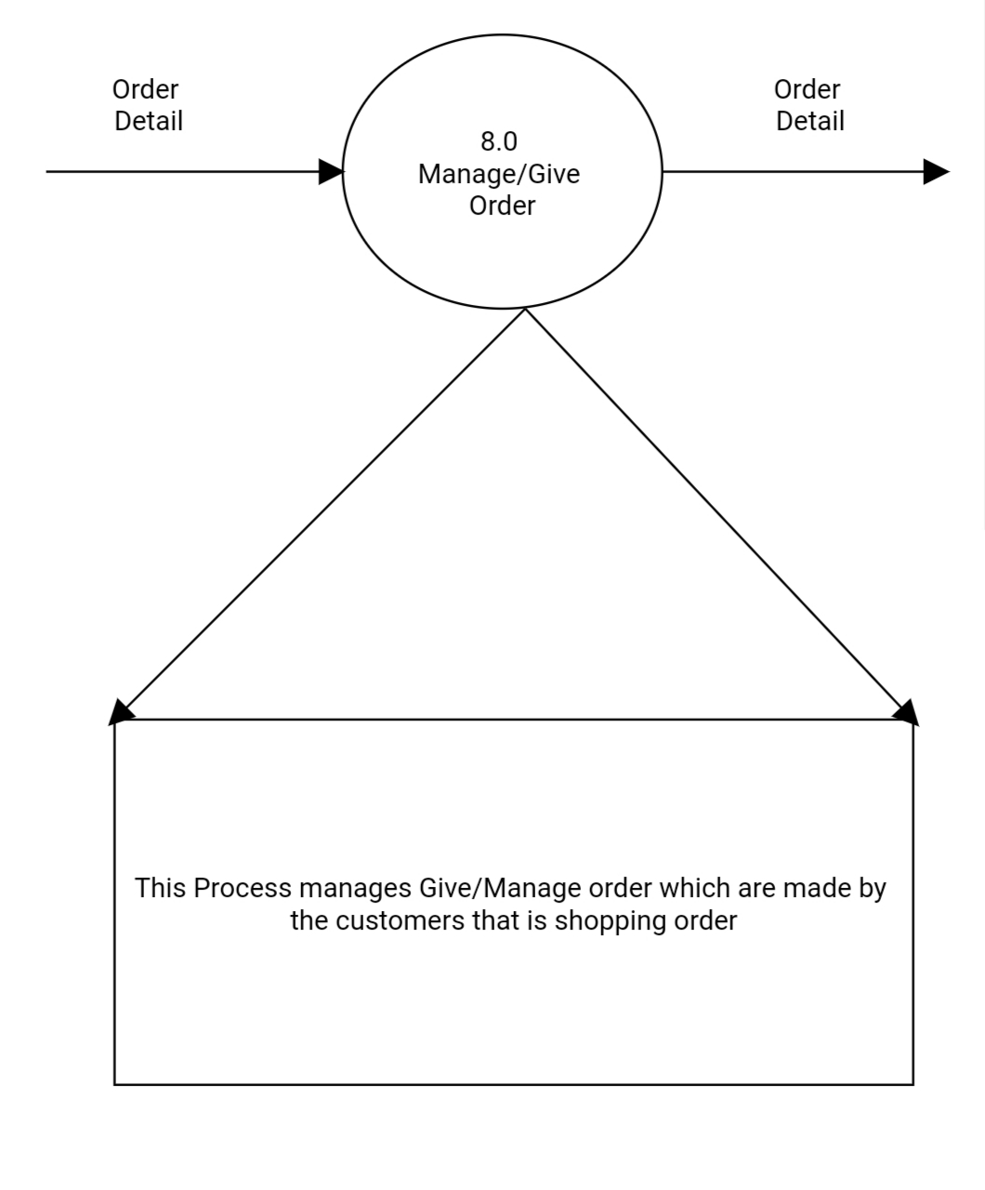

# 5.9 DATA DICTIONARY

1.category

|  |  |
| --- | --- |
| Name | Category |
| Alias | None |
| Where and how used | Input:  cid  cname  pic |
| Output | Cname  Pic |
| Description | Contains the details of category |

1. Subcategory

|  |  |
| --- | --- |
| Name- | Subcategory |
| Alias | None |
| Where and how used | Input:  sid  cid  sname  pic |
| Output | cid  sname  pic |
| Description | Contains the details of Subcategory |

3.Product

|  |  |
| --- | --- |
| Name | Product |
| Alias | None |
| Where and how used | Input:  pid  sid(Subcategory )  pname  pdescription  pprice  pqty  pstatus  pic |
| Output | sid(Subcategory )  pname  pdescription  pprice  pqty  pstatus  pic |
| Description | Contains the details of product |

4.Gallery

|  |  |
| --- | --- |
| Name | Gallery |
| Alias | None |
| Where and how used | Input:  gid  pid(product)  pic (product_picture) |
| Output | pid(product)  pic (product_picture) |
| Description | Contains the details of gallery |

5.Offer

|  |  |
| --- | --- |
| Name | Offer |
| Alias | None |
| Where and how used | Input:  oid  oname  pid(product )  odescription  opercentage  ostartdate  oenddate |
| Output | oname  pid(product )  odescription  opercentage  ostartdate  oenddate |
| Description | Contains the details of Offer |

6.AdminRegistration

|  |  |
| --- | --- |
| Name | AdminRegistration |
| Alias | None |
| Where and how used | Input:  aid  Email  Username  Password  pic |
| Output | Email  Username(AdminRegistration _name)  Password  Repeat Password(AdminRegistration_RepeatPassword )  Pic |
| Description | Contains the details of AdminRegistration |

7.FAQ

|  |  |
| --- | --- |
| Name | FAQ |
| Alias | None |
| Where and how used | Input:  id(FAQ _id)  Question  Answer |
| Output | Question  Answer |
| Description | Contains the details of FAQ |

8.ContactUS

|  |  |
| --- | --- |
| Name | ContactUS |
| Alias | None |
| Where and how used | Input:  uid  username  useraddress  usermobileno  userwebaddress  useremail |
| Output | username  useraddress  usermobileno  userwebaddress  useremail |
| Description | Contains the details of ContactUS |

9.AboutUs

|  |  |
| --- | --- |
| Name | AboutUs |
| Alias | None |
| Where and how used | Input:  userid  usertitle  userdescription |
| Output | usertitle  userdescription |
| Description | Contains the details of AboutUs |

10.Admin

|  |  |
| --- | --- |
| Name | Admin |
| Alias | None |
| Where and how used | Input:  aid  aname  email  Password  Pic |
| Output | aname  email  Password  Pic |
| Description | Contains the details of Admin |

11.UserRegistration

|  |  |
| --- | --- |
| Name | UserRegistration |
| Alias | None |
| Where and how used | Input:  Uid  Username  Gender  Dob  Usermobileno  Email  Password  Useraddress  Otp  status |
| Output | Username  Gender  Dob  Usermobileno  Email  Password  Useraddress |
| Description | Contains the details of UserRegistration |

12.Usercontact

|  |  |
| --- | --- |
| Name | Usercontact |
| Alias | None |
| Where and how used | Input:  ucid  ucname  ucemail  ucphone  ucsubject  ucmessage  ucstatus |
| Output | Ucname  ucemail  ucphone  ucsubject  ucmessage  ucstatus |
| Description | Contains the details of Usercontact |

13.Carthistory

|  |  |
| --- | --- |
| Name | carthistory |
| Alias | None |
| Where and how used | Input:  Cartid  Uid  Pid  Subtotal  Qty  Cdate |
| Output | Subtotal  Qty |
| Description | Contains the details of carthistory |

14.Order

|  |  |
| --- | --- |
| Name | Order |
| Alias | None |
| Where and how used | Input:  Ordid  Uid  Orduserfname  Orduserlname  Ordusercname  Ordcountryname  Ordstreetadd  Ordcity/town  Ordstate/country  Ordpostcode/zip  Ordphoneno  Ordemailid |
| Output | Orduserfname  Orduserlname  Ordusercname  Ordcountryname  Ordstreetadd  Ordcity/town  Ordstate/country  Ordpostcode/zip  Ordphoneno  Ordemailid |
| Description | Contains the details of order |

15.Cart

|  |  |
| --- | --- |
| Name | Cart |
| Alias | None |
| Where and how used | Input:  Cartid  Uid  Pid  Subtotal  Qty  Cdate |
| Output | Subtotal  Qty |
| Description | Contains the details of cart |

# 5.10 TABLE STRUCTURE

# about_us

|  |  |  |  |  |
| --- | --- | --- | --- | --- |
| **Column** | **Type** | **Null** | **Default** | **Comments** |
| userid *(Primary)* | int(11) | No |  | It contains id of about_us |
| Usertitle | varchar(30) | No |  | It contains title of about_us |
| Userdescription | varchar(5000) | No |  | It contains Description of about_us |

**admin**

|  |  |  |  |  |
| --- | --- | --- | --- | --- |
| **Column** | **Type** | **Null** | **Default** | **Comments** |
| aid *(Primary)* | int(11) | No |  | It contains id of admin |
| Aname | varchar(30) | No |  | It contains adminname of admin |
| Email | varchar(30) | No |  | It contains adminEmail of admin |
| Password | varchar(10) | No |  | It contains adminPassword of admin |
| Pic | varchar(500) | No |  | It contains adminPic of admin |

## cart

|  |  |  |  |  |
| --- | --- | --- | --- | --- |
| **Column** | **Type** | **Null** | **Default** | **Comments** |
| cartid (Primary) | int(11) | No |  | It contain id of cart |
| Uid | int(11) | No |  | It contain id of userregistration |
| Pid | int(11) | No |  | It contain id of product |
| Subtotal | int(11) | No |  | It contain subtotal of cart |
| Qty | int(11) | No |  | It contain qty of cart |
| Cdate | text | No |  | It contain current date of cart |

**category**

|  |  |  |  |  |
| --- | --- | --- | --- | --- |
| **Column** | **Type** | **Null** | **Default** | **Comments** |
| cid *(Primary)* | int(11) | No |  | It contains id of category |
| Cname | varchar(30) | No |  | It contains categoryname of category |
| Pic | varchar(5000) | No |  | It contains categorypic of category |

**contact_us**

|  |  |  |  |  |
| --- | --- | --- | --- | --- |
| **Column** | **Type** | **Null** | **Default** | **Comments** |
| userid *(Primary)* | int(11) | No |  | It contains id of contact_us |
| Username | varchar(30) | No |  | It contains Username of contact_us |
| Useraddress | varchar(100) | No |  | It contains Useraddress of contact_us |
| Usermobileno | varchar(10) | No |  | It contains Usermobileno of contact_us |
| Userwebaddress | varchar(30) | No |  | It contains Userwebaddress of contact_us |
| Useremail | varchar(30) | No |  | It contains Useremail of contact_us |

**faq**

|  |  |  |  |  |
| --- | --- | --- | --- | --- |
| **Column** | **Type** | **Null** | **Default** | **Comments** |
| id *(Primary)* | int(11) | No |  | It contains id of faq |
| Question | varchar(500) | No |  | It contains Question of faq |
| Answer | varchar(500) | No |  | It contains Answer of faq |

## carthistory

|  |  |  |  |  |
| --- | --- | --- | --- | --- |
| **Column** | **Type** | **Null** | **Default** | **Comments** |
| cartid (Primary) | int(11) | No |  | It contain id of cart |
| Uid | int(11) | No |  | It contain id of userregistration |
| Pid | int(11) | No |  | It contain id of product |
| Subtotal | int(11) | No |  | It contain subtotal of cart |
| Qty | int(11) | No |  | It contain qty of cart |
| Cdate | text | No |  | It contain current date of cart |

**gallery**

|  |  |  |  |  |
| --- | --- | --- | --- | --- |
| **Column** | **Type** | **Null** | **Default** | **Comments** |
| gid *(Primary)* | int(11) | No |  | It contains id of gallery |
| Pid | int(11) | No |  | It contains Productid of faq |
| Pic | varchar(500) | No |  | It contains Pic of faq |

**offer**

|  |  |  |  |  |
| --- | --- | --- | --- | --- |
| **Column** | **Type** | **Null** | **Default** | **Comments** |
| oid *(Primary)* | int(11) | No |  | It contains offerid of offer |
| Oname | varchar(50) | No |  | It contains offername of offer |
| Pid | int(11) | No |  | It contains Productid of offer |
| description | varchar(5000) | No |  | It contains offerdescription of offer |
| Percentage | int(11) | No |  | It contains offerpercentage of offer |
| Ostartdate | date | No |  | It contains offerstartdate of offer |
| Oendsdate | Date | No |  | It contains offerendsdate of offer |

**product**

|  |  |  |  |  |
| --- | --- | --- | --- | --- |
| **Column** | **Type** | **Null** | **Default** | **Comments** |
| pid *(Primary)* | int(11) | No |  | It contains productid of product |
| Sid | int(11) | No |  | It contains subcategoryid of product |
| Pname | varchar(50) | No |  | It contains productname of product |
| Pdescription | varchar(500) | No |  | It contains productdescription of product |
| Pprice | varchar(30) | No |  | It contains productprice of product |
| Psize | varchar(40) | No |  | It contains productsize of product |
| Qty | int(11) | No |  | It contains productquantity of product |
| Pstatus | int(11) | No |  | It contains productstatus of product |
| Pic | varchar(500) | No |  | It contains productpic of product |

**Registration(Admin)**

|  |  |  |  |  |
| --- | --- | --- | --- | --- |
| **Column** | **Type** | **Null** | **Default** | **Comments** |
| aid *(Primary)* | int(11) | No |  | It contains id of Registration |
| Email | varchar(50) | No |  | It contains Email of Registration |
| Username | varchar(40) | No |  | It contains Adminname of Registration |
| Password | varchar(12) | No |  | It contains Password of Registration |
| Pic | varchar(200) | No |  | It contains pic of Registration |

**subcategory**

|  |  |  |  |  |
| --- | --- | --- | --- | --- |
| **Column** | **Type** | **Null** | **Default** | **Comments** |
| sid *(Primary)* | int(11) | No |  | It contains id of subcategory |
| cid | int(11) | No |  | It contains category of subcategory |
| Sname | varchar(30) | No |  | It contains subcategoryname of subcategory |
| Pic | varchar(500) | No |  | It contains subcategorypic of subcategory |

**userregistration**

|  |  |  |  |  |
| --- | --- | --- | --- | --- |
| **Column** | **Type** | **Null** | **Default** | **Comments** |
| uid *(Primary)* | int(11) | No |  | It contains id of UserRegistration |
| Username | varchar(30) | No |  | It contains Username of UserRegistration |
| Gender | varchar(30) | No |  | It contains gender of UserRegistration |
| Dob | Date | No |  | It contains dob of UserRegistration |
| usermobileno | varchar(30) | No |  | It contains usermobileno of UserRegistration |
| Email | varchar(30) | No |  | It contains email of UserRegistration |
| Password | varchar(30) | No |  | It contains Password of UserRegistration |
| Useraddress | varchar(900) | No |  | It contains Useraddress of UserRegistration |
| Otp | int(11) | No |  | It contains otp of UserRegistration |
| Status | int(11) | No |  | It contains Status of UserRegistration |

**user_contact**

|  |  |  |  |  |
| --- | --- | --- | --- | --- |
| **Column** | **Type** | **Null** | **Default** | **Comments** |
| ucid *(Primary)* | int(11) | No |  | It contains id of UserContact |
| Ucname | varchar(50) | No |  | It contains Username of UserContact |
| Ucemail | varchar(50) | No |  | It contains Useremail of UserContact |
| Ucphone | varchar(10) | No |  | It contains Userphone of UserContact |
| Ucsubject | varchar(50) | No |  | It contains Usersubject of UserContact |
| Ucmessage | varchar(500) | No |  | It contains Usermessage of UserContact |
| Ucstatus | int(11) | No |  | It contains Userstatus of UserContact |

## order

|  |  |  |  |  |
| --- | --- | --- | --- | --- |
| **Column** | **Type** | **Null** | **Default** | **Comments** |
| ordid (Primary) | int(11) | No |  | It contain id of order |
| Uid | int(11) | No |  | It contain id of userregistration |
| Orduserfname | varchar(50) | No |  | It contain firstname of order userregistration |
| Orduserlname | varchar(50) | No |  | It contain lastname of order userregistration |
| Ordusercname | varchar(50) | No |  | It contain company name of order userregistration |
| ordcountryname | varchar(50) | No |  | It contain country name of order userregistration |
| Ordstreetadd | varchar(10000) | No |  | It contain country name of order userregistration |
| Ordcity | varchar(50) | No |  | It contain city name of order userregistration |
| ordstate | varchar(50) | No |  | It contain state name of order userregistration |
| Ordpostcode | varchar(50) | No |  | It contain postcode of order userregistration |
| Ordphoneno | varchar(50) | No |  | It contain phoneno of order userregistration |
| Ordemailid | varchar(50) | No |  | It contain emailid of order userregistration |

# TABLE STRUCTURE WITH PROPER RELATIONSHIP

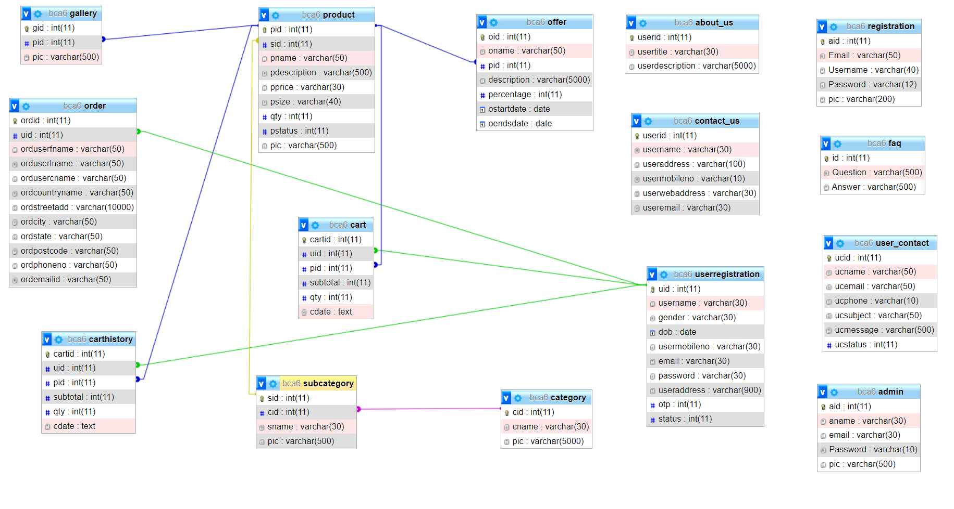

## CHAPTER 6

# TESTING REPORT

# TESTING REPORT

**6.1 Testing Issues**

* **Integration Testing:**

Integration testing is a systematic technique for constructing the program structure while conducting test to uncover errors associated with interfacing. The objective is to take unit tested module and build a program structure that has been dictated by design.

After our individual modules were tested out we go to the integrated to create a complete project. This integration process involves building the software and testing the resultant software for problems that arise from component interactions.

* **Black Box Testing:**

As s/w functions are operational, the set of input conditions. Exercising all functional requirements will be derived to uncover the different class of the behavioural errors such as incorrect functions, incorrect interfaces, external data structure errors, performance errors and termination errors.

* **White Box Testing:**

Based on the control structure of the procedural design, the logical paths are been exercised with specific set of conditions, loops at boundaries to examine the validity of the internal data structures.

* **Alpha Testing:**

The development site, the customer conducts an alpha test under the manual settings to record the errors and usage problems.

* **Beta Testing:**

At the customer site, the end-user conducts the “live” application test in customer environment to encounter the problems to be modified before product release.

* **System Testing:**

As the s/w is to be integrated with other system elements, system testing focuses on validating the system integration by,

* **Recovery Testing** : To assure proper recovery
* **Security Testing** : To protect the improper penetration
* **Stress Testing** : To confront the program with abnormal resources such as quantity, frequency or volume.

# 6.2 TestCaseDesign 2

The test plan focuses on how the testing for the project will proceed, which units will be tested, and what approaches (and tools) are to be used during the various stages of testing. However, it does not deal with the details of testing a unit, nor does it specify which test cases are to be used. Test case design has to be done separately for each unit. Based on the approach specified in the test plan, and the features to be tested, the test cases are designed and specified for testing the unit. Test case specification gives, for each unit to be tested, all test cases, inputs to be used in the test cases, conditions being tested by the test case, and outputs expected for those test cases. If test cases are specified in a document, the specifications look like a table of the form shown in Figure,

|  |  |  |  |  |  |
| --- | --- | --- | --- | --- | --- |
| **Test Version No.** | **Flied Name** | **Input** | **Condition**  **Checked** | **Output** | **Expected Output** |
|  |  |  |  |  |  |
|  |  |  |  |  |  |

# TestCase : Login Process

|  |  |  |  |  |  |
| --- | --- | --- | --- | --- | --- |
| Test Version No. | Filed  Name | Input | Condition  Checked | Output | Expected  output |
| 1 | Username,  Email ID, Password | Null | No Entry For Email ID, Username,  Password | Enter Username, Password Is Wrong | User Login |
|  |  |  |  |  |  |
| 2 | Username | 1234567 | Invalid Format | Enter Only Character | User Login |
|  |  |  |  |  |  |
| 3 | Password | Pla1996 | Valid Password | User Login | User Login |
|  |  |  |  |  |  |

# TestCase: Forgot Password Process:

|  |  |  |  |  |  |
| --- | --- | --- | --- | --- | --- |
| Test Version No. | Filed  Name | Input | Condition  Checked | Output | Expected  output |
| 1 | Email | [PalakShah@gmail.com](mailto:PalakShah@gmail.com) | Email ID Does Not Match | Please Check Your Email ID | Please Check Your  Email ID |
|  |  |  |  |  |  |
| 2 | Email | [PalakShah@gmail.com](mailto:PalakShah@gmail.com) | Email ID Match | Entry For Email Id | Please Check Your  Email ID |
|  |  |  |  |  |  |
|  |  |  |  |  |  |
|  |  |  |  |  |  |

# TestCase: change Password Process:

|  |  |  |  |  |  |
| --- | --- | --- | --- | --- | --- |
| Test Version No. | Filed  Name | Input | Condition  Checked | Output | Expected  output |
| 1 | Old Password | Null | No Entry For Old Password | Please enter Old Password | Please Enter Old Password |
| 2 | New Password | Null | No Entry For new Password | Please Enter New Password | Please Enter New Password |
| 3 | Confirm Password | Null | No Entry For Confirm password | No Entry For Confirm password | Please Enter Confirm password |
| 4 | Old Password | 1234 | Entry For Old Password | Right Old password | Right Old password |
| 5 | New Password | 5214 | Entry For new Password | New Password | New Password |
| 6 | Confirm Password | 5214 | Entry For Confirm password | Successfully Password Are Changed | Successfully Password Are Changed |

# TestCase: User Registration:

|  |  |  |  |  |  |
| --- | --- | --- | --- | --- | --- |
| Test Version No. | Filed  Name | Input | Condition  Checked | Output | Expected  Output |
| 1 | Username d name | Null | No entry For Username | Username is Require | Username is Require |
| 2 | Username | 123 | No valid entry for username | username must be Only Character | username must be Only Character |
| 3 |  | 1234 | Invalid verification code | Verification code does not match | Verification code does not match |
| 4 | Password | 12345 | Invalid password | Password must be strong | Password must be strong |
| 5 | Password | Palak123 | Valid password  Must be 6 character  (a-z,A-Z,0-9) | Password is Correct format | Password is Correct format |

# 7. Limitation of System

* The current implementation doesn’t take warehousing in its stride . In the upcoming version warehousing will be done from within the ambits of the mall to lessan the burden of the admin.
* This system does not provide online (banking) payment transaction.
* Dynamic Storefront: Each customer will have a web page personalized based on his or her recent purchase .This is the equivalent of having a unique storefront for each customer in hopes of drawing in as many return customers as possible.

# 8. Future Enhancement

* Further enhancement of this will be that we will add automated mobile alert for customer means if any user(customer) buys the products then alert will automatically go to the Admin

and after confirmation of purchasing products the alert of confirmation will also automatically go to the customer.

* Also if any customer signs up into our site then his/her user name and password will be send to his/her mobile. Any updates will also send to his/her mobile.
* If any new products or offers will be there then also message will be send to customers mobile.
* Now we are maintaining admin, customer communication through site notification, but in future we will implement it with mobile alert by sending all customer booking and personal
* Information automatically to admin mobile automatically.Also we will provide automated mail communication between admin and customer.
* Later we will add the payment method with other banking methods .

# 9. Conclusion of Online clothes shopping System

* The ‘Online clothes shopping system’ is designed to provide a web based application that would make searching , viewing and selection of product easier.
* The search engine provides an easy and convenient way to search for products where a user can search for a product interactively and the search engine would refine the products available based on the users input.
* The user can then view the complete specification of each product. They can also view the products reviews and also write their own reviews.
* The usefulness of any system depends upon some of then basic things which are:-
* Portability
* Reliability
* Maintainability
* Satisfaction of user requirements
* User friendiness
* Making a system 100% reliable is nearly possible thing as being student, but I and my group with the help of our guide have tried to make it more useful in all types of networking sector where Online clothes shopping system facility is provided to customers.
* The Online clothes shopping system has been designed by studying the existing processes and requirements . So I have tried make all the functionality in my website.

# 10. References of Online clothes shopping System

* <https://www.flipkart.com/>
* <https://www.Myntra.com/>
* <https://www.w3schools.com/>php/php_syntax.asp
* <http://themeforest.net/tags/user%20panel>