KIET GROUP OF INSTITUTIONS
B.Tech 2nd year/ III sem
Social Internship Report
Road Safety Audit in Local Areas
Name : Jatin Sharma
University Roll Number: 202501100200164
Library ID: 202501100200164
Branch: CSE
Section : C
Contact Number : +91 8077 601 646
Email ID : jatin.25002164@kiet.edu
Name of the Organization : Self - Social Internship
Location : Aligarh
Internship Duration : 01 July 2026 - 10 July 2026
Mentor : Faculty Coordinator, KIET Group of Institutions
Contact : Department of Computer Science & Engineering,
Description of Work Done
Daily Activities & Responsibilities :
During the internship, different roads in the selected locality were surveyed to assess their safety conditions. Geotagged photographs were captured at different locations to document road infrastructure and safety issues. The survey included observing potholes, road surface conditions, traffic signs, zebra crossings, street lighting, pedestrian footpaths, speed breakers, and traffic congestion. Notes were prepared after each visit, and the observations were analyzed to identify common safety concerns. Based on the collected information, suitable
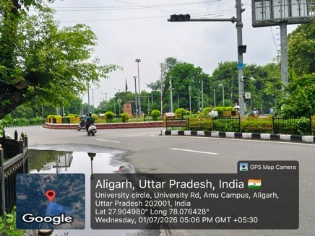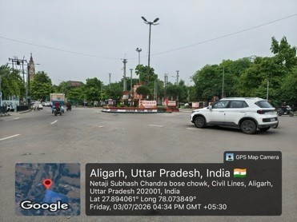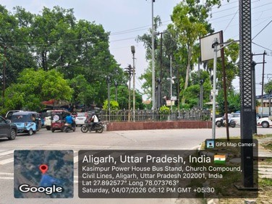
Skills Learned & Experience Gained:
This internship enhanced my practical understanding of road safety assessment and field surveys. I learned how to conduct systematic observations, document findings using geotagged photographs, and analyze public infrastructure from a safety perspective. The internship also improved my communication, problemsolving, report-writing, and analytical skills. It increased my awareness of sustainable development goals and the importance of community-focused engineering solutions.

Key Learnings & Contributions
Personal Growth:
The internship improved my ability to observe real-world engineering problems and analyze them critically. It strengthened my understanding of public safety, civic responsibility, and sustainable infrastructure. It also enhanced my confidence in conducting surveys, documenting evidence, and presenting practical recommendations.
Community Impact:
The survey identified several road safety issues that may affect pedestrians and vehicle users. Recommendations such as repairing potholes, maintaining road markings, improving street lighting, installing missing traffic signs, and maintaining pedestrian pathways can contribute to safer roads. Although this internship was observational, it highlighted practical measures that can improve community safety and support sustainable urban development.
Challenges Faced & Solutions
During the survey, some locations had heavy traffic, making detailed observations difficult. Weather conditions and peak-hour congestion also limited the time available for inspection. These challenges were addressed by conducting visits during suitable time periods, selecting safe observation points, and recording observations carefully. Multiple visits were made to verify findings and ensure the accuracy of the collected information.

Conclusion & Recommendations
Conclusion:
The Road Safety Audit in Local Areas provided valuable exposure to realworld road infrastructure and safety practices. The survey demonstrated that regular inspection and timely maintenance of roads, traffic signs, pedestrian facilities, and street lighting can significantly reduce accident risks. This internship strengthened my understanding of social responsibility and demonstrated how engineering knowledge can contribute to improving public safety and sustainable community development.
Recommendations:
Repair damaged road surfaces and potholes promptly.
Repaint faded zebra crossings and lane markings.
Install missing traffic signboards.
Improve street lighting in low-visibility areas.
Maintain pedestrian footpaths.
Conduct regular road safety inspections.
Organize road safety awareness programs for the public.
Certification & Attachments
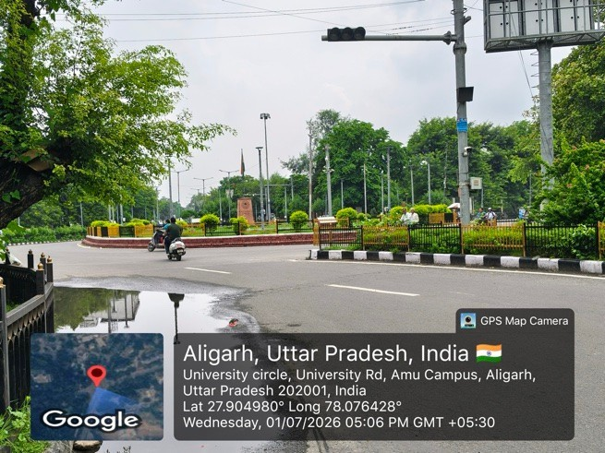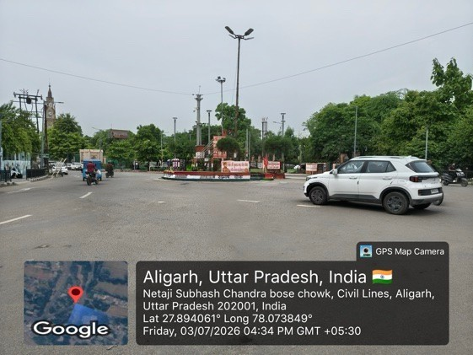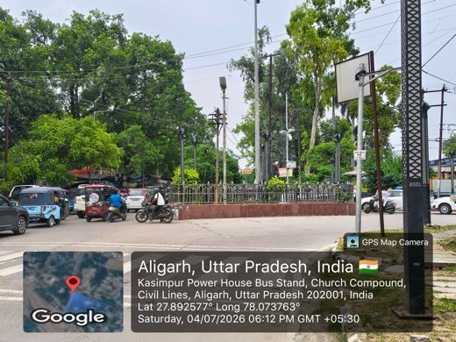
Google Drive link :
https://drive.google.com/drive/folders/1ZDk1L_9cMUhNifdOEKf7kwtbdNS8aCAw?usp=sharing

