Rajvaibhav Rahane

17u283 223045

SE-C Comp,Viit,Pune

**AIM :-**

Create structure for Doctors having members as Name, specialization and year of experience. Accept record of 5 different Doctors and display them using function.

**THEORY:-**

C/C++ arrays allow you to define variables that combine several data items of the same kind, but structure is another user defined data type which allows you to combine data items of different kinds.

To define a structure, you must use the **struct** statement. The struct statement defines a new data type, with more than one member, for your program. To access any member of a structure, we use the member access **operator (.)**.

***CODE:***

/*

*@Rajvaibhav Rahane

*/

/*

* Program to create structure Doctor

*

* implements functions-

* overloads >> and << operator functions

*/

#include<iostream>

using namespace std;

typedef struct Doctor{

int experience;

string name;

string specialisation;

} Doctor;

istream & operator>>(istream &in,Doctor &doctor){

cout<<"Enter Name\t";

//getline(in,doctor.name);

in>>doctor.name;

cout<<"Enter experience";

in>>doctor.experience;

//scanf("%d%*c",&doctor.experience);

cout<<"Enter Specialisation\t";

in>>doctor.specialisation;

//getch();

//getline(in,doctor.specialisation);

return in;

}

ostream & operator<<(ostream &out,Doctor doctor){

out<<doctor.name<<"\t"<<doctor.specialisation<<" "<<doctor.experience<<endl;

return out;

}

int main(){

Doctor doc[5];

for(int i=0;i<5;i++){

cin>>doc[i];

cout<<doc[i];

}

return 0;

}

***Output:***

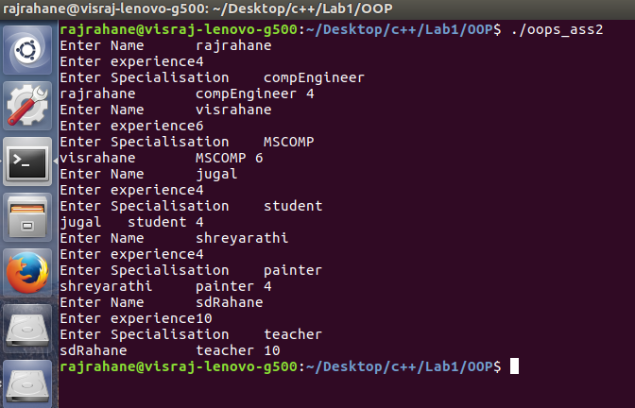

Conclusion-The Concept of structures was understood