Rajvaibhav Rahane

17u283 223045

SE-C Comp,Viit,Pune

***AIM:***

Using STL list container implement following member function of list class.

***OBJECTIVE:***

Objective of program is to perform following function.

1)Empty 2)Insert 3)Unique 4)Sort 5)Reverse

***THEORY:***

List is collection of elements in which only sequential access to the elements is allowed.This is basically a bidirectional linear list in which we can traverse the elements from left to right or right to left.

The header file <list> need to be included in the program.

***CODE:***

#include<list>

#include<iostream>

using namespace std;

void printMenu(){

cout<<"1)Insert Element in List\t";

cout<<"2)Check if List Empty?\t";

cout<<"3)Reverse List\t";

cout<<"4)Sort List\t";

cout<<"5)Delete Multiple Copies of an Element(Unique)\t";

cout<<"6)Print List\t";

cout<<"7)Clear List\n";

cout<<"8)Exit\tChoice ? ";

}

int main(){

list<float> floatList;

list<float>::iterator it;

int choice;float element;

if(floatList.empty())cout<<"ListEmpty\n";

for(int i=0;i<5;i++)floatList.push_back(42);

it=floatList.begin();it++;it++;floatList.insert(it,45);

printMenu();

do{

cin>>choice;

switch(choice){

case 1:{

it=floatList.end();

cin>>element;floatList.insert(it,element);break;

}

case 2:{

if(floatList.empty())cout<<"ListEmpty\n";

else cout<<"Size"<<floatList.size();

break;

}

case 3:{

floatList.reverse();break;

}

case 4:{

floatList.sort();

break;

}

case 5:{floatList.unique();break;}

case 6:{

for(it=floatList.begin();it!=floatList.end();it++)cout<<*it<<" ";

cout<<endl;

break;

}

case 7:floatList.clear();

case 8:break;

}

}while(choice!=8);

return 0;

}

***Output:***

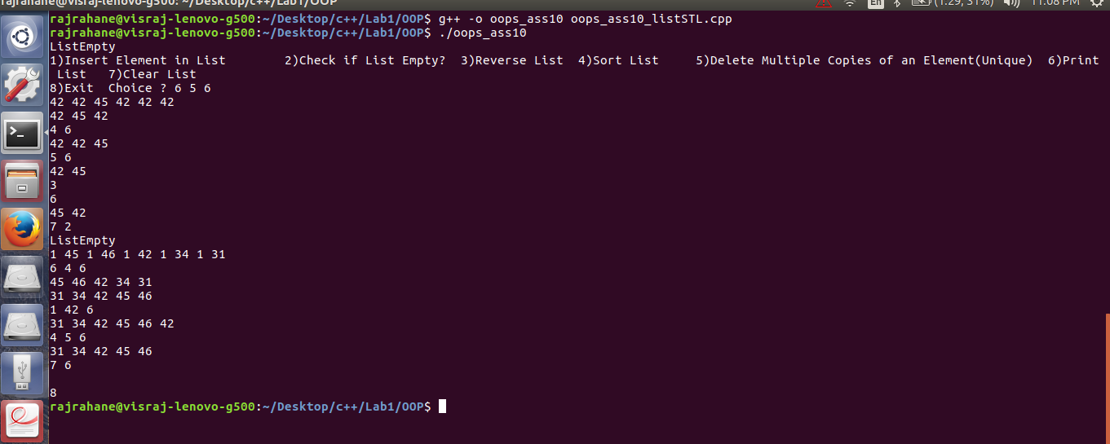

Conclusion- The List STL Container was Studied